

Radiolabelling, in vitro and in vivo evaluation of metal-labelled biomolecules for PET imaging

Dissertation
zur Erlangung des Grades
"Doktor der Naturwissenschaften"
im Promotionsfach Chemie

am Fachbereich Chemie, Pharmazie und Geowissenschaften
der Johannes Gutenberg-Universität
in Mainz

Ana de la Fuente Joaniquet
Geboren in Barcelona

Mainz, 2016

Dekan: Prof. Dr. Schneider

Tag der mündlichen Prüfung: 24.06.2016

“I hereby declare, that I wrote the dissertation submitted without any unauthorized external assistance and used only sources acknowledged in the work. All textual passages, which are appropriated verbatim or paraphrased from published and unpublished texts as well as all information obtained from oral sources are duly indicated and listed in accordance with bibliographical rules. In carrying out this research, I complied with the rules of standard scientific practice as formulated in the statutes of Johannes Gutenberg-University Mainz to insure standard scientific practice.”

Ana de la Fuente Joaniquet

A mi padre ,
José

“Caminante, no hay camino,
se hace camino al andar”

“Wayfarer, there is no way,
way is made by going farther”

Antonio Machado (1875-1939)

Abstract

Radiopharmaceuticals are a convenient tool in nuclear medicine for diagnosis and treatment of different pathologies. Their application is of great interest in oncology and infectious diseases therefore investigations on the development of nanoparticles for such purposes are under focus. Their characteristics need to be studied before application as many therapeutic drugs suffer from a poor balance between efficacy and toxicity. Nuclear medicine imaging techniques such as PET are being valuable (pre)clinical tools to non‐invasively assess drug performance in pharmaceutical research providing understanding into structure-property relationships in vivo towards optimization to more effective drug delivery.
In this study, different metal radioisotopes have been conjugated to diverse biomolecules such as antibodies, small based peptides molecules or polymer based micelles in order investigate their efficiency as disease imaging targets. Hence, versatile radiolabelling strategies were developed according to the requirements of each biomolecule and subsequent evaluations in vitro and in vivo were performed.

Zusammenfassung

In der Nuklearmedizin werden Radiopharmaka für die Diagnose und Therapie verschiedener Erkrankungen verwendet. Von besonderem Interesse ist ihre Anwendung in der Onkologie, infolgedessen steht die Entwicklung von Nanopartikeln für diese Verwendungen im Forschungsfokus.
Um das meist schlechte Verhältnis von Wirksamkeit zu Toxizität, welches bei vielen Therapeutika vorliegt, zu verbessern, müssen die entwickelten Nanopartikel intensiv hinsichtlich dieser Eigenschaft getestet werden. Nuklearmedizinische Techniken wie die Positronen-Emissions-Tomographie (PET) sind geeignete (prä)klinische Werkzeuge, um die Wirksamkeit von neuen Medikamenten nicht-invasiv zu ermitteln. Die hierdurch gewonnen Erkenntnisse zu den Struktur-Eigenschaft-Beziehungen in vivo können direkt in der Medikamentenentwicklung eingesetzt werden um den Wirkstofftransport zu optimieren.
In dieser Arbeit wurden verschiedene medizinisch relevante Strukturen, wie Antikörper, Peptide und Polymermizellen, mit verschiedenen Radiometallisotopen markiert und hinsichtlich ihrer Wirksamkeit als molekulare Marker von Erkrankungen untersucht. Es wurden, basierend auf den chemischen Eigenschaften der zu markierenden Strukturen, verschiedene Radiomarkierungsstrategien entwickelt und die markierten Verbindungen in vitro und in vivo evaluiert.

Table of contents

1 INTRODUCTION 1
1.1 Nanomedicine 1
1.1.1 Biological rationale using nanomedicines 2
1.1.1.1 Polymer based therapeutics 3
1.1.1.2 Active targeting agents 6
1.2 Nuclear medicine 8
1.2.1 PET 9
1.2.2 Radiometals for diagnosis 11
1.2.1.1 Generator produced PET isotopes 12
1.2.1.2 Production of non-standard PET isotopes 16
1.2.3 Radiometals for therapy 19
1.2.4 Labelling strategies for radiometals 19
1.3 Theranostics 21
1.3.1 Radiometals for theranostics 22

2 OBJECTIVES AND OUTLINE 31

3 MANUSCRIPTS AND SUPPLEMEMTARY RESULTS 35

3.1 Labeling of HPMA-based polymer-conjugates with metallic radionuclides for theranostic applications 37
3.2 ⁶⁸Ga-,¹¹¹In-oxine: A novel strategy of in situ radiolabelling of HPMA-based micelles. 67
3.3 ⁴⁴Sc-PSMA-617 for dosimetry of prostate cancer. 91
3.4 Labeling and preliminary in vivo assessment of niobium-labeled radioactive species: A proof-of-concept study 107
3.5 Conjugation, labelling and in vitro/ in vivo assessment of an anti-VEGF monoclonal antibody labelled with niobium isotopes. 127

4 SUMMARY, CONCLUSIONS AND FUTURE PERSPECTIVES 145

5 OUTLOOK 155

LIST OF ABBREVATIONS 157
ACKNOWLEDGEMENTS 158
CURRICULUM VITAE 161

1 Introduction

Current (chemo)therapeutic drugs often suffer from a narrow therapeutic index, which is the range of dose at which a medication is effective with minimized side effects [1]. To achieve a therapeutic concentration, in many cases large quantities of the drug have to be administered leading to adverse effects accompanying therapy. Consequently, efforts towards improved drug delivery have been carried out over the past decades leading to a new field of medical and scientific research termed “nanomedicine” using nanoscale carriers selectively delivering bioactive substances to diseased sites [2].
In terms of improvement of the poor balance between efficacy and toxicity, the combination of biomolecules with radioisotopes gave rise to nuclear medicine, which allows for treatment and/or diagnosis of a variety of diseases in a non-invasive way. In addition, it is a valuable tool in pharmaceutical research as nuclear imaging techniques like positron emission tomography (PET) can assess, in vivo, the performance of the drug identifying how properties such as binding affinity, size, charge or hydrophilicity affect to in the in vivo distribution of the nanoparticle.

  - NANOMEDICINE

Nanomedicine formulations aim to improve the biodistribution and the target site accumulation of (chemo)therapeutic agents with the ultimate goal of improving quality of life. They can be made of materials of diverse chemical nature, including for example: liposomes, polymers, micelles and antibodies [3,4]. One of the greatest advantages of nanoparticles is the ability to generate particles functionalized with a wide variety of targeting ligands and physicochemical properties, which permit the creation of agents that are specifically tailored for a desired application [5].
1.1.1 Biological rationale using nanomedicines
Biological barriers as well as obstacles such as sequestration by the mononuclear phagocyte system may end to nonspecific distribution of nanotherapeutics [6]. Advances in pharmacy, medicine, chemistry, biology and material sciences have led to an improvement in overcoming such limitations by adjusting the particle size, the hydrophilicity or the charge and the possibility to be multifunctionalised. To minimize clearance by the immune systems, to be visualized or to reach specific cells are some of the features achievable by functionalization. The inclusion of a targeting vector leads to two general concepts - “active” and/or “passive” targeting - when guiding drugs to pathological sites.
“Passive targeting”, which is utilized by most of the systems (particularly liposomes, polymers and micelles), is based on the inherent tendency of macromolecules to accumulate in tumor tissue. Maeda and co-workers demonstrated the potential for accumulation of long circulating nanoparticles in tumor sites through extravasation of blood vessels [7]. Compared to healthy tissue, tumors are characterized by abnormalities like a damaged lymphatic drainage and a fast and defective formation of new blood vessels (angiogenesis) creating, consequently, large gaps between endothelial cells and tumor blood vessels. This fact is exploited to target solid tumors with macromolecules, as they are able to extravasate tumor tissues and be retained. This passive accumulation in pathological tumor tissue has been termed “enhanced permeability and retention (EPR) effect” [8,9] (Fig. 1).
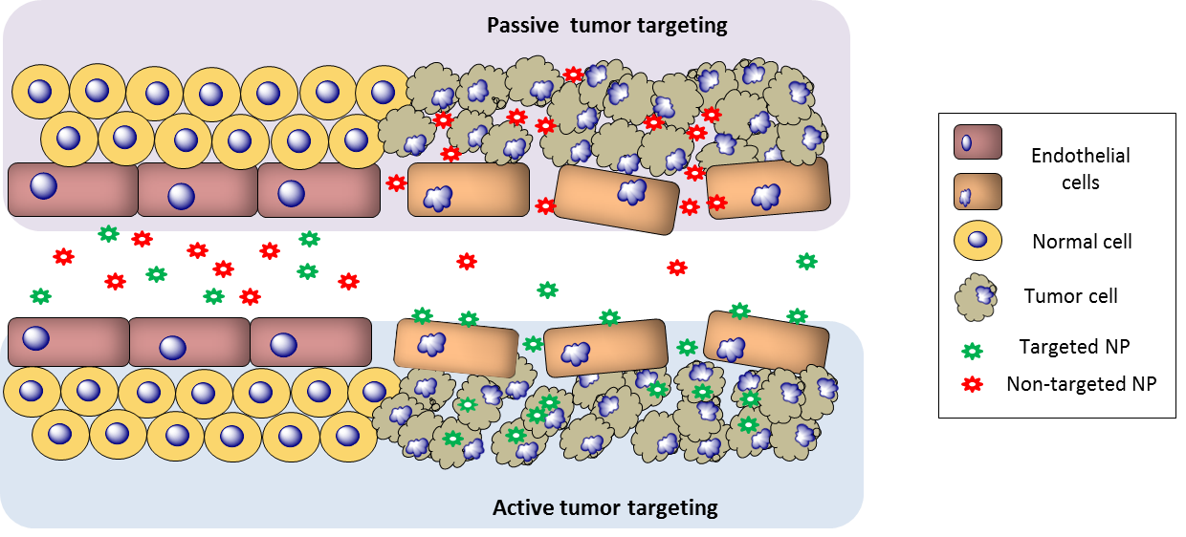

Figure 1: Active and passive targeting of nanoparticles
On the other hand, the concept of the “magic bullet” introduced by Paul Ehrich in 1903, has influenced research efforts to develop site-directed delivery strategies for drugs. This strategy is referred to as “active targeting” [10,11]. Active drug targeting relies on the use of antibodies, peptides, sugar moieties or blood cells to improve drug concentration at the diseased site thus maximizing therapeutic response [12]. In oncology, targeting not only tumor tissue but the receptors overexpressed by specific tumor cells or angiogenic endothelial cells can eradicate tumor vessels and deprive tumor cells from oxygen and nutrients hence reduce tumor grow [13]. In addition, some targeted nanoparticles can also be internalized by tumor cells via receptor-mediated endocytosis/phagocytosis, resulting in elevated concentration in tumor tissue.

1.1.1.1 Polymer based therapeutics
The use of polymers in the design for therapeutic agents has been widely investigated for several years [14]. It was in 1975 when Helmut Ringsdorf first proposed the concept of polymer–drug conjugation, a rational for pharmacologically active polymers [15]. The model compound consists of a biocompatible backbone where three main components are bound: (1) a solubilizer that ensures water solubility, (2) a drug, normally attached via a linker and (3) a targeting moiety that guides to a desired physiological destination (Fig. 2). This structure enables a better control of the drug delivery and improved drug availability to the targeted tissue. The possibility to tailor synthetic polymers in terms of molecular weight, architecture and size and the extensive array of functionalization options, that can be used to create versatile multifunctional systems for medical purposes, has resulted in a huge class of polymer based drug delivery systems [16, 17].
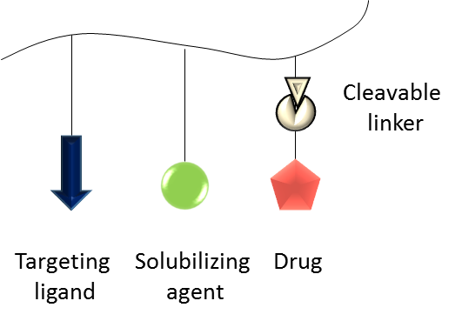

Figure 2: Model of a pharmacologically active polymer as envisioned by H. Ringsdorf.

Interdisciplinary research including polymer chemistry, medicine, cell biology and pharmaceutical sciences began to design biologically active polymeric drugs. Since then, drug delivery systems such as polymeric micelles, polymer–drug conjugates and polymer–peptide/protein conjugates have been elaborated. Such multicomponent polymer-based drugs and delivery systems have been termed as “polymer-therapeutics” [18].
To be efficient as transport vehicle, the polymer system requires being water soluble, non‐immunogenic, non‐toxic and should provide the possibility to achieve high drug payloads. Poly‐N‐(2‐hydroxypropyl)methacrylamide (pHPMA), polyethylene glycol (PEG) and polyglutamic acid (PGA) fulfil these requirements and have the most widely investigated chemistries and the clinically most relevant polymeric backbones [14,17,19,20].

HPMA based polymeric therapeutics
It was in the late 1970s when Kopecek and colleagues first synthetized polymer-drug conjugates based on N-(2-hydroxypropyl)methacrylamide (HPMA), which was already known to be non-immunogenic, non-toxic and to reside in the circulation well [21]. Other appealing properties of HPMA are the possibility of controlled synthesis and the multiple pendant side chains to carry drug residue payload. The success of HPMA polymers as drug carriers was achieved during the early 1990s when it was evaluated in clinical trials for therapeutic validation [22]. Up to now six HPMA anticancer conjugates have progressed into clinic using doxorubicin, paclitaxel, camptothecin and platinates as therapeutic agents being able to improve the balance between the efficacy and the toxicity of chemotherapy [23,24]. Careful control of the reaction conditions to regulate polymerization kinetics allows to synthetize HPMA precursors of relatively narrow molecular weight distribution.
The first HPMA conjugates in clinical trials were synthesized mostly via free radical polymerization (PM) technique, but the fast chain growth and the presence of the rapid irreversible termination limits the degree of control over polymer molecular weight distribution and polymer structure [2,21,25]. This route appeared to be rather difficult concerning clinical requirements such as careful characterization, reproducibility, purification and precision. To overcome these drawbacks, new methods were developed based on either reversible deactivation of polymer radicals or a degenerative transfer process. Controlled radical polymerizations such as nitroxide-mediated polymerization (NMP), atom transfer radical polymerization (ATRP) or reversible addition-fragmentation chain transfer polymerization (RAFT) represent key strategies for the preparation of polymers with narrow molecular weight distributions. Among them, RAFT is one of the most utilized methods as it can be used with a large variety of monomers, it is tolerant to a wide range of functional groups and reaction conditions and does not require any heavy metal catalyst as in ATRP [2,26].
Thus, RAFT polymerization offers the possibility to synthesize reactive block copolymers, which can be first precisely characterized and afterwards functionalized by polymer analogous reactions [27]. In addition, by combining RAFT with copolymers and especially block copolymers with activated ester units attached to the polymer backbone, a high variability can be achieved in terms of introducing functionality. This approach has been successfully applied for the synthesis of multifunctional HPMA‐based polymers [2,21,28,29]. Figure 3 shows the schematic synthetic route underlying this concept. Starting from a reactive ester monomer PFPMA (pentafluorophenyl methacrylate), a PFPMA‐homopolymer is synthesized which later can be derivatized using primary amines by polymer analogous reaction. This synthetic route enables the introduction of various functionalities that in a further step will allow facile attachment of imaging or therapeutic probes for example via amide bonds [2].
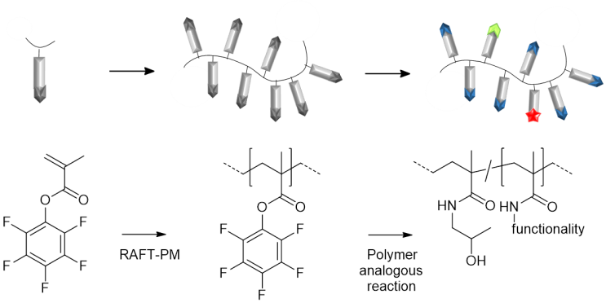

Figure 3: Schematic synthesis of functional HPMA polymers using RAFT polymerization technique and reactive ester approach [2].

HPMA can be modified with hydrophobic moieties that will serve as a micellar core in which hydrophobic drugs can be solubilized and retained while hydrophilic HPMA constitutes the micellar stealth corona. Lauryl methacrylate (LMA) hydrophobic moieties have been conjugated to HPMA thus forming amphiphilic HPMA-LMA copolymers that self-assemble forming aggregates and/or micellar structures. Such structures have been widely investigated and have shown promising results as a drug delivery system due to its capacity of loading drugs into their core and its longer circulation times when compared to homopolymers, which is translated in higher tumor accumulation [30-33]. Additional incorporation of PEG moieties (Fig. 4) reduces the uptake of the NP by the reticuloendothelial system (RES) and increases circulation time on top of diminishing aggregation between the particles and association with serum and tissue proteins [34].
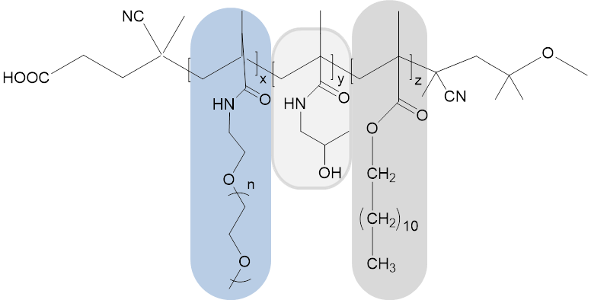
PEG
LMA
HPMA

Figure 4: HPMA polymer backbone with PEG and LMA moieties

1.1.1.2 Active targeting agents
Key molecules involved in proliferation, cell death, angiogenesis, invasion or metastasis have been discovered thanks to recent advances in molecular and cellular biology [34]. The identification of such biomarkers helps to understand their mechanism of action and therefore to design molecules that specifically target a certain antigen or receptor aiming to improve target site accumulation and/or target cell uptake. Antibodies and small molecules are examples of structures that have demonstrated such abilities [35].
Antibodies are large Y-shaped proteins produced by the immune system that identify and neutralize foreign objects like bacteria and viruses. A variety of antibodies (Mw 150 kDa) as well as antibody fragments and engineered variants, like minibodies, affibodies or nanobodies with Mw ranging from 25 to 100 kDa, have been engineered. Up to date more than 30 different antibodies are approved by the US Food and Drug Administration and much others are currently under preclinical investigation [34, 36].
Typically, the advantage of monoclonal antibodies (mAbs) in cancer treatment is based on their capability to bind antigens expressed on the tumour-cell surface with highly selectivity [37].
Of special interest are mAb approved for clinical use for targeting solid tumors such as: trastuzumab, cetuximab, panitumumab and bevacizumab. They interfere with signal transduction pathways by targeting growth factors or their receptors, the key drivers of tumor growth and survival, thus avoiding neovascularization and therefore reducing the tumor’s accessibility to oxygen and nutrients. These “solid tumor mAbs” are, in general, most effective when combined with chemo- or radiotherapy [34].
In contrast, small molecular weight compounds differ from the antibodies by having small sizes, low production costs and improved stability. These advantages translate into simple pre-formulation conjugation strategies and simple synthesis. In fact, the main challenge with small molecules is the identification of new ligands with high affinity for the substrates of interest [38]. Moreover, the difference in molecular size of small-molecules might be translated into more efficient tissue penetration, tumor internalization and retention and blood clearance when compared to antibodies [37].
Early examples of small molecules utilized as a targeting tumour ligands are carbohydrate moieties (mannose, glucose, galactose and their derivatives) or folic acid with high affinity and specificity for folate receptors frequently over-expressed on the surface of a variety of human tumors [38-40]. The gain of knowledge in cell biology, chemistry and pharmacy has led to the development of a wide array of small molecules with high specificity for a certain receptor. A result of such advances, for example, is the discovery of an integral transmembrane protein as an efficient prostate cancer biomarker. This protein, named Prostate Specific Membrane Antigen (PSMA), has demonstrated to be more effective than the initial target used for prostate cancer biomarkers, the secretory protein Prostate Specific Antigen (PSA) which high levels do not always correlate with disease [41, 42]. The discovery of the highly over-expressed PSMA in the tumor cells of nearly all kinds of prostate cancer as suitable target site lead, in parallel to the development and clinical utilization of PSMA-specific mAbs, to the development of an array of small molecules with high affinity to PSMA (Fig. 5). Small molecules such as ⁶⁸Ga-PSMA-11, ⁶⁸Ga-,¹⁷⁷Lu-PSMA-617, ¹⁸F-DCFBC or ¹³¹I-MIP-1095 have shown high potential for detection and treatment of prostate tumor lesions [43].

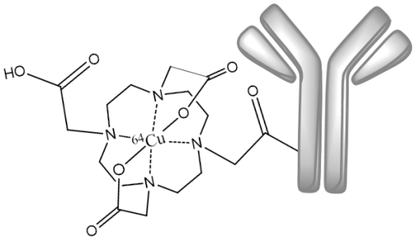
⁶⁴ Cu-mAb 3/A12
¹⁷⁷Lu-PSMA-617
¹³¹I-MIP-1095
¹⁸F-DCFBC

Figure 5: Comparison of antibody (> 1 x 10⁵ g/mol) and small compounds (< 2 x 10³ g/mol) exemplified for prostate cancer-based molecules.

1.2 NUCLEAR MEDICINE

The discovery of X-rays in 1895 by Wilhelm Conrad Roentgen and of radioactivity by Henri Becquerel (Nobel Prize in physics 1903, proportionately M. Curie) together with the work of George de Hevesy on the use of isotopes as tracers in the study of chemical processes (Nobel Prize in chemistry; 1943) paved the way of nuclear medicine [44-46]. Nuclear medicine takes advantage of the decay properties of radioisotopes and uses small amounts (nano- to picomols) of radioactive material to diagnose (e.g. brain, kidneys) and treat a variety of pathologies.
In contrast to other imaging techniques such as computed tomography (CT), ultrasound (US) or magnetic resonance imaging (MRI), the nuclear imaging techniques “single-photon emission computed tomography” (SPECT) and “positron-emission tomography” (PET) present (1) higher sensitivity and specificity, (2) are able to detect changes at cellular and subcellular levels in living subjects, (3) present no limit to tissue penetration in any organ allow for (4) dynamic images and (5) quantification of compound distribution [5,47]. These advantages make SPECT and PET important tools in accurate and early diagnosis. The basis of PET and SPECT techniques relies on the use of radionuclides emitting photons (directly or indirectly), with enough energy to penetrate the body and to be detected externally [48]. PET presents higher spatial and temporal resolution in comparison to SPECT, thus allowing for more precise localization with a lower dose of injected compound [49,50].
To improve the diagnostic potential and spatial resolution, synergistic combinations such as PET/MRI or PET/CT and SPECT/CT are available. Those multimodality imaging devices combine the potentials of both morphological and molecular imaging, providing detection of pathophysiological changes in early disease phases at high structural resolution.

1.2.1 PET
Positron emission tomography is a nuclear imaging technique that can dynamically image to trace amounts of positron-emitting radionuclide-labelled radiopharmaceuticals in vivo [51].

Fundamentals
All positron emitters are proton-rich nuclides that in order to stabilize transform a proton into a neutron by the conversion of an up-quark into a down-quark. This process is accompanied by the emission of a positron (β⁺), which is the antimatter of an electron, and a neutrino (ν) (eq. 1). In such transformation the daughter nucleus (Y) has the same mass number than the parent nuclide (X), but the atomic number is reduced by one (eq. 2).

${}_{1}^{1}p → {}_{0}^{1}n+ {}_{0}^{1}{β^{+}}+ {{}_{0}^{0}ν}_{e}$ (eq. 1)
${}_{Z}^{A}{X_{N}} → {}_{Z-1}^{A}{Y_{N+1}}+ {}_{0}^{1}{β^{+}}+ {{}_{0}^{0}ν}_{e}$ (eq. 2)

After emission from the nucleus, the positron travels a short distance while losing kinetic energy due to interactions with the surrounding matter (i.e., tissue) until it annihilates with an electron, producing a metastable intermediate species, the positronium (Ps) and emitting gamma rays [52]. The positronium can exist in two states: para-positronium, which occurs when positron and electron have antiparallel spins (singlet) or ortho-positronium, when both particles have parallel spin (triplet) [53].
When the positron and electron collide at absolute rest energy (E_{kin}= 0), the para-Ps is formed and transforms with a lifetime of 1.25 x 10⁻¹⁰ s into the diagnostically useful two gamma rays emitted in opposite directions (180°) with equal kinetic energy of 511 keV each. The ortho-Ps decays after a lifetime of 1.4 x 10⁻⁷ s into three gamma rays. The sum of E_{kin} always equals to 1.022 MeV [54].

Table 1: Comparison between ortho- and para-Ps
 | ortho-Ps | para-Ps
Status | triplet | singlet
Impulse (J) | 1 | 0
Life-time | 1.4 x 10⁻⁷ s | 1.25 x 10⁻¹⁰ s
(free Ps) | 1.4 x 10⁻⁷ s | 1.25 x 10⁻¹⁰ s
Annihilation | E_{γ1} + E_{γ2} + E_{γ3} = 1.02 MeV | 2 x 0,511 keV = 1.02 MeV
Angle | static | 180°

PET-technique
PET scanners typically consist of rings of 511 keV-sensitive scintillation detectors, with up to 25.000 individual scintillation elements made of NaI, bismuth germinate (BGO) or lutetium orthosilicate (LSO). The opposing PET detectors register the arrival of the annihilation photons as an event if they are detected within a narrow time frame (3-15 ns). This requirement of detecting both the photons within a time window is the fundamental basis of coincidence detection called electronic collimation [53]. PET scans thus consist of the collection of large numbers of coincidence events that later on, by using mathematical reconstruction methods and appropriate correction factors for phenomena such as gamma ray attenuation and scatter, provide information about the quantity and location of the positrons in the body (Fig. 6). Detection resolution is significantly dependent on the width of the crystal elements, but also on the range of the positron and the noncollinearity of the two gamma rays [51].
One of the main drawbacks of PET is the lack of a clear anatomical reference frame that may hamper to accurately localize anatomic structures or lesions that exhibit abnormal radiotracer accumulation. This can be solved by combining PET with anatomical imaging techniques such as CT or MRT.
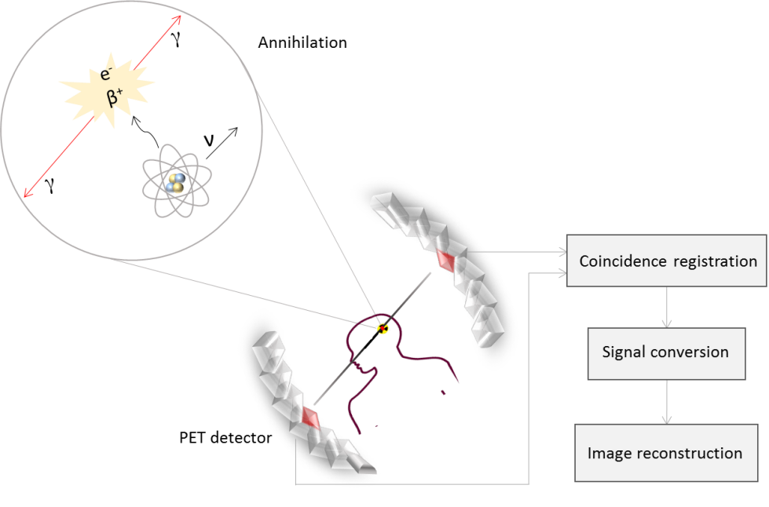

Figure 6: Schematic illustration of the principle behind PET technique.

1.2.2 Radiometals for diagnosis
The choice of radionuclides for medical purposes depends largely in its nuclear properties (t ½, type of radiation, energy, presence or lack of other particular emissions) as well as cost and availability.
Radiometals have become a fundamental component of many pharmaceuticals for diagnostic nuclear medicine applications because they offer many advantages over organic radioisotopes (¹⁸F, ¹¹C, ¹⁵O, ¹⁷N) [55]. Metal radionuclides present: (1) fast radiolabelling reactions with simple purification procedures, (2) lower cost and easier access of certain radiometals via radionuclide generators, (3) broad opportunities for design and development of new target-specific radiotracers able to change the biodistribution of the radiopharmaceutical by modifying the coordination environment of the radiometal with a variety of chelators, (4) the possibility to better match the biological half-life of the targeting vector thanks to the wider variety of metallic radionuclides and (5) the availability for some radionuclides of automatized synthesis “kits” allowing rapid labelling and to finally (6) switch between diagnostic and therapeutic options [57]. Table 2 summarizes the nuclear characteristics of selected PET nuclides appropriated for molecular imaging by means of positron emission tomography.

Table 2: Nuclear characteristics of selected PET nuclides appropriated for molecular imaging
Nuclide | t _{1/2} | Decay [%] | E_{β+} max [MeV] | Production
¹⁸F | 109.7 min | β⁺ (97) | 0.635 | ¹⁸O(p,n)¹⁸F
⁴⁴Sc | 3.97 h | β⁺ (94) | 1.474 | ⁴⁴Ti/⁴⁴Sc generator
⁶⁸Ga | 67.7 min | β⁺ (89) | 1.899 | ⁶⁸Ge/⁶⁸Ga generator
⁶⁸Ga | 67.7 min | EC(11) | 1.899 | ⁶⁸Ge/⁶⁸Ga generator
¹²⁴I | 4.2 h | β⁺ (23) | 2.138 | ¹²⁴Te(p,n)¹²⁴I
¹²⁴I | 4.2 h | EC (77) |  | ¹²⁴Te(d,2n)¹²⁴I
⁶⁴Cu | 12.7 h | β⁺ (17) | 0.653 | ⁶⁴Ni(p,n)⁶⁴Cu
⁶⁴Cu | 12.7 h | EC (44) | 0.653 | ⁶⁴Ni(p,n)⁶⁴Cu
⁹⁰Nb | 14.6 h | β⁺ (53) | 1.500 | ⁹⁰Zr(p,n)⁹⁰Nb
⁹⁰Nb | 14.6 h | EC (77) | 1.500 | ⁹⁰Zr(p,n)⁹⁰Nb
⁸⁶Y | 14.7 h | β⁺ (33) | 3.141 | ⁸⁶Sr(p,n)⁸⁶Y
⁸⁶Y | 14.7 h | EC (66) | 3.141 | ⁸⁶Sr(p,n)⁸⁶Y
⁷⁴Br | 16.2 h | β⁺ (55) | 3.941 | ⁷⁶Se(p,n)⁷⁶Br
⁷⁴Br | 16.2 h | EC (45) | 3.941 | ⁷⁶Se(p,n)⁷⁶Br
⁸⁹Zr | 3.3 d | β⁺ (23) | 0.901 | ⁸⁹Y(p,n)⁸⁹Zr
⁸⁹Zr | 3.3 d | EC (77) | 0.901 | ⁸⁹Y(p,n)⁸⁹Zr

For SPECT imaging, ^{99m}Tc remains the most widely used radiometal due to its optimal nuclear properties and easy availability at low cost. The cyclotron-produced ¹¹¹In is also important for SPECT imaging and it is often used as imaging surrogate for the therapeutic radionuclide ⁹⁰Y [58].

1.2.2.1 Generator-produced PET radioisotopes
The use of short-living radionuclides has grown considerably as large doses can be administrated to the patient with minimal radiation dosage and at the same time to generate images with high quality [59]. This fact has led to the development of radionuclide generators, which provide high specific activity, no-carrier added (n.c.a) identity and a convenient alternative to accelerators or reactors and eventually on-line medical application [60]. In a generator, the long-living parent nuclide is allowed to decay to its short-living daughter that can be chemically separated with low effort. The chemical properties of both radionuclides must be different thus affording a good separation in which the daughter nuclide is obtained in a pure radionuclidic and radiochemical form [61]. Radionuclide generator systems provide both diagnostic and therapeutic radionuclides for application in nuclear medicine. In spite of many parent/daughters pairs, only a small number are currently in routine clinical and research use as generator systems [62].

⁶⁸Ge/⁶⁸Ga generator
⁶⁸Ga decays with a half-life of 67.71 min to stable ⁶⁸Zn by positron emission (89%) and with a maximum positron energy of 1.89 MeV (Fig. 7). Such decay characteristics in addition to its cyclotron-independent availability via the ⁶⁸Ge/⁶⁸Ga generator and its well-known coordination chemistry, make ⁶⁸Ga a radionuclide of great interest for nuclear medicine [63].
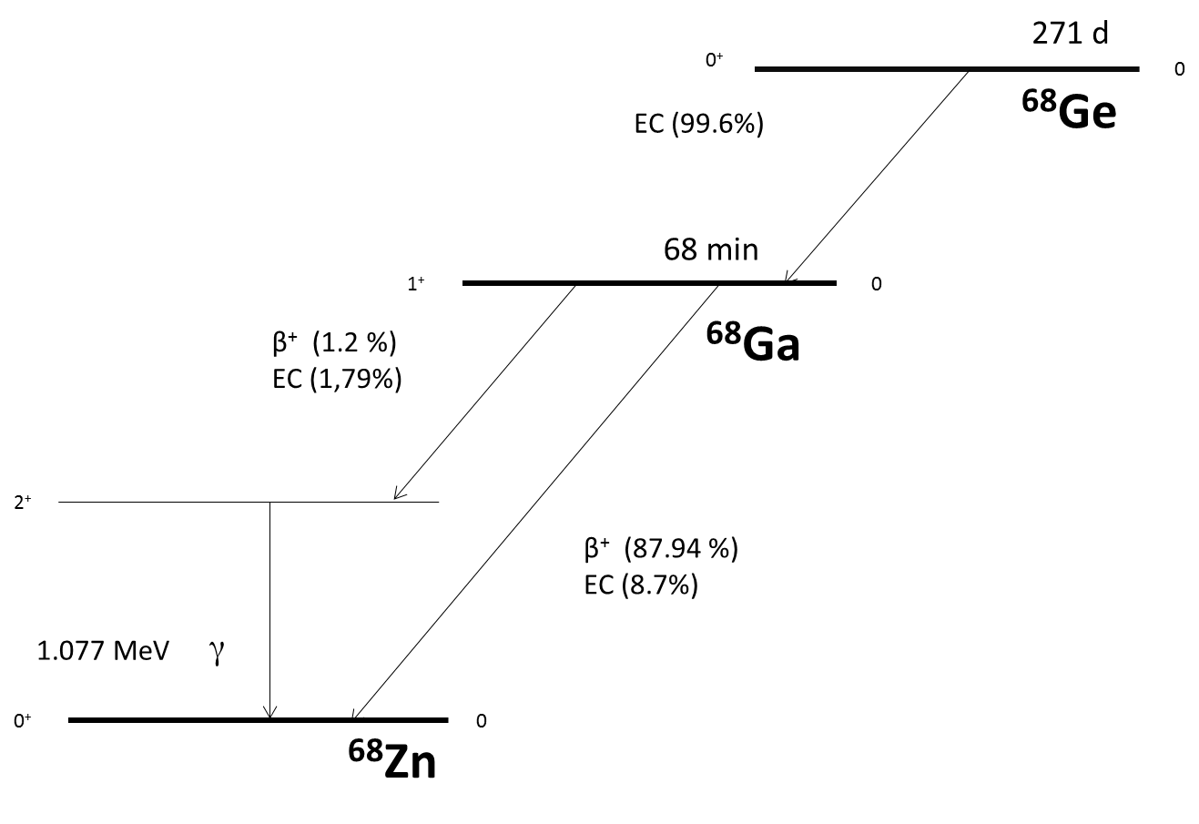

Figure 7: Decay scheme of ⁶⁸Ge and ⁶⁸Ga

The production of the parent radionuclide ⁶⁸Ge (t ½ = 271 d), can be achieved via different nuclear reaction pathways, being the (p,2n) reaction to Ga₂O₃ targets the most relevant [64]. After separation from the irradiated target, ⁶⁸Ge is strongly absorbed to a solid support, such as metal oxides or organic resins, from which the short-living daughter nuclide ⁶⁸Ga can be selectively eluted.
Nowadays commercially available generators use TiO₂, SnO₂ or polymer matrices to immobilise ⁶⁸Ge. ⁶⁸Ga is quantitatively eluted using a low concentrated HCl solution, but the conditions in which is obtained are not suitable for direct labelling of radiopharmaceuticals. The eluate has large volumes, an acidic pH, a breakthrough of ⁶⁸Ge that increases with time or frequency of use, and impurities such as stable Zn(II) generated by the decay of ⁶⁸Ga, Ti(IV) as a constituent of the column material, and Fe(III) as a general impurity. Thus, a post-processing is recommended to pre-concentrate and purify the initial generator eluate [65, 66].
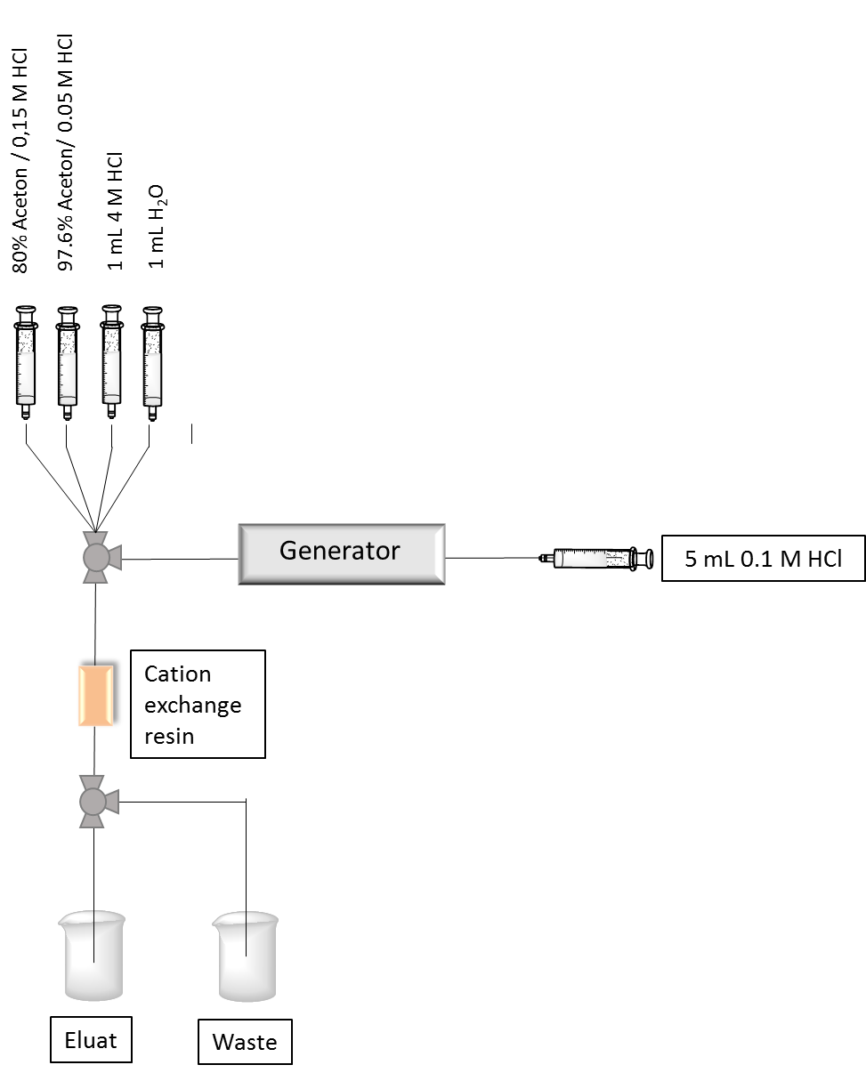

Figure 8: ⁶⁸Ga generator with cation exchanger applying the acetone post-processing

A number of methods for post-processing of the eluate including fractionation, anion or cation exchange purification and combination of both have been developed. The one, first developed by Zhernosekov et al., is the most effective method [66]. These systems have been also implemented into fully automated modules allowing generator elution, post-processing radiolabelling and formulation, complying with regulatory demands [67]. Figure 8 shows an elution scheme of ⁶⁸Ga generator with cation post-processing using acetone/HCl solutions for desorption of ⁶⁸Ga.

⁴⁴Ti/⁴⁴Sc generator
⁴⁴Sc has a half-life of 3.97 hours, a high positron branching of 94.27% and mean β⁺ energy of 632 keV. It is of high interest for application in nuclear medicine (Fig. 9). ⁴⁴Sc is obtained via a radionuclide generator or, alternatively, it can be produced in a cyclotron through the irradiation of ⁴⁴Ca target with protons (⁴⁴Ca(p,n)⁴⁴Sc)[68].
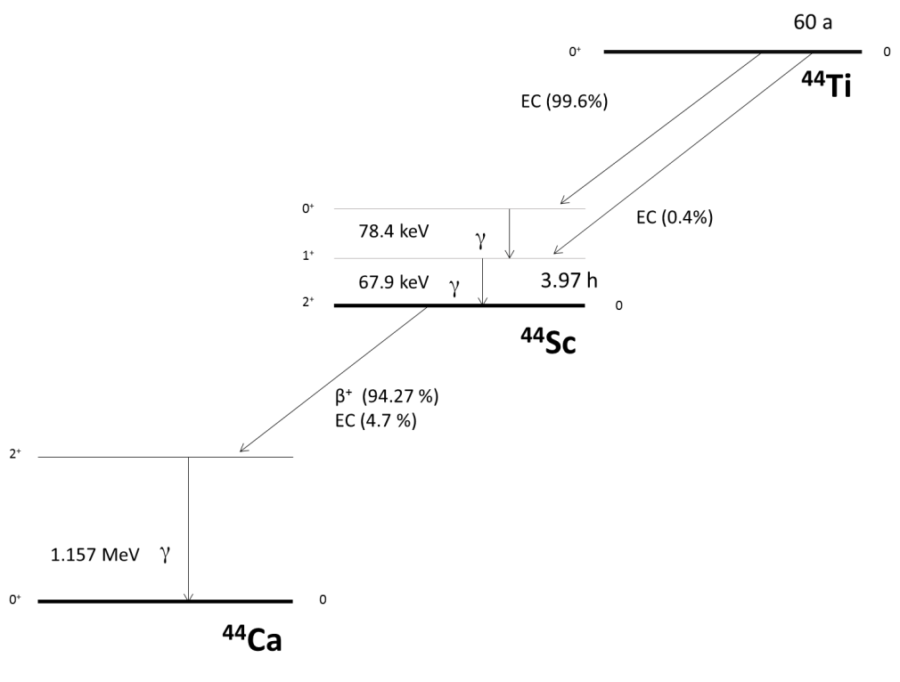

Figure 9: Decay scheme of ⁴⁴Ti/⁴⁴Sc

During the 1960s and 1970s, several radiochemical studies were carried out in order to design a ⁴⁴Ti/⁴⁴Sc generator [69-71]. But it was recently when for the first time a ⁴⁴Ti/⁴⁴Sc generator was described involving pharmaceutical aspects [72]. In this generator an anion-exchange resin is used to fix the parent nuclide ⁴⁴Ti (t ½ = 60 years), previously produced via ⁴⁵Sc(p,2n)⁴⁴Ti nuclear reaction, which transforms directly into the ground state of ⁴⁴Sc via electron capture. Elution of the generator with 20 mL of a 0.07 M HCl/ 0.005 M H₂C₂O₄ mixture provides 180 MBq ⁴⁴Sc with a ⁴⁴Ti breakthrough of 90 Bq which corresponds to an excellent separation factor of 2 x 10⁶. During the elution, ⁴⁴Sc is online trapped on a cation exchange resin and will be later desorbed with 3 mL of 0.25 M ammonium acetate (NH₄OAc) buffer, pH= 4.0 with a high recovery yield (>85%) (Fig. 10) [73]. The use of this post-processing minimizes contamination with foreign ions, optimizes the pH and reduces the volume of ⁴⁴Sc eluate for subsequent labelling of targeting vectors, thus ensuring the safe production of ⁴⁴Sc radiopharmaceuticals [74].

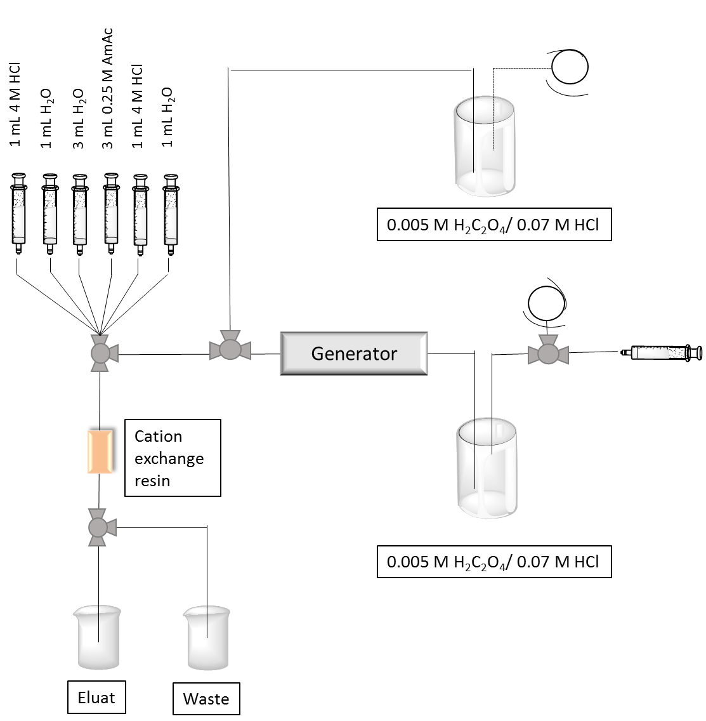

Figure 10: Scheme of ⁴⁴Ti/⁴⁴Sc generator

Owing to the long half-life of ⁴⁴Ti, the generator can be used for several years. Therefore it must be ensured that the generator parameters remain constant. In practise, the distribution of ⁴⁴Ti has to remain as stable as possible on the anion exchanger even after many elutions. Therefore the generator is eluted after the elution ⁴⁴Sc one more time. This second elution runs in the opposite direction and is essential for the shelf-life of the generator [72].

1.2.1.2 Production of non-standard PET isotopes
New radionuclides which can be routinely used for diagnosis or for evaluation of therapy would be valuable additions to the already available radionuclides used in nuclear medicine (standard nuclides). There is a big potential for production and development of new radiopharmaceuticals using PET radionuclides with cyclotrons in the energy range of 10–20 MeV present in several medical centers [75].
Besides availability via generators, positron emitters are produced in charged-particle accelerators via bombardment of the target with high energy protons, deuterons, ³He or α particles [76]. Due to the limited number of ³He and α particle accelerators as well as the low production yield of these reactions, the most common method is currently the irradiation with protons in cyclotrons with low energy (up to 20 MeV) [50].

Irradiation
Several parameters that play a key role in the production of non-standard PET radionuclides need to be taken into account in order to achieve high production yields, which can be defined as the amount of activity (MBq) that can be produced at a defined energy per one μA for 1 hour irradiation time [49,77,78]. Such considerations are:
(1) Natural isotopic composition of the target: It should be high enough to produce the desired nuclide and minimize side reactions. To reduce contamination, isotopic enrichment of the target (up to 99.9%) can be applied, which will reduce co-production of other radionuclides but will increase the production cost.
(2) A high cross section value of the nuclear reaction is desired.
(3) Irradiation parameters: Energy of incident particles (MeV), beam intensity (μA), time of irradiation (h) and thickness of target material (mm).
(4) Melting point of the target material: An increase in current will create additional heating on the target surface, which a cooling system is called to reduce. Some target materials with “low” melting points can limit production yield or increase irradiation time by restriction of particle intensity.

Separation and purification
After irradiation, the micro-amount of product in the no-carrier added (n.c.a) state should be isolated from a macro-amount of target material [49,79]. In a first step, a crude separation allows isolation of the bulk amount of the target material [80]. Following gentle separation steps, afford additional separation and preconditioning of the radionuclide for further labelling (volume, media and purity) [81].
It is important that in the final sample there are neither tracers of aggressive media used for separation which are not comparable with an animal or human application nor other radioisotopes that can create additional dose burden for the patients and sufficiently decrease quality of imaging.

Non-standard PET isotope ⁹⁰Nb
Driven by the increasing availability of preclinical and clinical PET scanners, the use of non-standard PET nuclides has been growing in the past decade. Largely complementary to the roles of standard PET nuclides such as ¹⁸F, ¹¹C or ⁶⁸Ga, non-standard PET nuclides enable the novel design and synthesis of a wider range of PET tracers to probe a variety of biological events [82]. Examples are ⁸⁶Y, ⁶⁴Cu or ⁸⁹Zr with high increase in its application during the last few years. Another non-standard positron-emitter is ⁹⁰Nb, whose decay characteristics make it promising for quantitative investigations on biological processes with slow distribution kinetics. It has a half-life of 14.6 hours and decays with a positron branching of 53% and a relatively low β⁺-energy of E_{mean} = 0.66 MeV and E_{max} = 1.5 MeV [83].
⁹⁰Nb can be produced via several reactions by irradiation of ⁹⁰Zr, ⁹³Nb and ^{nat}Y targets with accelerated protons, deuterons, ³He or alpha particles. The (p,n)-reactions lead to higher production yields over the other processes without requirement of high energy flux, therefore being the most advantageous route for production of ⁹⁰Nb. Results of cross section measurements demonstrate that ⁹⁰Nb can be produced efficiently and in high radionuclidic purity by means of the (p, n)-process on enriched ⁹⁰Zr with maximum proton energies of about 17 MeV [83,84].

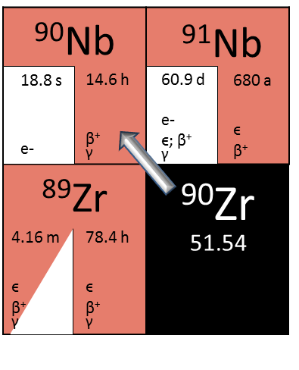

Figure 11: fragment of the chart of nuclides showing the production route to obtain ⁹⁰Nb
1.2.3 Radiometals for therapy
Radionuclide therapy can selectively deliver therapeutic radiation doses in targeted tissues. The basis for successful radionuclide therapy is an efficient concentration and prolonged retention of the radiopharmaceutical on the disease site with as little harm as possible to the nearby healthy tissue. This effect is determined by the total absorbed radiation dose and the sensitivity of the lesion to radiation [85].
The type of particle radiation for targeted radionuclide therapy (β⁻, α, Auger electrons) which causes biological damage as well as the energy and half-life, the blood clearance, the specific activity and production feasibility are factors to be considered to identify an appropriate radionuclide [86,87]. Among various radionuclides the generator produced ⁹⁰Y (high energy betta emitter) and the reactor-produced ¹⁷⁷Lu (low energy beta emitter) are the most commonly used depending on the tumor size and location [88]. ¹⁷⁷Lu- or ⁹⁰Y-labelled octreotides (DOTATOC, DOTATATE) for example, have shown to be an appropriate treatment option for patients suffering from neuroendocrine tumors.
Other examples of β⁻ emitting nuclides are ¹⁸⁸Re und ¹⁶⁹Er, used ⁸⁹Sr used in nuclear medicine for example as palliative therapy for bone metastasis, and α-emitters such as e.g. ²²³Ra and ²⁵⁵Ac.

1.2.4 Labelling strategies for radiometals
The use of radiometals for labelling biomolecules generally requires bifunctional chelators (BFC), which strongly bind and stabilize the metal cation at one terminus and contain a functional group for covalent linkage to the biomolecule at the second terminus. Radiometal-based radiopharmaceuticals can be described as a four component structure: Biomolecule as a carrier, BFC, a linker moiety that connects these two functional components, and the radiometal (Fig. 12).
Selection of appropriate BFC and optimization of its labelling efficiency is an important step of the development of radiopharmaceuticals and its choice is mainly determined by the co-ordination chemistry of the metallic radionuclide.
The optimal BFC should ideally form a complex that is thermodynamically stable and kinetically inert to prevent ligand exchange or hydrolysis in vivo, to afford rapid complexation kinetics, to be selective to the radiometal of interest over other metals and to provide versatile conjugation chemistry [57].

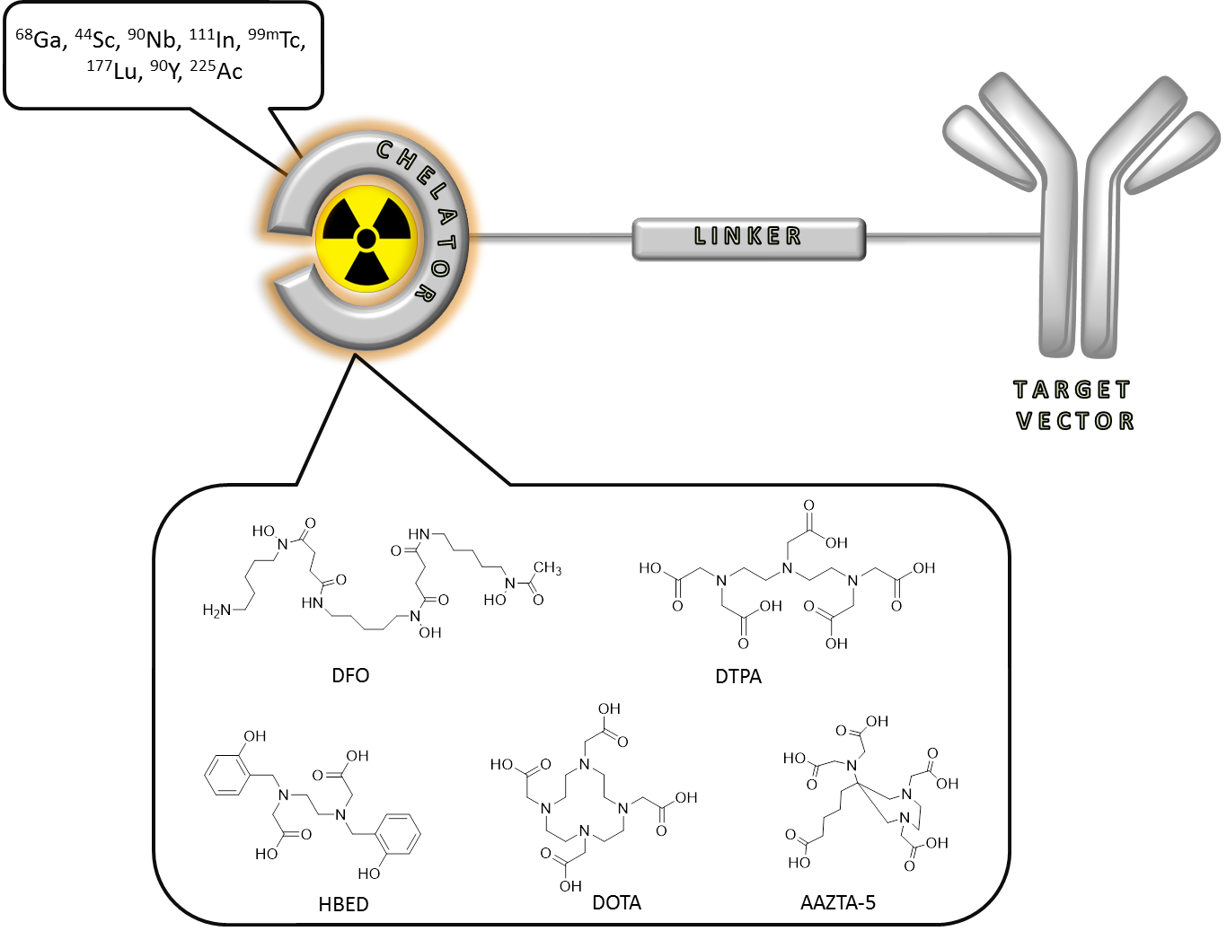
Figure 12: Construction of a metal-based radiopharmaceutical: a bifunctional chelator complex the radiometal and is bound via a linker to the targeting vector (exemplified for a monoclonal antibody).

There is also considerable interest in the development of chelators which are able to label quantitatively at room temperature and at milder pH due to the sensibility of some biomolecules (e.g. antibodies) to high temperatures and acidic pH. In general acyclic chelators (e.g. HBED, DFO, DTPA) present lower kinetic stability than macrocyclic ones (e.g. DOTA, NOTA, NODAGA) [58]. But, on the other hand, the metal-ligand complex formation with acyclic chelators occurs faster and normally under milder conditions, being an advantage especially for short living nuclides [88].
In spite that the use of a BFC is the most applied strategy for labelling a biomolecule with a radiometal, a BFC is not always required. Some chelating agents such as tropolone, hexamethyl-propylene-amine oxime (HMPAO) or 8-hydroxyquinoleine (oxine) have been widely used for radiolabelling of white blood cells for imaging of infection or inflammatory diseases. The complexes that such chelating agents form with some radiometals like ^{99m}Tc [89] or ¹¹¹In [90], normally in a ratio 3:1, are small and hydrophobic enough to be able to passively penetrate the cell membrane and once inside the cell be retained in the cytoplasm. Another example of radiolabelling of metals without utilizing BFC that has been reported is the direct labelling of antibodies [91-93]. In this case the radiometal is coordinated with donor groups (mainly sulfhydryl groups found in cysteine residues) present in the antibody structure. This coordination presents strong bonds between the Ab and the radionuclide resistant to transchelation, but at the same time it can change sufficiently the structure and influence on further behaviour of biomolecules.

1.3 THERANOSTICS

The combination of both diagnostic and therapy gives rise to the concept of theranostics. In the context of nuclear medicine, it refers to the use of molecular targeting vectors labelled either with diagnostic radionuclides or with therapeutic radionuclides for detection and treatment respectively of a particular disease specifically targeted by the vector [94].
Beyond simply therapeutic functionality, theranostic materials provide a platform to integrate both therapeutic and diagnostic agents thus facilitating simultaneous and synergistic diagnosis and therapies [95]. In theranostic strategies, patients are pre-selected on the basis of initial target site accumulation studies using a diagnostic radionuclide-labelled tracer to perform initial low dose imaging to evaluate the maximum tolerated dose, followed by subsequent radiotherapy with the same precursor coupled to a therapeutic radionuclide [13]. By use of theranostic radionuclides, both applications are accessible with minimal change in the pharmacokinetics. An example is the use of ⁶⁸Ga-PSMA-617 for diagnosis and ¹⁷⁷Lu-PSMA-617 for treatment of neuroendocrine tumors [94].

1.3.1 Radiometals for theranostics

In order to predict the biodistribution and delivered dose of the radiotherapeutic tracer with the aim to minimize undesirable side effects, dosimetry studies are required. Dosimetry allows follow-up of personalized treatment utilizing an imaging analogue of the therapeutic pharmaceutical compound. The imaging probe quantifies the absorbed dose delivered in a specific site, offering accurate monitoring and planning of the patient’s response to therapy. Finally, the efficiency of the therapy is evaluated in a post-therapeutic control [96].
The optimal condition for theranostic application is to use isotopes of the same element since they present the same electronic structure and, consequently, the chemical, biochemical and pharmacologic characteristics of the diagnostic and therapeutic entities are identical. An example is the yttrium pair ⁹⁰Y/⁸⁶Y [97]. However, for most of the radionuclide pairs a lot of important information (e.g. long-term distribution) is not available due to the different half-lives of the two radionuclides. Such difference is exemplified by the diagnostic nuclide ⁶²Cu (t ½ = 9.74 min) vs. its therapeutic pair ⁶⁷Cu (t ½ = 2.58 d) [98]. Alternatively, another diagnostic radionuclide from a chemical element different to the therapeutic one may be used. In this case, however, pharmacological studies need to ensure that the analogy in chemistry reflects a similarity in pharmacology for the two different radiolabelled compounds. Trivalent radionuclides are of special interest due to their similar chemistry, this fact has focused the development of such metals for their application in nuclear medicine. The PET isotopes ⁶⁸Ga and ⁴⁴Sc and eventually ^{110m}In provide valuable information on labelled radiopharmaceuticals with trivalent β⁻ emitters such as ⁹⁰Y, ¹⁵³Sm and ¹⁷⁷Lu, sufficiently reflecting the biological parameters such as e.g. the in vitro binding affinities of the original therapeutics [99]. The radiation exposure in a particular tissue can be determined by equation 3.

$\overline{D}$_{t s} = S_{t s} Ã_{s} (eq. 3)

With $\overline{D}$ = mean absorbed dose, s = source organ, t = target organ, S = mean absorbed dose of the target organ when the unit dose is homogeneously distributed in the source organ, Ã = time integral of the accumulated activity.
For the time integral, the accumulated activity is:

Ã_{s} = $\int{A}$_{s} (t) dt (eq. 4)
Ã_{s} = ʃ A_{s} $e$ ^{– ( λphys + λbiol ) t} dt (eq. 5)

Where A_{s}= activity, λ_{phys} = physical component and λ_{biol} the biological component and finally equation 6 is obtained.

$\overline{D}$_{t s} = S_{t s} ʃ A_{s} $e$ ^{– ( λphys + λbiol ) t} dt (eq. 6)

PET:
Uptake kinetics
- (Bq / mL / min)

MIRD:
- S factors
- T½
PET:
Absolute activity in s
- (Bq / mL)

This equation was developed by the Medical Internal Radiation Dose (MIRD) committee of the Society of Nuclear Medicine and Molecular Imaging (SNMMI) and states that for determining the absorbed dose in the patient both the physical as well as the biological component must be considered [100].
The dosimetric properties are unique for each radionuclide according to their decay parameters such as half-life, type, abundance and energy of emissions, and these values are tabulated (S-factors). However, the residence times of the labelled compounds should be measured experimentally. Adequate positron emitters, covering at least the relevant initial uptake kinetics, are ideal to determine these biological kinetic processes.
For the calculation of radiation doses of specific radiotherapeutics, the biological residence data derived for the PET surrogate tracer may be used, while the S-factors of the therapeutic nuclide are employed.

Table 3: Radiometals for theranostic applications (PET/therapy) [96].
Therapeutic | nuclide |  | Diagnostic | nuclide
Nuclide | t _{1/2} |  | Nuclide | t _{1/2} | β⁺_{branch} [%]
Isotope pair
⁴⁷Sc | 3.34 d |  | ⁴⁷Sc | 3.93 h | 94
⁶⁷Cu | 2.58 d |  | ⁶²Cu | 9.74 min | 97
⁹⁰Y | 2.67 d |  | ⁸⁶Y | 14.74 h | 33
Non-isotopic | substituents
⁹⁰Y | 2.67 d |  | ⁶⁸Ga | 67.71 min | 89
¹⁵³Sm | 1.95 d |  | ⁴⁴Sc | 3.93 min | 94
¹⁷⁷Lu | 6.67 d |  | ^{110m}In | 1.15 h | 62
²⁷³Bi | 45.6 min
²²⁵Ac | 10.0 d

If the positron emitter and the therapeutic nuclide are representing isotopes of the same element, equation 6 is valid. However, if the PET nuclide represents a nuclide of another chemical element, the biological parameters of the two pharmaceuticals may differ to a specific degree. In this case, another factor may be introduced considering these deviations [96,99]. In table 3 some radionuclides applied in PET and therapy for theranostic purposes are enumerated.

REFERENCES

[1] Tamargo J, Le Heuzey JV, Mabo P. Narrow therapeutic index drugs: a clinical pharmacological consideration to flecainide. Eur J Clin Pharmacol 2015; 71: 549–567.
[2] Moderegger D, PhD thesis, Johannes Gutenberg-Universität, Mainz, 2012, 227 pp.
[3] Lammers T, et al. Theranostic nanomedicine. Acc chem res 2011; 10: 1029-1038.
[4] Duncan R, Gaspar R. Nanomedicine(s) under the microscope. Mol Pharmaceutics 2011; 8: 2101–2141.
[5] Branco De barros AL, Ferreira Soares DC. Theranostic Nanoparticles: Imaging and therapy combined. J Mol Pharm Org Process Res 2014; 2: e113
[6] Blanco E, Shen H, Ferrari M. Principles of nanoparticle design for overcoming biological barriers to drug delivery. Nat Biotechnol 2015; 33: 941-951.
[7] Matsumura Y, Maeda HA. A new concept for macromolecular therapeutics in cancer chemotherapy: mechanism of tumoritropic acumulation of proteins and the antitumor agent. Cancer res 1986; 46: 6387-6392.
[8] Fang J Nakamura H, Maeda H. The EPR effect: Unique features of tumor blood vessels for drug delivery, factors involved, and limitations and augmentation of the effect. Adv Drug Deliv Rev 2011; 63: 136-151.
[9] Greish K. Enhanced permeability and retention (EPR) effect for anticancer nanomedicine drug targeting. Methods Mol Biol 2010; 624: 25-37.
[10] K Strebhardt K, Ullrich A. Paul Ehrlich´s magic bullet concept: 100 years of progress. Nat Rev Cancer 2008; 8: 473–480.
[11] Breimer D. D., Future challenges for drug delivery research. Adv Drug Deliv Rev 1998; 33: 265–268.
[12] Fernandez-Fernandez A, Manchanda R, McGoron AJ. Theranostic applications of nanomaterials in cancer: Drug delivery, image-guided therapy and multifunctional platforms. Appl Biochem Biotechnol 2011; 167: 1628-1651.
[13] Rizzo LY, et al. Nanotheranostics and Image-guided Drug Delivery: current concept and future direction. Curr Opin Biotechnol 2013; 4: 1-8.
[14] Larson N, Ghamdehari H. Polymeric conjugates for drug delivery. Chem mater 2012; 24: 840-853.
[15] Ringsdorf H. Journal of Polymer Science: Polymer Symposia 1975; 51: 135‐153.
[16] Fox ME, Szoka FC, Fréchet JMJ. Soluble polymer carriers for the treatment of cancer Acc Chem Res 2009; 42: 1141-1151.
[17] Duncan R. The dawning era of polymer therapeutics. Nat Rev Drug Discov 2003; 2: 347‐360.
[18] Duncan R. Polymer therapeutics as nanomedicines: new perspectives. Curr Opin Biotechnol 2011; 22: 492–501.
[19] Duncan R. Polymeric conjugates for drug delivery. Adv Drug Deliv Rev 2009; 61: 1131‐1148.
[20] Dumitriu S, Popa V. Polymeric Biomaterials, 3rd ed, vol. 2, Taylor & Francis, USA, 2013.
[21] Kopeček J, Baẑilová H. Poly[N‐(2‐hydroxypropyl)methacrylamide]-I. Radical polymerization and copolymerization. Eur Polym J 1973; 9: 7‐14.
[22] Kopeček J. Polymer-drug conjugates: origins, progress to date and future directions. Adv Drug Deliver Rev 2013; 65: 49-59.
[23] Lammers T. Improving efficacy of combined modality anticancer therapy using HPMA copolymer-based nanomedicine formulations. Adv Drug Deliver Rev 2010; 62: 203-230
[24] Duncan R. Vicent MJ. Do HPMA copolymer conjugates have a future as clinically useful nanomedicines? A critical overview of current status and future opportunities. Adv Drug Deliver Rev 2010; 62: 272‐282.
[25] Moad G, et al. Living free radical polymerization with reversible addition – fragmentation chain transfer (the life of RAFT). Polym Intern 2000; 49: 993-1001.
[26] Scales CW, Vasilieva YA, Convertine AJ, Lowe AB, McCormick CL. Direct, Controlled Synthesis of the Nonimmunogenic, Hydrophilic Polymer, Poly(N -(2-hydroxypropyl)methacrylamide) via RAFT in Aqueous Media. Biomacromolecules 2005; 6: 1846–1850.

[27] Eberhardt M, Mruk R, Zentel, R. Theato, P. Postpolymerization modification of poly(pentafluorophenyl methacrylate): synthesis of a diverse water-soluble polymer library.
Eur Polym J 2005; 41: 1569.
[28] Barz M, et al. From Defined Reactive Diblock Copolymers to Functional HPMA-Based Self-Assembled Nanoaggregates. Biomacromolecules 2008; 9: 3114–3118.
[29] Allmeroth M, et al. Modifying the Body Distribution of HPMA-Based Copolymers by Molecular Weight and Aggregate Formation. Biomacromolecules 2011; 12: 2841–2849.
[30] Talelli M, et al. Micelles based on HPMA copolymers. Adv Drug Deliv Rev 2010; 62: 231-239.
[31] Barz M, et al. The uptake of N-(2-hydroxypropyl)-methacrylamide based homo, random and block copolymers by human multi-drug resistant breast adenocarcinomacells. Biomaterials 2009; 29: 5682-5690.
[32] Hemmelmann M, et al. Amphiphilic HPMA–LMA copolymers increase the transport of Rhodamine 123 across a BBB model without harming its barrier integrity. J Control Rel 2012; 163: 170-177.
[33] Hemmelmann M, et al. Radioactive Labeling of Defined HPMA-Based Polymeric Structures Using [18F]FETos for In Vivo Imaging by Positron Emission Tomography. . Biomacromolecules 2012; 13: 4065-4074.
[34] Jockerst JV, Lobovkina T, Zare RN, Gambhir SS. Nanoparticle PEGylation for imaging and therapy. Nanomedicine 2011; 6: 715-728
[35] Van Dongen GA, et al. Immuno-PET: A Navigator in Monoclonal Antibody Development and Applications. Oncologist 2007; 12: 1379–1389.
[36] Wang M, et al. Targeting the Urokinase Plasminogen Activator Receptor with Synthetic Self-Assembly Nanoparticles. Bioconj Chemistry: 2009; 20: 32-40.
[37] U. S. Food and Drug Administration, U. S. Department of Health and Human Services. [Website] Available, from: http://www.fda.gov
[38] Imai K, Takaoka A. Comparing antibody and small-molecule therapies for cancer. Nature Rev 2006; 6: 714-727.
[39] Bertrand N, et al. Cancer nanotechnology: the impact of passive and active targeting in the era of modern cancer biology. Adv Drug Deliv Rev 2014; 66: 2–25.
[40] Zhang H, Ma Y, Sun XL. Recent developments in carbohydrate-decorated targeted drug/gene delivery. Med Res Rev 2010; 30: 270-89
[41] Li X, Zhou H, Yang L, Du G, Pai-Panandiker AS, Huang X, Yan B. Enhancement of cell recognition in vitro by dual-ligand cancer targeting gold nanoparticles. Biomaterials 2011; 32: 2540-2545.
[42] Chang SS. Overview of Prostate-Specific Membrane Antigen. Rev Urol 2004; 6: 13-18.
[43] Hillier et al. Preclinical Evaluation of Novel Glutamate-Urea-Lysine Analogs that Target Prostate Specific Membrane Antigen as Molecular Imaging Pharmaceuticals for Prostate Cancer. Cancer Res 2009; 69: 6932–6940.
[44] Eder M, et al. PSMA as a target for radiolabelled small molecules. Eur J Nucl Med Mol Imaging 2013; 40: 819–823.
[45] Bequerel A. Nobel Lect. 1903, 52–70.
[46] Hevesy GD. The Absorption and Translocation of Lead by Plants, A Contribution to the Application of the Method of Radioactive Indicators in the Investigation of the Change of Substance in Plants. Biochem J 1923; 17: 439–445.
[47] De Hevesy G. Nobel Lect. 1944.
[48] Kim EE, Jackson EF. Molecular Imaging in Oncology: PET, MRI, and MRS. Springer-Verlag Berlin-Heidelberg 1999.
[49] Cutler CS, et al. Radiometals for Combined Imaging and Therapy. Chem Rev 2013; 113: 858-883.
[50] Radchenko V. PhD thesis, Johannes Gutenberg-Universität, Mainz, 2013, 159 pp.
[51] Mc Ardle BA, Dowsley TF, deKemp RA, Wells GA, Beanlands RS. Does rubidium-82 PET have superior accuracy to SPECT perfusion imaging for the diagnosis of obstructive coronary disease?: A systematic review and meta-analysis. J Am Coll Cardiol 2012; 60: 1828-37.
[52] Cherry SR. Fundamentals of positron emission tomograpgy. J Clin Pharmacol 2001; 41: 482-491.
[53] Basu S, et al. Special Techniques and Technical Advances in PET/Computed Tomographic Imaging. Ann NY Acad Sci 2011; 1228: 1-18.
[54] Bailey DL, Karp JS, Surti, S. Positron emission tomography: basic science and clinical practice. Springer-Verlag London Ltd. Chapter: physics and instrumentation in PET. 2003: 41-67.
[55] Ache H. Angew. Chemie des positrons und positroniums. Chemie 1972, 84, 234–255.
[56] Carroll V, Demoin DW, Hoffman TJ, Jurisson SS. Inorganic chemistry in nuclear imaging and radiotherapy: current and future directions. Radiochi Acta 2012; 100: 635-667
[57] Zeglis BM, et al. Underscoring the Influence of Inorganic Chemistry on Nuclear Imaging with Radiometals. Inorg Chem 2014; 53: 1880–1899
[58] Bhattacharyya S, Dixit, M. Metallic radionuclides in the development of diagnostic and therapeutic radiopharmaceuticals. Dalton Trans 2011; 40: 6112–6128.
[59] Gopal B. Saha 2010. Fundamentals of Nuclear Pharmacy pp 67-82
[60] Production of long lived parent radionuclides for generators: ⁶⁸Ge, ⁸²Sr, ⁹⁰Sr and ¹⁸⁸W. Vienna : International Atomic Energy Agency, 2010.
[61] Rösch F, Baum RP. Generator-based PET radiopharmaceuticals for molecular imaging of tumours: on the way to THERANOSTICS. Dalton Trans 2011; 40: 6104-6111.
[62] Rösch F, Knapp FF. Radionuclide generators. 2010. Handbook of nuclear chemistry
[63] Maecke HR, André JP. Ernst Schering Res Found Workshop. 2007; 62: 215-42.
[64] Rösch F, Riss JR. The Renaissance of the 68Ge/68Ga Radionuclide Generator Initiates New Developments in ⁶⁸Ga Radiopharmaceutical Chemistry. Curr Top Med Chem 2010; 10:1633-1668.
[65] Rösch F. Past, present and future of ⁶⁸Ge/⁶⁸Ga generators. ‎Appl Radiat Isot 2013; 76: 24-30.
[66] Zhernosekov K, et al. Processing of generator-produced ⁶⁸Ga for medical application. J Nucl Med 2007; 48: 1741–1748
[67] K. Eigner Henke. Production of gallium-68 for PET-diagnostics using “ionic“ ⁶⁸Ge/⁶⁸Ga radionuclide generator. Nuclear Physics Institute Řež Czech Republic. Biennial report 2007-2008.
[68] Krajewski S. Cyclotron production of ⁴⁴Sc for clinical application. Radiochim Acta 2013; 101: 333–338.
[69] Rösch F. Scandium-44: benefits of a long-lived PET radionuclide available from the ⁴⁴Ti/⁴⁴Sc generator system. Curr Radiopharm 2012; 5: 187-201
[70] Greene MW, Hillman M. A scandium generator. Int J Appl Radiat Isot 1967; 18: 540–541
[71] Mirza MY, Aziz A. A scandium generator. Radiochim. Acta 1969; 11: 43–44.
[72] Filosofov DV, Loktionova NS, Rösch F. A ⁴⁴Ti/⁴⁴Sc radionuclide generator for potential application of ⁴⁴Sc-based PET-radiopharmaceuticals. Radiochim Acta 2010; 98: 149–156.
[73] Prusynski M, et al. Post-elution processing of ⁴⁴Ti/⁴⁴Sc generator-derived ⁴⁴Sc for clinical application. Appl Rad Isot 2010; 68: 1636-1641
[74] Pruszynski M, Majkowska-Pilip A, Loktionova NS, Eppard E, Rösch F. Radiolabeling of DOTATOC with the long-lived positron emitter 44Sc. Appl Rad Isot 2012; 70: 974–979.
[75] Cyclotron Produced Radionuclides: Emerging Positron Emitters for Medical Applications: ⁶⁴Cu and ¹²⁴I. 2016 IAEA Radioisotopes and radiopharmaceuticals reports No 1.
[76] Qaim SM. New trends in nuclear data research for medical radionuclide production. Radiochim. Acta 2013; 101: 473–480.
[77] Qaim SM. Decay data and production yields of some non-standard positron emitters used in PET. J Nucl Med Mol Imaging 2008; 52(2); 111-120.
[78] Cyclotron produced radionuclides: physical characteristics and production methods. Technical reports series No. 468, International Atomic Energy Agency, Vienna, 2009
[79] Jahn M, Radchenko V, Filosofov D, Hauser H, Eisenhut M, Jennewein M, Rösch F. Separation and purification of no carrier added arsenic from bulk amounts of germanium being adequate to radiopharmaceutical labeling chemistry. Radiochim Acta 2010; 98: 807-812.
[80] Radchenko V, Filosofov D, Bochko OK, Lebedev NA, Rakhimov AV, Hauser H, Eisenhut M, Aksenov NV, Bozhikov GA, Ponsard B, Roesch F. Separation of Nb-90 from zirconium target for application in immuno-PET. Radiochim Acta 2014; (5): 433–442
[81] Bunney R, Ballou NE, Pascual J, Foti S. Quantitative Radiochemical Analysis by ion Exchange Anion Exchange Behavior of Several Metal Ions in Hydrochloric, Nitric, and Sulfuric Acid Solutions. Anal Chem 1959; 31: 324-326
[82] Hao G, Singh AN, Liu W, Sun X. PET with non-standard nuclides. Curr Top Med Chem 2010;10:1096-112.
[83] Busse S, Rösch F, Qaim SM. Cross section data for the production of the positron emitting niobium isotope 90Nb via the ⁹⁰Zr(p, n)-reaction. Radiochim Acta 2002;90:1-5.
[84] Radchenko V, Hauser H, Eisenhut M, Vugts DJ, van Dongen GA, Roesch F. ⁹⁰Nb: a potential PET nuclide: production and labeling of monoclonal antibodies. Radiochim. Acta 2012; 100: 857-863.
[85] Hoefnagel C. Radionuclide cancer therapy. Annals of nuclear medicine 1989; 12: 61-70.
[86] Advancing Nuclear Medicine Through Innovation. 2007 ISBN: 0-309-11068-8, 176 pp.
[87] Liu S. Bifunctional Coupling Agents for Radiolabeling of Biomolecules and Target Specific Delivery of Metallic Radionuclides. Adv Drug Del Rev 2008; 60: 1347-1370
[88] Stavroula S. Radionuclide carriers for targeting of cancer. Int J Nanomedicine 2008; 3: 181–199.
[89] Aydın F, Cengiz AK, Güngör F. Tc-99m Labeled HMPAO white Blood Cell Scintigraphy in Pediatric Patients. Mol Imaging Radionucl Ther 2012; 21: 13–18.
[90] Roca M, de Vries EFJ, Jamar F, Israel O, Signore A. Guidelines for the labelling of leucocytes with ¹¹¹In-oxine. Eur J Nucl Med Mol Imaging 2010; 37: 835–841.
[91] Griffiths GL, David M. Goldenberg, Knapp FF, Callahan AP, Chang CH, Hansen HJ. Direct Radiolabeling of Monoclonal Antibodies with Generator-produced Rhenium-188 for Radioimmunotherapy: Labeling and Animal Biodistribution Studies. Cancer Res 1991 51; 4594-4602.
[92] Direct labeling of antibodies and other protein with metal ions. Patent US 5460785 A U.S. Pat. No. 4, 424, 200, entitled Method for Radiolabelling
[93] Garron JY, Moinereau M, Pasqualini R, Saccavini JC. Direct ^{99m}Tc labeling of monoclonal antibodies: radiolabeling and in vitro stability. Int J Rad Appl Instrum 1991; 18: 695-703.
[94] Baum RP, Kulkarni HR. THERANOSTICS: From Molecular Imaging Using Ga-68 Labeled Tracers and PET/CT to Personalized Radionuclide Therapy - The Bad Berka Experience. Theranostics 2012; 2: 437–447.
[95] Peng H, et al. Polymeric multifunctional nanomaterials for theranostics. J Mater Chem 2015; 3: 6856-6870
[96] Eppard E. PhD thesis, Johannes Gutenberg-Universität, Mainz, 2013, 189 pp.
[97] Bockisch A. Matched pairs for radionuclide-based imaging and therapy. Eur J Nucl Med Mol Imaging 2011; 38: 1-3.
[98] Cutler CS, Hennkens HM, Sisay N, Hucleier-Markai, Jurisson SS. Radiometals for combined Imaging and Therapy. Chem Rev 2013; 113: 858-883.
[99] Rösch F, Baum RP. Generator-based PET radiopharmaceuticals for molecular imaging of tumours: on the way to THERANOSTICS. Dalton Trans 2011; 40: 6104-6111.
[100] Bolch et al. A Generalized Schema for Radiopharmaceutical Dosimetry Standardization of Nomenclature. J Nucl Med 2009; 50:477–484.

2 OBJECTIVES AND OUTLINE

PET is a powerful non-invasive imaging technique of metabolic processes in vivo. It is widely used in the clinics for detection of several pathologies including areas such as oncology or cardiology, aiming to set up a personalized treatment plan for best therapeutical response rates.
A big array of nanoparticles is used to treat different diseases and investigations keep ongoing towards their improvement. In this sense PET is an important tool as well in research. It can provide information about specific characteristics such as charge, hydrophilic‐lipophilic balance or flexibility affecting the in vivo performance of carrier systems, which is essential to optimize and further functionalize carrier systems to guide the way to new generation nanomedicines.
In this work different nanoparticles have been radiolabelled and evaluated systematically with the objective to improve their pharmacology as theranostic agents for further possible applications in nuclear medicine. Due to their different pysico-chemical characteristics various radioisotopes have been employed to match their physical half-life with the biological half-life of the nanoparticles.

Aspect 1. Optimization of HPMA-based nanoparticles for theranostic applications

Among polymer-based carrier systems, HPMA is a promising biocompatible polymer that has demonstrated to accumulate in tumor tissue by means of the EPR effect [1]. Moreover, its polymerization via RAFT offers the possibility to synthetize well defined structures and a facile introduction of several functionalities.
In nuclear medicine both metal and organic radioisotopes can be employed. However, radiometals offer the advantage of providing higher radiolabelling yields in contrast to organic isotopes. In addition, some radiometals of them are easy available via generators. Nevertheless, the labelling of nanoparticles with a radiometal requires a bifunctional chelate that is previously attached to the nanoparticle. The modification of nanoparticles with chelates may alter their biological functions. Part of this work aimed to achieve quantitative radiolabelling yields by modifying as less as possible the HPMA-based nanocarriers.
Thus, different HPMA-linker-DOTA polymer conjugates were synthetized aiming to identify the less amount of chelate needed to still provide a quantitative radiochemical yield.
As chelate, DOTA was chosen owing to its capacity to form stable complexes with a variety of radiometals including both diagnostic and therapeutic nuclides. To facilitate the introduction of the chelate in the polymeric structure, various DOTA-linker systems with different linker structure (alkyl chains or alkoxy) and length (1-12 carbon atoms) were synthesized and later coupled in a polymer-analogous reaction to the HPMA backbone. Subsequent labellings with ⁶⁸Ga, ⁴⁴Sc and ¹⁷⁷Lu as well as in vitro evaluations were performed. Finally the conjugates with the highest stability should be evaluated in vivo.
On the other hand, exploiting the capacity of amphiphilic polymers to self-assemble forming micelles and spontaneously incorporate hydrophobic drugs into their core, a novel strategy to radiolabel micelles was investigated. The strategy provides a fast and quantitative labelling with a radiometal without previous modification of the polymer structure with a chelate. The key point is the use of hydrophobic chelating agents that will be incorporated in the hydrophobic core of the micelles. Three different structures of HPMA-LMA based polymer (random, block and PEGylated-block) were radiolabelled using such strategy and their stability was analysed in vitro. The polymer architecture that presented highest stability in vitro was further evaluated in vivo in healthy mice.

Aspect 2. Formulation and evaluation of a novel radiopharmaceutical for diagnosis of prostate cancer lesions

Prostate cancer is the second most common cancer and the sixth leading cause of cancer death in men worldwide [2]. Big efforts are being made to develop theranostic drugs for its efficient diagnosis and treatment. In nuclear medicine, ¹⁷⁷Lu-labelled DKFZ-617 has recently entered into the clinics and has demonstrated successful response against prostate cancer lesions. Nevertheless, there is no accurate dosimetry study on this radiopharmaceutical after 5 h p.i [3]. Dosimetry calculations are an important step on the way to personalized medicine. A pre-therapy study is necessary to evaluate the response to the therapeutic drug as well as the received dose in tumor and non-tumor tissues.
⁶⁸Ga-DKFZ-617 is up-to-date the analogue of ¹⁷⁷Lu-PSMA-617 for imaging of prostate cancer. ⁶⁸Ga has a significate importance in current clinical practice due to its favourable decay characteristics and its cyclotron independence production via the ⁶⁸Ge/⁶⁸Ga generator. However, its short physical half-life of 68 min does not allow follow up at late time points.
In this context, ⁴⁴Sc presents an alternative owing to its decay characteristics (t ½ = 3.97 h and positron branching = 94.27%) and its generator and cyclotron availability. With a half-life 4 times longer than ⁶⁸Ga, ⁴⁴Sc provides an extended frame time for in vivo follow up, consequently being more suitable for dosimetry calculations on ¹⁷⁷Lu analogues.
In this work we propose ⁴⁴Sc-DKFZ-617 as a PET imaging agent for prostate cancer lesions. In order to be used as imaging agent in the clinics, a fast an efficient labelling needs to be achieved. Stability in physiological conditions should be ensured and affinity and internalization values of the novel imaging radiopharmaceutical to prostate cancer cells should not differ from the therapeutical radiopharmaceutical values. A detailed evaluation of DKFZ-617 with ⁴⁴Sc has been completed and successful results have led to human in vivo evaluation in a patient suffering from prostate cancer.

Aspect 3. Evaluation of ⁹⁰Nb as potential PET isotope

With rising interest on using antibodies or antibody fragments for tumor imaging and therapy, radionuclides with long and intermediate half-life are on demand. However, the lack of nuclides that in addition have decay characteristics suitable for nuclear imaging has motivated the present work.
⁹⁰Nb is a potential radionuclide for application in immuno-PET thanks to its decay parameters (t ½ = 14.6 h, positron branching of 53%, E_{β}⁺ mean = 0.66 MeV). Production and separation of ⁹⁰Nb from irradiated target has been recently developed [4,5] but strategies for in vivo application need further investigation.
In this study ⁹⁵Nb (t ½ = 35 d) has been used as analogue of ⁹⁰Nb, to develop a labelling protocol of antibodies for later evaluation in vivo. *Nb isotopes were obtained by irradiation of ^{nat}Zr. ⁹⁵Nb was produced via the ^{nat}Zr(n, γ)-reaction in a reactor and ⁹⁰Nb via the ⁹⁰Zr(p,n)-reaction in a cyclotron. ^{90/95}Nb was recovered from irradiated target in a multistep separation that afforded the desired niobium isotope in conditions suitable for direct labelling (pH, volume, specific activity). The monoclonal antibodies bevacizumab and citubximab were modified with DFO chelate, which has shown to form stable complexes with niobium. High in vitro stability of purified *Nb-mAb lead to in vivo evaluation of ⁹⁵Nb-mAb in healthy and tumor bearing mice.

References

[1] M. Allmeroth et al. PEGylation of HPMA-based block copolymers enhances tumor accumulation in vivo: A quantitative study using radiolabeling and positron emission tomography. J Control Rel 2013; 172: 77–85.
[2] Jemal A, Bray F, Center MM, Ferlay J, Ward E, Forman D. Global cancer statistics. Cancer J Clin 2011; 61: 69–90.
[3] Ali Afshar-Oromieh. The novel theranostic PSMA-ligand PSMA-617 in the diagnosis of prostate cancer by PET/CT: biodistribution in humans, radiation dosimetry and first evaluation of tumor lesions. J Nucl Med 2015; 56: 1697-1705
[4] Busse S, Rösch F, Qaim SM. Cross section data for the production of the positron emitting niobium isotope ⁹⁰Nb via the ⁹⁰Zr (p, n)-reaction. Radiochim Acta 2002; 90: 1-5.
[5] Busse S, Brockmann J, Roesch F. Radiochemical separation of no-carrier-added radioniobium from zirconium targets for application of ⁹⁰Nb-labelled compounds. Radiochim Acta 2002; 90: 411-415.

3 MANUSCRIPTS

This work is based on the following manuscripts:

(I) E. Eppard, A. de la Fuente, N. Mohr, M. Allmeroth, R. Zentel, F. Rösch. Labeling of HPMA-based polymer-conjugates with metallic radionuclides for theranostic applications
(II) A. de la Fuente, S. Kramer, N. Mohr, S. Pektor, N. Bausbacher, R. Zentel, F. Rösch. ⁶⁸Ga-oxine: A novel strategy of in situ radiolabelling of HPMA-based micelles.
(III) A. de la Fuente, E. Eppard, M. Benesova, F. Roesch, M. Essler, K. Kopka. ⁴⁴Sc-PSMA-617 for dosimetry of prostate cancer.
(IV) V. Radchenko, P. Bouziotis, T. Tsotakos, M. Paravatou-Petsotas, A. de la Fuente, G. Loudos, A.L. Harris, S. Xanthopoulos, D. Filosofov, H. Hauser, M. Eisenhut, B. Ponsard, F. Roesch. Labeling and preliminary in vivo assessment of niobium-labeled radioactive species: A proof-of-concept study. Nuclear Medicine and Biology 2016; 43: 280–287.
(V) A. de la Fuente, V. Radchenko, T. Tsotakos, C. Tsoukalas, M. Paravatou-Petsotas, A. L. Harris, U. Köster, F. Rösch*, P. Bouziotis. Conjugation, labelling and in vitro/in vivo assessment of an anti-VEGF monoclonal antibody labelled with niobium isotopes. Submitted Nucl Med Biol

3.1 Labeling of HPMA-based polymer-conjugates with metallic radionuclides for theranostic applications

Labeling of HPMA-based polymer-conjugates with metallic radionuclides for theranostic applications

E. Eppard¹, A. de la Fuente¹, N. Mohr², M. Allmeroth^{C}, R.Zentel², F. Rösch^{1*}

¹ Institute of Nuclear Chemistry, Johannes Gutenberg-University, Fritz-Straßmann-Weg 2, 55128 Mainz, Germany
² Institute of Organic Chemistry, Johannes Gutenberg-University, Duesbergweg 10-14, 55128 Mainz, Germany

ABSTRACT

Nanomaterials play a key role in medicine as drug carrier systems aiming to improve lack of selectivity of utilized anticancer drugs. In this work, diverse DOTA-linker systems were conjugated in different amounts to HPMA homopolymer aiming to identify the fewer amount and the optimal DOTA-linker structure that provides quantitative labeling yields. PET and therapeutic nuclides were employed for labelling and in vitro stability and in vivo evaluations were performed
Methods:
HPMA homopolymers were modified with different DOTA-linker systems following RAFT technique. Radiolabelling were performed with ⁶⁸ Ga, ⁴⁴Sc and ¹⁷⁷Lu and influence of linker structure and amount incorporated was evaluated. In vitro stability of labelled polymers was studied in different media: 0.9 % NaCl, human serum (HSA), metal cations (Fe³⁺, Mg²⁺, Ca²⁺) and competing ligands (EDTA, DTPA). Final proof-of-principle in vivo evaluation of one of the conjugates was performed in tumor bearing rat.

Results:
Complex formation depends on the incorporation rate of DOTA and minimum of 1.6 % DOTA is enough to obtain labeling yields >90 % after 20 min. Alkoxy linkers generally exhibit lower labeling yields than alkane linkers despite of similarly chain length and DOTA incorporation. A short linker is enough to provide quantitative radiolabeling yields. High stability in all examined solutions was presented for all conjugates. Accumulation in tumor site was observed for the first in vivo evaluation in tumor-bearing rat.
Conclusions:
This study confirms the principle applicability of HPMA-conjugates for labeling with different radionuclides with established radiolabeling chemistry. Introducing as less than only c.a 1.5% of DOTA chelator using a short linker chain, which facilitates the synthesis and efficiency of the polymer conjugates, allows introduction of both diagnosis and therapeutic radiometals.

KEYWORDS: HPMA-DOTA-conjugates; theranostic; ⁶⁸Ga; ⁴⁴Sc; PET

1 INTRODUCTION

One of the major problems in current chemotherapy is the lack of selectivity of the utilized anticancer drugs. Most of these agents (e.g. doxorubicin, cisplatin) are compounds of low molecular weight (< 800 g/mol), which inhibit cell growth by affecting DNA duplication and cell division. As a result of affecting not only cancer cells, but basically all cells with high proliferation rates, conventional chemotherapeutic drugs suffer from a narrow therapeutic index. The therapeutic index of a drug can be improved by increasing the accumulation at the target site. In this context nanomaterials moved in the focus of drug development as drug carrier systems. The particles are too big to overcome the tight junctions of healthy tissue (normally 2-4 nm) and the renal threshold (5-7 nm). In addition, nanomaterials are a convenient base to combine imaging agents and drugs within one formulation. Due to the particle size (< 100 nm) nanomaterials often can prolongate pharmacokinetics and may passively and/or actively invade and accumulate in tumor tissue. Consequently, an increase in circulation time is induced and bioavailability while affection of healthy tissue is minimized. For the first investigations radionuclides of choice are ⁶⁸Ga and ⁴⁴Sc, two generator produced positron emitters. These two nuclides, with half-lives of 67.71 min (⁶⁸Ga) and 3.97 h (⁴⁴Sc), are suitable to investigate processes such as EPR mediated accumulation of nanoparticles in tumor tissue. Long-term investigation of pharmacokinetics could also be accessible using radionuclides with longer physical half-life like ⁶⁴Cu, or utilizing other imaging techniques like MRI (Gd) or SPECT (¹¹¹In). For the controlled incorporation of a metallic radionuclide, highly efficient binding ligands such as DOTA (1,4,7,10-tetraazacyclododdecane-tetraaceticacid) are necessary. DOTA was chosen as chelator to enable the introduction of several imaging and therapeutic nuclides and consequently different imaging techniques (MRI, PET, SPECT) could be applied. The chelator was coupled to the polymer using three different linkers, an alkane chain with two, six and twelve carbons, and two different alkoxy chains, in order to evaluate the influence of the DOTA morphology on the radiolabeling efficacy. Incorporation rate of the chelator was also varied.

1.1 Imaging
In medicine, nanomaterials are primary designed to improve the therapeutic index of systemically administered drugs. To enable pharmacokinetic analyses, it is useful to quantitatively determine circulation time and biodistribution in real-time. This approach is in particular important if the assay can be performed in vivo, i.e. with a living object. For this purpose, nanomaterials have been co-loaded with imaging agents. Imaging agents applied to SPECT (Single Photon Emission Computed Tomography) and PET (Positron Emission Tomography) utilize photon-radiation emitted from the corresponding radionuclides (Tab. 1).

Table 1: Commonly used isotopes for non-invasive imaging of nanomaterials [1-6].
Isotope | Emission | Half-life | E_{max} (γ) [keV]
¹³¹I | γ (81.2 %) | 8.0 d | 284, 364, 637
⁶⁷Ga | γ | 78.3 h | 93, 184, 300, 393
¹¹¹In | Auger, γ | 67.2 h | 171, 245
¹²³I | Auger, γ | 13.2 h | 159
^{99m}Tc | γ | 6.0 h | 140
¹⁸F | β⁺ | 1.83 h | 511
⁶⁴Cu | β⁺ | 12.7 h | 511
¹⁸⁸Re | γ (15 %), β | 16.9 h | 155

Apart from only two exceptions (iodine and fluorine) all of the dedicated radioisotopes are metals. For radiolabeling with metallic radionuclides like ⁶⁷Ga, ⁶⁴Cu or ¹¹¹In it is indispensable to either covalently attach or to load a chelating function to the nanomaterial. The chelate should be able to form stable complexes with the utilized radionuclide (Fig. 1). Those chelators can be bifunctionally coupled to the nanoparticle via versatile linker systems.
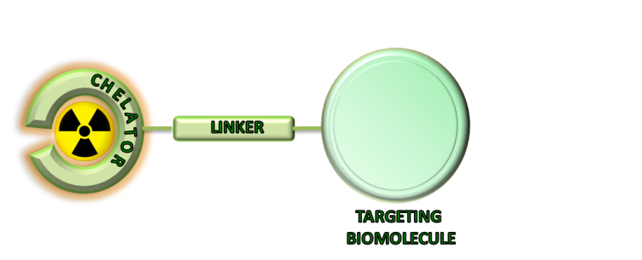

Figure 1: Chelator attached to a nanoparticle over a linker structure, which is coupled to a coupling functionality of the chelator and the targeting vector that can be a nanoparticle.

By the use of suitable chelators, different metallic radionuclides can be incorporated and therefore several imaging techniques can be used by minimal alteration in pharmacokinetics. A new and extremely promising approach is on “theranostics”, i.e. to select particle-emitting radionuclides in order to add a therapeutic option. Radioisotopes like ⁶⁷Cu, ⁹⁰Y, ¹⁷⁷Lu support the therapeutic effect of the loaded drug. This combination principally allows an effective minimal-invasive diagnosis and based on that, an individualized treatment planning [7].
Among the metallic radionuclides mentioned in table 1, only ¹⁸⁸Re is available via ¹⁸⁸W/¹⁸⁸Re radionuclide generator. With regard to costs and availability it is desirable to take the advantage of the cyclotron independent isotopes to label nanomaterials. ⁶⁸Ga is a positron emitter (89 %) with a half-life of 67.71 min and average positron energy of 1.899 MeV. Its physical half-life is adequate to allow the preparation and purification of ⁶⁸Ga-labeled radiopharmaceuticals and for imaging biological processes with short half-life. The major advantage of ⁶⁸Ga is its availability via a ⁶⁸Ge/⁶⁸Ga generator system, which affords a cyclotron independent and cost-effective source of the isotope in suitable conditions for labeling after its post-processing [10-14]. Other metallic radionuclide suitable for PET imaging is ⁴⁴Sc (94%), which is also available via the ⁴⁴Ti/⁴⁴Sc generator system [8, 15]. Due to its longer physical half-life of 3.97 h, ⁴⁴Sc facilitates the tracking of processes with longer biological half-life than ⁶⁸Ga or even ¹⁸F. It could be applied for more exact planning and dosimetry calculations in endoradiotherapy and also for direct matching of the β⁻ emitting ⁴⁷Sc radiopharmaceuticals [9]. According to that, the matched pair ⁴⁴Sc/⁴⁷Sc would permit coordinated dosimetry PET imaging and therapy like ⁶²Cu/⁶⁷Cu or ⁸⁶Y/⁹⁰Y. Contrary to ⁶⁸Ga and ⁴⁴Sc, ¹⁷⁷Lu is not suitable for PET imaging, but as a result of emitting both β⁻ (average energy 133.1 keV) and gamma radiation (113.0 and 208.4 keV) it can be used for therapy and SPECT imaging.

1.2 Polymeric nanoparticles
Various studies on hydrophilic polymers investigated their potential as cancer drug carrier systems. They have been used to modify proteins, liposomes or the surface of biomaterials as well as carrier systems for drugs to improve their pharmacokinetics. Since the early 1970s N-(2-hydroxypropyl)methacrylamide (HPMA) is investigated as drug delivery system based on the enhanced permeability and retention (EPR) effect. HPMA-based copolymers are hydrophilic, biocompatible and non-immunogenic [16, 17] and its selection of as drug carrier is based on detailed studies of the relationship between structure and biocompatibility hydrophilic polymers [18-24]. HPMA-copolymer conjugates have been successfully utilized in the delivery of miscellaneous drugs (e. g. doxorubicin [25], paclitaxel [26], camptothecin [27]). Modification can be achieved through activated comonomers leading to biocompatible polymers with functionalities for polymer analoge reaction. This strategy is very flexible in the choice of ligands, type of activation and occupancy rate and was already used in various studies [28]. Reaction of a reactive ester polymer with several ligands leads to multifunctionalised copolymers which can be applied for theranostic applications.
In the present study, we aimed to synthesize “theranostic” HPMA-conjugated DOTA copolymers with alkyl- and alkoxy-linkers for labeling with metallic radionuclides for cancer PET imaging and therapy. The chelator DOTA allows the introduction of several diagnostic and therapeutic nuclides representing trivalent metals (Gd; ⁴⁴Sc; ⁶⁴Cu, ⁶⁸Ga, ¹¹¹In; ¹⁷⁷Lu; ⁹⁰Y) and consequential the utilization for several applications (MRI; PET; SPECT; therapy). The main objective was to show the influence of the linker (structure and length) as well as the amount of DOTA incorporated on labeling kinetics, stability and whether labeling procedures for different radionuclides can be utilized. Labeling of the synthesized DOTA-conjugated copolymers was first performed with ⁶⁸Ga to evaluate reaction parameters (incubation time, amount of compound, temperature, influence of organic solvent). The stability of the ⁶⁸Ga-labeled conjugates was analysed in vitro in 0.9% NaCl and human serum (HSA), as well as in the presence of different metal cations and other competing chelators, like EDTA and DTPA. Additionally, labeling with the diagnostic and therapeutic isotopes ⁴⁴Sc and ¹⁷⁷Lu was performed. Finally, proof-of-principle in vivo experiments on the pharmacology of ⁶⁸Ga-DOTA-HPMA derivative 31 was conducted in tumor bearing rat.

2 MATERIALS AND METHODS

All chemicals were analytical or pure reagent grade and used as received unless otherwise specified. DOTA-(^{t}Bu)₃ was obtained from CheMatech (Dijon, Graz). All other organic and inorganic reagents were purchased from Sigma-Aldrich and Across Organics. Deionized Milli-Q water (18.2 MΩ•cm; Millipore) was used in all organic reactions. Dioxane was distilled over a sodium/potassium composition. Lauryl methacrylate was distilled to remove the stabilizer and stored at -18 °C. 2,2’-Azo-bis-(isobutyronitrile) (AIBN) was recrystallized from diethyl ether and stored at -18 °C as well. ¹H-NMR spectra were obtained by a Bruker AC 300 spectrometer at 300 MHz, ¹⁹F-NMR analysis was carried out with a Bruker DRX-400 at 400 MHz. The synthesized polymers were dried at 40 °C under vacuum overnight, followed by Gel Permeation Chromatography (GPC). GPC was performed in tetrahydrofuran (THF) as solvent, using following equipment: pump PU 1580, autosampler AS 1555, UV detector UV 1575 and RI detector RI 1530 from Jasco as well as a miniDAWN Tristar light scattering detector from Wyatt. Columns were used from MZ Analysentechnik, 300x8.0 mm: MZ-Gel SDplus 106 Å 5 µm, MZ-Gel SDplus 104 Å 5 µm and MZ-Gel SDplus 102 Å 5 µm. GPC data were evaluated by using the software PSS WinGPC Unity (Polymer Standard Service Mainz, Germany). The flow rate was set to 1 mL/min with a temperature of 25 °C. Commercial generators based on TiO₂ phase absorbing ⁶⁸Ge(IV) were obtained from Cyclotron Co. Ltd (Obninsk, Russia). Typically, batch activities of 80-150 MBq were used. ⁴⁴Sc was provided from a ⁴⁴Ti/⁴⁴Sc generator system developed in Mainz [8]. Batch activities of 165-180 MBq were used. ¹⁷⁷Lu was obtained from ITG (Munich, Germany) and used without further purification. Counting was performed in a borehole counter (Nuklear-Medizintechnik Dresden GmbH, Germany). Thin layer chromatography (TLC) was performed on silica-gel (silica-gel 60 F254; MERCK, Darmstadt, Germany)) coated aluminium TLC-sheets and analysed using an instant imager (Instant Imager, Canberra Packard, Schwadorf, Austria). The cation exchange resins AG 50W-X8 (- 400 mesh), AG 50W-X4 (200 – 400 mesh) and AG 50W-X8 (200 - 400 mesh) were obtained from Bio-Rad (Munich, Germany). Strata-X mini-C-18 cartridges were obtained from Phenomenex (Aschaffenburg, Germany). HiTrap™ Desalting Columns were purchased from GE-Healthcare Europe GmbH (Freiburg, Germany). TraceSelect water (Sigma-Aldrich, Germany) was used for all aqueous radiolabeling solutions.

2.1 Synthesis and characterization of HPMA-DOTA-conjugates
The HPMA-DOTA conjugates were prepared following the synthesis routes depicted in figures 2 and 3. Figure 2 shows the preparation of different DOTA-linkers that later on were conjugated to HPMA backbone in different amounts. Details on the synthesis route and characterization are added in the supplementary information.

Figure 2: Synthesis of the (^{t}Bu)₃-DOTA ligands (17-21).

Figure 3. Synthesis of the HPMA-linker-DOTA systems (31-35)

2.2 Radiochemistry

Labeling with ⁶⁸Ga

Labeling of DOTA-conjugated HPMA-homopolymers was performed by mixing aliquots of polymer stock-solution (1 mg/mL in water) with post-processed ⁶⁸Ga eluate. Investigation of the needed amount of conjugate for labeling reaction was performed by varying time and concentration of DOTA-conjugated polymer using conjugate 31 with acetone post-processed ⁶⁸Ga and was adopted for all the other labeling reactions. Acetone post-processed eluate 400 µL N2 (97.56 % acetone/0.05 N HCl) containing 40-60 MBq of ⁶⁸Ga, was added to 3 mL 1 M NaAcetate containing the polymer and the reaction mixture was heated up to 95°C. In addition, labeling with HPMA homopolymer without DOTA-functionalization was performed under these conditions to investigate the unspecific binding. Additionally labeling with ethanol post-processed eluate was performed for conjugates (33-35). 1 mL N5 (90 % ethanol/0.9 N HCl) was added to 3 mL 1 M NaAcetate buffer containing polymer and the reaction mixture was heated up to 95°C for 30 min.

Labeling with ⁴⁴Sc

Labeling of DOTA-conjugated HPMA-homopolymers was performed with 250 μL polymer stock solution (1 mg/mL in water) in post-processed ⁴⁴Sc eluate (3 mL) and heating up to 95°C for 30 min.

Labeling with ¹⁷⁷Lu

Labeling of DOTA-conjugated HPMA-homopolymers was performed with 250 μL polymer stock-solution (1 mg/mL in water) with 150 μL 0.1 M NaAcetate buffer (pH = 8) and 100 μL ¹⁷⁷Lu, and heating up to 95°C for 30 min. The ratio polymer to ¹⁷⁷Lu was 10:1.

Purification of the labeled conjugates

The radiolabeled polymeric systems were cleaned from unreacted radiometal by Sephadex G-25 size exclusion chromatography (HiTrap™ Desalting Column, Sephadex G-25 Superfine, 0.9% NaCl, flow rate: 0.5 mL/min) leading to a pure, ⁶⁸Ga-labeled polymer solution ready for subsequent experiments.

Quality control

Quality control of complex formation was performed by radiothin-layer chromatography (radioTLC). The TLC plates were developed with 0.1 M citric buffer (pH = 4). Quantitative distribution of radioactivity on TLC plates was measured using an instant imager.

In vitro stability

Stability studies were performed with ⁶⁸Ga-labeled polymers of radiochemical purity > 98 % in physiological conditions and in presence of competing metals and chelates. Detailed set up is explained in the supplementary section.

3 RESULTS AND DISCUSSION

3.1 Organic Synthesis

For coupling reaction between the HPMA backbone and the bifunctional chelator, orthogonal amidation chemistry via active ester groups was selected. Synthesis of the amine terminated DOTA based ligands (17-21) from commercially available (^{t}Bu)₃-DOTA is depicted in figure 2. First, the commercially available α,ω-diamines (1-5) were mono-Cbz-protected. The protection was realized with benzylphenylcarbonate (6) for (1-3) [29] and with benzylchloroformate for (4-5). As reported in [34] the selectivity of the mono-Cbz-protection using (6) decreases with the length of the alkyl chain but achieves good yields for (1-3). Mono-Cbz-protection with (6) was ineffective for the alkoxy diamines (4-5) so benzylchloroformate was used instead obtaining good yields of the desired product. The following amidation of (^{t}Bu)₃-DOTA with (7-11) afforded the Cbz-protected (^{t}Bu)₃-DOTA ligands (12-16) in good yields of 66-79 %. The Cbz-protecting group was removed via hydrogenation to obtain the (^{t}Bu)₃-DOTA ligands (17-21) in almost quantitative yields (93-97 %).

The synthetic route to the HPMA-DOTA conjugates is depicted in figure 3. Starting from pentafluorophenyl methacrylate monomer (23) the precursor homopolymer (24) was synthesized according to literature [30-32]. The dithioester end group was removed by an excess of 2,2´-azo-bis-(isobutyronitrile) as described in literature [33] taking the advantage of circumventing side reactions during the next reaction steps. Functionalization of the polymeric precursor was obtained by aminolysis via the amine terminated (^{t}Bu)₃-DOTA ligands (17-21). The incorporation was calculated to be between 0.6 – 11 % DOTA for each conjugate. Addition of 2-hydroxylamine lead to the polymeric structures (26-30). Entire conversion of the reactive ester groups was proved by means of ¹⁹F-NMR spectroscopy, evidencing their complete disappearance of ¹⁹F-signals of the polymeric backbone. In a final step the chelator was deprotected using TFA. The pure HPMA-DOTA conjugates, ready for labeling, could be obtained as white powders with good yields of 89 %, except conjugate (32), which could not be recovered from the dialysis flexible tube.

As intended, five different DOTA-conjugated polymer conjugates with relatively low polydispersity index (PDI) and therefore narrow molecular weight distribution have been achieved by RAFT polymerization and successfully functionalized in a following polymer analogous reaction. Their molecular weight average number (Mn), polydispersity index (PDI) and % of incorporated chelator are shown in table 2.

Table 2: Analytical data of the final HPMA-DOTA conjugates (31-35).
Polymer | M_{n} [g/mol] | PDIª | % DOTA^{b} | Linker
(31) | 15.000 | 1.3 | 11 | (1)
(33) | 12.000 | 1.2 | 1.6 | (3)
(34a) | 12.000 | 1.2 | 0.6 | (4)
(34b) | 12.000 | 1.2 | 1.2 | (4)
(35) | 13.000 | 1.2 | 3.5 | (5)
ªDetermination by GPC in THF as solvent. ^{b}Determined by ¹H-NMR spectroscopy after polymer analogous reaction with 2-hydroxypropylamine.

Later on, in order to have only one variable for direct comparison (the conjugates so far presented different linker structures with different incorporation rates of DOTA), conjugate 31 was modified with different percentages of DOTA, affording the conjugates 31a-31c following the same synthesis route as described for conjugate 31 (Tab. 3).

Table 3: Analytical data of the final HPMA-DOTA conjugates (31 derivate).
Polymer | M_{n} [g/mol] | PDIª | % DOTA^{b} | Linker
(31) | 15.000 | 1.2 | 11 | (1)
(31a) | 14.000 | 1.2 | 4.8 | (1)
(31b) | 13.000 | 1.2 | 3.3 | (1)
(31c) | 13.000 | 1.2 | 1.6 | (1)
ªDetermination by GPC in THF as solvent. ^{b}Determined by ¹H-NMR spectroscopy after polymer analogous reaction with 2-hydroxypropylamine.
3.2 Radiochemistry

Commonly used chelators in radiopharmacy are macrocyclic as they are able to form more stable complexes than acyclic ones. Nevertheless, DOTA derivatives generally require elevated temperatures for complex formation in contrast to acyclic chelators. Standard labeling procedures of DOTA derivatives use temperatures of about 95°C to form complexes with different radionuclides (e.g. ⁶⁸Ga, ⁴⁴Sc, ¹⁷⁷Lu), on that score, only 95°C was used as standard temperature for labeling experiments with the HPMA-DOTA conjugates. Nonspecific binding of the metal cation to nanoparticles is a basic problem in labeling those systems, investigation of nonspecific binding of ⁶⁸Ga to a HPMA polymer was performed with 20 nmol HPMA homopolymer without functionalization (Mn: 12.000 g/mol, 0% DOTA) utilizing the optimized protocol. The polymer presents no labeling with ⁶⁸Ga. Within 25 min less than 5 % of the radioactivity binds to the HPMA homopolymer (Fig. 4).
Figure 4 shows the kinetics of ⁶⁸Ga-(31) complexation. The accessible labeling yield is not influenced by the amount of conjugate used. Thereon, 20 nmol was used for further experiments. Labeling with generator derived and acetone post-processed ⁶⁸Ga in water is accomplished within 15 min at 95°C with RCY of 90 %. The complex formation is fast and efficient.

Figure 4: Comparison of the time course of ⁶⁸Ga complex formation with varying amount of HPMA-DOTA conjugate (31d) and polymer 20 not modified with DOTA as a control.

Labeling of all HPMA-DOTA-conjugates using the same conditions is shown in figure 5 and summarized in table 4. Within 15 min labeling yields of 44-92 % can be achieved. It was found that labeling efficiency depends on the length of the linker and the incorporation rate into polymer. Due to the short ethyl linker of (31) lower radiolabeling yields than for (33) with a dodecyl linker can be expected. This could obviously be, compensated by its high incorporation rate of 11 % DOTA. More explicit is the effect of incorporation rate for conjugates (34). 34b has twice as much DOTA incorporated (1.2%) as 34a (0.6%). Here the labeling yield lowers from 60 % for 34b to less than 5 % for 34a.

Figure 5: Labeling yield using acetone post-processed ⁶⁸Ga (20 nmol; 15 min; 95°C; n = 3)

Table 4: Labeling of HPMA-DOTA conjugates (31-35) using acetone and ethanol post-processed ⁶⁸Ga-eluate (20 nmol, 20 min, 95°C).
Polymer | Linker | % DOTA | RCY Acetone PP (%) | RCY Ethanol PP (%)
(31) | (1) | 11 | 91 ± 1 | 98 ± 1
(33) | (3) | 1.6 | 75 ± 2 | 97 ± 1
(34b) | (4) | 1.2 | 55 ± 3 | 40 ± 8
(35) | (5) | 3.5 | 45 ± 22 | 67 ± 6

Labeling is also affected by the linker structure. Conjugates (33) and (35) have the same chain length (n = 12) but differ in the structure. Conjugate (33) contain a dodecyl linker while the positions 4 and 9 are substituted with oxygen atoms in the linker chain of (35). This structural difference is reflected in the decreasing labeling yield from 75 % ((33)) to 45 % ((35)) although (33) has the lower DOTA incorporation rate (tab 2).
The influence of the DOTA incorporation rate in polymers with the same linker length is shown in figure 6. It can be observed that radiolabeling kinetics is not direct proportional to the amount of incorporated chelator. Faster radiolabeling kinetics are achieved for the polymer with lowest presence of DOTA (1.6%), followed by the polymer with higher amount of DOTA (11%). That could be explained by a possible steric interaction between chelators impeding coordination of radiometal, which will not be relevant for the polymer with highest amount of DOTA due to the compensation of total interactions with total amount of chelators. In any case, all conjugates showed quantitative radiolabeling yields after 25 min.

Figure 6: Radiolabeling yield of conjugates 31 utilizing acetone post-processed ⁶⁸Ga (20 nmol; 25 min; 95°C; n = 3).

Recently, benefit of additional use of organic solvents to facilitate more efficient radiolabeling was proven [35] and utilized in an ethanol-based post-processing [14]. It has been shown that this ethanol-based post-processing protocol increases significantly radiochemical yield even at lower temperature compared to the standard procedure for DOTATOC as model compound [14]. To take the advantage of additional ethanol, enhancing labeling yields, conjugate 33-35 were labeled utilizing this protocol too. Figure 7 shows the results of labeling conjugate (33) utilizing the two post-processing methods. Labeling with the ethanol post-processed ⁶⁸Ga in 1 M NaHEPES buffer leads to significantly increased yields of complex formation. The difference between both labeling procedures is accounted for 20 %. An additional advantage of the ethanol-based post-processing is the possibility to reduce the overall volume the labeling solution from 5.25 mL (acetone) to 2.25 mL (ethanol), and therefore to increase the specific activities.

Figure 7: Comparison of labeling yields of (33) using EtOH and acetone post-processed ⁶⁸Ga (95°C; n = 3).

3.2.1 Purification of ⁶⁸Ga-labeled HPMA-DOTA-conjugates and quality control

After labeling, the polymeric systems could be purified fast and easy using Sephadex G-25 size exclusion chromatography. Over 90 % of the radiolabeled product can be collected in two fractions with radiochemical purity of >98 %. As the product is eluted from the column with 0.9 % NaCl the resulting solution could be directly used for in vivo studies.
Radiochemical analysis of complex formation with thin-layer chromatography (TLC) using 0.1 M citric buffer as mobile phase. The R_{f} values for free uncomplexed ⁶⁸Ga and labeled conjugates were determined as R_{f} (⁶⁸Ga) = 0.9 and R_{f} (⁶⁸Ga-conjugate) = 0. The R_{f} values for ⁴⁴Sc and ¹⁷⁷Lu utilizing the same method are the same as for ⁶⁸Ga 0.9.

3.2.2 Radiolabeling with ⁴⁴Sc
Scandium belongs to the transition metals group and its complex formation strongly depends on pH of aqueous solution as previously shown for ⁴⁴Sc-DOTATOC complex formation [31]. Utilizing the post-processing method leads to a final solution of ⁴⁴Sc in ammonium acetate buffer (pH 4) suitable for direct labeling [15]. Labeling with post-processed ⁴⁴Sc, in ammonium acetate buffer (pH 4), yields up to 95 % within 30 min for (31) (Fig. 6).

3.2.3 Radiolabeling with ¹⁷⁷Lu

Radiolabeling with ¹⁷⁷Lu is fast and efficient. Within 3 min reaction is completed and yields up to 97 % can be obtained for conjugated 31 (Fig. 8).

Figure 8: Labeling yields for (31) with ⁴⁴Sc, ⁶⁸Ga and ¹⁷⁷Lu (20 nmol; 30 min; 95°C; n = 3).

3.3 In vitro stability

Stability of the formed complex is a crucial factor in the development of new radiopharmaceuticals. It is necessary to guarantee the stability of the complex not less than two half-lives of the investigated biological process. Therefore several experiments were done to explore stability of the labeled conjugates in NaCl (used as final solvent), human serum, against transmetallation (Fe³⁺; Ca²⁺; Mg²⁺) and transchelation (EDTA, DTPA).
Stability was determined for the HPMA-DOTA conjugates were first analysed in 0.9 % NaCl. The results for all conjugates are presented in figure 9. It indicates a higher stability of the labeled conjugates even after 2 h incubation at 37°C.

Figure 9: Stability of ⁶⁸Ga-labeled conjugates in 0.9 % NaCl within 120 min at 37°C (n = 3).

Figure 10: Stability of ⁶⁸Ga-labeled conjugates in HSA within 120 min at 37°C (n = 3).

In human serum the conjugates with alkyl linkers (31) and (33) indicate high stability. For both conjugates the percentage of intact ⁶⁸Ga-conjugate is higher than 95 %. Contrary to that the conjugates with alkoxy linker structure show higher decomposition rate that can be explained as a possible unstable complexation of Ga(III) with the oxygens present in the linker (Fig 10).

Presence of different metal cations (e.g. Fe³⁺) in the final solution or in blood can cause transmetallation of radiolabeled conjugate and finally lead to a release of free radionuclide into solution. Therefore, it is necessary to determine prior to in vivo studies whether the conjugate forms stable complexes in presence of relevant metal cations or not.

Table 5: Stability of ⁶⁸Ga conjugates at 37°C in presence of different metal cations at 10⁻² M concentrations (n = 3).
Conjugate | Linker | % DOTA | % of intact ⁶⁸Ga conjugate ± SD
Conjugate | Linker | % DOTA | Fe³⁺ | Mg²⁺ | Ca²⁺
(31c) | (1) | 1.6 | 94 ± 3 | 92 ± 1 | 92 ± 5
(33) | (3) | 1.6 | 94 ± 9 | 69 ± 2 | 99 ± 2
(34a) | (4) | 0.6 | 88 ± 2 | 80 ± 3 | 70 ± 1
(34b) | (4) | 1.2 | 84 ± 2 | 86 ± 2 | 90 ± 1
(35) | (5) | 3.5 | 74 ± 2 | 85 ± 1 | 83 ± 8

Conjugate 31 shows the highest stability against transmetallation (Tab. 5). Corresponding to the stability in HSA (34-35) are affected by addition of other metal cations. Within 120 min decomposition up to 30 % can be observed. More complex are the results for (33). This conjugate indicate high stability in experiments with HSA, Fe³⁺ and Ca²⁺ while a decomposition is observed for challenge studies against Mg²⁺.
Similarly, stability against other complexing agents like EDTA and DTPA was investigated to check if transmetallation from HPMA-DOTA conjugate to competing ligand occurs. The results are shown in table 6.

Table 6: Stability of ⁶⁸Ga conjugates at 37°C in presence of EDTA or DTPA at molar ratio 100:1 of competing ligand to conjugate (n = 3) after 120 min.
Conjugate | Linker | % DOTA | % of intact ⁶⁸Ga conjugate ± SD
Conjugate | Linker | % DOTA | EDTA | DTPA
(31c) | (1) | 1.6 | 92 ± 5 | 83 ± 1
(33) | (3) | 1.6 | 90 ± 2 | 87 ± 1
(34a) | (4) | 0.6 | 77 ± 2 | 59 ± 1
(34b) | (4) | 1.2 | 80 ± 3 | 61 ± 1
(35) | (5) | 3.5 | 78 ± 5 | 93 ± 1

4 CONCLUSIONS

Optimized conjugation of DOTA onto HPMA-backbone yielded several poly(HPMA)-linker-DOTA conjugates with different linker-structure and with variation of amount of DOTA. These derivatives can be labeled with various metallic radionuclides (⁶⁸Ga, ⁴⁴Sc, ¹⁷⁷Lu) linked to the HPMA-backbone. Labeling and stability of the produced conjugates were investigated in detail with the generator derived PET radionuclide ⁶⁸Ga.
It was observed that complex formation with ⁶⁸Ga depends on the incorporation rate of DOTA. A minimum of 1.6 % DOTA is enough to obtain labeling yields higher of 90 %. The linker structure also is a variable that influences on labeling efficiency. Alkoxy linker structure generally exhibit lower labeling yields than alkane linkers despite of similarly chain length and DOTA incorporation. Moreover it was observed that a short linker (two-carbon chain) is enough to provide quantitative radiolabeling yields. Another investigated effect is the radiolabeling in presence of ethanol, which is known to improve labeling efficacy. Utilizing the ethanol post-processed ⁶⁸Ga eluate enhances the labeling efficacy for all conjugates. In conclusion, ca. 1.5% of DOTA allow achieving quantitative radiolabeling, if the optimal conditions are applied.
These results are consistent with the transmetallation and transchelation values, where (31c) and (33) showed the highest stability against presence of other metal cations or competing ligands. The conjugates with alkoxy linker structure not only exhibit lower labeling yields, they also showed slightly lower stability even with comparable DOTA incorporation or linker length.
With regards to future in vivo evaluations special efforts were focused on stability studies of ⁶⁸Ga labeled conjugates. Only the conjugates with alkyl chains as linker structure ((31), (33)) provide high stability in all examined solutions: 0.9 % NaCl, human serum (HSA), metal cations (Fe³⁺, Mg²⁺, Ca²⁺) and competing ligands (EDTA, DTPA). In addition labeling was successfully adopted for ⁴⁴Sc (PET imaging) and ¹⁷⁷Lu (therapy).
This study confirms the principle applicability of HPMA-conjugates for labeling with different radionuclides with established radiolabeling chemistry. Introducing as less than only 1.5% of DOTA chelator using a short linker chain, which facilitates the synthesis and efficiency of the polymer conjugates, it allows introduction of both diagnosis and therapeutic radiometals.

REFERENCES

- X. Ying, H. E. Wen, W. L. Wu, J. Du, J. Guo, W. Than, Y. Zhang, R. J. Li, T. Y. Yang, D. W. Shang, J. N. Lou, L. R. Zhang, Q. Zhang, Dual-targeting daunorubicin liposomes improve therapeutic efficacy of brain glioma in animals. J. Control. Release 141 (2010) 183-192.

- K. Kostarelos, D. Emfietzoglou, Liposomes as carriers of radionuclides: from imaging to therapy. J. Liposome Res. 9 (1999) 429-460.

- H. Hong, Y. Zhang, J. Sun, W. Cai, Molecular imaging and therapy of cancer with radiolabeled nanoparticles. Nano Today 4 (2009) 399-413.

- S. Sofou, Molecular imaging and therapy of cancer with radiolabeled nanoparticles. Int. J. Nanomed. 3 (2008) 181-199.

- A. J. L. Villaraza, A. Bumb, M. W. Brechbiel, Macromolecules, Dendrimers, and Nanomaterials in Magnetic Resonance Imaging: The Interplay between Size, Function, and Pharmacokinetics. 110 (2010) 2921-2959.

- H. Kobayashi, Y. Koyama, T. Barrett, Y. Hama, C. A. S. Regino, I. S. Shin, B.-S. Jang, N. Le, C. H. Paik, P. L. Choyke, Y. Urano, Multimodal Nanoprobes for Radionuclide and Five-Color Near-Infrared Optical Lymphatic Imaging. 1 (2007) 258-264.

- F. Rösch, R. P. Baum, Generator-based PET radiopharmaceuticals for molecular imaging of tumours: on the way to THERANOSTICS. Dalton Trans. 10 (2011) 6104-6111.

- D. V. Filosofov, N. S. Loktionova, F. Rösch, A ⁴⁴Ti/⁴⁴Sc radionuclide generator for potential nuclear-medical application of ⁴⁴Sc-based PET-radiopharmaceuticals. Radiochim. Acta 98 (2010) 149-156.

- L. F. Mausner, V. Joshi, K. L. Kolsky, G. E. Meinken, R. C. Mease, M. P. Sweet, S. C. Srivastava, Evaluation of chelating agents for radioimmunitherapy with scandium-47. J. Nucl. Med. 36 (1995) 104.

- W. A. P. Breeman, M. de Jong, E. de Blois, B. F. Bernard, M. Konijnenberg, E. P. Krenning, Radiolabelling DOTA-peptides with ⁶⁸Ga. Eur J Nucl Med Mol Imaging 32 (2005) 478-485.

- G.-J. Meyer, H. Mäcke, J. Schuhmacher, W. H. Knapp, M. Hofmann, ⁶⁸Ga-labelled DOTA-derivatised peptide ligands. Eur. J. Nucl. Med. Mol. Imaging 31 (2004) 1097-1104.

- K. P. Zhernosekov, D. V. Filosofov, R. P. Baum, P. Aschoff, H. Bihl, A. A. Razbash, M. Jahn, M. Jennewein, F. Rösch, Processing of Generator-Produced ⁶⁸Ga for Medical Application. J. Nucl. Med. 48 (2007) 1741-1748.

- D. Mueller, I. Klette, R. P. Baum, M. Gottschaldt, M. K. Schultz, W. A. P. Breeman, Simplified NaCl Based ⁶⁸Ga Concentration and Labeling Procedure for Rapid Synthesis of ⁶⁸Ga Radiopharmaceuticals in High Radiochemical Purity. Bioconjugate Chem. 23 (2012) 1772-1717.

- E. Eppard, M. Wuttke, P. L. Nicodemus, F. Rösch, Ethanol-based post-processing of generator derived ⁶⁸Ga towards kit-type preparation of ⁶⁸Ga-radiopharmaceuticals. J Nucl Med (2014); 55: 1023-1028

- M. Pruszynski, N. S. Loktionova, D. V. Filosofov, F. Rösch, Post-elution processing of ⁴⁴Ti/⁴⁴Sc generator-derived ⁴⁴Sc for clinical application. Appl Rad Isotop 2010;68: 1636-41

- J. Kopecek, H. Bazilova, Poly[N-(2-hydroxypropyl)methacrylamide]—I. Radical polymerization and copolymerization. Eur. Polym J. 9 (1973) 7-14.

- M. Bohdanecky, H. Bazilova, J. Kopecek, Poly[N-(2-hydroxypropyl)methacrylamide]—II. Hydrodynamic properties of diluted polymer solutions. Eur. Polym J. 10 (1974) 405-410.

- L. Sprincl, J. Vacik, J. Kopecek, D. Lim, Biological tolerance of poly(N-substituted methacrylamides). J. Biomed. Mater. Res. 5 (1971) 197-205.

- J. Kopecek, L. Sprincl, H. Bazilova, J. Vacik, Biological tolerance of poly(N-substituted methacrylamides). J. Biomed. Mater. Res. 7 (1973) 111-121.

- L. Sprincl, J. Kopecek, D. Lim, Effect of porosity of heterogeneous poly(glycol monomethacrylate) gels on the healing-in of test implants. J. Biomed. Mater. Res. 5 (1971) 447-458.

- L. Sprincl, J. Vacik, J. Kopecek, D. Lim, Biological tolerance of ionogenic hydrophilic gels. J. Biomed. Mater. Res. 7 (1973) 123-136.

- K. Ulbrich, L. Sprincl, J. Kopecek, Biocompatibility of poly(2,4-pentadiene-1ol). J. Biomed. Mater. Res. 8 (1974) 155-161.

- J. Kopecek, L. Sprincl, D. Lim, New types of synthetic infusion solutions. I. Investigation of the effect of solutions of some hydrophilic polymers on blood. J. Biomed. Mater. Res. 7 (1973) 179-191.

- J.Kopecek, L. Sprincl, Relationships between structure and biocompatibility. Polim. Med. 4 (1974) 109-117.

- P. A. Vasey, S. B. Kaye, R. Morrison, C. Twelves, P. Wilson, R. Duncan, A. H. Thomson, L. S. Murray, T. E. Hilditch, T. Murray, S. burtles, D. Fraier, E. Frigerido, J. Cassidy, Phase I Clinical and Pharmacokinetic Study of PK1 [N-(2-Hydroxypropyl)methacrylamide Copolymer Doxorubicin]: First Member of a New Class of Chemotherapeutic Agents - Drug-Polymer Conjugates. Clin. Cancer Res. 5 (1999) 83-94.

- J. M. Meerum Terwogt, W. W. ten Bokkel Huinink, J. H. M. Schellens, M. Schot, I. A. M. Mandjes, M. G. Zurlo, M. Rocchetti, H. Rosing, F. J. Koopman, J. H. Beijnen, Phase I clinical and pharmacokinetic study of PNU166945, a novel water-soluble polymer-conjugated prodrug of paclitaxel. Anticancer Drugs 12 (2001) 315-323.

- N. E. Schoemaker, C. van Kesteren, H. Rosing, S. Jansen, M. Swart, J. Lieverst, D. Fraier, M. Breda, C. Pellizzoni, R. Spinelli, M. G. Porro, J. H. Beijnen, J. H. M. Schellens, W. W. ten Bokkel Huinink, A phase I and pharmacokinetic study of MAG-CPT, a water-soluble polymer conjugate of camptothecin. Br. J. Cancer 87 (2002) 608-64.

- J. Kopecek, P. Kopecekova, T. Minko, Z.-R. Lu, HPMA copolymer-anticancer drug conjugates: design, activity, and mechanism of action. Eur. J. Pharm. Biopharm. 50 (2000) 61-81.

- M. Pittelkow, R. Lewinsky, J. B. Christensen, Selective Synthesis of Carbamate Protected Polyamines Using Alkyl Phenyl Carbonates. Synthesis 15 (2002) 2195-2202.

- M. Perez-Malo Cruz, F. Roesch, Improved efficacy of synthesis of ⁶⁸Ga radiopharmaceuticals in mixtures of aqueous solution and non-aqueous solvents. Eur. J. Nucl. Med. Mol. Imag. 39 (2012).

- M. Pruszynski, A. Majkowska-Pilip, N. S. Loktionova, E. Eppard, F. Roesch. Radiolabeling of DOTATOC with the long-lived positron emitter ⁴⁴Sc. Appl. Rad. Isotop. 70 (2012) 974-979.

Supporting Information

Labeling of HPMA-based polymer-conjugates with metallic radionuclides for theranostic applications

E. Eppard, A. de la Fuente, N. Mohr, M. Allmeroth, R. Zentel, F. Rösch

Contents

1 Experimental section

I. Synthesis of Benzyl-phenyl-carbonate
II. Synthesis of mono-Cbz-protection of unprotected alkanediamines
III. Synthesis of mono-Cbz-protection of unprotected alkoxydiamines
IV. Coupling of mono-Cbz-protected spacers to DOTA-(tBu)₃
V. Hydrogenation
VI. Pentafluorophenyl methacrylate (PFPMA)
VII. Synthesis of reactive ester homopolymers (macro-CTA)
VIII. Removal of dithioester end groups
IX. Synthesis of DOTA derivatives
X. Deprotection of homopolymers
XI. In vitro stability
2 References

1 Experimental

I. Synthesis of Benzyl-phenyl-carbonate

Benzyl alcohol (0.64 mol, 69.21 g) and pyridine (0.79 mol, 64 mL) were mixed with 175 mL CH₂Cl₂. Within 1 h phenylchloroformate (0.64 mol, 100.21 g) was added drop wise. The reaction mixture was stirred for 3 h and then added to 250 mL H₂O. The organic phase was washed 2 x with 250 mL 2 M H₂SO₄, dried and concentrated under vacuum. Excess of benzyl alcohol was removed under vacuum and the residue dried under vacuum. The method gave 142.85 g (0.63 mol; 98 % yield) product as white solid. ¹H NMR (300 MHz, CDCl₃) δ (ppm) = 5.28 (s, 2H), 7.18 – 7.28 (m, 3H), 7.36 – 7.46 (m, 7H). MS (ESI) m/z (% rel Int) = 229.30 [M-H]⁺, 251.35 [M-Na]⁺

II Synthesis of mono-Cbz-protection of unprotected alkanediamines

Benzyl-phenyl-carbonate (5 mmol, 1.141 g) in 5 mL EtOH was added drop wise over a period of 1 h to a solution of α,ω-diamine (5 mmol) in 25 mL abs. EtOH at 0 °C. The reaction mixture was stirred at room temperature for 2 days, concentrated under vacuum and the residue added to 25 mL H₂O. The pH was adjusted to 3 with 4 N HCl and the aqueous phase extracted 3 x with 50 mL CH₂Cl₂. After adjusting the pH with 2 N NaOH to 11 N the aqueous phase was extracted 3x with 80 mL CH₂Cl₂. The organic phase was dried with MgSO₄ and evaporated under reduced pressure. The residue was then dried under vacuum to yield the product as white solid.
- Benzyl-2-aminoethylcarbamate (7)
(85 % yield). ¹H NMR (300 MHz, CDCl₃) δ (ppm) =1.43 (s, 2H), 2.75 – 2.79 (t, 2H), 3.17 – 3.21 (m, 2H), 5.08 (s, 2H), 5.44 (bs, 1H), 7.28 – 7.34 (m, 5H). MS (ESI) m/z (% rel Int) = 195.11 [M-H]⁺, 217.10 [M-Na]⁺
- Benzyl-6-aminohexylcarbamate (8)
(67 % yield). ¹H NMR (300 MHz, CDCl₃) δ (ppm) =1.25 (s, 2H), 1.32 – 1.50 (m, 8H), 2.65 – 2.69 (t, 2H), 3.15 – 3.20 (m, 2H), 5.09 (s, 2H), 5.44 (bs, 1H), 7.32 – 7.37 (m, 5H). MS (ESI) m/z (% rel Int) = 251.17 [M-H]⁺, 274:20 [M-Na]⁺
- Benzyl-12-aminododecylcarbamate (9)
(50 % yield). ¹H NMR (300 MHz, CDCl₃) δ (ppm) =1.25 (s, 16H), 1.40 – 1.50 (m, 4H), 2.67 – 2.72 (t, 2H), 3.15 – 3.22 (m, 2H), 5.09 (s, 2H), 5.44 (bs, 1H), 7.33 – 7.37 (m, 5H). MS (ESI) m/z (% rel Int) = 335.26 [M-H]⁺, 357.26 [M-Na]⁺
III. Synthesis of mono-Cbz-protection of unprotected alkoxydiamines

Alkoxydimamine (20 mmol) and Na₂CO₃ (2 g) were mixed in 50 mL CHCl₃ and cooled to 0°C. To this solution Cbz-Cl (10 mmol, 1.612 g) was added drop wise within 2 h. The mixture was stirred 2 h at 0°C, then 1 day at RT. After concentration the residue was added to 25 mL H₂O. pH was adjusted to 3 with 4 N HCl and then the mixture was extracted 3x with 50 mL CH₂Cl₂. After adjusting the pH with 2 N NaOH to 11 the aqueous phase was extracted 3x with 80 mL CH₂Cl₂. The organic phase was dried with Na₂SO₄ and concentrated under reduced pressure. The residue was dried under vacuum to yield the product as white solid.
- Benzyl-2-(2-(2-aminoethoxy)ethoxy)ethylcarbamate (10)
(47 % yield). ¹H NMR (300 MHz, CDCl₃) δ (ppm) =1.53 (s, 2H), 2.78 – 2.81 (t, 2H), 3.32 – 3.37 (m, 2H), 3.43 – 3.49 (m, 6H), 3.50 – 3.59 (m, 6H), 5.06 (s, 2H), 7.28 – 7.32 (m, 5H). MS (ESI) m/z (% rel Int) = 283.12 [M-H]+, 305.14 [M-Na]⁺
- Benzyl-3-(4-(3-aminopropoxy)butoxy)propylcarbamate (11)
(39 % yield). ¹H NMR (300 MHz, CDCl₃) δ (ppm) =1.56 – 1.67 (m, 8H), 2.74 – 2.76 (m, 2H), 3.22 – 3.29 (m, 2H), 3.36 – 3.45 (m, 10H), 5.05 (s, 2H), 7.27 – 7.32 (m, 5H). MS (ESI) m/z (% rel Int) = 339.20 [M-H]⁺, 361.24 [M-Na]⁺

IV. Coupling of mono-Cbz-protected spacers to DOTA-(tBu)₃

DOTA-(tBu)₃ (0.035 mmol; 20 mg), mono-Cbz-protected amine (0.052 mmol) and TMP (0.08 mmol; 9 mg) were dissolved in 5 mL NMP and cooled to 0°C. COMU (0.055 mmol; 23.5 mg) was dissolved in 2 mL NMP, added drop wise to the mixture and stirred 15 min at 0°C and 2 h at RT. The mixture was then diluted with 20 mL EtOAc and extracted 3x with 20 mL 0.1 N HCl, NaHCO₃ and Brine. The organic phase was dried and concentrated under reduced pressure. The product was achieved as colourless oil.
-^{t}Butyl-2,2´,2´´-(10-(2-(2-(benzoyloxycarbonylamino)ethylamino)-2-oxoethyl)-1,4,7,10-tetraazacyclodo-decane-1,4,7-triyl)triacetate (12)
(75% yield). ¹H NMR (300 MHz, CDCl₃) δ (ppm) =1.45 (s, 27H), 1.63 (s, 8H), 2.50 – 3.50 (bm, 20H), 5.06 (s, 2H), 7.31 – 7.35 (m, 5H). MS (ESI) m/z (% rel Int) = 749.48 [M-H]+, 771.36 [M-Na]⁺
-^{t}Butyl-2,2´,2´´-(10-(2-(6-(benzoyloxycarbonylamino)hexylamino)-2-oxoethyl)-1,4,7,10-tetraazacyclodo-decane-1,4,7-triyl)triacetate (13)
(72% yield). ¹H NMR (300 MHz, CDCl₃) δ (ppm) =1.15 – 1.30 (m, 10H), 1.33 - 153 (s, 27H), 1.98 (s, 2H) 2.32 – 3.24 (bm, 24H), 5.07 (s, 2H), 7.26 – 7.35 (m, 5H). MS (ESI) m/z (% rel Int) = 805.58 [M-H]+, 827.44 [M-Na]⁺
-^{t}Butyl-2,2´,2´´-(10-(2-(12-(benzoyloxycarbonylamino)dodecylamino)-2-oxoethyl)-1,4,7,10-tetraazacyclo-dodecane-1,4,7-triyl)triacetate (14)
(66% yield). ¹H NMR (300 MHz, CDCl₃)) δ (ppm) =1.24 – 1.35 (m, 37H), 2.00 – 2.99 (s, 16H) 3.15 – 3.73 (bm, 10H), 5.05 (s, 2H), 7.28 – 7.39 (m, 5H). MS (ESI) m/z (% rel Int) = 889.64 [M-H]⁺, 911.59 [M-Na]⁺
-^{t}Butyl-2,2´,2´´-(10-(3,14-dioxo-1-phenyl-2,8,10-trioxa-4,13-diazapentadecan-15-yl)-1,4,7,10-tetraaza-cyclododecane-1,4,7-triyl)triacetate (15)
(70% yield). ¹H NMR (300 MHz, CDCl₃) δ (ppm) =1.24 – 1.35 (m, 37H), 2.00 – 2.99 (s, 16H) 3.15 – 3.73 (bm, 10H), 5.05 (s, 2H), 7.28 – 7.39 (m, 5H). MS (ESI) m/z (% rel Int) = 837.58 [M-H]⁺, 859.50 [M-Na]⁺
-^{t}Butyl-2,2´,2´´-(10-(3,18-dioxo-1-phenyl-2,8,13-trioxa-4,17-diazanondecan-19-yl)-1,4,7,10-tetraazacyclo-dodecane-1,4,7-triyl)triacetate (16)
(79% yield). ¹H NMR (300 MHz, CDCl₃) δ (ppm) =1.24 – 1.30 (m, 10H), 1.40 – 1.49 (s, 27H), 1.52 – 1.61 (m, 4H), 1.66 – 1.79 (m, 4H), 2.20 – 2.99 (s, 16H) 3.15 – 3.73 (bm, 20H), 5.05 (s, 2H), 7.28 – 7.39 (m, 5H). MS (ESI) m/z (% rel Int) = 893.52 [M-H]+, 915.55 [M-Na]⁺

V. Hydrogenation
Pd/C (30 mg), 0.06 mmol of the compounds (12-16) were mixed in 5 mL THF:MeOH (1:1) and stirred for 4 h under H₂-atmosphere at RT. The mixture was passed over celite, concentrated and dried under vacuum. The product was achieved as colourless oil.
-^{t}Butyl-2,2´,2´´-(10-(2-(2-ethylamino)-2-oxoethyl)-1,4,7,10-tetraazacyclododecane-1,4,7-triyl)triacetate (17)
(96% yield). ¹H NMR (300 MHz, CDCl₃) δ (ppm) =1.45 (s, 27H), 1.63 (s, 8H), 2.50 – 3.50 (bm, 20H)
-^{t}Butyl-2,2´,2´´-(10-(2-(6-aminohexylamino)-2-oxoethyl)-1,4,7,10-tetraazacyclododecane-1,4,7-triyl)-triacetate (18)
(97% yield). ¹H NMR (300 MHz, CDCl₃) δ (ppm) =1.15 – 1.30 (m, 10H), 1.33 - 153 (s, 27H), 1.98 (s, 2H) 2.32 – 3.24 (bm, 24H)
-^{t}Butyl-2,2´,2´´-(10-(2-(12-aminododecylamino)-2-oxoethyl)-1,4,7,10-tetraazacyclododecane-1,4,7-triyl)-triacetate (19)
(93% yield). ¹H NMR (300 MHz, CDCl₃) δ (ppm) =1.24 – 1.35 (m, 37H), 2.00 – 2.99 (s, 16H) 3.15 – 3.73 (bm, 10H)
-^{t}Butyl-2,2´,2´´-(10-(2-(2-(2-(2-aminoethoxy)ethoxy)ethylamino)-2-oxoethyl)-1,4,7,10-tetraazacyclodo-decane-1,4,7-triyl)triacetate (20)
(96% yield). ¹H NMR (300 MHz, CDCl₃) δ (ppm) =1.24 – 1.35 (m, 37H), 2.00 – 2.99 (s, 16H) 3.15 – 3.73 (bm, 10H)
-^{t}Butyl-2,2´,2´´-(10-(2-(3-(4-(3-aminopropoxy)butoxy)propylamino)-2-oxoethyl)1,4,7,10-tetraazacyclo-dodecane-1,4,7-triyl)triacetate (21)
(94% yield). ¹H NMR (300 MHz, CDCl₃) δ (ppm) =1.24 – 1.30 (m, 10H), 1.40 – 1.49 (s, 27H), 1.52 – 1.61 (m, 4H), 1.66 – 1.79 (m, 4H), 2.20 – 2.99 (s, 16H) 3.15 – 3.73 (bm, 20H)

VI Synthesis of 4-Cyano-4-((thiobenzoyl)sulfanyl)pentanoic acid (CTP) (22)
4-Cyano-4-((thiobenzoyl)sulfanyl)pentanoic acid was used as chain transfer agent (CTA) and synthesized according to the literature [1].

VII. Synthesis of pentafluorophenyl methacrylate (PFPMA) (23)
Pentafluorophenyl methacrylate was prepared according to reference [2].

VIII. Synthesis of reactive ester homopolymers (macro-CTA) (24)
RAFT polymerization of pentafluorophenyl methacrylate with 4-cyano-4-((thiobenzoyl)sulfanyl)pentanoic acid was carried out in a schlenk tube [3, 4]. For this purpose, 4 g of PFPMA were dissolved in 5 mL of absolute dioxane, furthermore CTP and AIBN were added. The molar ratio of CTP/AIBN was chosen 1:8. After three freeze-vacuum-thaw cycles, the mixture was immersed in an oil bath at 65 °C and stirred overnight. Afterwards, the polymeric solution was precipitated three times in hexane, centrifuged and dried under vacuum at 40 °C overnight. A slightly pink powder was obtained. (52% yield). ¹H-NMR (300 MHz, CDCl₃) δ (ppm): 1.20-1.75 (br), 2.00-2.75 (br s). ¹⁹F-NMR (400 MHz, CDCl₃) δ (ppm): -162.03 (br), -156.92 (br), -152 to -150 (br)

IX. Removal of dithioester end groups
The dithiobenzoate end group was removed using the protocol reported by Perrier et al. 2005 [5]. Therefore a 25-fold molar excess of AIBN was added to the polymer dissolved in dioxane. After 4 h of heating the solution in an oil bath at 70 °C, the polymer was precipitated twice in hexane and collected by centrifugation. The polymer was dried under vacuum overnight, a colourless powder was obtained. Yield: 75 %. Removal of the dithioester end group could be proven by UV-Vis spectroscopy.

IX. Synthesis of DOTA derivatives
For radioactive labeling of homopolymers the protocol was applied as follows. 180 mg of poly(PFPMA) homopolymer was dissolved in 2 mL of absolute dioxane. 0.11 mmol of DOTA-spacer (17-21) and 11 mg of triethylamine were diluted in abs. DMSO and added to the vessel. After stirring for 36 h at 45 °C, 45 mg of 2-hydroxypropylamine and 61 mg of Et₃N were added and the solution further stirred for 48 h. For final removal of reactive ester side groups 45 mg of 2-hydroxypropylamine were additionally added the next morning. The solution was finally prepared in a DMSO/water mixture for dialysis. After lyophilisation a white, crystalline powder could be obtained. (51%-55% yield). ¹H-NMR (400 MHz, d. DMSO) δ (ppm): 0.60-1.40 (br), 1.35-1.45 (s), 1.45-2.20 (br), 2.75-3.10 (br), 3.50-3.80 (br), 4.60-4.80 (br)

X. Deprotection of homopolymers
The polymer was dissolved in acetonitrile and TFA was added (1:1). This solution was stirred 4 h at RT. For purification dialysis over 2 days was used. The product was obtained as white powder. Yield: 89-92 %; (Exception: It was not possible to recover the purified conjugate (32) from the dialysis flexible tube) ¹H-NMR (400 MHz, d. DMSO) δ (ppm): 0.60-1.40 (br), 1.45-2.20 (br), 2.75-3.10 (br), 3.50-3.80 (br), 4.60-4.80 (br)

XI. In vitro stability
Stability studies were performed with ⁶⁸Ga-labeled polymers of radiochemical purity > 98 %. Stability studies in 0.9 % NaCl and human serum were performed by addition 50 μL of purified product to 500 μL of pre-warmed NaCl or human serum. Solutions were incubated for 2 h at 37 °C. Stability of ⁶⁸Ga-labeled product was also monitored in solutions containing different metal cations (Fe³⁺, Ca²⁺, Mg²⁺) at concentration levels of 10⁻² M each. 50 μL purified product were added to 500 μL of an aqueous solution containing one of the metal cations. Solutions were incubated for 2 h at 37 °C. Studies with ETDA or DTPA solutions were also performed to check the stability of labeled product in presence of competing chelating ligands. The aliquot of purified product were added to DTPA or EDTA solutions in 0.9 % NaCl with a final molar ratio of 100:1. The final volume of the solution was 550 μL. Solutions were incubated for 2 h at 37 °C. From all studied solutions aliquots were taken after 1, 10, 25, 40, 60, 80 and 120 min and analysed by TLC.

2 REFERENCES

[1] E. R. G. Moad, S. H. Thang, Living Radical Polymerization by the RAFT process. Aust. J. Chem. 58 (2005) 379-410.

[2] M. Eberhardt, R. Mruk, R. Zentel, P. Théato, Synthesis of pentafluorophenyl(meth)acrylate polymers: New precursor polymers for the synthesis of multifunctional materials. Eur. Polym. J. 41(7) (2005) 1569-1575.

[3] P. Theato, Synthesis of well-defined polymeric activated esters. J. Polym. Sci., Part A: Polym. Chem. 46(20) (2008) 6677-6687.

[4] M. Barz, R. Luxenhofer, R. Zentel, A. V. Kabanov, The uptake of N-(2-hydroxypropyl)-methacrylamide based homo, random and block copolymers by human multi-drug resistant breast adenocarcinoma cells. Biomat. 30 (2009) 5682-5690.

[5] S. b. Perrier, P. Takolpuckdee, C. A. Mars, Reversible Addition-Fragmentation Chain Transfer Polymerization: End Group Modification for Functionalized Polymers and Chain Transfer Agent Recovery. Macromol. 38(6) (2005) 2033-2036.

3.2 ⁶⁸Ga-, ¹¹¹In-oxine: A novel strategy of in situ radiolabelling of HPMA-based micelles

⁶⁸Ga-,¹¹¹In-oxine: A novel strategy of in situ radiolabelling of HPMA-based micelles

A. de la Fuente¹, S. Kramer², N. Mohr², S. Pektor³, N. Bausbacher³, R. Zentel², F. Rösch¹

¹ Institute of Nuclear Chemistry, Johannes Gutenberg-University, Fritz-Straßmann-Weg 2, 55128 Mainz, Germany
² Institute of Organic Chemistry, Johannes Gutenberg-University, Duesbergweg 10-14, 55128 Mainz, Germany

³ Department of Nuclear Medicine, University Medical Center Johannes Gutenberg-University, Langenbeckstrasse 1, 55131 Mainz

ABSTRACT

Polymeric micelles are of increasing interest as drug delivery vehicles since they can accumulate in tumor tissue through EPR effect and be visualized no invasively by nuclear imaging techniques. A novel fast and efficient technique for radiolabelling the biocompatible HPMA-LMA based polymer with metal radionuclides was investigated. Promising in vitro stability results lead to in vivo evaluation in healthy mice.

Methods:
Different amphiphilic HPMA-LMA based polymers were synthesized by controlled radical polymerization. Hydrophobic ⁶⁸Ga-, ¹¹¹In-oxine complexes were spontaneously incorporated into the micellar core within 1 min at room temperature. Stability of purified micelles was analyzed in NaCl 0.9% and in human serum. In vivo behaviour of radiolabelled micelles was evaluated 1, 4 and 24 h post injection in healthy mice.
Results:
⁶⁸Ga- and ¹¹¹In-oxine complexes were formed quantitatively at 40 °C in 10 min. The incorporation rates for ⁶⁸Ga-¹¹¹In- oxine into the micellar core were 79% ± 4 for the random copolymer, 92% ± 2 for the block copolymer and 97% ± 1 for the PEGylated block copolymer. Stability in HS was of c.a 60% after 30 min for random and after 2 h for the block micelles. Stability of PEGylated block micelles was of 91% ± 3 after 2 h and 87% after 2 days; however ex vivo studies showed c.a 15 % stability after 24 h p.i.
Conclusions:
Fast and high incorporation of ⁶⁸Ga/¹¹¹In-oxine into the micellar core of HPMA-LMA based polymers was achieved within one minute. PEGylated block copolymer presented the highest labelling efficacy and in vitro stability. Unfortunately ex vivo evaluation in healthy mice showed low stability in vivo already after 1 hour post injection. Satability of such structure needs to be further investigated to build a stable entity in vivo.

Keywords: HPMA, micelles, PET, SPECT, ⁶⁸Ga, ¹¹¹In

1 INTRODUCTION

Recently, polymer micelles have been under focus as a versatile nanomedicine platform for drug delivery systems, particularly for anticancer applications [1]. Bader et al. initiated the approach of introducing block copolymer micelles as drug vehicles with the concept of mimicking lipoprotein structures [2].
Micelles are formed by self-assembly of amphiphilic copolymers, consisting of both hydrophobic and hydrophilic blocks, in aqueous solution.
Their inner hydrophobic core serves as a reservoir for hydrophobic compounds, which are either physically entrapped or chemically attached, while the hydrophilic shell is responsible for the colloidal stability and protects them against protein adsorption and opsonisation during circulation, resulting in prolonged circulation times.
The size of polymeric micelles (ranging from 200 to 10 nm) and their long circulation, allows for accumulation in pathological sites with leaky vasculature (e.g. tumors), through the enhanced permeability and retention (EPR) effect [3].
Furthermore, it has been shown that random amphiphilic copolymers are able to mediate drug delivery over biological barriers into the brain [4].
Therefore, polymeric micelles have been recognized as a desirable and attractive class of drug carriers.
To select promising candidates at an early stage of research and development, imaging approaches are essential [5]. By visualizing pharmacokinetics in vivo, the influence of specific characteristics such as charge or hydrophilic‐lipophilic balance affecting the behaviour of carrier systems can be studied, which is necessary to optimize the preparation and formulation of carrier systems and to guide the way to a new generation of nanomedicines.
Positron emission tomography (PET) and single photon emission computed tomography (SPECT) are both non‐invasive, quantitative and whole body molecular imaging techniques that provide information of the in vivo behaviour of the labelled biomolecule.
In order to be able to use these techniques, PET and SPECT radionuclides, as listed in table 1, are commonly used. The challenge consists in selectively incorporate them into the micelles.

Table 1: Nuclear characteristics of selected PET and SPECT nuclides for molecular imaging [6].
Nuclide | t ½ | Decay (%) | Production
⁶⁸Ga | 67.7 min | β⁺ (89) | ⁶⁸Ge/⁶⁸Ga generator
⁶⁸Ga | 67.7 min | EC (11) | ⁶⁸Ge/⁶⁸Ga generator
¹⁸F | 109.7 min | β⁺(89) | ¹⁸O (p,n) ¹⁸F
¹⁸F | 109.7 min | EC(11) | ¹⁸O (p,n) ¹⁸F
⁴⁴Sc | 4.0 h | β⁺(94) | ⁴⁴Ti/⁴⁴Sc generator
¹²⁴I | 4.2 h | β⁺ (89) | ¹²⁴Te (p,n) ¹²⁴I
¹²⁴I | 4.2 h | EC (11) | ¹²⁴Te(d,2n) ¹²⁴I
⁶⁴Cu | 12.7 h | β⁺ (17) | ⁶⁴Ni (p,n)⁶⁴Cu
⁶⁴Cu | 12.7 h | EC (44) | ⁶⁴Ni (p,n)⁶⁴Cu
⁹⁰Nb | 14.6 h | β⁺ (53) | ⁹⁰Zr(p,n) ⁹⁰Nb
⁹⁰Nb | 14.6 h | EC (47) | ⁹⁰Zr(p,n) ⁹⁰Nb
⁷⁶Br | 16.2 h | β⁺ (55) | ⁷⁶Se (p,n) ⁷⁶Br
⁷⁶Br | 16.2 h | EC (45) | ⁷⁶Se (p,n) ⁷⁶Br
^{99m}Tc | 6.0 h | IT (100) | ⁹⁹Mo/^{99m}Tc generator
¹¹¹In | 2.8 d | EC (100) | ¹¹²Cd (p,2n) ¹¹¹In

The structure of the nanocarrier micellar system as well as the radiolabeling strategy need to be designed to guarantee a stable radiolabelled compound for in vivo applications.
The chemistry to incorporate such radionuclides can be divided into two general types depending on the characteristics of the nuclide: covalent and ionic.
In covalent chemistry, examples of such nuclides are ¹⁸F, ¹¹C, ⁷⁶Br and ^{123/124}I, the nuclide is incorporated as ¹¹C-carbon or radiohalogen-carbon bond. In most cases, those nuclides do not significantly alter the structure or the pharmacokinetics of the radiolabelled compound, but the chemical procedures are often lengthy, tedious and providing low yields.
In contrast, radiometals are introduced in forms of coordination chemistry. Bifunctional chelator are needed when metallic radioisotopes such as ⁶⁸Ga, ⁴⁴Sc, ⁹⁰Nb, ^{99m}Tc are involved. Bifunctional chelators have a metal binding moiety, which allows complexation of the radionuclide in its cavity and a chemical reactive functional group for covalent attachment to the biomolecule of interest.
For stable complexation, chelating agents based on polyamino carboxylic acids e.g. diethylene triamine pentaacetic acid (DTPA) or 1,4,7,10‐tetraazacyclododecane‐N,N’’,N’’’,N’’’’‐tetraacetic acid (DOTA) are commonly used in radiopharmacy, as they provide high thermodynamic stability of the complex. Radiolabelling typically is fast and proceeds in aqueous solution. Moreover, chemical properties of the radiolabelled product may be altered due to the prerequisite of a rather large chelating group [7].
Typically, the chelating agent itself is rather large, bulky and charged and as a result influences the particle structure and consequently its biological behaviour [8]. In this context, we have developed a novel radiolabelling strategy that applies to micelles and overcomes the drawbacks of both radiolabelling strategies. Taking profit of the micelles capacity to spontaneously incorporate hydrophobic drugs [9], a hydrophobic *Me(III)-ligand complex, has been introduced into the micellar core with no requirement of previous modification of the polymers with a chelator. Furthermore, high radiolabelling yields have been achieved in contrast to non-metallic radiolabelling strategies.
⁶⁸Ga-oxine has been identified as the hydrophobic *Me(III)-ligand complex. For the experiments, different structures of the well-known biocompatible HPMA polymer [10] modified with the hydrophobic moiety LMA have been studied as well as the stability of the labelled micelles in presence of human serum and NaCl 0.9%. Figure 1 schematically represents the labelling strategy.
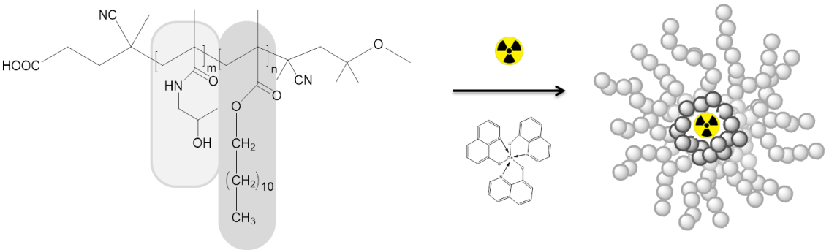

Figure 1: Illustration of the novel labelling strategy of HPMA-based micelles.

1.1 HPMA as a building block of micelle-forming copolymers
Poly[N-(2-hydroxypropyl)methacrylamide] (pHPMA) is a hydrophilic polymer currently under investigation for its use in polymer–drug conjugates. Its biocompatibility, non-immunogenicity and the possibility for functionalization are properties that resulted in broad pharmaceutical and biomedical applications, also in the micelle technology research.
Being hydrophilic, it can serve as a micellar stealth corona, while it can also be modified with hydrophobic moieties such as lauryl meta acrylate (LMA), to serve as a micellar core in which hydrophobic drugs can be solubilized and retained [3,9], therefore in the present study, HPMA was modified with hydrophobic LMA moieties and additionally, the block copolymer was modified with PEG moieties owing to its shielding efficacy and stabilization properties reducing micelles aggregation size [11] (Fig.2).

Figure 2: HPMA based polymer backbone: left PEG moiety, middle HPMA, right LMA.

As result of the influence of the additive PEG groups on the physical, chemical and biological properties of the micellar nanocarriers [3], the loading capacity and the drug release profile in presence of human serum and saline for the following three different polymeric structures (random copolymer, block copolymer, PEGylated block copolymer) were investigated using ⁶⁸Ga-oxine as model drug.
1.1.1 Random copolymer
Random copolymers contain many independent hydrophobic groups spread throughout the hydrophilic polymer chain, therefore in aqueous solution the structure of the micelles are not well defined as hydrophobic groups can be present in the corona (Fig. 3a).

1.1.2 Block copolymer
Block copolymers are composed of well-separated hydrophilic and hydrophobic blocks, the hydrophilic exterior provides steric stabilization/shielding and the hydrophobic core enables the facile entrapment of lipophilic drugs [12] (Fig. 3b).

1.1.3 PEGylated block copolymer
Increasing the hydrophilicity of the hydrophilic HPMA block by incorporation of highly hydrophilic PEG segments is a promising concept to decrease aggregate size by increasing steric stabilization. In addition, PEG is known for its shielding efficacy towards opsonic proteins [11] (Fig. 3c).
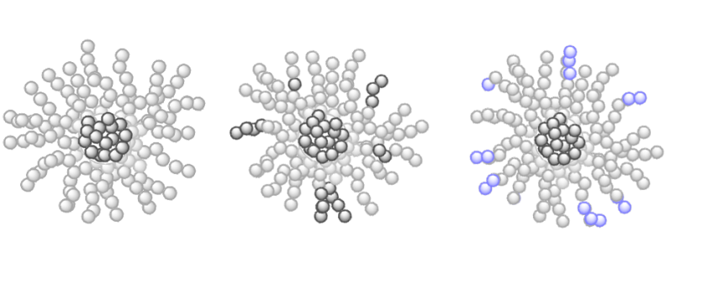
A
C
B

Figure 3: schematic structures of polymeric micelles formed by a) random polymer b) block copolymer c) PEGylated block copolymer

2 MATERIALS AND METHODS

2.1 Materials
All chemicals were analytical or pure reagent grade and used as received unless otherwise specified.
Deionized Milli-Q water (18.2 MΩ•cm; Millipore) was used in all organic reactions. Dioxane was distilled over a sodium/potassium composition. Lauryl methacrylate was distilled to remove the stabilizer and stored at -18 °C. 2,2’-Azo-bis-(isobutyronitrile) (AIBN) was recrystallized from diethyl ether and stored at -18 °C as well. ¹H-NMR spectra were obtained by a Bruker AC 300 spectrometer at 300 MHz, ¹⁹F-NMR analysis was carried out with a Bruker DRX-400 at 400 MHz. All measurements were accomplished at room temperature. The synthesized polymers were dried at 40 °C under vacuum overnight, followed by Gel Permeation Chromatography (GPC). GPC was performed in tetrahydrofuran (THF) as solvent, using following equipment: pump PU 1580, autosampler AS 1555, UV detector UV 1575 and RI detector RI 1530 from Jasco as well as a miniDAWN Tristar light scattering detector from Wyatt. Columns were used from MZ Analysentechnik, 300x8.0 mm: MZ-Gel SDplus 106 Å 5 µm, MZ-Gel SDplus 104 Å 5 µm and MZ-Gel SDplus 102 Å 5 µm. GPC data were evaluated by using the software PSS WinGPC Unity (Polymer Standard Service Mainz, Germany). The flow rate was set to 1 mL/min with a temperature of 25 °C.
Commercial generators based on TiO₂ were obtained from Cyclotron Co. Ltd (Obninsk, Russia). The cation exchange resins AG 50W-X8 (- 400 mesh), AG 50W-X4 (200 – 400 mesh) and AG 50W-X8 (200 - 400 mesh) were obtained from Bio-Rad (Munich, Germany). HiTrap™ Desalting Columns were purchased from GE-Healthcare Europe GmbH (Freiburg, Germany). TraceSelect water (Sigma-Aldrich, Germany) was used for all aqueous radiolabeling solutions.
Thin layer chromatography (TLC) was performed on silica-gel (silica-gel 60 F254; MERCK, Darmstadt, Germany)) coated aluminium TLC-sheets and instant thin layer chromatography (iTLC).They were analysed using an instant imager (Instant Imager, Canberra Packard, Schwadorf, Austria). RadioHPLC using HiTrapTM column (5mL, G-25 sephadex) was used to quantify the purity of the compounds. HPLC was performed using Hitachi L–7100 pump system coupled with UV (Hitachi L–7400) and radiometric (Gamma Raytest) detectors. Isocratic elution (100% water) and ﬂow rate of 0.2 mL/ min.

2.2 Synthesis of polymers
Synthesis and characterization of the polymers is explained in detail in the supporting section.

2.3 Synthesis of ^{nat}Ga-oxine
8-Hydroxiquinoline (3.5 eq) was dissolved in 10% acetic acid solution and Ga(NO₃)₃ (1 eq) was slowly added. The solution was stirred for 10 minutes and then heated up to 80°C under reflux. After few minutes pH was adjusted to 7 with concentrated NH₄OH. The yellow suspension was refluxed for 1 hour. The yellow precipitate was filtered off, washed with hot water and dried at 100°C.

2.4 Synthesis of ⁶⁸Ga-oxine and ¹¹¹In-oxine
The ⁶⁸Ge/⁶⁸Ga generator was eluted using 5 mL of 0.1 N HCl and the ⁶⁸Ga was online trapped on a cation exchange resin. ⁶⁸Ga was post-processed as previously described [13, 14]. 400 µL of the acetone post-processed ⁶⁸Ga eluate were added to 1 mL NaOAc 1 M solution together with 10-15 µL of oxine in ethanol (20 mg/mL). ¹¹¹In was obtained as ¹¹¹InCl₃ in 0.02 N HCl solution from Mallinckrodt. Aliquots of these solutions were added to 1 mL of NaOAc 1 M together with 10-15 µL of oxine in ethanol (20 mg/mL). The reaction mixture was stirred for 10 minutes at room temperature for both reactions. Final pH was of 6.6-6.8. ⁶⁸Ga-oxine and ¹¹¹In-oxine were analysed by iTLC: CHCl₃/MeOH (95:5).

2.6 Micelle formation
Different amounts of polymer (3 mg – 7.5 mg) and of cold Ga-oxine (1.5 mg – 5.5 mg) were dissolved in 100 µL DMSO and added to the ⁶⁸Ga-oxine NaOAc solution. The formed solution was slowly added to 1 mL of NaCl 0.9%. The micelles were formed spontaneously within 1 minute. After micelle formation purification using Sephadex G-25 size exclusion chromatography with saline as eluent was performed. Micelle formation was analysed by TLC using citrate buffer 0.1 M pH = 4.0 as a mobile phase.

2.7 In vitro stability
Stability of purified micelles was tested in fresh human serum and isotonic solution, both at a 1:4 v/v dilution. The samples were incubated at 37°C and at various time points, aliquots were taken and analysed by TLC using citrate buffer 0.1 M pH 4.0 as a mobile phase.

2.8 Ex vivo evaluation
¹¹¹In-oxine-micelles (1.5 mg in 1 mL of isotonic saline) and ¹¹¹In-oxine (0.15 mg/mL) to serve as a control were injected i.v. in anaesthetized healthy mice (C57BL6/J, male, 6 weeks, from Janvier) via the retro-orbital venous plexus, with a mean activity of 1.6 ± 0.3 MBq for micelles and of 1.6 ± 0.4 MBq for the ¹¹¹In-oxine. After 1, 4 and 24 hours, the animals were sacrificed and different organs and blood were removed. The tissue samples were weighed and the ¹¹¹In-activity in the organs was directly measured in a γ-counter (2470 WIZARD2 Automatic Gamma Counter, PerkinElmer). All animal experiments had previously been approved by the regional animal ethics committee and were conducted in accordance with the German Law for Animal Protection and the UKCCCR Guidelines [16].
2.9 Ex vivo metabolism evaluation
Blood samples (ca. 100 µl), collected during the biodistribution, were mixed with heparin solution (150 µl) to avoid coagulation. Blood samples were weighed and activity was measured in a γ-counter. 500 µl of PBS were added and the blood was centrifuged at 4000 rpm for 5 min in order to separate blood cells and plasma. The plasma fractions were weighed and activity was measured in a γ-counter. Proteins and micelles were precipitated by adding 200 µl of acetonitrile to the plasma fraction. To separate proteins and free polymer from plasma water the samples were centrifuged at 4000 rpm for 5 min. The supernatants were weighed followed by determination of the activity in a γ-counter. The percentage of radioactivity in the blood cells, protein plus micelles and plasma water fractions was calculated by subtracting the activities of the supernatants from the activity of the whole blood sample.

3 RESULTS

3.1 Synthesis of oxine complexes
The Ga-oxine cold complex was obtained as a yellow powder after purification by precipitation in diethyl ether. IR signal of –OH group of oxine was not detectable for the gallium complex which is an indicator of successful formation of the complex.
⁶⁸Ga-oxine complex was quantitatively (>96 %) formed within 15 minutes at room temperature Results were analysed by iTLC using a mixture of CHCl₃/MeOH (95:5) as eluent. Rf (⁶⁸Ga) = 0, Rf (⁶⁸Ga-oxine) = 0.9 [15]. Same protocol was applied to ¹¹¹In-oxine. The specific activity of ⁶⁸Ga was of 155 MBq/µmol oxine.

3.2 Synthesis of polymers
Amphiphilic p(HPMA-co-LMA) copolymers were synthesized by controlled radical polymerization with lauryl methacrylate (LMA) monomers having 20-23 mol % of hydrophobic lauryl side chains. Their molecular weight and polydispersity are shown in table 1.

Table 1. Chemical analitics of the three HPMA polymers used
Polymer | M_{n} PFPMA-LMA precursor | Ɖ | % LMA | M_{n} HPMA-LMA Polymer | M_{n} g/mol | Ɖ
Random | 68.400 g/mol | 1.2 | 20 | 44.4400 g/mol | 76.300 | 1.4
Block | 26.800 g/mol | 1.3 | 23 | 17.800 g/mol | 26.000 | 1.3
Block-PEG | 26.800 g/mol | 1.3 | 23 | 36.400 g/mol | 46.000 | 1.3

3.3 Micelle formation
For all polymer systems, micelles were formed within one minute. The incorporation rates for ⁶⁸Ga-oxine into the micellar core were of about 79 % ± 4 for the random copolymer, 92 % ± 2 for the block copolymer and 97 % ± 1 for the PEGylated block copolymer.
For the three polymeric systems, different amounts of cold Ga-oxine, as hydrophobic excipient, were used in micelle formation in order to find the best ratio polymer/Ga-oxine that will represent the efficiency on ⁶⁸Ga-oxine loading. A ratio of 1/0.75 molecular weight polymer/Ga-oxine was found to be optimal for micelle stabilization.
Purification through size exclusion columns was performed for the three type of polymeric micelles affording >97 % of purified labelled micelles in all cases. NaCl 0.9 % solution was used as eluent. Results were analysed by TLC using citrate buffer 0.1 M as mobile phase (micelles Rf = 0, ⁶⁸Ga/¹¹¹In-oxine Rf = 0.9). RadioHPLC was performed with a 5 mL size exclusion column using Milli-Q water as a mobile phase at a flow rate of 0.2 ml/min. Retention time of labelled micelles was 3.8 min with 99% purity. A broad tailored signal with peak maximum at 33 min was observed for ⁶⁸Ga-oxine complex. Both chromatograms are shown in figure 4.

Figure 4: radioHPLC chromatograms of labelled purified micelles (left) and ⁶⁸Ga-oxine (right).
3.4 In vitro stability
After administration, polymer therapeutics are exposed to biological media like blood, which may influence and alter their physicochemical properties due to interactions with proteins or serum components [17]. The release of radioactivity was measured as an indicator for the micelle stability both in NaCl 0.9% solution and in fresh human serum. Random polymeric micelles showed to be the less stable micelles releasing half of the loaded activity after 30 minutes of incubation. After 120 min of incubation at 37°C in NaCl 0.9% solution, random, block and PEGylated-block presented 66% ± 5, 77% ± 3 and 89% ± 2 of stable radioactive micelles respectively.
In human serum media, only 56 % ± 3 of random micelles were still intact after 30 minutes of incubation (Fig.5) while block and PEGylated-block micelles showed 63 % ± 2 and 91 % ± 3 respectively at the same time point. After 1 hour incubation, block micelles had released 48 % ± 1 of the radioactive ⁶⁸Ga complex while for the PEGylated-block micelles, only 14 % ± 4 of the activity was released from the micelle core (Fig. 5). Additional stability analysis after 1 day incubation were performed in the PEGylated micelles labelled with ¹¹¹ In-oxine prior to in vivo injection, >80 % micelles were still intact.

Figure 5: Stability of radiolabelled micelles in fresh human serum (n=3).

3.5 Ex vivo biodistribution
The favorable loading capacity and stability presented by the PEGylated block-copolymer micelles claimed for in vivo evaluation to gain knowledge of their biodistribution and whether the stability presented in vitro would persist.
The biodistribution of labelled micelles did not show specific uptake in any organ and values remained quite constant for each organ during the three time points analyzed (Fig. 6). High uptake was observed in the lungs (31.2 % ± 2.9), spleen (17.8 % ± 2.3) and kidneys (21.7 % ± 1.6) after 1 h p.i, and it barely changed after 4 and 24 h p.i. High accumulation was also observed in blood after 1 h (25.9 % ± 2.8) and 4 h (26.4 % ± 0.7) p.i however it decreased to 18.3 % ± 1.3 after 24 h p.i. Uptake in liver and heart did not show remarkable variations in the 3 points, with a mean value of 9.3 % ± 1.2 and 8.9 % ± 0.7 respectively. Remarkable is the high uptake (11.9 %) in urine after 1 h p.i. Slight bone accumulation is also observed.

Figure 6: Ex vivo biodistribution of radiolabeled micelles in healthy mice (n=3) after 1 h, 4 h and 24 h p.i.

Control experiments were performed with ¹¹¹In-oxine (Fig.7). High retention in the lungs was detected at all time points (>40 % ID/g). High uptake of c.a 28 % was observed in the blood after 1 and 4 h p.i, which decreased to c.a 18 % after 24 h p.i. Uptake of c.a 20% in the kidneys remained constant during the three time points analyzed. Slight increase of activity over time was observed in spleen, liver and heart, with maximum values of 14.8 % ± 1.9, 6.1 % ± 0.4 and 12.0 % ± 0.4 respectively, after 24 h p.i.

Figure 7: Ex vivo biodistribution of ¹¹¹In-oxine in healthy mice (n=3) after 1 h, 4 h and 24 h p.i

Comparing the two graphics a similar patern of both substances can be observed in some organs: a small uptake increase over time in spleen and kindneys, a high retention in lungs and a decrease in blood uptake after 24 h p.i. Urine uptake after 1 h p.i of micelles showed higher values when compared to ¹¹¹In-oxine.

3.6 Ex vivo metabolism
In order to investigate the in vivo stability of the labelled micelles and ¹¹¹In-oxine, the blood samples obtained during biodistribution were separated into different fractions: a) blood cells, b) polymer + proteins and c) plasma water. Figures 8a and 8b show the amount of radioactivity in the different fractions with reference to the total amount of radioactivity in the blood samples of ¹¹¹In-oxine and ¹¹¹In-oxine-labelled micelles. ¹¹¹In-oxine remains constantly concentrated in the blood cell fraction at all time points with values >90 %. 67.4 % ± 2.4 of the radiolabelled micelles are found after 1 h p.i in the blood cells fraction and only 30.1 % ± 1.9 in the fraction containing proteins and micelles, which decreased to 21.1 % ± 1.4 and 15.1 % ± 1.5 after 4 and 24 h p.i respectively, while it increased in the blood cells fraction up to 77.4 % ± 1.4 and 82.4 % ± 1.5 after 4 and 24 h. The concentration on plasma water remained constant at low values below 2.5 % during the complete observation period of 24 h.
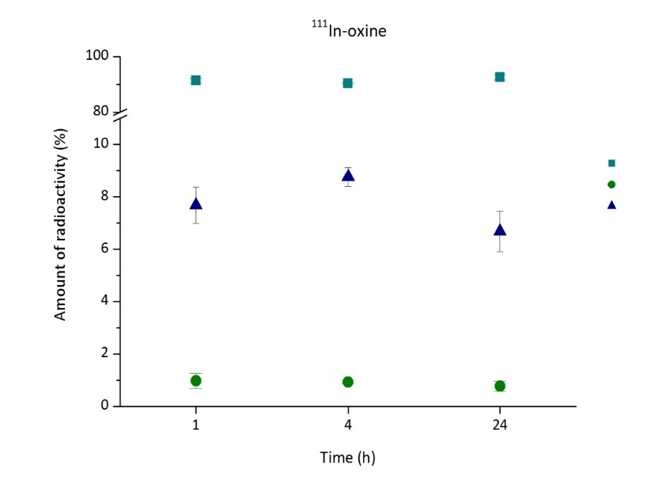
Blood cell
Plasma water
Proteins/micelles

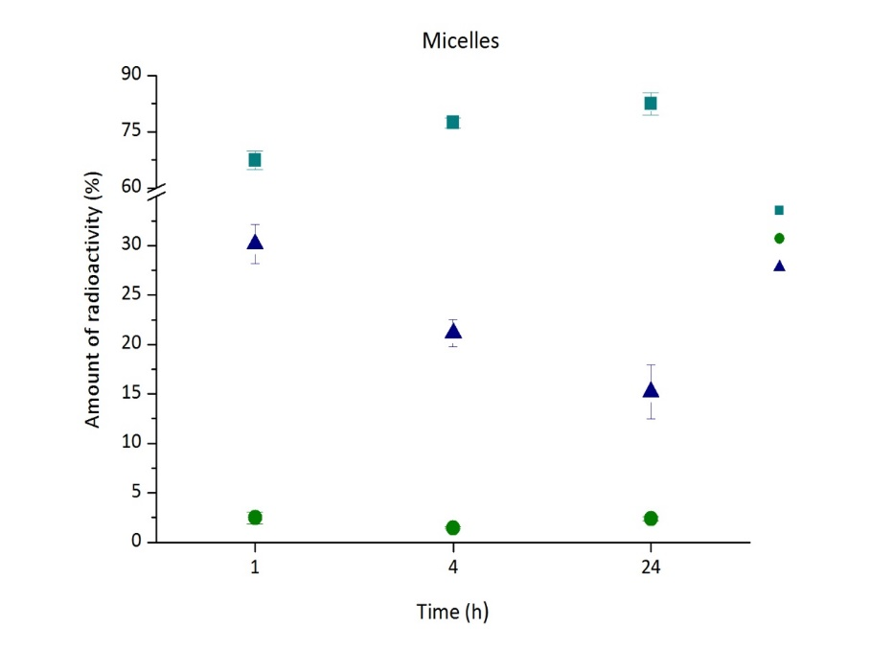
Figure 8a: Distribution of ¹¹¹In-oxine in the blood for up to 24 h (n=3). Data is expressed as percentage of the amount of radioactivity that was present in the whole blood sample (mean ± SEM).
Blood cell
Plasma water
Proteins/micelles

Figure 8b: Distribution of labelled micelles in the blood for up to 24 h (n=3). Data is expressed as percentage of the amount of radioactivity that was present in the whole blood sample (mean ± SEM).

4 DISCUSSION

The different structures of the polymers chosen were of interest as previous reports have demonstrate the capacity of those HPMA micellar structures as drug delivery systems [9, 18].
The encapsulation of ⁶⁸Ga-oxine into the micellar core showed different values depending on the structure of the polymer used. The lowest capability to incorporate the hydrophobic drug ⁶⁸Ga into the micellar core was observed for the random copolymer structure. Its nature leads to conformations where hydrophobic LMA can be close to the surface of the core-shell of the micelles leading to a micellar aggregation formation, which promotes the alteration of the micellar structure, and consequently the release of the incorporated drug [4]. This phenomenon is also observed in the lower stability of the radioactive micelles in human serum. It can be assumed that the hydrophobic moieties closer to the surface facilitate hydrophobic interactions [19] with serum proteins and therefore ⁶⁸Ga is released from the micellar core.
HPMA block copolymer micelles, having a well-defined structure, facilitate the incorporation of the hydrophobic complex into the core. Moreover, as the presence of hydrophobic LMA moieties in the micellar surface is minor when compared to random structures, the interactions between LMA and proteins present in human serum decrease. This fact is translated in a higher in vitro stability. However, the results were not as satisfactory as expected, in particular concerning the stability in human serum. As the core and shell of the micelles are clearly differentiated and the addition of the hydrophobic excipient, Ga-oxine, should help to induce more extensive micelle formation, besides stabilization of the hydrophobic regions, higher stability of the amphiphilic block copolymer was expected.
In order to increase stability, PEG moieties were incorporated to the corona of the block copolymer. The high hydrophilicity and flexibility of the PEG chains form a protective layer that will reduce the interactions between micelles and serum components. This fact is due to PEG is only an acceptor for H-bonding whereas poly(HPMA) is both a donor and an acceptor [11]. Finally, such micelles revealed higher loading capacity of ⁶⁸Ga-oxine, with quantitative incorporation and improved stability over time.
After successful results of loading capacity and stability of the PEGylated micelles, further ex vivo biodistribution studies were performed in healthy mice to evaluate their in vivo behaviour. Do to the short half-life of ⁶⁸Ga,¹¹¹In was employed instead to allow longer time frame evaluation e.g. 24 h.
The analysis of the three different blood fractions revealed low in vivo stability of the micelles. Only 30% of the total activity of the blood sample was found after 1 hour p.i in the pellet containing proteins and polymer, and it decreased after 4 and 24 hours to c.a 21% and 15% respectively. These results indicate release of the ¹¹¹In-oxine from the micellar core, consequently the amount of radioactivity in the blood cell fraction increased proportionally.
¹¹¹In-oxine was found to remain in high amounts in the blood cell fraction (>95%) from 1 h to 24 hours, this fact could be explained as a consequence of the high hydrophobicity of the complex, which is able to penetrate the blood cells [20]. ¹¹¹In-oxine is known to diffuse into red and white blood cells serving as an imaging agent of e.g. infection or inflammation in vivo [21-22]. Values below 2.5 % in the water plasma indicate that ¹¹¹In-oxine complex remained stable; there was almost no release of free ¹¹¹In.
These results are in concordance with the biodistribution analysis. Assuming that the micelles are not stable and only approximately 30% remained intact after 1 h p.i, the organ uptake values do not provide information on the micelles distribution, as around 70% of the activity measured belongs to free ¹¹¹In-oxine. This fact gets worse after 4 and 24 h post injetcion as more ¹¹¹In-oxine was released from the micelles. The only remarkable difference observed after 1 h p.i is the much higher uptake in the urine and lower uptake in liver 40% vs 30%. We could especulate that labelled micelles are rapid excreeted through the kidneys, however only one valueof urine was obtained.

5 CONCLUSIONS

Three different structures of amphiphilic HPMA-LMA based copolymers that self-assemble into micelles were studied to apply a novel radiolabelling technique. Spontaneous incorporation of hydrophobic ⁶⁸Ga-oxine or ¹¹¹In-oxine complexes in the micellar core was quantitative after one minute. The strategy does not require of previous modification of the polymer in order to be labelled with a radiometal and therefore the biological characteristics of the polymer will be totally preserved. The incorporation efficiency as well as in vitro stability in human serum and saline clearly depends on the polymer morphology. The optimum results were achieved for those polymers with a well-defined structure, in particular for the polymer that contains PEG moieties in the corona. Further ex vivo evaluation in healthy mice did not correlate with the in vitro stability values. Only c.a 30% of the micelles remained stable after 1 h p.i and this number decreased to c.a 15 % after 24 h p.i. This study shows an efficient labelling technique, but further investigations are needed in order to ensure in vivo stability.
REFERENCES

[1] Kataoka K, Kwon GS, Yokoyama M, Okano T, Sakurai Y. Block copolymer micelles as vehicles for drug delivery. J Control Release 1993; 24: 119- 132.
[2] Bader H, Ringsdorf H, Schmidt B. Watersoluble polymers in medicine. Ang. Macromol. Chem 1984; 123: 457-485.
[3] Talelli M, Rijcken CJF, van Nostrum CF, Storm G, Hennink WE. Micelles based on HPMA copolymers. Adv Drug Deliv Rev 2010; 62: 231–239.
[4] Hemmelmann M, Kurzbach D, Koynov K, Hinderberger D, Zentel R. Aggregation Behavior of Amphiphilic p(HPMA)-co p(LMA) Copolymers Studied by FCS and EPR Spectroscopy Biomacromolecules 2012; 13: 4065−4074.
[5] Willmann JK, van Bruggen N, Dinkelborg LM, Gambhir SS. Molecular imaging in drug development. Nat Rev Drug Discov 2008; 7: 591‐607.
[6] van Dongen GA, Visser GWM, Lub-de Hooge MN, de Vries EG, Perk LR. Immuno-PET: A Navigator in Monoclonal Antibody Development and Applications. The Oncologist 2007; 12: 1379–1389.
[7] Moderegger D. Radiolabeling of Defined Polymer Architectures with Fluorine-18 and Iodine-131 for Ex Vivo and in Vivo Evaluation: Visualization of Structure Property Relationships. Ph.D. Thesis, Institute of Nuclear Chemistry, Johannes Gutenberg-University, Mainz 2012.
[8] Herth M, Barz M, Moderegger D, Allmeroth M, Jahn M, Thews O, Zentel Z, Rösch F. Radioactive Labeling of Defined HPMA-Based Polymeric Structures Using [18F]FETos for In Vivo Imaging by Positron Emission Tomography. Biomacromolecules 2009, 10: 1697–1703.
[9] Hemmelmann M, Knoth C, Schmitt U, Allmeroth M, Moderegger D, Barz M, Koynov K, Hiemke C, F. Rösch F, Zentel R .HPMA Based Amphiphilic Copolymers Mediate Central Nervous Effects of Domperidone. Macromol Rapid Commun 2011; 32, 712–717.
[10] Duncan R. Development of HPMA copolymer–anticancer conjugates: Clinical experience and lessons learnt. Adv Drug Deliv Rev 2009; 61: 1131–1148.
[11] Allmeroth M, Moderegger D, Gündel D, Buchholz HG, Mohr N, Koynov K, Rösch F, Thews O, Zentel R. PEGylation of HPMA-based block copolymers enhances tumor accumulation in vivo: A quantitative study using radiolabeling and positron emission tomography. J Control Release 2013; 172: 77–85.
[12] Gaucher G, Dufresne MH, Sant VP, Kang N, Maysinger D, Leroux JC. Block copolymer micelles: preparation, characterization and application in drug delivery. J Control Release 2005; 109; 169–188.
[13] Zhernosekov KP, Filosofov DV, Baum RP, Aschoff P, Bihl H, Razbash AA, Jahn M, Jennewein M, Rösch F. Processing of Generator-Produced ⁶⁸Ga for Medical Application. J Nucl Med 2007; 48: 1741-1748.
[14] Mueller D, Klette I, Baum RP, Gottschaldt M, Schultz MK, Breeman WAP. Simplified NaCl Based ⁶⁸Ga Concentration and Labeling Procedure for Rapid Synthesis of ⁶⁸Ga Radiopharmaceuticals in High Radiochemical Purity. Bioconjugate Chem 2012; 23: 1772-1717.
[15] Yano Y, Budinger TF, Ebbe SN, Mathis CA, Singh M, Brennan KM, Moyer BR. Gallium-68 Lipophilic Complexes for Labeling Platelets. J Nucl Med 1985; 26: 1429-1437.
[16] Workman P, et al. Guidelines for the welfare and use of animals in cancer research. Br J Cancer 2010; 102: 1555-1577.
[17] Hemmelmann M, Mohr N, Fischer K, Zentel R, Schmidt M. Interaction of pHPMA−pLMA Copolymers with Human Blood Serum and Its Components. Mol Pharmaceutics 2013; 10, 3769−3775.
[18] Hemmelmann M, Metz VV, Koynov K, Blank K, Postina R, Zentel R. Amphiphilic HPMA–LMA copolymers increase the transport of Rhodamine 123 across a BBB model without harming its barrier integrity. J Control Release 2012; 163: 170–177.
[19] Winzelberg GG, Castronovo FP, Callahan RJ, McKusick KA, Strauss HW. ¹¹¹In oxine labeled red cells for detection of simulated lower gastrointestinal bleeding in an animal model. Radiology 1980; 135: 455-61.
[20] Ebbe S, Taylor S, Maurer H, Kullgren B. Uptake of Indium-111-Labeled Platelets and Indium-111 Oxine by Murine Kidneys after Total-Body Irradiation. Radiation Research 1996; 146: 216-222.
[21] Heyns AP, MG Lotter MG, Kotze HF, Wessels P, Pieters H, Badenhorst PN. Kinetics, distribution, and sites of destruction of indium-111 oxine labelled red cells in haemolytic anaemia. J Clin Pathol 1985; 38:128-132.
[22] Becker W, Fischbach W, Jenett M, Reiners C, Börner W. ¹¹¹In-oxine-labelled white blood cells in the diagnosis and follow-up of crohn's disease. Int J Mol Imaging 1986; 64: 141-148.

Supporting Information

⁶⁸Ga-, ¹¹¹In- oxine: A novel strategy of in situ radiolabelling of HPMA-based micelles

A. de la Fuente, S. Kramer, N. Mohr, S. Pektor, N. Bausbacher, R. Zentel, F. Rösch

Contents

1 Experimental section

I. Synthesis of 4-cyano-4-((thiobenzoyl)sulfanyl)pentanoic acid
II. Synthesis of Pentafluorophenylmethacrylate (PFPMA)
III. Synthesis of the reactive ester random copolymer
IV. Synthesis of the reactive ester block copolymer
V. Removal of the dithioester end groups
VI. Polymer analogous reactions

2 References

I Synthesis of 4-cyano-4-((thiobenzoyl)sulfanyl)pentanoic acid
The 4-cyano-4-((thiobenzoyl)sulfanyl)pentanoic acid was used as the chain transfer agent (CTA) and synthesized according to the literature in a three step reaction [1].

II Synthesis of Pentafluorophenylmethacrylate (PFPMA)
PFPMA was prepared according to the literature [2].

III Synthesis of the reactive ester random copolymer
RAFT polymerization of pentafluorophenylmethacrylate (PFPMA) and lauryl methacrylate (LMA) with 4-cyano-4-((thiobenzoyl)sulfanyl)pentanoic acid (CTA) was carried out in a schlenk tube [1,2]. For this purpose , 4 g of PFPMA and 1.2 g of LMA were dissolved in 5 ml of absolute dioxane and 8.5 mg of CTA and 1.9 mg of 2,2´-Azobis-(4-methoxy)-2,4-dimethyl)valeronitrile (ABNDM) were added. After three-freeze-vacuum-thaw cycles, the mixture was immersed in an oil bath at 40 °C and stirred overnight. Afterwards the polymer solution was precipitated three times in n-hexane, centrifuged und dried under vacuum at 40 °C over night. A slightly pink powder was obtained. ¹H NMR (300 MHz, CDCl₃): δ [ppm] 4.00 (br, 2H), 2.48-0.83 (m, 5H). ¹⁹ F NMR (400 MHz, CDCl₃): δ [ppm] -151.5 - -153.1 (br, 2F), -157.9 - -158.2 (br, 1F), -162,9 - -163.4 (br, 2F).

IV Synthesis of the reactive ester block copolymer
- Synthesis of the reactive ester homopolymer (macro-CTA):
The PFPMA-macro-CTA was synthesized by RAFT polymerization of PFPMA with CTA under schlenk conditions. The reaction vessel was loaded with 4 g of PFPMA, 40 mg of CTA, 4 mg of ABNDM and 5 ml of absolute dioxane. Following three freeze-vacuum-thaw cycles, the tube was immersed into an oil bath at 40 °C and stirred overnight. After the polymerization the polymer solution was precipitated three times in n-hexane, isolated by centrifugation and dried overnight under vacuum at 40 °C. In the end a slightly pink powder was obtained. ¹H NMR (300 MHz, CDCl₃): δ [ppm] 2.1 – 2.5 (br, 2H), 1.3 – 1.6 (m, 3H). ¹⁹ F NMR (400 MHz, CDCl₃): δ [ppm] -151.5 - -153.1 (br, 2F), -157.9 - -158.2 (br, 1F), -162,9 - -163.4 (br, 2F).

- Synthesis of the reactive ester block copolymer:
0.5 g of the macro-CTA obtained after homo polymerization of PFPMA was dissolved in 4 ml of absolute dioxane. Afterwards 0.3 g of LMA and 1.4 mg of ABNDM were added and mixed. After three freeze-vacuum-thaw cycles, the tube was immersed into an oil bath at 40 °C and stirred for three days. Afterwards poly(PFPMA)-b-poly(LMA) was precipitated three times from dioxane into ethanol, isolated by centrifugation and dried overnight under vacuum at 40 °C. In the end a slightly pink powder was obtained. ¹H NMR (300 MHz, CDCl₃): δ [ppm] 3.9 (br, 2H), 2.4 – 0.9 (m, 5H). ¹⁹ F NMR (400 MHz, CDCl₃): δ [ppm] -151.5 - -153.1 (br, 2F), -157.9 - -158.2 (br, 1F), -162,9 - -163.4 (br, 2F).

V Removal of the dithioester end groups
The copolymer was precipitated in ethanol and collected by centrifugation. The copolymer was dried under vacuum at 40 °C overnight and a colourless powder was obtained. Yield: 380-390 mg (95-98 weight %). The absence of the dithiobenzoate end group was confirmed by UV/Vis spectroscopy by the absence of the peak at 302 nm.

VI Polymer analogous reactions
- Synthesis of poly(HPMA)-random-poly(LMA)
A total of 40 mg of the poly(PFPMA)-ran-poly(LMA) precursor polymer without dithioester end groups, was dissolved in 4 ml absolute dioxane and 1.5 ml absolute dimethylsulfoxide under argon atmosphere. 121 μL of 2-hydroxypropylamine and the equivalent molar amount of triethylamine were added. The mixture was stirred at 50 °C for three days. Afterwards the solution was diluted with Milli-Q water and dialysed for 3 days using Spectra/Por membranes (MWCO 3500 g/mol) and changing the water every 12 hours. The resulting solution was freeze dried to obtain a colourless powder. Yield: (90%). ¹H NMR (400 MHz, DMSO-d₆): δ [ppm] 7.4 – 7.2 (br, -NH), 4.7 (br, 1H), 3.7 – 3.4 (br, 2H), 2.9 (br, 2H), 2.3 – 0.8 (br, 5H).

- Synthesis of poly(HPMA)-block-poly(LMA).
A total of 100 mg of the poly(PFPMA)-b-poly(LMA) precursor polymer without dithioester end groups, was dissolved in 4 ml absolute dioxane and 1.5 ml absolute dimethylsulfoxide under argon atmosphere. 262 μL of 2-hydroxypropylamine and the equivalent molar amount of triethylamine were added. The mixture was stirred at 50 °C for three days. Afterwards the solution was diluted with Milli-Q water and dialysed for 3 days using Spectra/Por membranes (MWCO 3500 g/mol) and changing the water every 12 hours. The resulting solution was freeze dried to obtain a colourless powder. Yield: (90%). ¹H NMR (400 MHz, DMSO-d₆): δ [ppm] 7.4 – 7.2 (br, -NH), 4.7 (br, 1H), 3.7 – 3.4 (br, 2H), 2.9 (br, 2H), 2.3 – 0.8 (br, 5H).

- Synthesis of PEGylated poly(HPMA)-block-poly(LMA)
A total of 100 mg of the poly(PFPMA)-b-poly(LMA) precursor polymer without dithioester end groups, was dissolved in 4 ml absolute dioxane and 1.5 ml absolute dimethylsulfoxide under argon atmosphere. 53 mg of PEG_{2kDa} with amine functionality and an equivalent amount of triethylamine was added. The colourless solution was stirred at 50 °C for 24 hours. Afterwards 120 μL of 2-hydroxypropylamine and the equivalent molar amount of triethylamine were added and stirred at 50 °C for another three days. The polymer solution was diluted with Milli-Q water and dialysed for 3 days using Spectra/Por membranes (MWCO 3500 g/mol) and changing the water every 12 hours. The resulting solution was freeze dried to obtain a colourless powder. Yield: (93%). ¹H NMR (400 MHz, DMSO-d₆): δ [ppm] 7.4 – 7.2 (br, -NH), 4.7 (br, 1H), 3.7 – 3.4 (br, 2H, 4H PEG), 3.3 (s, 2H PEG), 2.9 (br, 2H), 2.3 – 0.8 (br, 5H).

REFERENCES

[1] Chong YK, Moad G, Rizzardo E, Tang SH. A More Versatile Route to Block Copolymers and Other Polymers of Complex Architecture by Living Radical Polymerization: The RAFT Process. Macromolecules 1999; 32: 2071–2074.
[2] Eberhardt M, Mruk R, Zentel R, Theato P. Synthesis of pentafluorophenyl(meth)acrylate polymers: New precursor polymers for the synthesis of multifunctional materials. Eur Polym J 2005; 41: 1569–1575.

3.3 ⁴⁴Sc labelling of PSMA-617 for dosimetry of prostate cancer

⁴⁴Sc-PSMA-617 for dosimetry of prostate cancer

A. de la Fuente^{1*}, E. Eppard^{2*}, M. Benesova³, F. Rösch¹, M. Essler², K. Kopka³

¹Institute of Nuclear Chemistry, Johannes Gutenberg University,
55128 Mainz, Germany
²Department of Nuclear Medicine, University Hospital Bonn,
53127 Bonn, Germany
³Division of radiopharmaceutical chemistry, German Cancer Research Center, 69120 Heidelberg, Germany

*contributed equally

ABSTRACT

A broad pool of radionuclides becomes available for labelling of the prostate-specific membrane antigen (PSMA) inhibitor, Glu-NH-CO-NH-Lys (Ahx), when using DOTA as chelator. Recently the novel DOTA based PSMA-617 has shown great results in prostate cancer therapy and PET imaging when labelled with ¹⁷⁷Lu and ⁶⁸Ga. Do to the short half-life of ⁶⁸Ga, long acquisition periods cannot be carried out. In this context, ⁴⁴Sc with a half-life of 3.97 h and suitable decay characteristics for PET imaging, it is an alternative to ⁶⁸Ga. In this study, ⁴⁴Sc-labelled PSMA-617 was investigated and evaluated as a prostate cancer PET imaging agent.
Methods:
PSMA-617 was labelled with ⁴⁴Sc produced via ⁴⁴Ti/⁴⁴Sc generator. The stability of the radiopharmaceutical was examined in physiological conditions and in presence of competing relevant cations and chelates. Internalization and affinity constant was evaluated in LNCaP cells. First human in vivo investigation was carried out.
Results:
Labelling yield of 98% was achieved with 18 nmol of PSMA-617 after 20 min at 95 °C. After purification, product of 100% RCY was obtained, which presented high stability (>95%) in all solutions analysed. Affinity constant in LNCaP cells was of 4.72 ± 0.7 nM and internalization of 15.78 ± 2.14 % injected activity/10⁶ LNCaP cells. ⁴⁴Sc-PSMA-617 PET/CT imaging of PSMA receptor positive metastases in a 77-year old patient showed successful detection of the lesions even after 19 h p.i.
Conclusions:
Efficient synthesis of DKFZ-617 with ⁴⁴Sc was achieved within 20 min. Stability as well as affinity and internalization values in LNCaP cells led to the first human evaluation with ⁴⁴Sc-PSMA-617. In vivo results confirmed the suitability of ⁴⁴Sc-PSMA-617 as a promising radiotracer for PET imaging of prostate cancer lesions

Keywords: prostate cancer, PSMA-617, ⁴⁴Sc, PET, dosimetry, theranostics

1 INTRODUCTION

Prostate cancer (PC) is the second most common cancer and the sixth leading cause of cancer death in men worldwide despite of the significant decrease in mortality in recent years due to early detection [1].
Current diagnosis is typically through digital rectal exam and blood prostate specific antigen (PSA) testing. Nevertheless, around 25% of the men with prostate cancer have serum PSA levels within the normal range, resulting in false negatives, while others have elevated serum PSA levels due to other reasons than prostate cancer resulting in false positives and unnecessary biopsies [2,3].
Since elevated serum PSA levels do not always correlate with disease, the prostate-specific membrane antigen (PSMA) has recently focused the attention for PC identification. PSMA, is an integral transmembrane protein significantly overexpressed (>95%) in prostate cancer, including metastatic disease, conceiving PSMA as a very attractive target for prostate cancer on the way to a personalized medicine, in which nuclear medicine offers both diagnostic and therapeutic tools using different radioisotopes [2-5].
Different radiopharmaceuticals have been in clinics for detection and treatment of prostate cancer but those with low molecular weight presented better results [6-9]. This fact gave rise to development of low-molecular-weight urea-based inhibitors pepidomimetics with high affinity to the catalytic domain of PSMA [9,11]. Among them, a DOTA derivative of the Glu-urea-Lys motif (PSMA-617) has been recently developed, the chelator is conjugated via an aromatic linker that improves tumor accumulation while simultaneously reducing kidney uptake. The novel compound has shown successful in vivo results not only with ¹⁷⁷Lu but also with ⁶⁸Ga, being nowadays powerful theranostic tracers for prostate cancer [12-15].
The treatment of identified lesions with therapeutic radionuclides needs of dosimetric calculations on tumor site and nearby organs to assess safety and efficacy of treatment as well as the pre-selection of patients. The analogue imaging probe quantifies the absorbed dose delivered in a specific site, offering accurate monitoring and planning of the patient’s response to therapy and final response to the treatment in a post-therapeutic control [16].
⁶⁸Ga has been to date, the isotope used for imaging with the novel PSMA radiopharmaceutical [10, 11]. In spite its suitable decay characteristics ideal for PET imaging (β⁺ = 89%, Ē = 0.74 MeV) and its availability via a ⁶⁸Ge/⁶⁸Ga generator, its short half-life of 68 min limits its application as it only covers imaging periods of few hours. In this sense, the longer-lived positron-emitter ⁴⁴Sc is an alternative to ⁶⁸Ga.
⁴⁴Sc (β⁺ = 94%, Ē = 0.597 MeV) has a half-life of 3.97 h and it is both generator and cyclotron produced [17, 18]. As ⁶⁸Ga is a trivalent cation but its half-life is 4 times longer thus providing a longer imaging frame-time. Another advantage of Sc^{III} in nuclear medicine, is the possibility of using the isotope ⁴⁷Sc (β⁻, primary γ-ray of 159 keV and t ½ = 3.3 d) for therapy, constituting together a match for imaging and therapy ^{44/47}Sc representing a real theranostic [19,20].
The aim of this work was to determine optimal conditions for radiolabeling PSMA-617 with ⁴⁴Sc to be used as prostate cancer imaging agent allowing for dosimetry calculation of the therapeutic ¹⁷⁷Lu analogue (Fig.1). Parameters that influence reaction kinetics, like incubation time, influence of organic solvent, temperature and amount of chelate-peptide of the reaction were investigated. Stability of the formed conjugate was checked in 0.9% NaCl, phosphate buffered-saline (PBS, pH 7.4), human serum and in presence of different metal cations as well as other competing chelators, like EDTA and DTPA. Affinity and internalization of ⁴⁴Sc-PSMA-617 were studied in LnCaP cells and the results were compared with ¹⁷⁷Lu and ⁶⁸Ga analogues. ⁴⁴Sc-PSMA-617 was finally evaluated in a 77-year old patient suffering from prostate cancer.

Figure 1: Structure of ⁴⁴Sc-PSMA-617

2 MATERIALS AND METHODS

Reagents were purchased from Sigma-Aldrich (Germany) and used without further purification, unless otherwise stated. Deionized water (18 MΩ cm⁻¹) was used in all reactions. No further special measures were taken regarding working under strict metal-free conditions. PSMA-617 was obtained as GMP-grade from ABX (Radeberg, Germany).
⁴⁴Sc was obtained from ⁴⁴Ti/⁴⁴Sc -generator. ⁴⁴Sc was eluted with 20 mL of 0.005 M H₂C₂O₄/0.07 M HCl mixture which were directly post-processed onto a miniaturized column filled with cation-exchange resin AG50W–X8 (200–400 mesh, H⁺ form, 60 mg) where ⁴⁴Sc was quantitatively adsorbed online and successively eluted using 2–3 mL of 0.25 M ammonium acetate buffer (pH 4.0) [17]. This ⁴⁴Sc solution of small volume and free of competing oxalates was used for labelling.

2.1 Labelling of PSMA-617 with ⁴⁴Sc
Labelling of PSMA-617 with ⁴⁴Sc was performed by mixing different volumes of PSMA-617 stock solution (1 mg/mL) with post-processed ⁴⁴Sc eluate in 0.25 M ammonium acetate buffer pH 4.0. Effect of PSMA-617 concentration on labelling yields was evaluated with quantity of peptide varying from 14 to 26 nmol. Solutions were heated for 20 min at 95°C.

2.2 Solid phase extraction (SPE)
⁴⁴Sc-PSMA-617 was purified from unreacted ⁴⁴Sc species by reversed-phase chromatography with mini C–18 cartridges (Phenomenex Strata–X Tube, 30 mg). Final product was obtained in 1 mL of EtOH.

2.3 Quality control
Analysis of ⁴⁴Sc-PSMA-617 formation was monitored by thin-layer chromatography (TLC) (Silica-gel 60, Merck) using 0.1 M sodium citrate pH 4.0 as eluent, by iTLC (Instant thin layer chromatography) with a mixture 1:1 of ammonium acetate 1 M and ethanol, and by HPLC using Lichrosphere 100–RP18 EC column (5 mm, 250mm x 4 mm) (phenomenex). The gradient elution system utilized mobile phase A (deionized H₂O with 0.01% TFA) and mobile phase B (100% acetonitrile) at a flow rate of 1 mL/min, starting with 82% A/18% B for 30 min, after which gradient parameters returned to the initial conditions during next 2 min.
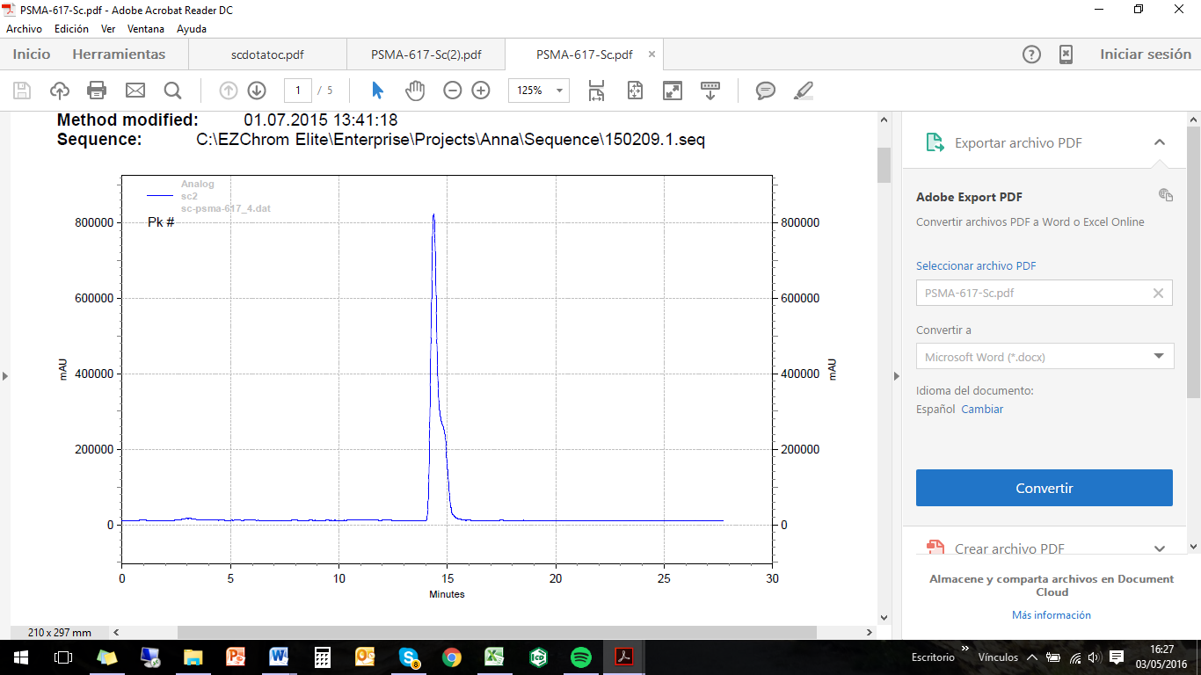
0 5 10 15 20 25 30
Minutes
40000000000

20000000000

800000
mAU00000

0

60000000000

⁴⁴Sc-PSMA-617
⁴⁴Sc

Figure 2: HPLC chromatogram of ⁴⁴Sc-PSMA-617

2.4 In vitro stability
Stability was performed by addition 20 µL of purified ⁴⁴Sc-PSMA-617 conjugate to 500 μL of 0.9% NaCl, human serum and solutions containing different metal cations (Fe³⁺, Ca²⁺ and Mg²⁺) at concentration levels of 10⁻² M. Solutions were incubated for 24 h at 37°C.
Studies with DTPA and EDTA were also performed to check the stability of synthesized ⁴⁴Sc-PSMA-617 in the presence of competing chelating ligands. The appropriate aliquots of purified ⁴⁴Sc-PSMA-617 were added to DTPA or EDTA solutions in 0.9% NaCl in such a way that the final molar ratio of DTPA or EDTA to conjugate was equal to 100:1. The final volume of all solutions was 500 μL.

2.5 Binding affinity and internalization.
Competitive binding and internalization experiments were performed using the PSMA+ LNCaP cell line (European Collection of Cell Cultures, Salisbury, UK) derived from an androgen-sensitive human lymph node metastatic lesion of prostatic adenocarcinoma (ATCC CRL-1740). The cells were grown in RPMI 1640 medium (PAN-Biotech, Aidenbach, Germany) supplemented with 10% fetal calf serum (FCS) and 1% l-glutamine. Cell cultures were maintained in an atmosphere of 5% CO₂ at 37 °C in a humidified incubator.
The binding affinity was determined using a cell-based competitive assay with ⁶⁸Ga-labelled Glu-urea-Lys-(Ahx)-HBED-CC dimer (⁶⁸Ga-PSMA-10) and expressed as K_{i} values. ^{nat}Sc-PSMA-617 at twelve different concentrations (0–5000 nM) was incubated with 0.75 nM of ⁶⁸Ga-PSMA-10 together with LNCaP cells (10⁵ LNCaP cells/well). After 45 min incubation at 37 °C, the cells were washed three times with ice-cold PBS. A gamma counter measured radioactivity accumulated in the cells and the data fitted using a nonlinear regression algorithm (GraphPad Software) to calculate 50% inhibitory concentrations (IC₅₀ values).
For the determination of internalization, LNCaP cells (10⁵ LNCaP cells/well) were seeded in poly-l-lysine coated plates 24 h before the experiment. The cells were incubated for 45 min at 37 °C with 32 nM of ⁴⁴Sc-labelled PSMA-617 in 250 μL Opti-MEM. Additionally, for confirmation of specific cellular uptake, the second set of compounds was also treated with 500 μM/well of PSMA-inhibitor 2-PMPA (2-(phosphonomethyl)pentane-1,5-dioic acid). The cells were washed four times with ice-cold PBS and the surface-bound radioactivity was removed by washing twice with 50 mM glycine (pH 2.8). After washing the cells with PBS, the internalized fraction was determined by lysis of the LNCaP cells using 0.3 M NaOH. The radioactivity collected from the glycine and hydroxide fractions was measured in a gamma counter and calculated as %IA/10⁶ LNCaP cells.

2.6 Human evaluation
Labelling was performed with 40 nmol of PSMA-617 for 20 min at 95 °C. After purification with a C-18 column, the final product was formulated in isotonic NaCl 0.9 % solution with subsequent sterile filtration with a 94% recovery (decay corrected). A 77-year old man suffereing from prostate cancer was injected with 55.76 MBq of ⁴⁴Sc-PSMA-617 in the Nuclear Medicine department of University Klinikum Bonn, and the protocol for dosimetry studies was followed:
1) withdrawal of blood samples in heparinized syringe ofr determining of blood haematocrit value. 2) Acquisition of low dose CT scan for patient positioning and attenation correction. 3) 30 min dynamic PET scan under PET/CT camera. 6 images x 10 sec, 10 images x 30 sec and 8 images x 180 sec. 4) Static whole body scans (proximal femur to base of skull) preceded by low dose CT scan at: a) 30 min p.i with 2 min acquisition per bed position, b) 2 h p.i with 4 mn acquisition per bed position and c) 19 h p.i with 5 min acquisition per bed position. 4) Collection of 3 mL venous samples after 30 min, 2 h and 19 h whole body scan. 5) Collection of all urine voided during dynamic scan as well as during the entire length of acquisition up to 3 h p.i in separate containers. Images were acquired using Siemens Biograph 2 PET/CT scanner and images were reconstructed with software Synchro.

3 RESULTS AND DISCUSSION

The formation of the ⁴⁴ Sc-DOTA complex formation requires heating at elevated temperatures therefore the reaction was carried out at 95 °C. The radiochemical yield was evaluated with different amounts of PSMA-617 and after 20 minutes was of 98% when 18 nmol of PSMA-617 were added to c.a 110 MBq of post-processed ⁴⁴Sc eluate (pH 4.0). Increasing amount of compound did not influence the reaction yield by that time but amounts >20 nmol presents quantitative yields after 10 minutes of reaction (Fig.3).

Figure 3: Time course of ⁴⁴Sc complexation reaction forming ⁴⁴Sc-PSMA-617 with different amounts of PSMA-617 at pH 4.0 (T= 95 ºC, n = 3).

Purification for further in vitro and in vivo studies was performed on cation exchange and the conjugate was recovered in 500 mL fraction of ethanol with a 91% efficacy and containing 0.8% free ⁴⁴Sc. After administration, polymer therapeutics are exposed to biological media like blood which may influence and alter their physicochemical properties due to interactions with proteins or serum components [18]. Therefore stability at physiological conditions must be proved.
Stability of ⁴⁴Sc-PSMA-617 was analysed in 0.9% NaCl and human serum albumin at 37°C simulating physiological conditions. After 24 h incubation >95% of labelled compound remained still intact (Fig. 4).

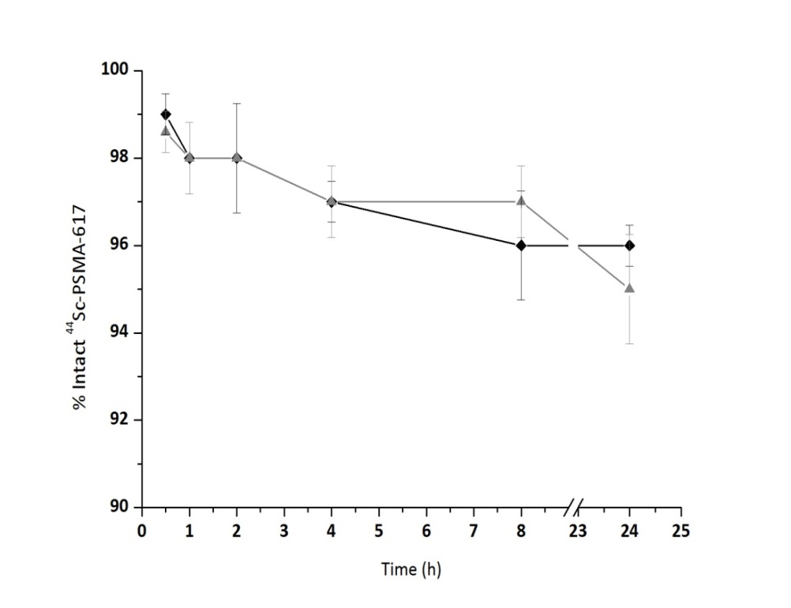
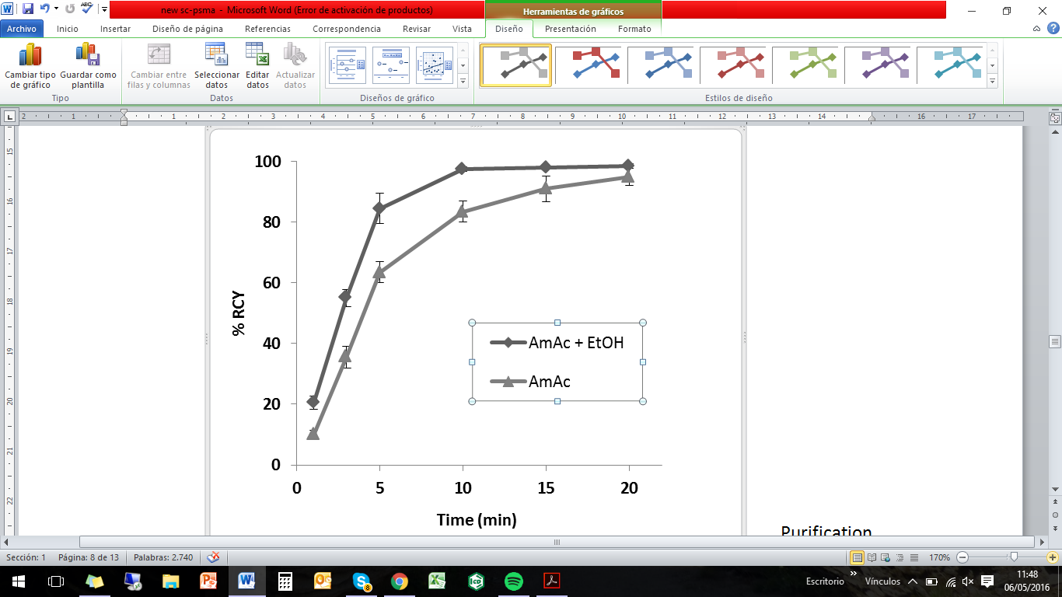
NaCl 0.9 %
HS

Figure 4: Stability of ⁴⁴Sc-PSMA-617 in NaCl 0.9% and human serum at 37 ^{O}C (n = 3).

Presence of different metal cations in final solution can cause transmetallation of radionuclide-conjugate and finally induce a release of ⁴⁴Sc into solution. Therefore, it is interesting to determine whether ⁴⁴Sc-PSMA-617 is stable in presence of relevant metal cations. The addition of Ca²⁺, Mg²⁺ and Fe³⁺ did not induce decomplexation of ⁴⁴Sc. ⁴⁴Sc-PSMA-617 presented high stability values even after 24 h incubation at rather high metal concentration levels of 10⁻² M (Tab. 1).

To calculate the affinity (K_{i}) of ⁴⁴Sc-PSMA-617, natural Sc was used instead. The affinity of ^{nat}Sc-PSMA-617 for the receptor was determined indirectly by measuring its ability to compete with dimeric PSMA inhibitor (PSMA-7) labelled with ⁶⁸Ga. Various concentrations of ^{nat}Sc-PSMA-617 were allowed to compete with a fixed concentration of ⁶⁸Ga-dimer (0.75 nM) for a receptor and while the concentration of unlabelled ligand increases, the amount of radioligand bound to the receptor decreases. A nanomolar affinity of 4.72 ± 0.7 nM was revealed for ^{nat}Sc-PSMA-617 on LNCaP cells, such results are directly comparable to the ^{nat}Ga- and ^{nat}Lu-labelled PSMA-617 values from the literature (Tab. 2).

Table 1: Stability of ⁴⁴ Sc-PSMA-617 at 37 ºC in presence of different metal cations and in presence of DTPA and EDTA at 10⁻² M concentration (n = 3)

Time (h) |  | % Intact ⁴⁴Sc-PSMA-617 ± SD
Time (h) |  | Ca²⁺ | Mg²⁺ | Fe³⁺ | EDTA | DTPA
0.5 |  | 98.0 ± 0.0 | 98.7 ± 0.5 | 97.3 ± 0.9 | 96.7 ± 0.1 | 96.7 ± 1.2
1 |  | 98.3 ± 0.5 | 98.3 ± 0.5 | 98.0 ± 0.8 | 97.3 ± 0.1 | 97.7 ± 0.5
2 |  | 97.0 ± 0.1 | 98.0 ± 0.8 | 98.0 ± 0.8 | 97.3 ± 0.1 | 97.0 ± 0.8
4 |  | 97.0 ± 1.4 | 97.7 ± 0.5 | 96.7 ± 0.5 | 97.3 ± 0.1 | 96.7 ± 0.5
24 |  | 96.7 ± 0.8 | 97.2 ± 0.8 | 95.0 ± 1.4 | 95.9 ± 1.2 | 95.1 ± 0.8

⁴⁴Sc-PSMA-617 was specifically internalized into human prostate carcinoma (LNCaP) cells, up to 15.78 ± 2.14 percentage injected activity/10⁶ LNCaP cells (n = 4). The results of the three radiopharmaceuticals do not present remarkable differences. The internalization values are slightly below the ⁶⁸Ga and ¹⁷⁷Lu analogues, but in contrast, ⁴⁴Sc-PSMA-617 showed reduced unspecific binding values. (Tab.2, Fig.5).
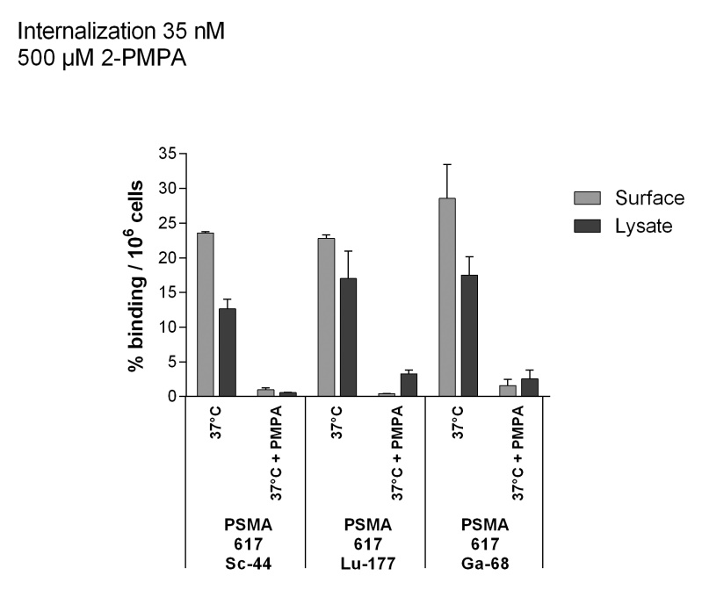
Surface
Internalized

Figure 5: Internalization values of ⁴⁴Sc-, ⁶⁸Ga and ¹⁷⁷Lu-labelled PSMA-617 in LNCaP cells
Table 2: Affinity constant and internalization values of ⁴⁴Sc- ⁶⁸Ga- ¹⁷⁷Lu-labelled PSMA-617 compounds. Same set up was used for the three compounds [15].
 | K_{i} ± SD | Internalization ± SD
⁴⁴Sc | 4.72 ± 0.78 | 15.78 ± 2.14
⁶⁸Ga | 6.40 ± 1.02 | 17.67 ± 4.35
¹⁷⁷Lu | 6.91 ± 1.32 | 17.51 ± 3.10

The labelling efficiency as well as in vitro stability, affinity and internalization results brought ⁴⁴Sc-PSMA-617 to a first evaluation in humans in the Nuclear Medicine department of University Klinikum Bonn.
⁴⁴Sc-PSMA-617 PET/CT imaging of PSMA receptor positive metastases in a 77-year old man was clearly successful (Fig. 6). Even at low activity of c.a 3 MBq, at a late time-point of 19 h post injection, lesions are still detectable. In that case all activity is in the lesions with no uptake in urin or kidneys.
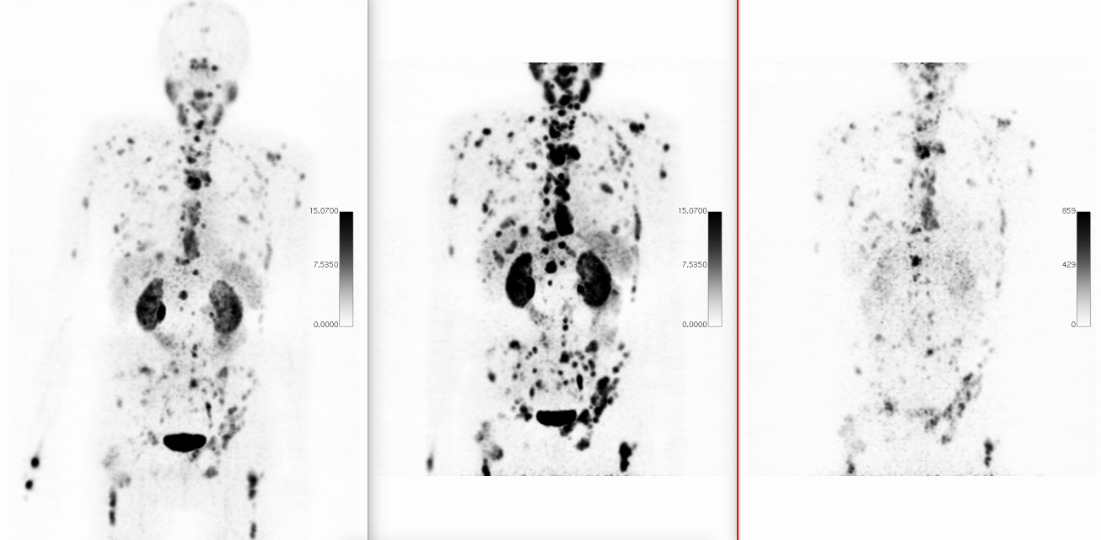
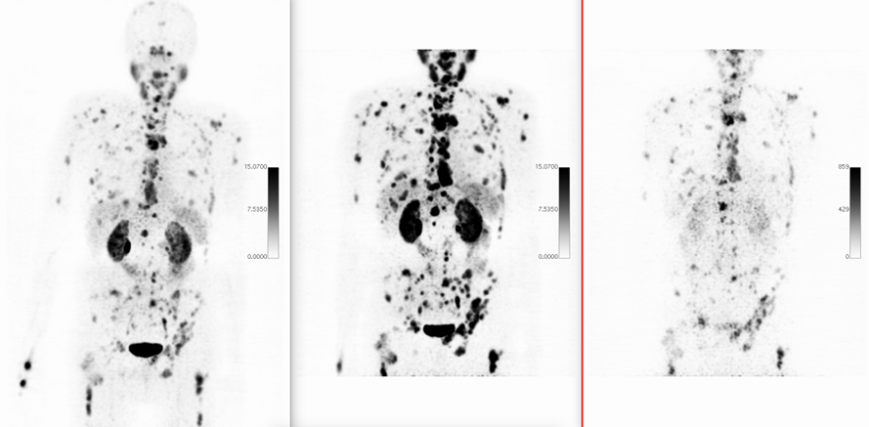
A B C

Figure 6: ⁴⁴Sc-PSMA-617 PET/CT imaging (55.76 MBq Injected) of PSMA receptor positive metastases after A) 30 min p.i, B) 2 h p.i and C) 19 h p.i (Department of Nuclear Medicine, Uniklinikum Bonn, Germany)

In addition to the detection of the prostate lesions, the purpose of such in vivo evaluation, is to measure the uptake kinetics of ⁴⁴Sc-PSMA-617 in metastatic tumors in order to estimate the optimum radiation dose the individual patient will receive in a subsequent therapeutic application of the biologically and chemically analogous compound ¹⁷⁷Lu-PSMA-617. Such calculations are still ongoing.

4 CONCLUSIONS

Radiolabelling of PSMA-617 with the generator derived PET radionuclide ⁴⁴Sc was investigated in detail for its application as a PET imaging agent of prostate cancer lesions. Incorporation of ⁴⁴Sc into PSMA was almost quantitative at pH 4.0 after 20 min with 18 nmol of PSMA-617.
The radiopharmaceutical presented high stability in physiological conditions as well as against competing cations and chelates that could induce transmetallation. Affinity and internalization results showed reduced unspecific binding and higher specific internalization in LNCaP cells with similar values than those for ⁶⁸Ga and ¹⁷⁷Lu. Such promising results were translated into the clinics and evaluated for a first time in a patient suffering from prostate cancer.
⁴⁴Sc-PSMA-617 showed successful PSMA receptor localization even after 19 hours post injection.
This study confirms that the novel radiopharmaceutical ⁴⁴Sc-PSMA-617 can be considered as an ideal tracer for PET imaging prostate cancer lesions.

REFERENCES

[1] Jemal A, Bray F, Center MM, Ferlay J, Ward E, Forman D. Global cancer statistics. CA Cancer J Clin 2011; 61: 69–90.
[2] Hillier SM, et al. Preclinical Evaluation of Novel Glutamate-Urea-Lysine Analogs that Target Prostate Specific Membrane Antigen as Molecular Imaging Pharmaceuticals for Prostate Cancer. Cancer Res. 2009; 69: 6932-6940.
[3] Wright GL Jr, Haley C, Beckett ML, Schellhammer PF. Expression of Prostate-Specific Membrane Antigen in Normal, Benign, and Malignant Prostate Tissues. Urol Oncol 1995; 1: 18-28.
[4] Davis MI, Bennett MJ, Thomas LM, Bjorkman PJ. Proc Natl Acad Sci U S A. 2005; 102: 5981-5986. Crystal structure of prostate-specific membrane antigen, a tumor marker and peptidase.
[5] Eder M, Eisenhut M, Babich J, Haberkorn U. PSMA as a target for radiolabelled small molecules. Eur J Nucl Med Mol Imaging. 2013; 40: 819–823.
[6] Small EJ. Monoclonal Antibody Therapy for Prostate Cancer: Finally a Reality? J Clin Oncol 2004; 22: 2515-2516.
[7] Ali Afshar-Oromieh, et al. Comparison of PET imaging with a ⁶⁸Ga-labelled PSMA ligand and ¹⁸F-choline-based PET/CT for the diagnosis of recurrent prostate cancer. Eur J Nucl Med Mol Imaging 2014; 41: 11–20.
[8] Rinnab L, et al. [(11)C]choline PET/CT in prostate cancer patients with biochemical recurrence after radical prostatectomy. World J Urol 2009; 27: 619–25.
[9] Lütje S, et al. PSMA Ligands for Radionuclide Imaging and Therapy of Prostate Cancer: Clinical Status. Theranostics 2015; 5: 1388-1401.
[10] Martin Schäfer M. A dimerized urea-based inhibitor of the prostate-specific membrane antigen for ⁶⁸Ga-PET imaging of prostate cancer EJNMMI Res. 2012; 2: 23.
[11] Eder M, Schäfer M, Bauder-Wüst U, Hull WE, Wä C. ⁶⁸Ga-Complex Lipophilicity and the Targeting Property of a Urea-Based PSMA Inhibitor for PET Imaging. Bioconjug Chem 2012: 23:688-697.

[12] Baum RP, et al. Lutetium-177 PSMA Radioligand Therapy of Metastatic Castration-Resistant Prostate Cancer: Safety and Efficacy. J Nucl Med. 2016; [Epub ahead of print]
[13] Kabasakal L, AbuQbeitah M, Aygün A, Yeyin N, Ocak M, Demirci E, Toklu T. Pre-therapeutic dosimetry of normal organs and tissues of (177)Lu-PSMA-617 prostate-specific membrane antigen (PSMA) inhibitor in patients with castration-resistant prostate cancer. Eur J Nucl Med Mol Imaging 2015; 42: 1976-83.
[14] Delker A. Dosimetry for (177)Lu-DKFZ-PSMA-617: a new radiopharmaceutical for the treatment of metastatic prostate cancer. Eur J Nucl Med Mol Imaging 2016; 43: 42-51.
[15] Benesova M, et al. Preclinical Evaluation of a Tailor-Made DOTA-Conjugated PSMA Inhibitor with Optimized Linker Moiety for Imaging and Endoradiotherapy of Prostate Cancer. J Nucl Med 2015; 56: 914-920.
[16] Zechmann CM, et al. Radiation dosimetry and first therapy results with a ^{124/131} I. Eur J Nucl Med Mol Imaging. 2014; 41: 1280-92.
[17] Roesch F. Scandium-44: Benefits of a Long-Lived PET Radionuclide Available from the ⁴⁴Ti/⁴⁴Sc Generator System. Current Radiopharmaceuticals, 2012, 5, 187-201.
[18] Alliot C, Kerdjoudj R, Michel N, Hadad F, Huclier S. Cyclotron production of high purity ^{44m/44}Sc with deuterons from ⁴⁴CaCO₃ targets. Nucl Med Biol 2015; 42: 524-529.
[19] Rösch F, Baum RP. Generator-based PET radiopharmaceuticals for molecular imaging of tumours: on the way to THERANOSTICS. Dalton Trans 2011; 40, 6104-6011.
[20] Marek Pruszynski M, Majkowska-Pilip A, Loktionova N, Eppard E, Rösch F. Radiolabeling of DOTATOC with the long-lived positron emitter ⁴⁴Sc. Appl. Radiat. Isotopes 2012; 70: 974–979.
[21] Hemmelmann M, Mohr K, Fischer K, Zentel R, Schmidt M. Interaction of pHPMA−pLMA Copolymers with Human Blood Serum and Its Components. Mol. Pharmaceutics 2013; 10: 3769−3775

3.4 Labeling and preliminary in vivo assessment of niobium-labeled radioactive species: A proof-of-concept study

Labeling and preliminary in vivo assessment of niobium-labeled radioactive species: A proof-of-concept study

V. Radchenkoª, P. Bouziotis^{b}, T. Tsotakos^{b}, M. Paravatou-Petsotas^{b}, A. de la Fuenteª, G. Loudos^{b,c}, A.L. Harris^{d}, S. Xanthopoulos^{b}, D. Filosofov^{e}, H. Hauser^{f}, M. Eisenhut^{f}, B. Ponsard^{g}, F. Roeschª.

ªInstitute of Nuclear Chemistry, Johannes Gutenberg University, Mainz, Germany
^{b}Institute of Nuclear & Radiological Sciences & Technology, Energy & Safety, N.C.S.R. “Demokritos”, Athens, Greece
^{c}Department of Biomedical Engineering, Technological Educational Institute of Athens, Athens, Greece
d ^{d}Weatherall Institute of Molecular Medicine, University of Oxford, Oxford, UK
^{e}Dzhelepov Laboratory of Nuclear Problems, Joint Institute of Nuclear Research, Dubna, Moscow region, Russian Federation
^{f}Radiopharmaceutical Chemistry, German Cancer Research Center, Heidelberg, Germany
^{g}Institute of Nuclear Materials Science, BR2 Reactor, Radioisotopes and NTD Silicon Production, Belgian Nuclear Research Centre, SCKCEN, Mol, Belgium

ABSTRACT

The application of radionuclide-labeled biomolecules such as monoclonal antibodies or antibody fragments for imaging purposes is called immunoscintigraphy. More specifically, when the nuclides used are positron emitters, such as zirconium-89, the technique is referred to as immuno-PET. Currently, there is an urgent need for radionuclides with a half-life which correlates well with the biological kinetics of the biomolecules under question and which can be attached to the proteins by robust labeling chemistry. ⁹⁰Nb is a promising candidate for in vivo immuno-PET, due its half-life of 14.6 h and low β⁺ energy of E_{mean} = 0.35 MeV per decay. ⁹⁵Nb on the other hand, is a convenient alternative for longer-term ex vivo biodistribution studies, due to its longer half-life of (t ½ = 35 days) and its convenient, lower-cost production (reactor-based production). In this proof-of-principle work, the monoclonal antibody bevacizumab (Avastin®) was labeled with ^{95/90}Nb and in vitro and in vivo stability was evaluated in normal Swiss mice and in tumor-bearing SCID mice.
Initial ex vivo experiments with ⁹⁵Nb -bevacizumab showed adequate tumor uptake, however at the same time high uptake in the liver, spleen and kidneys was observed. In order to investigate whether this behaviour is due to instability of *Nb-bevacizumab or to the creation of other *Nb species in vivo, we performed biodistribution studies of ⁹⁵Nb-oxalate, ⁹⁵Nb-chloride and ⁹⁵Nb-Df. These potential metabolite species did not show any specific uptake, apart from bone accumulation for ⁹⁵Nb-oxalate and ⁹⁵Nb-chloride, which, interestingly, may serve as an “indicator” for the release of ⁹⁰Nb from labeled biomolecules. Concerning the initial uptake of ⁹⁵Nb-bevacizumab in non-tumor tissue, biodistribution of a higher specific activity radiolabeled antibody sample did show only negligible uptake in the liver, spleen, kidneys or bones.

Keywords: ^{95/90}Nb Bevacizumab, Labeling, VEGF, PET, Biodistribution

1 INTRODUCTION

Targeted imaging of cancer is crucial to modern-day cancer management, and radionuclides attached to biomolecules are an exciting strategy for tumor diagnosis and therapy [1]. An attractive feature, but also the key challenge of this strategy is to select radionuclides and targeting vehicles with characteristics which are best suited for a particular application. Angiogenesis is the development of new blood vessels from pre-existing ones. It is regulated by chemical signals of the organism, which function as an “angiogenesis switch”, regulating the formation of new vasculature. Bevacizumab is a humanized monoclonal antibody (mAb) which binds all VEGF-A isoforms [2]. Currently many studies focus on labeling of bevacizumab with radionuclides for in vivo evaluation [3–7]. An important criterion for selecting of radionuclides for mAb is the half-life of the radionuclide which should favourably correlate to the biological kinetic of large-size biomolecules. Due to the long circulation of intact antibodies, optimal tumor-to-non tumor ratios can be reached from approximately 2 to 5 days post-injection, therefore radionuclides with an appropriate half-life should be chosen. Positron-emitting radionuclides with long and medium-long half-life of interest for PET-imaging with antibodies and antibody fragments are, for example, ⁸⁹Zr (t ½ = 78.4 h) [8,9], ⁶⁴Cu (t ½ = 12.7 h) [10,11], ⁸⁶Y (t ½ = 14.7 h) [12], ⁷⁶Br (t ½ = 16.0 h) [13].
Several factors and characteristics apply to radionuclide candidates for immuno-PET, the most important ones are: i) a physical half-life paralleling the biological half-life of the mAb or antibody fragment; ii) a high positron branching with no or weak accompanying other radiation (β⁻, γ) to offer high-sensitivity PET imaging while reducing the radiation burden of the patient; iii) a preferably low β⁺-energy to allow for high-resolution PET imaging; and iv) the availability of the radionuclide, i.e., an efficient production and radiochemical separation route. In previous works we have reported a convenient way for production of ⁹⁰Nb–labeled biomolecules and proposed ⁹⁰Nb as a promising candidate for application in immuno-PET [14–17]. Its intermediate half-life of 14.6 h and a high positron branching of 53% may make ⁹⁰Nb an ideal candidate for application with antibody fragments, monoclonal antibodies, drug delivery systems and nanoparticles. Moreover, the chelate desferrioxamine (Df) has been identified as an excellent moiety to label *Nb to proteins [17,18]. In this work we report on the in vitro stability and in vivo behaviour of ^{95/90}Nb radiolabeled bevacizumab. Biodistribution studies of ⁹⁵Nb-oxalate, ⁹⁵Nb-chloride and ⁹⁵Nb-Df were performed in healthy mice, to provide more information on the fate of *Nb-labeled species in vivo.
2 MATERIALS AND METHODS

2.1 Materials
Reagents were purchased from Sigma-Aldrich (Germany) and used without further purification, unless otherwise stated. Deionized water (18 MΩ cm−1) and ultra-pure HCl solution were used. No further special measures were taken regarding working under strict metal-free conditions. The mAb bevacizumab (Avastin®, Roche) directed against the VEGF-A family of isoforms was bought from Roche Ellas S. A. (Greece). For the purification of conjugated and labeled antibodies, PD-10 columns (GE Healthcare Life Science) were applied, for ion exchange separation Aminex A27, 15±2 μm and AG1 x 8, 200–400 mesh anionic exchange resins and DOWEX 50x8, 200–400 mesh (BioRad) were used. For solid phase extraction, UTEVA® resin (Triskem Int., France) was applied. The production yield, radionuclidic purity, radiochemical purity and separation yield of ^{95/90}Nb were determined by γ-ray spectroscopy using an Ortec HPGe detector system and Canberra Genie 2000 software.
The dead time of the detector was always kept below 10%. The detector was calibrated for efficiency at all positions with the certified standard solution QCY48, R6/50/38 (Amersham, UK). VEGF 165-transfected MDA MB 213 cells (M165) were kindly provided by Cancer Research UK. MDAMB 231 breast cancer cells were infected with virus expressing VEGF 165. The virus was made in Pheonix cells using the plasmid pLXRSpBMN-IRES-GFP. The VEGF clone is human. The cells are cultured at safety level I in minimum essential medium (Eagle) with 2mML-glutamine in the presence of 10% fetal bovine serum, at 37 °C in a humidified 5% CO₂ incubator. Labeling efficiency and stability of the ^{95/90}Nb labeled mAb was monitored by instant thin layer chromatography (iTLC) and high performance liquid chromatography (HPLC). ITLC was performed on chromatography strips (Biodex, NY). As mobile phase, 0.02 M citrate buffer (pH 5.0) was used. HPLC monitoring was performed on a Waters HPLC system using a TSK gel G3000SWXL size exclusion column (TOSOH Bioscience, Germany). As eluent, a mixture of 0.05 M sodium phosphate and 0.15 M sodium chloride (pH 6.8) solution was used at a flow rate of 0.8 mL/min. Formation of ⁹⁵Nb-Df was measured via ITLC at conditions described above. All numerical data were expressed as the mean of the values ± the standard error of the mean. Statistical analysis was performed using the t-test. A p value less than 0.05 was considered statistically significant.

2.2 Production of ⁹⁰Nb and ⁹⁵Nb
⁹⁰Nb was produced via the ⁹⁰Zr(p,n)⁹⁰Nb reaction at the cyclotron MC32NI of the German Cancer Research Center, Heidelberg. For irradiation, a stack of three disks of natural zirconium (natural abundance: 51.45% ⁹⁰Zr) foils of 10 mm diameter and a thickness of 0.25 mm each was used. Irradiation was performed at 20 MeV proton energy and a current of 5 μA for 1 h. This initial proton energy decreased, by using an aluminium holder cover of 0.5 mm thickness, to 17.5 MeV while entering the first foil of Zr. Twenty-four hours after end of bombardment (EOB), production yield and impurities were measured by gamma ray spectroscopy. The absolute activity of ⁹⁰Nb was calculated as average of its two gamma-lines at 141.2 keV (66.8% abundance) and 1129.2 keV (92.7%). ⁹⁵Nb (t ½ = 35 days) was employed for the ex vitro biodistribution experiments. ⁹⁵Nb was produced via the ⁹⁴Zr(n,γ) → ⁹⁵Zr (β⁻, t ½ = 64 days) → ⁹⁵Nb reaction from natural zirconium granules (1–3 mm, 99.8% ChemPur, Germany). Neutron irradiations were performed at the BR2 reactor at the Belgian Nuclear Research Centre, Belgium and at BERII reactor at Helmholtz Centre in Berlin, Germany.
The production of the radionuclides ⁹⁵Zr/⁹⁵Nb and ⁹⁰Nb was monitored by gamma ray spectroscopy, via emissions at 724.2 keV (44.2%) and 756.7 keV (54.0%) for ⁹⁵Zr, and at 765.8 keV (100%) for ⁹⁵Nb and 1129 KeV (92%) for ⁹⁰Nb.

2.3 Separation and purification of n.c.a. ^{95/90}Nb
2.3.1 First separation strategy
The first separation strategy was applied for biodistribution studies in tumor-bearing mice. The separation procedure was modified following the procedure described by Busse et al. [14]. In short, the zirconium metal target (260 ± 3 mg) was transferred into a 50 mL vial and 2 mL of water was added. Under ice-cooling, 48% HF (0.63 mL) was added in small portions. After complete dissolution, 10 M HCl (6mL) and saturated boric acid (3.4 mL) were added. The ^{95/90}Nb fraction was extracted with 0.02 M N-benzoyl-N-phenylhydroxylamine (BPHA) in CHCl₃ (5 mL) by vigorous stirring of the two phases in a 50 mL vial for 20 min. The aqueous phase was additionally washed with CHCl₃ (3mL). The organic phases were combined and washed with a mixture of 9 M HCl/0.001 M HF (2 mL) and with 9 M HCl (2 mL) and finally extracted with aqua regia (5 mL). For a final purification of ^{95/90}Nb from remaining trace amounts of zirconium, an anionic exchange method was employed. After the aforementioned back extraction, the aqueous phase was evaporated to dryness. The residue was dissolved in a mixture of 0.25 M HCl/0.1 M oxalic acid (0.5 mL) and adsorbed onto a small Aminex A27 (15±2 μm) anionic exchange column (20 × 1.5 mm). Elution was performed under slight overpressure of 0.3 bars. After loading, the column was washed with 10 M HCl (100 μL). Residues of Zr were removed by washing with a mixture of 9 M HCl/0.001 M HF (200 μL). ^{95/90}Nb was eluted by a mixture of 6 M HCl/0.01 M oxalic acid (200 μL).

2.3.2 Alternative separation strategy
A second separation strategy was applied to provide a sample of ⁹⁵Nb with a higher radioactive concentration, for use in consequent biodistribution studies. Crude separation from the Zr target was performed following a published protocol [16]. In short, 2 mL of 21 M hydrofluoric acid containing the irradiated zirconium target was passed through the cation exchange resin (DOWEX 50 × 8, 100 mg, 200–400 mesh, 10 × 5 mm) resin in F⁻ form for the removal of colloids, unsolved target particles and possible trace contamination of 2⁺ and 3⁺ charged metals, such as for example Cu²⁺ or Fe3⁺, from the target holder. The column was additionally washed with concentrated hydrofluoric acid (1 mL). The solution (3 mL) which passed through the cation exchange resin was transferred to an anion exchange column (300 mg, 25 × 5 mm) filled with AG 1 × 8 resin (200–400 mesh) in the F⁻ form. Nb^{V} remained on this resin and the bulk amount of Zr^{IV} passed through. The column was washed with concentrated HF (4.5 mL) to elute traces of Zr^{IV}, while *Nb stays on the column. A small plastic column was filled with UTEVA resin (150 μm, 100 mg, 10 × 5 mm). The aforementioned anion exchange column was directly connected with the UTEVA column and 7 mL of 0.3 M oxalic acid/ 7.5 M HCl were passed through both columns. The UTEVA column was next washed with 5 M HCl (5 mL). Traces of Zr^{IV} passed through the UTEVA, while *Nb^{V} remains absorbed on the column. For elution of *Nb 0.1 M oxalic acid was applied. The column was washed with 200 μL and *Nb eluted with another 400 μL of 0.1 M oxalic acid.

2.4 Preparation of ⁹⁵Nb-oxalate, ⁹⁵Nb-chloride, and ⁹⁵Nb-desferrioxamine
⁹⁵Nb-Df-oxalate (10 mM) was prepared by dilution of the aliquot of the purified ⁹⁵Nb (5 ± 1 MBq) fraction with saline. ⁹⁵Nb-chloride was prepared by evaporation of an aliquot (50 μL) of the oxalate fraction obtained after ⁹⁵Nb (5 ± 1 MBq) purification and addition of several portions (3 × 100 μL) of 30 % HCl, after which the mixture was the dried again at 100 °C. The resulting preparation was dissolved in saline. For the preparation of ⁹⁵Nb-Df, 50 mM of Df in saline (1.45 mL) was mixed with ⁹⁵Nb-oxalate (50 μL) and incubated for 30 min at room temperature. The formation of ⁹⁵Nb-Df was monitored by thin layer chromatography.
2.5 Monoclonal antibody modification with Df-Bz-NCS.
The labeling of bevacizumab with ⁹⁵Nb was performed after the coupling of Df to bevacizumab. Coupling was performed by use of the novel bifunctional chelator p-isothiocyanato-benzyl-desferroxiamine (Df-Bz-NCS) from Macrocyclics (Dallas, USA). In short, while gently shaking, a threefold molar excess of Df-Bz-NCS (in 25 μL DMSO) was added to the mAb (2–3 mg in 1 mL 0.1 M NaHCO₃ buffer, pH 9.0), and incubated for 30 min at 37 °C. Non-conjugated chelate was removed by size-exclusion chromatography using a PD-10 column and 0.9% sodium chloride (pH 6.5) as the eluent. The number of chelates per antibody was assumed to be 1.5 according to our previous work [16] and the report from Perk et al [18].

2.6. Labeling of bevacizumab with ^{95/90}Nb
Df-Bz-NCS-bevacizumab (abbreviated up to now as Df-bevacizumab) was labeled with ^{95/90}Nb following two different labeling protocols. For the first protocol, to a ^{95/90}Nb solution (10 ± 2 MBq for ⁹⁵Nb) in 6 M HCl/0.01 M oxalic acid solution (200 μL), 6 M NaOH (180 μL) and 1 M NaOH (230 μL) were added. After 3 min, 0.5 M HEPES buffer (pH 7.0) (390 μL) and Df-mAb (1.5mg/mL) (1.0mL) were added. The total volume of the mixture was 2 mL. For the second labeling protocol, a purified ^{95/90}Nb fraction (10 ± 2 MBq for ⁹⁵Nb) in 0.1 M oxalic acid (20 μL) was mixed with 300 μL of normal saline and then the mixture was adjusted to pH 6–7 with 0.1 M Na₂CO₃ (50–60 μL). The modified mAb (300 μg, 2 nmol, 120 μL) was then added to this mixture and then the volume of the mixture was adjusted to 1mL saline. Both mixtures were incubated at room temperature for 60 min. Analysis of product formation was monitored by ITLC (0.02 M citric acid/MeCN, 90/10) at 10, 30 and 60 min and by HPLC at 60 min post-incubation. Finally, ^{95/90}Nb-Df-Bz-NCS-bevacizumab was purified by using a PD-10 column, with 0.9% sodium chloride solution as the mobile phase. Figure 1 schematically represents the mAb modification with Df and further labelling with ⁹⁰Nb.

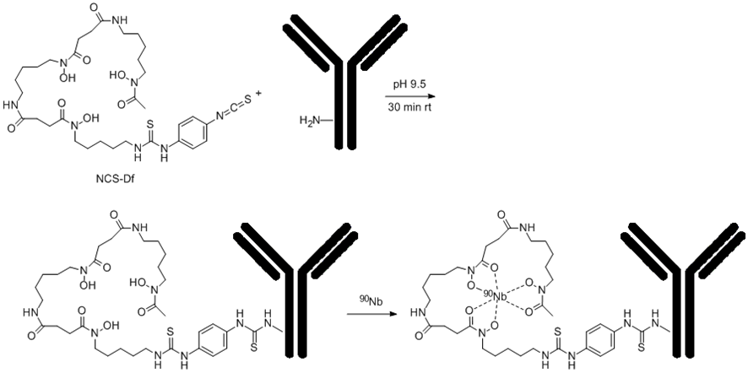
Figure 1: Df-conjugation of the mAb via NCS-Bz-Df and labeling with ^{95/90}Nb (not proven by crystal structure)

2.7 In vitro stability
Stability of ^{95/90}Nb-Df-bevacizumab was studied in two setups, first in normal saline at room temperature and in fresh human plasma at 37 °C. For preparation of human plasma, human blood was collected in heparinized polypropylene tubes and centrifuged at 5000 rpm at 4 °C for 5 min. The plasma was collected and three fold excess (300 μL) was incubated with ^{95/90}Nb-Df-bevacizumab (100 μL) at 37 °C. Aliquots of the sample were withdrawn at 60 min, 3 h, 3 days, 5 days and 7 days, and analysed by ITLC and HPLC.

2.8 Biodistribution studies
All animal experiments were carried out in compliance to European and Greek regulations. Female athymic SCID (Severe Combined Immunodeficiency) mice (average weight 20 g, 5 weeks) as well as normal Swiss mice were obtained from the breeding facilities of the NCSR ‘Demokritos’. The animals were kept under aseptic conditions until the day of biodistribution. The SCID mice were inoculated subcutaneously into the right front leg with M165 cells (1 × 10⁷ cells/animal) in 100 μL fetal bovine serum-free medium. When tumors reached a size of 0.2 to 1 g (i.e., 10 to 15 days), biodistribution studies were performed. Tumor-bearing mice were injected via the tail vein with 100 μL of radiotracer [270 kBq/100 μg or 0.4 TBq/mmol (10.94 Ci/mmol)]. Groups of three animals were sacrificed at 4, 24, 48 and 168 h after injection of radiolabeled antibody. To determine VEGF-specificity, an excess of unlabelled bevacizumab (100-fold) was injected 24 h prior to the injection of the ⁹⁵Nb-Df-bevacizumab. Blocking studies were performed at 24 and 48 h p.i. Biodistribution studies of ⁹⁵Nb-Df, ⁹⁵Nb-chloride and ⁹⁵Nb-oxalate were performed in healthy mice. Each animal received an injection of 100 μL of radiotracer [300 kBq/~10 μg or 4.5 TBq/mmol (121,56 Ci/ mmol)]. Groups of three animals were sacrificed at 4, 24, 48 and 168 h after injection of the compounds. Tumors (in the case of SCID mice), tissues and organs (blood, heart, liver, stomach, intestines, spleen, muscle, lungs, pancreas, muscle and bones) were excised, blotted dry and weighed. Samples were counted in a gamma counter (NaI gamma counter, Packard). Standards were prepared from the injected material and were counted each time simultaneously with the tissues excised, allowing for calculations to be corrected for physical decay of the radioisotope. Radiolabeled antibody distribution over time was expressed as injected dose per gram (%ID/g).

3 RESULTS

3.1 Production of *Nb

3.1.1 Production of ⁹⁰Nb
The overall irradiation yield of ⁹⁰Nb for three 1 h and 5 μA irradiations was 720 ± 50 MBq, i.e., 145 ± 10 MBq/μAh under given irradiation parameters. The radionuclidic purity of 90Nb after EOB was more than 97%. Minor isotopic impurities found were: ^{92m}Nb (t ½ = 10.2 days) = 1.64%, ⁹⁵Nb (t ½ = 35.0 days) = 0.08%, ^{95m}Nb (t ½ = 3.6 days) = 0.29% and ⁹⁶Nb (t ½ = 23.4 h) = 0.88%. The calculated theoretical specific activity for ⁹⁰Nb is 8.9 x 10⁷ GBq/g.

3.1.2 Production of ⁹⁵Nb
At a neutron flux of 2 · 10¹⁴ s⁻¹ · cm⁻² (BER II), a 50-day irradiation of 300 mg target produced more than 1.5 GBq of ⁹⁵Zr. The maximum daughter activity of ⁹⁵Nb generated from ⁹⁵Zr was obtained at ~67 days, EOB. The calculated theoretical specific activity for ⁹⁵Nb is 1.4 x 10⁶ GBq/g.

3.2 Separation and purification of no-carrier added ^{95/90}Nb
3.2.1 First separation strategy
The extraction steps provided crude separation of ^{95/90}Nb from the target material with the organic phase collecting more than 99% of ^{95/90}Nb. After the back extraction procedure, the 5 mL aqueous phase contained 90–95% of the ^{95/90}Nb activity. After both extractions this corresponds to a high reduction of the Zr target mass by a factor of 10⁴. Subsequent anionic exchange separation further removes those traces of Zr. The final separation yield of ^{95/90}Nb was 60–65% and the decontamination factor for Zr/Nb was ≥10⁷, representing ≤26 ng of Zr present in the final ^{95/90}Nb fraction. The separation was performed for each niobium isotope separately.
3.2.2 Second separation strategy
The overall separation proceeds with a yield of 93–95% of ^{95/90}Nb, collected in 400 μL 0.1 M oxalic acid. The whole separation procedure takes less than one hour, which is almost 4 times faster than the first separation method. The decontamination after UTEVA purification is 3 × 10⁸. This decontamination factor equals 0.77 ng of zirconium present in the final fraction for a 260 mg zirconium target.
3.3 Preparation of ^{95/90}Nb-labeled Df-Bz-NCS-mAb
The ⁹⁰Nb labeling yield was > 90 % (96% ITLC, 95 % HPLC) after 1 h. Labeling kinetics indicate that the labeling yields reached ≥ 80 % already at 15 min and increased to more than 90 % after 50 min. After SEC separation on a PD-10 column, the ⁹⁰Nb-Df-mAb derivative had 99.0 % purity. The specific activity of ^{95/90}Nb-bevacizumab labeled with the ⁹⁵Nb from the first separation strategy was 0.4 TBq/mmol (10.94 Ci/mmol), while from the alternative separation strategy, the specific activity of the radiotracer was 4.5 TBq/mmol (121.56 Ci/mmol).
3.4 In vitro stability
After 3 days of incubation in saline at room temperature, more than 99% (≥ 99 % HPLC, ≥ 99 % ITLC) and after 7 days ≥ 95 % (99 % HPLC, 97 % ITLC) of ^{95/90}Nb-Df-bevacizumab were detected. Stability testing in fresh human plasma at 37 °C showed only slightly higher product degradation (Fig. 2). After 3 days of incubation ≥ 94 % (97 % HPLC, 94 % ITLC) of labeled product was available, while at 7 days ≥ 86 % (89 % HPLC, 86 % ITLC) of the product was still intact.

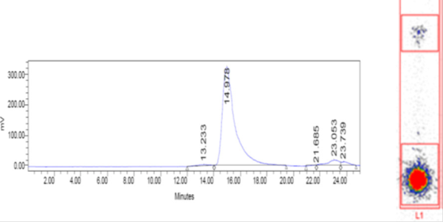
⁹⁰Nb
⁹⁰Nb-Df-mAb
⁹⁰Nb-Df-mAb
⁹⁰Nb

Figure 2: ITLC image (right) and HPLC chromatogram (left) of in vitro stability ⁹⁰Nb-Df-bevacizumab after 7 days in saline at room temperature

3.5 Biodistribution experiments
3.5.1 Biodistribution of ⁹⁵Nb-oxalate, ⁹⁵Nb-chloride and ⁹⁵Nb-Df in healthy mice
The biodistribution of ⁹⁵Nb-oxalate and ⁹⁵Nb-chloride showed similar results, with no specific organ uptake observed (Fig. 3). However, for ⁹⁵Nb-chloride the uptake in all organs was higher in comparison to ⁹⁵Nb-oxalate. The main uptake was in the blood, lungs and bones. Slight bone accumulation was measured for both substances. Uptake for liver, kidneys and spleen was approximately 1% at 24 h p.i. for oxalate and below 3 % for the chloro species. After 168 h (7 days) p.i, all organs uptakes except for bone were below 1 % and 2 % respectively, for both ⁹⁵Nb-oxalate and ⁹⁵Nb-chloride, apart from the bone uptake, which was ≥ 2 % for the oxalate and ≥ 4 % for the chloride species. ⁹⁵Nb-Df showed a very fast clearance from the body (Fig. 3). At 24 h p.i., no single organ uptake above 0.5 % was observed. After 4 h, uptake in kidneys, stomach and intestines was still detected, while uptake in all other organs was almost negligible. After 168 h p.i. the radiolabeled products had almost completely cleared from the organism.

Figure 3: Biodistribution of ⁹⁵Nb-oxalate, ⁹⁵Nb-chloride and ⁹⁵Nb-Df in healthy mice
3.5.2 Biodistribution of ⁹⁵Nb-Df-bevacizumab of two different specific activities in tumor-bearing and healthy mice
Biodistribution of ⁹⁵Nb-Df-bevacizumab at an injected dose of 270 kBq/100 μg/mouse showed a relatively low accumulation in the tumor (≤ 3 %) at 24 h p.i., which decreased in time (Fig. 4). On the other hand, high accumulation in the liver (> 30 %), spleen (> 10 %) and kidneys (> 5 %) was detected. Indicative blocking studies performed at two time-points (24 and 48 h p.i.) showed that VEGF was significantly blocked when an excess amount of bevacizumab (100-fold) was injected 24 h prior to the injection of the radiotracer, thus showing the specificity of ⁹⁵Nb-bevacizumab binding to the VEGF-positive tumor (24 h p.i.: 2.8 % ± 1.1 ID/g vs 1.1 % ± 0.4 ID/g, p < 0.01; 48 h p.i.: 1.6 % ± 0.6 ID/g vs 0.6 % ± 0.3 ID/g, p < 0.03).
To prove that the previous biodistribution data, i.e., high liver, lung and spleen uptake, were a consequence of the antibody concentration, i.e., the specific activity of the ⁹⁵Nb-Df-bevacizumab batch injected and not of the instability of the labeled product, another biodistribution study was conducted, where normal Swiss mice were injected with a higher specific activity product [4.5 TBq/mmol (121.56 Ci/mmol)].

Figure 4: Biodistribution of low specific activity 0.4 TBq/mmol (10.94 Ci/mmol) of ⁹⁵Nb-Df-bevacizumab in tumor-bearing mice

The results presented in figure 5 show a different kinetic behaviour for the higher specific activity of ⁹⁵Nb-Df-bevacizumab. Significantly less uptake in the liver (3.3 ± 0.3 % ID/g vs 33.3 % ± 4.8 ID/g, p < 0.0002), as well as in the spleen (2.2 % ± 0.3 ID/g vs 12.5 % ± 3.7 ID/g, p < 0.004) was observed at 24 h p.i. for the higher-specific activity radiotracer, which further rapidly decreased over time. After 168 h, the uptake in these organs was less than 2 %. On the other hand, a much higher initial uptake in blood (13.0 % ± 1.1 ID/g vs 1.7 % ± 0.4ID/g,) and lungs (5.9 % ± 0.1 ID/g vs 1.43 ± 0.95 % ID/g, p < 0.0006) was detected. At 168 h p.i., the uptake in these organs is significantly decreased as well (6.9 % ± 1.5 ID/g vs 13.0 % ± 1.1 ID/g, p < 0.003 and 2.7 % ± 0.8 ID/g vs 6.0 % ± 0.1 ID/g, p < 0.001 for blood and lung at 168 h and 24 h p.i., respectively). High tracer uptake was observed in the heart, which can be attributed to high blood uptake levels. A constant bone uptake (c.a 2 % ID/g) was observed over the range of 4 to 168 h, thus allowing us to conclude that no release of ⁹⁵Nb from the labeled monoclonal antibody occurs.

Figure 5: Biodistribution of high specific activity 4.5 TBq/mmol (121.56 mCi/mmol) of ⁹⁵Nb-Df-bevacizumab in normal Swiss mice

4 DISCUSSION

The radiolabeled monoclonal antibody ⁹⁵Nb-Df-bevacizumab, with a maximal specific activity of 0.4 TBq/mmol (10.94 Ci/mmol) was synthesized during the first separation strategy which is described herein. Our alternative separation strategy provided more than 10 times higher specific activity [4.5 TBq/mmol (121,56 Ci/mmol)] for ⁹⁵Nb and even higher for ⁹⁰Nb (~45 TBq/mmol (1216 Ci/mmol).
This study aimed at first evaluations of a ⁹⁰Nb-labeled monoclonal antibody. While both isotope productions and labeling appear to be established, the data on the in vitro stability of the proof-of-principle ⁹⁵Nb-Df-bevacizumab have been obtained for the first time. It can be concluded, that the Df-mediated label is stable in vitro. In vivo experiments showed the same result, where ⁹⁰Nb-data in vivo match ⁹⁵Nb data from in vitro studies. However, the pharmacology of the two radiotracers clearly depended on the specific activity of the ⁹⁰Nb-labeled monoclonal antibody, revealing significant accumulation in non-tumor organs.
Consequently, the separation chemistry of radio-niobium from both nuclear reactor (⁹⁵Nb) and cyclotron (⁹⁰Nb) irradiated zirconium targets was improved. This allowed the synthesis of ⁎Nb-Df-bevacizumab batches of significantly increased specific activity, which is comparable to the specific activity of bevacizumab radiolabeled with other isotopes, as shown by various groups e.g. Nagengast et al. [3] reported specific activities of 8.7 TBq/mmol (235.14 Ci/mmol) and 7.5 TBq/mmol (202.7 Ci/mmol) for ⁸⁹Zr-bevacizumab and ¹¹¹In-bevacizumab, respectively, while Paudyal et al [4] acquired specific activities of 0.38–0.6 TBq/mmol (10.2–16.2 Ci/mmol) for ⁶⁴Cu-bevacizumab.
Biodistribution of 100 μg of bevacizumab with our lower specific activity of ⁹⁵Nb-Df-bevacizumab (0.4 TBq/mmol) showed adequate tumor uptake (3%), with tumor-to-blood ratios of 1.65 and 3.64 at 24 and 168 h p.i. respectively, which are comparable to the results of Nagengast et al., for ⁸⁹Zr-bevacizumab (T/B ratios of 0.51 and 1.86 at 24 and 168 h p.i. respectively), and other groups [3,4]. The significant difference which was observed was the unusually high uptake in liver, spleen and kidneys at 24 h p.i. The first image of a ⁹⁰Nb-labeled antibody was also acquired on an experimental small animal PET camera, which was in good agreement to our ex vivo biodistribution studies, i.e., even though the acquired images need refining, satisfactory tumor and enhanced liver uptake can be observed. To prove that liver and spleen uptake is the result of low specific activity radiolabeled antibody, an in vivo evaluation of ⁹⁵Nb-oxalate, ⁹⁵Nb-chloride and ⁹⁵Nb-Df was initially conducted. These compounds can be formed by destruction of the labeled product. They biodistribution values in healthy mice did not show specific uptake in any organs.
The concentration of ⁹⁵Nb-chloride and ⁹⁵Nb-oxalate in the blood remained high up to 24 h p.i., which can probably be attributed to the formation of metal complexes with plasma proteins [19,20]. A relatively high uptake in the heart and lung, both highly-vascularized organs, is also observed up to 24 h p.i. This activity was rapidly cleared in favour of uptake in the bone. The bone uptake for both ⁹⁵Nb-chloride and ⁹⁵Nb-oxalate demonstrates the high affinity of Nb(V) to phosphonate, which is so strong that, in the case of ⁹⁵Nb-oxalate it shows a slow but steady increase in percentage of bone uptake, while for ⁹⁵Nb-chloride a small decrease in bone uptake is observed. ⁹⁵Nb-Df was immediately cleared from the system, without any sign of bone uptake. The final step in this work was to evaluate a higher specific activity sample of ⁹⁵Nb-bevacizumab in healthy mice. These results showed pronounced uptake in the blood, heart and lungs, which diminished at 24 h p.i., while uptake in the liver, spleen and kidneys, as well as in bone, was low. These data clearly prove the high in vivo stability of *Nb-Df-conjugated biomolecules.

5 CONCLUSIONS

The obtained results provide a very important proof of stability of ^{95/90}Nb labeled biomolecules in vivo. The radiolabeled monoclonal antibody ⁹⁵Nb-Df-bevacizumab with a relatively high specific activity (4.5 TBq/mmol (121.56 Ci/mmol) was obtained, which allowed us to conduct biodistribution studies upon injection of a low concentration of bevacizumab (~10 μg/100 μL). The continuation of this project is well justified, as our results show that there is great promise for the application of ⁹⁰Nb in immuno-PET.

ACKNOWLEDGMENTS
The authors gratefully acknowledge financial support from the COST Action TD1004 (Theranostics Imaging and Therapy: An Action to Develop Novel Nanosized Systems for Imaging-Guided Drug Delivery), the Program for the Promotion of the Exchange and Scientific Cooperation between Greece and Germany IKYDA, scientific project titled “Targeted Immuno-PET imaging of neoangiogenesis with biomolecules labeled with the positron-emitter Niobium-90” (Contract number 205), the German Research Foundation under DFO Ro 985/40-1 and Russian Foundation for Fundamental Research grant (RFBR 15-53-12372). We <would also like to thank the teams of BR2 Berlin and TRIGAMainz reactors for production of the Niobium isotopes.

REFERENCES

[1] Rösch F, Baum RP. Generator-based PET radiopharmaceuticals for molecular imaging of tumours: on the way to THERANOSTICS. Dalton Trans 2011;40(23):6104–11.
[2] Ellis LM, Hicklin DJ. VEGF-targeted therapy: mechanisms of anti-tumour activity. Nat Rev Cancer 2008; 8 :579–91.
[3] Nagengast WB, de Vries EG, Hospers GA, Mulder NH, de Jong JR, Hollema H, et al. In vivo VEGF imaging with radiolabeled bevacizumab in a human ovarian tumor xenograft. J Nucl Med 2007; 48: 1313–9.
[4] Paudyal B, Paudyal P, Noboru O, Hanaoka H, Tominaga H, Endo K. Positron emission tomography and biodistribution of vascular endothelial growth factor with 64Cu-labeled bevacizumab in colorectal cancer xenografts. Cancer Sci 2011;201(1):117–21.
[5] Nagengast WB, de Korte MA, Oude Munnink TH, Timmer-Bosscha H, den Dunnen WF, Hollema H, et al. ⁸⁹Zr-bevacizumab PET of early antiangiogenic tumor response to treatment with HSP90 inhibitor NVP-AUY922. J Nucl Med 2010;51:761–7.
[6] Nayak TK, Garmestani K, Baidoo KE, Milenic DE, Brechbiel MW. PET imaging of tumor angiogenesis in mice with VEGF-A-targeted 86Y-chx-a″-dtpa-bevacizumab. Int J Cancer 2011;128:920–6.
[7] Chang AJ, Sohn R, Lu ZH, Arbeit JM, Lapi SE. Detection of rapalog-mediated therapeutic response in renal cancer xenografts using ⁶⁴Cu-bevacizumab immunoPET. 2013; 8(3):e58949.
[8] Vugts DJ, Visser GW, van Dongen GA. ⁸⁹Zr-PET radiochemistry in the development and application of therapeutic monoclonal antibodies and other biologicals. Curr Top Med Chem 2013;13(4):446–57.
[9] Severin GW, Engle JW, Barnhart TE, Nickles RJ. ⁸⁹Zr radiochemistry for positron emission tomography. Med Chem 2011;7(5):389–94.
[10] Anderson CJ, Ferdani R. Copper-64 radiopharmaceuticals for PET imaging of cancer: advances in preclinical and clinical research. Cancer Biother Radiopharm 2009; 24(4):379–93.
[11] Rösch F, Herzog H, Stolz B, Brockmann J, Kohle M, Muhlensiepen H, et al. Uptake kinetics of the somatostatin receptor ligand [86Y]DOTA-DPHE1-TYR3-octreotide ([⁸⁶Y]smt487) using positron emission tomography in non-human primates and calculation of. Med Mol Imag 2003;30:510–8.
[12] Nayak TK, Brechbiel MW. ⁸⁶Y based PET radiopharmaceuticals: radiochemistry and biological applications. Med Chem 2011 Sep;7(5):380–8.
[13] Tolmachev V. Radiobromine-labelled tracers for positron emission tomography: possibilities and pitfalls. Curr Radiopharm 2011;4(2):76–89.
[14] Busse S, Brockmann J, Roesch F. Radiochemical separation of no-carrier-added radioniobium from zirconium targets for application of 90Nb-labelled compounds. Radiochim Acta 2002; 90: 411–5.
[15] Radchenko V, Filosofov DV, Bochko OK, Lebedev NA, Rakhimov A, Aksenov NV, et al. Separation of 90Nb from zirconium target for application in immuno-PET. Radiochim Acta 2014;102(5):433–43.
[16] Radchenko V, Hauser H, Eisenhut M, Vugts JD, van Dongen GAMS, Roesch F. ⁹⁰Nb— a potential PET nuclide: production and labeling of monoclonal antibodies. Radiochim Acta 2012;100(11):857–63.
[17] Radchenko V, Busse S, Roesch F. Desferrioxamine as an appropriate chelator for ⁹⁰Nb: comparison of its complexation properties for M-Df-octreotide (M = Nb, Fe, Ga, Zr). Nucl Med Biol 2014;41(9):721–7.
[18] Perk LR, Vosjan MJ, Visser GW, Budde M, Jurek P, Kiefer GE, et al. psothiocyanatobenzyl- desferrioxamine: a new bifunctional chelate for facile radiolabeling of monoclonal antibodies with zirconium-89 for immuno-PET imaging. Eur J Nucl Med Mol Imaging 2009;37:250–9.
[19] Mealy J. Turn-over of carrier-free zirconium in man. Nature 1957; 179: 673–674.
[20] Backstrom J, Hammarstrom L, Nelson A. Distribution of zirconium and niobium in mice: autoradiographic study. Acta Radiol Diagn 1967;6(2):122–8.

3.5 Conjugation, labelling and in vitro / in vivo assessment of an anti-VEGF monoclonal antibody labelled with niobium isotopes

Conjugation, labelling and in vitro / in vivo assessment of an anti-VEGF monoclonal antibody labelled with niobium isotopes.

A. de la Fuente1, V. Radchenko1, T. Tsotakos2, C. Tsoukalas2, M. Paravatou-Petsotas², A. L. Harris³, U. Köster4, F. Rösch*¹, P. Bouziotis2

1Institute of Nuclear Chemistry, Johannes Gutenberg University, Mainz, Germany
2Institute of Nuclear & Radiological Sciences & Technology, Energy & Safety, N.C.S.R. “Demokritos”, Athens, Greece
³Weatherall Institute of Molecular Medicine, University of Oxford, Oxford, U.K.
⁴ Institut Laue-Langevin, Grenoble, France.

ABSTRACT
⁹⁰Nb is a positron-emitting radionuclide that exhibits attractive characteristics for use in the design and synthesis of radioimmunoconjugates. In the current study we investigated ⁹⁰Nb as a possible future isotope for immuno-PET. Prior to ⁹⁰Nb in vivo evaluatios, this paper describes in vitro and ex vivo studies using a ⁹⁵Nb-monoclonal antibody analogue. ⁹⁵Nb has a half-life of 35 days and is convenient for long-term studies. ⁹⁵Nb-labelled bevacizumab was evaluated for early antiangiogenic tumor response assessment and the results were compared with other well established PET nuclides for immuno-PET.
Methods:
Bevacizumab was modified with Df-Bz-NCS (Df) and labelled with ⁹⁵Nb which was previously separated from irradiated natural Zr in a multistep procedure. Stability of ⁹⁵Nb-Df-bevacizumab was evaluated in saline and in human plasma over 7 days. Biodistribution ex vivo studies were performed in M165 tumor-bearing mice.
Results:
⁹⁵Nb was obtained in high purity and high specific activity in 200 µL oxalic acid (0.1 M), ready for labelling. Df-bevacizumab labelling was efficient (>95%) and in vitro stability of ⁹⁵Nb-Df- bevacizumab was high. Ex vivo studies displayed good tumor-to-background ratios, optimum after 2 d p.i., when 20 µg of antibody per mouse were injected.
Conclusions:
⁹⁵Nb was successfully produced, purified and labelled to a pre-modified desferrioxamine-bevacizumab. After in vitro stability of ⁹⁵Nb-Df-bevacizumab has been demonstrated, ex vivo biodistribution studies showed specific tumor uptake in M165 tumor-bearing mice. Consequently, in vivo studies with ⁹⁰Nb-Df-bevacizumab and small animal PET are in preparation, and we expect, that ⁹⁰Nb-Df-conjugated antibodies will show potential for immuno-PET.

Keywords: 90/95Nb / bevacizumab / labelling / VEGF / biodistribution/ immuno-PET

1 INTRODUCTION

The application of radionuclide-labelled biomolecules such as monoclonal antibodies or antibody fragments for imaging purposes is named immunoscintigraphy. More specifically, when the nuclides used are positron emitters, the technique is referred to as immuno-PET, which combines the high sensitivity and resolution of a PET camera with the specificity of a monoclonal antibody (mAb). In personalized therapeutic strategy, immuno-PET provides the confirmation of both tumor expression and verification of the mAb accumulation, thus being a key tool in treatment evaluation [1].
Currently, there is an urgent need for radionuclides with a half-life (t ½) which correlates with the biological kinetics of biomolecules under question. Radionuclide candidates have to match some features to be used for immuno-PET. The most important ones are: i) a half-life paralleling the biological half-life of the mAb, ii) a high positron branching with no or weak accompanying radiation (β⁻, γ), iii) a preferably low β⁺-energy to allow high-resolution PET imaging, iv) the availability of the radionuclide, i. e. an efficient production and radiochemical separation route and v) a facile, efficient and stable coupling to mAbs as well as maintenance of the in vivo biological characteristics of the antibody. Nowadays the following positron emitters are under investigation for immuno-PET: ⁷⁶Br (t ½ = 16.2 h) [2], ⁸⁶Y (t ½ = 14.7 h) [3], ⁶⁴Cu (t ½ = 14 h) [4], ⁸⁹Zr (t ½ = 78.4 h) [5-7] and ¹²⁴I (t ½ = 100.3 h) [8] (Tab.1).

Table 1. Main characteristics of the most commonly-used PET nuclides [1].
Positron | Half-life | Main β⁺ energies
emitter | (hours) | (keV) | (%)
⁶⁸Ga | 1.13 | 1.899 | 87.9
¹⁸F | 1.83 | 634 | 100.0
⁶⁴Cu | 12.7 | 653 | 17.4
⁸⁶Y | 14.7 | 1.221 | 11.9
⁸⁶Y | 14.7 | 1.545 | 5.6
⁷⁶Br | 16.3 | 990 | 5.2
⁷⁶Br | 16.3 | 3.382 | 25.8
⁷⁶Br | 16.3 | 3.941 | 6.0
⁸⁹Zr | 78.4 | 897 | 22.7
¹²⁴I | 100.3 | 1.535 | 11.8
¹²⁴I | 100.3 | 2.138 | 10.9
Due to the slow pharmacokinetics of intact antibodies, positron-emitting radionuclides with long and medium-long half-life are of interest for PET-imaging with antibodies; therefore ⁶⁸Ga and ¹⁸F, which are common nuclides in routine PET imaging applications, are not suitable. ⁹⁰Nb is a promising candidate due its half-life of 14.6 hours, rather high positron branching of 53% and low β⁺ energy of E_{mean} = 0.35 MeV [2]. In previous reports, we have proposed ⁹⁰Nb as a promising candidate for application in immuno-PET [9-12]. Moreover, among the group of niobium isotopes we find the beta-emitter ⁹⁵Nb, which could be exploited as a therapeutic isotope for molecules presenting slower pharmacokinetics, such as monoclonal antibodies. These two isotopes of niobium could constitute the theranostic pair ⁹⁰Nb/⁹⁵Nb, where the same biomolecule will be labeled with two different radioisotopes of the same element, thus affording both an imaging and a therapeutic agent with identical in vivo properties.
The humanized monoclonal antibody (mAb) bevacizumab was the antibody chosen for the experiments as currently many studies are concentrating on the labelling of bevacizumab with radionuclides for analyzing its in vivo behavior [4, 10, 13-16]. Bevacizumab plays a key role in angiogenesis, as it binds all vascular endothelial growth factor-A (VEGF-A) isoforms, preventing them from binding to receptors, thus blocking the biologic pathways induced after VEGF binding [17]. By blocking the receptors, the growth of vascular endothelial cells derived from arteries and veins, which are necessary to supply solid tumors with oxygen and nutrients, is highly diminished. Because of the great variability of response to bevacizumab and lack of any predictive biomarkers [18], search for sensitive technologies to monitor anti-angiogenic response in vivo is an ongoing one. It has previously been shown that radiolabelled bevacizumab can be used for in vivo VEGF visualization and quantification, due to its interaction with the larger isoforms of VEGF-A that are associated with the surface and/or the extracellular matrix [19]. Our research efforts are focused on the development of ⁹⁰Nb-bevacizumab as an alternative PET imaging agent for in vivo monitoring of VEGF-A levels within tumors.
In order to introduce ⁹⁰Nb as a novel positron emitter for immuno-PET, we have assessed the in vitro stability of ⁹⁵Nb-radiolabelled bevacizumab, as well as its cell binding capacity to breast cancer cells transfected with the VEGF-165 isoform. Furthermore, ex vivo biodistribution studies on tumor-bearing SCID mice were performed.

2 MATERIALS AND METHODS

2.1 Materials

Reagents were purchased from Sigma-Aldrich (Germany) and used without further purification, unless otherwise stated. Deionized water (18 MΩ cm⁻¹) and ultra-pure HCl solution were used. No further special measures were taken regarding working under strict metal-free conditions. Bevacizumab (Avastin®, Roche) was bought from Roche Ellas S. A. (Greece). For the purification of conjugated and labeled antibodies, PD-10 columns (GE Healthcare Life Science) were applied, for ion exchange separation Aminex A27, 15 ± 2 μm and AG1x8, 200-400 mesh anionic exchange resins and DOWEX 50x8, 200-400 mesh (BioRad) were used. For solid extraction, UTEVA® resin (Triskem Int., France) was applied.
The production yield, radionuclidic purity, radiochemical purity and separation yield of ⁹⁵Nb were determined by γ-ray spectroscopy using an Ortec HPGe detector system and Canberra Genie 2000 software. The dead time of the detector was always kept below 10%. The detector was calibrated for efficiency at all positions with the certified standard solution QCY48, R6/50/38 (Amersham, UK).

VEGF165-transfected MDA MB 213 cells (M165) were cultured at safety level I in minimum essential medium (Eagle) with 2 mM L-glutamine in the presence of 10% fetal bovine serum, at 37 °C in a humidified 5% CO₂ incubator.
Labelling efficiency and stability of ⁹⁵Nb-bevacizumab was monitored by instant thin layer chromatography (iTLC) and high performance liquid chromatography (HPLC). ITLC was performed on chromatography strips (Biodex, NY). As mobile phase, 0.02 M citrate buffer (pH 5.0) was used. HPLC monitoring was performed on a Waters HPLC system using a TSKgel G3000SWXL size exclusion column (TOSOH Bioscience, Germany). As eluent, a mixture of 0.05 M sodium phosphate and 0.15 M sodium chloride (pH 6.8) solution was used at a flow rate of 0.8 mL/min. T-test was used for statistical analysis. A p value less than 0.05 was considered statistically significant.

2.2 Production of ⁹⁵Nb

⁹⁵Nb (t ½ = 35 d) was employed for biodistribution experiments to cover longer periods. It was produced via the ⁹⁴Zr (n, γ) → ⁹⁵Zr (β⁻, t ½ 64 d) → ⁹⁵Nb reaction from 99.94% pure zirconium foil (Product No. 00417, Alfa Aesar, USA). The foil contained 0.16 ppm Nb. Neutron irradiation was performed at the high flux reactor of Institute Laue-Langevin in Grenoble, France. The production of the radionuclides ⁹⁵Zr / ⁹⁵Nb was monitored by gamma ray spectrometry, via emissions at 724.2 keV (44.2%) and 756.7 keV (54.0%) for ⁹⁵Zr, and at 765.8 keV (100%) for ⁹⁵Nb.

2.3 Separation and purification of n.c.a. ⁹⁵Nb

The separation/purification strategy, leading to high radioactive concentration of ⁹⁵Nb, has been described elsewhere⁹. Briefly, the irradiated zirconium target, dissolved in 21 M HF, was passed through a cation exchange resin (DOWEX 50x8, 100 mg, 200-400 mesh, 10x5 mm) in F⁻ form for the removal of colloids, unsolved target particles and possible trace contamination of 2⁺ and 3⁺ metal cations, such as for example Cu²⁺ or Fe³⁺ from the target holder. The column was additionally washed with concentrated hydrofluoric acid (1 mL). This solution (3 mL) was transferred to an anion exchange column (300 mg, 25x5 mm) filled with AG 1x8 resin (200-400 mesh) in the F⁻ form. ⁹⁵Nb^{V} remained on this resin and the bulk amount of Zr^{IV} passed through. The column was washed with concentrated HF (4.5 mL) to elute traces of Zr^{IV}, while ⁹⁵Nb stays on the column. A small plastic column was filled with UTEVA resin (150 µm, 300 mg, 25 x 5 mm). The aforementioned anion exchange column was directly connected with the UTEVA column and 4 mL of 0.3 M oxalic acid/ 7.7 M HCl were passed through both columns. The UTEVA column was next washed with 5 M HCl (5 mL). Traces of Zr^{IV} passed through the UTEVA, while ⁹⁵Nb^{V} remains absorbed on the column. For elution of ⁹⁵Nb, oxalic acid 0.1 M was applied, the column was first washed with 200 μL with another 400 μL ⁹⁵Nb was eluted.

2.4 Monoclonal antibody modification with Df-Bz-NCS

Desferrioxamine (Df) has been shown to be an appropriate chelator for Nb [20]. Bevacizumab was pre-modified with the bifunctional chelator Df-Bz-NCS following the protocol for ⁸⁹Zr labelling [21]. In short, a threefold molar excess of Df-Bz-NCS (in 20 μL DMSO) was added to 5 mg of the mAb in 1 ml 0.1 M NaHCO₃ buffer, pH 9.0, and incubated for 30 min at 37 °C. Non-conjugated chelator was separated by size exclusion chromatography (SEC) using a PD-10 column and saline as the eluent.

2.5 Labelling of bevacizumab with ⁹⁵Nb

A purified ⁹⁵Nb fraction in 0.1 M oxalic acid (20-100 µL) was mixed with 300 µL of 0.9% sodium chloride solution and then the mixture was adjusted to pH 6-7 with 0.1 M Na₂CO₃ (50-60 µL). The modified mAb (150-300 µg, 120 µL) was then added to this mixture and the volume of the mixture was adjusted to 1 mL with normal saline. The mixture was incubated at room temperature for 60 min. Finally, ⁹⁵Nb-Df-Bz-NCS-bevacizumab was purified using a PD-10 column, with 0.9% sodium chloride solution as the mobile phase. Analysis of the product was monitored by ITLC (0.02 M citric acid/ACN, 90/10) and HPLC using a TSKgel G3000SWXL size exclusion column (TOSOH Bioscience, Germany) and as eluent, a mixture of 0.05M sodium phosphate and 0.15M sodium chloride (pH 6.8) solution at a flow rate of 0.8mL/min for 60 min.

2.6 In vitro metabolic stability

Metabolic stability of ⁹⁵Nb-Df-bevacizumab was studied in normal saline at room temperature and in fresh human plasma at 37°C. For preparation of human plasma, human blood was collected in heparinized polypropylene tubes and centrifuged at 5000 rpm at 4°C for 5 min. The plasma was collected and in three fold excess (300 µL) incubated with ⁹⁵Nb-Df-bevacizumab (100 µL) at 37°C. Aliquots of the sample were withdrawn, treated with ethanol (2:1 EtOH/aliquot, v/v) and analyzed by ITLC and HPLC.

2.7 Immunoreactivity

The immunoreactivity of radiolabelled bevacizumab was determined using a VEGF ELISA assay, as described by Collingride et al [22]. Briefly, 96-well ELISA plates were coated with 100 μl human VEGF165 (5 μg/ml, R&D Systems; Oxfordshire, United Kingdom) overnight in bicarbonate coating buffer (15 mM Na₂CO₃, 35 mM NaHCO₃, pH 9.6) at 4°C. As a next step, wells were blocked with 100 μl of 1% BSA in PBS. The wells were then washed three times with PBS and 0.1% Tween 80. Radiolabelled bevacizumab was diluted to 10 ng/ml, added to the wells (100 μl) and allowed to bind for 2 h at room temperature. After incubation, the unbound antibody was removed, the wells were washed three times with PBS and 0.1% Tween 80, and the bound antibody was solubilized with 0.2 M NaOH. The total radioactivity added to each well and the radioactivity from bound antibody was measured on a multisample γ-counter system Packard Minaxi 5500 equipped with a 3’’ NaI (Tl) crystal. Immunoreactivity of the antibody was calculated as bound counts x 100/total counts. Experiments were repeated three times.

2.8 Cell binding

For the cell binding experiments, MDA MB 231 human breast cancer cells stably transfected with the VEGF-165 isoform were used. These M165 cells overexpressing VEGF-165 were cultured in DMEM supplemented by 10% (v/v) fetal bovine serum (FBS) 100 U/mL penicillin and 100 µg/mL streptomycin. Cells were kept in a controlled humidified atmosphere containing 5% CO₂ at 37°C.
On the previous day of the experiment, cells were seeded in 24-well plates and grown to confluency. For the binding experiment, increasing concentrations of the labelled antibody (0.4, 0.8, 2.0, 4.0, and 10.0 nM) were added to each well. Triplicates of each concentration were incubated at 37° C for 60 min. In order to assess specificity of binding, M165 cells in some of the wells were pretreated with an excess of unlabeled bevacizumab (125 μg). The supernatant was then removed, the cells were washed three times with ice-cold PBS, and the bound antibody was solubilized with 0.2 M NaOH. The total radioactivity added to each well and radioactivity from bound antibodies was measured in a gamma counter.

  - Biodistribution studies

All animal experiments were performed in compliance with EC Directive 86/609 and its implementation in national legislation (updated version EL 56/2013). Female athymic SCID mice (average weight 20 g, 5 weeks) were obtained from the breeding facilities of the Institute of Biology of the NCSR “Demokritos”. The SCID mice were inoculated subcutaneously into the right front leg with M165 cells (1 x 10⁷cells/animal) in 100 μL fetal bovine serum-free medium. When tumors reached a size of 0.2 to 1 g (i.e. 10 to 15 days), biodistribution studies were performed.
Tumor-bearing mice were injected with 100 μL of ⁹⁵Nb-Df-bevacizumab [(270 kBq/20 μg or 2.03 TBq/mmol (54.83 mCi/mmol)] via the tail vein. Groups of three animals were sacrificed at 1, 2 and 4 days post-injection.

To prove specific binding of the ⁹⁵Nb-Df-bevacizumab to the tumor, blocking experiments were performed in the tumor-bearing mice. A group of animals was treated with 125-fold excess of the cold bevacizumab (2500 µg /100 µL) and after 24 hours, these animals were injected with 270 kBq/20 µg [2.03 TBq/mmol (54.83 mCi/mmol)] ⁹⁵Nb-Df-bevacizumab and sacrificed at 4 days after injection of the labelled antibody.

Tumors, tissues and organs (blood, heart, liver, stomach, intestines, spleen, muscle, lungs, pancreas, muscle and bones) were excised, blotted dry and weighed. Samples were measured in a gamma counter (NaI gamma counter, Packard). Standards were prepared from the injected material and were counted each time simultaneously with the tissues excised, allowing calculations to be corrected for physical decay of the radioisotope. Radiolabelled antibody distribution over time was expressed as injected dose per gram (%ID/g).

3 RESULTS

3.1 Production of ⁹⁵Nb

⁹⁵Zr was produced in the ILL high flux reactor at neutron fluxes of 1.5x 10¹⁵ s-1·cm⁻² and. 1.0x10¹⁵ s⁻¹·cm⁻² respectively. A 7-day irradiation of 356.2 mg of natural Zr produced more than 1.5 GBq ⁹⁵Zr. The maximum daughter activity of 1 GBq ⁹⁵Nb generated from ⁹⁵Zr was obtained at ~67 d after end of irradiation.

3.2 Separation and purification of no-carrier-added ⁹⁵Nb

The overall separation proceeds with a yield of 95-98% of ⁹⁵Nb, collected in 400 μL 0.1 M oxalic acid with the whole separation procedure lasting less than one hour. Decontamination after UTEVA purification is 3 x 10⁸ which equals to 0.77 ng of zirconium present in the final fraction for a portion of 260 mg zirconium target.

3.3 Preparation of ⁹⁵Nb-labeled Df-Bz-NCS-bevacizumab

Labelling kinetics indicate a yield of ≥ 80% already at 15 min, increasing to more than 90% after 50 min. The final labelling yield with ⁹⁵Nb was ≥ 95% (96% ITLC, 95% HPLC) after 1 hour. After SEC separation on a PD-10 column, the ⁹⁵Nb-Df-bevacizumab had a radiochemical purity of 99%. The specific activity was 2.03 TBq/mmol (54.83 mCi/ mmol).

3.4 In vitro stability

After 7 days of incubation of ⁹⁵Nb-Df-bevacizumab in NaCl 0.9% solution at 37°C and RT, ≥ 95% (99% HPLC, 97% ITLC) was still detected. Stability testing in fresh human serum at 37°C showed slightly higher product degradation. After 3 days of incubation ≥ 94% (97% HPLC, 94% ITLC) of labelled product was available, while at 7 days ≥ 86% (89% HPLC, 86% ITLC) of the product was still intact.

  - Immunoreactivity and cell binding experiments

An immunoreactivity assay was performed to ascertain the biological integrity of the labeled ⁹⁵Nb-Df-bevacizumab, the result of which is shown in figure 1. For reasons of comparison, the immunoreactivity of ^{99m}Tc labeled bevacizumab is also shown.

⁹⁵Nb-Df-bevacizumab
^{99m}Tc-bevacizumab

Figure 1: Immunoreactivities of radiolabelled bevacizumab: ^{99m}Tc-bevacizumab (partial reduction of disulfide bonds of antibody), ⁹⁵Nb-Df-Bevacizumab. Immunoreactivity of the antibody was calculated as bound counts x 100/total counts.

In vitro binding studies performed on M165 cells showed a very low overall percentage of ⁹⁵Nb-Df-bevacizumab binding, compared to the initially added activity (~ 2%), and the binding of the radiolabeled antibody was diminished when the cells were pretreated with an excess of cold bevacizumab (unblocked vs blocked cells). Thus, we are thus led to the conclusion that ⁹⁵Nb-Df-bevacizumab mainly bound to the secreted VEGF-165, but also showed selectivity for the cell-associated VEGF-165.

Figure 2: Cell binding studies on M165 cells incubated with increasing concentrations of ⁹⁵Nb-Df-bevacizumab.

3.6 Biodistribution

Biodistribution of ⁹⁵Nb-Df-bevacizumab, at an injected dose of 270 kBq/20 µg [2.03 TBq/mmol (54.83 mCi/mmol)] per mouse was performed in tumor-bearing mice (Figure 3). At all time-points, the levels of radiotracer in most tissues (blood, liver, spleen, lungs, heart, stomach, intestines and pancreas) were less than those in the tumor. Tumor uptake showed a decreasing pattern in time (9.42 ± 3.75 %ID/g and 1.21 ± 0.38 %ID/g at 1 and 4 days p.i., respectively), however the tumor-to-blood ratios increased from 1 to 2 days p.i. (3.58 and 5.11 respectively), showing a slight drop at 4 days p.i (4.69) (Table 2).

Table 2: Tumor-to-blood ratios of injected ⁹⁵Nb-Df-bevacizumab
1 day | 2 days | 4 days | 4-day blocking
3.58 | 5.11 | 4.69 | 1.06

Specificity of tumor targeting was assessed by injecting tumor-bearing mice with an excess of unlabelled bevacizumab, also shown in figure 3. When mice were given unlabeled bevacizumab 1 day prior to ⁹⁵Nb-Df-bevacizumab and sacrificed 4 days later, the %ID/g in the tumor decreased by ~50 %, compared with unchallenged mice (0.68 ± 0.02 %ID/g vs 1.21 ± 0.38 %ID/g respectively). The %ID/g for the other tissues did not decrease, on the contrary, ⁹⁵Nb-Df-bevacizumab showed a slight increase after pretreatment with unlabelled bevacizumab.

Figure 3: Biodistribution of ⁹⁵Nb-Df-bevacizumab (270 kBq/20 µg/mouse, [2.03 TBq/mmol (54.83 mCi/mmol) in tumor-bearing mice

4 DISCUSSION

During the past decade a number of antiangiogenic agents such as sorafenib, an inhibitor of several tyrosine protein kinases, and ranibizumab, a monoclonal antibody that inhibits VEGF-A, have been US FDA approved. An important issue that needs our attention is the careful selection of patients that are most likely to respond to a specific antiangiogenic treatment. Nuclear imaging modalities have been explored as a possible way to screen patients for antiangiogenic therapy. Previous groups have demonstrated that radiolabeled bevacizumab accumulates in VEGF-A expressing tumors, and has thus been investigated as a potential SPECT and PET imaging agent for the selection of patients who are likely to benefit from antiangiogenic therapies [13-16]. More specifically, Nagengast et al were the first to report on the noninvasive measurement of VEGF-A levels in the tumor, with ¹¹¹In- and ⁸⁹Zr-labeled bevacizumab [13]. Nayak et al recently took a step further, by reporting on the radiolabelling of bevacizumab with ⁸⁶Y for PET imaging of VEGF-A tumor angiogenesis and as a surrogate marker for ⁹⁰Y-based radioimmunotherapy (RIT), thus introducing a true theranostic agent, with distinct advantages over bevacizumab radiolabeled with ¹¹¹In and ⁸⁹Zr, which have been proposed as surrogate markers for ⁹⁰Y-based RIT [15].

Our focus is on the development of a novel PET imaging agent, namely ⁹⁰Nb-Df-bevacizumab, by investigating the radiolabelling and in vitro/in vivo characteristics of bevacizumab radiolabeled with ⁹⁵Nb, a convenient alternative for longer-term ex vivo biodistribution studies, due to its longer half-life (t ½ = 35 d) and its convenient, lower-cost production (reactor-based production). Apart from its gamma emissions, ⁹⁵Nb decays by emitting beta particles with 43 keV average energy. Therefore, what we are actually proposing in this work is a theranostic, radioimmunodiagnostic/radioimmunotherapeutic pair, i.e. ⁹⁰Nb-Df-bevacizumab for PET imaging of VEGF-A tumor angiogenesis and ⁹⁵Nb-Df-bevacizumab for RIT.

Immunoreactivity studies showed adequate VEGF binding of ⁹⁵Nb-Df-bevacizumab, thus proving that bevacizumab retained its immunoreactivity post-labelling. In the case of ^{99m}Tc-bevacizumab, the direct method of reducing endogenous disulfide bonds resulted in lower biological activities of the labelled antibody (16.11 ± 2.66 binding efficiency), when compared to the labelling of the antibody with ⁹⁵Nb via the desferrioxamine chelator (47.98 ± 1.62 binding efficiency). The results acquired for ⁹⁵Nb-Df-bevacizumab were comparable to other reported immunoreactivity data for radiolabeled bevacizumab [13-15]. Cell binding studies on M165 cells showed that ⁹⁵Nb-Df-bevacizumab bound to the cells, and that binding was decreased when an excess of bevacizumab was added to the cells prior to the addition of the radiotracer.

⁹⁵Nb-Df-bevacizumab remains intact over a long period. A biodistribution study was performed in tumor-bearing mice injected at 1, 2 and 4 days p.i. [270 kBq/20 µg/mouse, 2.03 TBq/mmol (54.83 mCi/mmol)]. A dramatic decrease in blood pool activity was observed up to 4 days p.i. (2.63 ± 0.93% ID/g at 1 day vs 0.26 ± 0.11% ID/g at 4 days). Maximum tumor accumulation was observed at 1 day p.i., with ~ 68% of the radioactivity still present in the tumor at 2 days p.i (9.42 ± 3.75% ID/g vs 6.44 ± 3.07% ID/g). While tumor uptake further decreased at 4 days p.i., tumor-to-background ratios increased from 1 to 2 days p.i. (3.58 vs 5.11), showing only a slight decrease at 4 days p.i. (4.69). In all cases, low bone uptake was observed over time, which demonstrates the stability of the ⁹⁵Nb-Df complex.
Tumor uptake of ⁹⁵Nb-Df-bevacizumab was lower than that observed with bevacizumab labelled with other isotopes [4, 13, 15, 16] and this may be due to the differences in the available target for the antibody. While bevacizumab has high binding affinity to all VEGF-A isoforms, the M165 cell line used in our experiments overexpresses the VEGF-165 isoform, which is partly cell- and extracellular matrix associated and partly secreted from the cells. This could be the reason for the observed washout from the tumor.
Finally, the use of 20 μg of ⁹⁵Nb-Df-bevacizumab per mouse for biodistribution studies may have resulted in accelerated and increased clearance of the radiotracer in the absence of IgG production by nude mice [23]. Nonetheless, the tumor-to-blood ratios of our experiments are higher than those that have been shown by other groups.
The pre-injection of an excess of unlabeled bevacizumab prior to ⁹⁵Nb-Df-Bevacizumab resulted in a significant reduction in tumor uptake (1.22 ± 0.38 %ID/g vs 0.68 ± 0.02 %ID/g), leading to the conclusion, that ⁹⁵Nb-Df-bevacizumab binds specifically to VEGF in vivo. A slight increase in radiotracer uptake in the normal tissues was also observed, which is probably attributable to the fact that unlabeled bevacizumab blocks the available VEGF binding sites in tumors, thus leading to an excess of ⁹⁵Nb-Df-bevacizumab in the circulation. This is also demonstrated in ⁹⁵Nb-Df-bevacizumab blood levels of mice injected pretreated with excess antibody, which are significantly higher than in those without excess antibody (0.64 ± 0.24 %ID/g vs 0.26 ± 0.12 %ID/g, respectively) [15, 22].

5 CONCLUSIONS

Obtained data clearly showed excellent labelling, and excellent stability of 95Nb-Df- bevacizumab in vitro and in vivo. The *Nb/Zr separation chemistry developed should allow the synthesis of ⁹⁰Nb-Df-bevacizumab following the ⁹⁰Zr(p,n) production. This PET tracer will be used to reproduce the promising results shown here with 95Nb-Df-bevacizumab and to further validate its potential for application in immuno-PET. In conclusion, we believe that ⁹⁰Nb-Df-bevacizumab would be a valuable tool not only for the selection of patients most likely to benefit from antiangiogenic therapies targeting VEGF-A, but also for the selection of appropriate candidates to undergo ⁹⁵Nb-RIT.
ACKNOWLEDGMENTS

The authors gratefully acknowledge financial support from the COST Actions TD1004 (Theranostics Imaging and Therapy: An Action to Develop Novel Nanosized Systems for Imaging-Guided Drug Delivery) and D38 (Metal-Based Systems for Molecular Imaging Applications), the Program for the Promotion of the Exchange and Scientific Cooperation between Greece and Germany IKYDA 2013 (Contract No. 205), the People Program (Marie Curie Actions) of the European Union’s seventh Framework Program (FP7/2007-2013) under REA grant agreement no.PITN-GA-2012-317019 ‘Trace’n Treat’, and the Deutsche Forschungsgemeinschaft (DFG) under grant DFG Ro 985/40 – 1. Acknowledgements are also due to Mr. Stavros Xanthopoulos, for technical assistance. We also acknowledge the reactor teams of BER2 Berlin and TRIGA Mainz where irradiations for preparatory experiments had been performed and the reactor team of ILL Grenoble for producing the ⁹⁵Zr/⁹⁵Nb activity used in the present work.

REFERENCES

[1] Van Dongen GA, Visser GWM., Lub-de Hooge MN, de Vries EG, Perk LR. Immuno-PET: A Navigator in Monoclonal Antibody Development and Applications. Oncologist 2007; 12: 1379–1389.
[2] Tolmachev V. Radiobromine-labelled tracers for positron emission tomography: possibilities and pitfalls. Curr Radiopharm 2011; 4: 76-89.
[3] Nayak TK, Brechbiel MW. ⁸⁶Y based PET radiopharmaceuticals: radiochemistry and biological applications. Med Chem 2011; 7: 380-388.
[4] Chang AJ, Sohn R, Lu ZH, Arbeit JM, Lapi SE. Detection of rapalog-mediated therapeutic response in renal cancer xenografts using ⁶⁴Cu-bevacizumab immunoPET. PLoS ONE 2013; 8:e58949
[5] Vugts DJ, Visser GW, van Dongen GA. ⁸⁹Zr-PET radiochemistry in the development and application of therapeutic monoclonal antibodies and other biologicals. Curr Top Med Chem 2013; 13: 446-457.
[6] Verel IMS, Visser GWM, Boellaard R., Stigter-van Walsum M, Snow GB, van Dongen, GA. ⁸⁹Zr Immuno-PET: Comprehensive procedures for the production of ⁸⁹Zr-labeled monoclonal antibodies. J Nucl Med 2013; 44: 1271–1281.
[7] Severin GW, Engle JW, Barnhart TE, Nickles RJ. ⁸⁹Zr radiochemistry for positron emission tomography. Med Chem 2011; 7: 389-394.
[8] Chacko AM, Li C, Nayak M, Mikitsh JL, Hu J, Hou C, et al. Development of ¹²⁴I immuno-PET targeting tumor vascular TEM1/endosialin. J Nucl Med 2014; 55: 500-507.
[9] Radchenko V, Hauser H, Eisenhut M., Vugts JD, van Dongen GA, Roesch F. ⁹⁰Nb – a Potential PET Nuclide: production and labeling of monoclonal antibodies. Radiochim Acta 2012; 100: 857-864.
[10] Radchenko V, Bouziotis P, Tsotakos T, Paravatou-Petsotas M., de la Fuente A, Loudos G, et al. Labeling and preliminary in vivo assessment of Niobium-labeled radioactive species: a proof-of-concept study. Nucl Med Bio 2016; 43: 280-287.
[11] Busse S, Rösch F, Qaim SM. Cross section data for the production of the positron emitting niobium isotope ⁹⁰Nb via the ⁹⁰Zr (p, n)-reaction. Radiochim Acta 2002; 90:1-5.
[12] Busse S, Brockmann J, Roesch F. Radiochemical separation of no-carrier-added radioniobium from zirconium targets for application of ⁹⁰Nb-labelled compounds. Radiochim Acta 2002; 90: 411-415.
[13] Nagengast WB, de Vries EG, Hospers GA, Mulder NH, de Jong JR., Hollema H, et al. In vivo VEGF imaging with radiolabeled bevacizumab in a human ovarian tumor xenograft. J Nucl Med 2007; 48: 1313–1319.
[14] Nagengast WB, de Korte MA, Oude Munnink TH, Timmer-Bosscha H, den Dunnen WF, Hollema H, et al. ⁸⁹Zr-bevacizumab PET of early antiangiogenic tumor response to treatment with HSP90 inhibitor NVP-AUY922. J Nucl Med 2010;51:761–767.
[15] Nayak TK, Garmestani K, Baidoo KE, Milenic DE, Brechbiel MW. PET imaging of tumor angiogenesis in mice with Vegf-A-targeted ⁸⁶Y-chx-a″-dtpa-bevacizumab. Int J Cancer 2011; 128: 920–926.
[16] Stollman TH, Scheer MGW, Leenders WPJ. Specific imaging of VEGF-A expression with radiolabeled anti-VEGF monoclonal antibody. Int J Cancer 2008; 122: 2310–2314.
[17] Ferrara N, Hillan KJ, Novotny W. Bevacizumab (Avastin), a humanized anti-VEGF monoclonal antibody for cancer therapy. Biochem Biophy Res Commun 2005; 333: 328–335.
[18] Jayson GC, Kerbel R, Ellis LM, Harris AL. Antiangiogenic therapy in oncology: current status and future directions. 2016 doi: 10.1016/ S0140-6736(15)01088-0.
[19] Stollman TH, Scheer MG, Franssen GM., Verrijp KN, Oyen WJ, Ruers TJ, et al. Tumor accumulation of radiolabeled bevacizumab due to targeting of cell- and matrix-associated VEGF-A isoforms. Cancer Biother Radiopharm 2009; 24: 195-200.

[20] Radchenko V, Busse S, Roesch F. Desferrioxamine as an appropriate chelator for ⁹⁰Nb: Comparison of its complexation properties for M-Df-Octreotide (M=Nb, Fe, Ga, Zr). Nucl Med Biol 2014; 41: 721–727.

[21] Vosjan MJ, Perk LR., Visser GW, Budde M, Jurek P, Kiefer GE, van Dongen GA. Conjugation and radiolabeling of monoclonal antibodies with zirconium-89 for PET imaging using the bifunctional chelate p-isothiocyanatobenzyl-desferrioxamine. Nat. Protocols 2010; 5: 739–743.
[22] Collingridge DR, Carroll VA, Glaser M, Agoagye EO, Osman S, Hutchinson, OC, Barthel H, et al. The development of [¹²⁴I]Iodinated-VG76e: A novel tracer for imaging vascular endothelial growth factor in vivo using positron emission tomography. Cancer Res 2002; 62: 5912-5919.
[23] Sharkey RM, Natale A, Goldenberg DM, Mattes MJ. Rapid blood clearance of immunoglobulin G2a and immunoglobulin G2b in nude mice. Cancer Res 1991; 51: 3102-3107.

4 SUMMARY, CONCLUSIONS AND FUTURE PERSPECTIVES

4.1 Optimization of HPMA based nanoparticles for theranostic applications.

One of the major problems in current chemotherapy is the lack of selectivity of the utilized anticancer drugs. The therapeutic index of a drug can be improved by increasing the accumulation at the target site. In this context, HPMA-based polymers came under focus of drug development as drug carrier systems due to their biocompatibility and possible multifunctionality as well as their capacity to accumulate in tumor tissue by means of the EPR effect [1].
To benefit of these advantages and bring them to the field of nuclear medicine, different HPMA polymers have been investigated to serve as imaging or therapeutical agents. By combining both HPMA nanoparticles and nuclear medicine a powerful theranostic tool can be accomplished.
In nuclear medicine, both metal and organic radioisotopes can be employed. Radiometals offer the advantage of providing higher radiolabelling yields in contrast to organic isotopes. In addition some radiometals with application in nuclear medicine are easy available via generators. However, the labelling of nanoparticles with a radiometal requires of a bifunctional chelate that is previously attached to the nanoparticle, and the modification of nanoparticles with chelates may alter their biological functions.
Part of this work aimed to achieve quantitative radiolabelling yields by modifying as less as possible different HPMA-based nanocarriers. Labelling and stability results of several synthetized HPMA-linker-DOTA systems show that: alkane chains are more suitable than alkoxy chains to serve as linker structures, shorter linker lengths provide faster labelling kinetics and only a minimum amount of 1.6 % of DOTA is enough to achieve quantitative yields after 20 minutes incubation at 95 °C (Tab.1). Stability in different media was ensured after 2 h incubation at 37 °C.

Table 1: Description of HPMA-DOTA conjugate 31c
Characteristics |  |  | Organic synthesis
Name |  | 31c | RCY linker | ̴̴60%
n |  | 2 | RCY linker | ̴̴60%
 |  | 2 | Polymer-linker | ̴̴25%
% DOTA |  | 1.6 | Polymer-linker | ̴̴25%
Structure |  |  | ⁶⁸Ga Radiolabelling
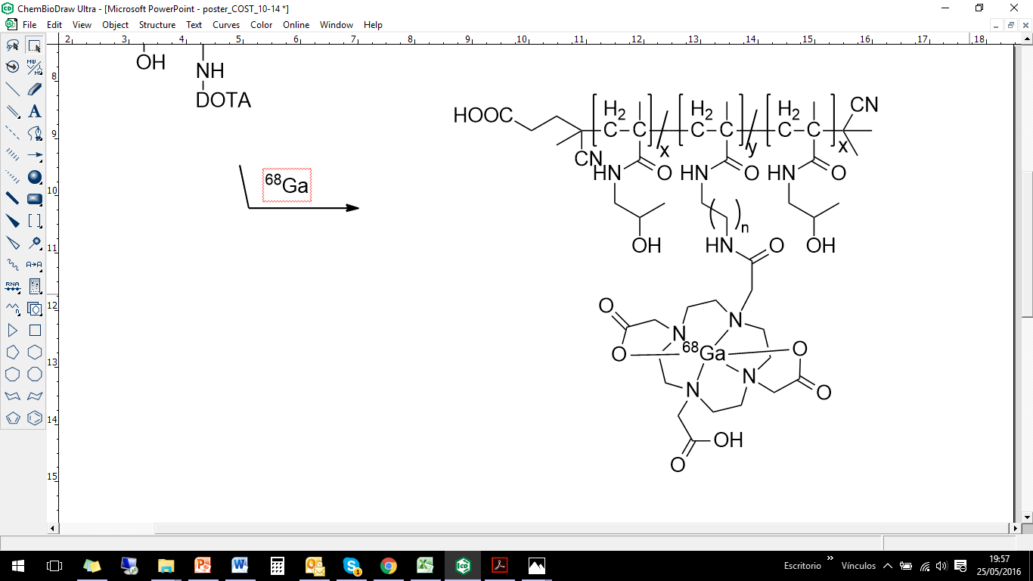 |  |  | nmol | 20
 |  |  | time | 20 min
 |  |  | T | 95°C
 |  |  | RCY | >95%
 |  |  | Stability after 2 h
 |  |  | NaCl 0.9% | 98 ± 1
 |  |  | HS | 95 ± 2
 |  |  | DTPA | 83 ± 1
 |  |  | EDTA | 92 ± 5
 |  |  | Ca²⁺ | 92 ± 5
 |  |  | Fe³⁺ | 94 ± 3
 |  |  | Mg²⁺ | 92 ± 1

An initial proof-of-principle in vivo evaluation in tumor-bearing rat with the ⁶⁸Ga-labeled HPMA-DOTA conjugate 31 (11% DOTA, alkane linker of 12 carbons lengh) has been carried out (Fig. 2) [2]. Accumulation in tumor site was observed by means of EPR effect, however further in vivo experiments need to be performed for a better evaluation of the HPMA-based polymers modified with DOTA, particulary for the conjugate 31c (1.6% DOTA, alkane linker of 2 carbons lengh).

Figure 2: First PET image of ⁶⁸Ga-DOTA-HPMA 31 after 120 min p.i in tumor bearing rat (walker Mamma carcinoma) [2].

Another approach to minimize the modification of the carrier for its labelling with radiometals exploits the inherent ability of micelles to incorporate into their core hydrophobic substances. Hydrophobic ⁶⁸Ga-oxine complex was spontaneously introduced in the micellar nucleus of three different structures of HPMA-based unimers. Block architectures showed higher entrapment of ⁶⁸Ga-oxine and higher stability in contrast to the random architecture. Such results are attributed to a well defined structure of the block polymers that decreases the possibility to present hydrophobic moieties in the corona [3]. The values were improved when PEG moieties were added to the block copolymer. The highly hydrophilic PEG segments decrease aggregate size by increasing steric stabilization, fact that would explain their higher stability in vitro [4].
The successful labelling efficiency of the PEGylated-block micelles as well as their in vitro stability in NaCl 0.9% and serum (Fig. 2) led to their ex vivo evaluation in healthy mice, using ¹¹¹In-oxine as ⁶⁸Ga-oxine analogue due to its longer half-life, allowing for investigations for a longer frame-time.
In spite of the high stability in vitro, in vivo stability was not ensured. Ex vivo biodistribution results of the labelled micelles were quite similar to the values of the free ¹¹¹In-oxine injected as a control. This fact suggests a low stability of the micelles and the later blood metabolite studies confirmed such instability. After 1 h p.i only 30.1% ± 1.9 remained still intact. This value decreased after 4 h to 21.1% ± 1.4 and after 24 h p.i to 15.1% ± 1.5.

Figure 3: Left: % incorporation of ⁶⁸Ga/¹¹¹In-oxine in different polymer architecures (n=3). Right: Stability of the different labelled micelles in HS (n=3)

In order to be able to apply this efficient and fast technique for radiolabelling micelles, the in vivo stability needs to be imporved. An approach that could increment the stability would be to cross-link the micelles after incorporation of the hydrophobic complex. A number of core cross linked polymeric micelles have demonstrated promising efficacy in animal models preventing premature disintegration [5].

4.2 ⁴⁴Sc-PSMA-617 for dosimetry of prostate cancer

In the field of nuclear medicine, emerging treatments against prostate cancer have given rise to PSMA-617, a novel DOTA derivative of the Glu-urea-Lys motif. PSMA-617 has been labelled with the PET nuclide ⁶⁸Ga (t ½ = 68 min) and the therapeutic ¹⁷⁷Lu (t ½ = 6.7 d) showing beneficial results in the clinics. Nowadays, PSMA-617 is a powerful theranostic tracer for prostate cancer.
Besides the positive results obtained with ⁶⁸Ga-PSMA-617, in addition to the great interest in nuclear medicine for ⁶⁸Ga due to its favourable decay characteristics for PET imaging and its availability via generator, its short half-life limits its application. This is an important drawback on the way to personalized medicine, as dosimetry evaluation with ⁶⁸Ga can only be assessed during few hours post injection.
In this context, the PET nuclide ⁴⁴Sc with a half-life of 3.97 hours and being also generator produced is a great alternative to overcome the limitation presented by ⁶⁸Ga. ⁴⁴Sc decay characteristics (high β⁺ branching of 94%, Ē = 0.6 MeV) provide high quality PET images and like ⁶⁸Ga forms stable complexes with the DOTA chelate. Such aspects have motivated the present work.
PSMA-617 has been quantitatively (>95%) labelled with ⁴⁴Sc obtained from ⁴⁴Ti/⁴⁴Sc generator within 20 minutes at 95ºC. A minimum amount of 18 nmol of precursor is needed to ensure efficient labelling, amounts <18 nmol lowered the yields. After removal of trace amounts of un-reacted ⁴⁴Sc by reverse-phase chromatography, in vitro stability evaluation was carried out with high purity product (>99 %). The radiopharmaceutical presented high stability in human serum and saline as well as in presence of an excess of competing cations and chelates that could induce transmetallation in vivo.
Considering that the effectiveness of a drug depends on its affinity to the substrate, a ligand binging assay on LNCaP cells was also performed. The value of the inhibitory constant obtained is in the nanomolar range, which demonstrates a high affinity of ⁴⁴Sc-PSMA-617 to the prostate carcinoma cells. In addition, in a parallel experiment, efficient internalization on the same cell line was revealed, the results obtained are comparable to the values of the ⁶⁸Ga- and ¹⁷⁷Lu-labelled PSMA-617 (Tab.2).

Table 2: Affinity constant and internalization values of ⁴⁴Sc-, ⁶⁸Ga-, ¹⁷⁷Lu-labelled PSMA-617 compounds. Same set up was used for the three compounds [6].
 | K_{i} ± SD | Internalization ± SD
⁴⁴Sc | 4.72 ± 0.78 | 15.78 ± 2.14
⁶⁸Ga | 6.40 ± 1.02 | 17.67 ± 4.35
¹⁷⁷Lu | 6.91 ± 1.32 | 17.51 ± 3.10

Finally, evaluation of ⁴⁴Sc-PSMA-617 in a patient suffering from prostate cancer was performed (Fig.4). ⁴⁴Sc-PSMA-617 revealed high in vivo stability and pharmacological parameters adequate to long-term (up to one day) molecular imaging. Initial human studies hold promise for a diagnostic application and dosimetric calculations.
A B C

Figure 4: ⁴⁴Sc-PSMA-617 PET/CT imaging (55.76 MBq Injected) of PSMA receptor positive metastases after A) 30 min p.i, B) 2h p.i and C) 19 h p.i (Department of Nuclear Medicine, Uniklinikum Bonn, Germany).

4.3 Evaluation of ⁹⁰Nb as potential PET isotope

The advantages offered by PET over other imaging techniques have promoted the development of a big array of imaging agents. In spite of this expansion, the quantity of radionuclides with intermediate half-life, required for molecules with long pharmacokinetics such as antibodies, and with suitable decay parameters for PET imaging is small. Current options are: ⁷⁶Br (t ½ = 16.0 h) ⁸⁶Y (t ½ = 14.7 h) and ⁶⁴Cu (t ½ = 12.7 h). ⁸⁶Y and ⁶⁴Cu present low positron branching and low mean E_{β}⁺; ⁸⁶Y (33% and 0.21 MeV) for ⁶⁴Cu (17.8%, 0.05 MeV). The proposed ⁹⁰Nb (t ½ = 14.6 h) has a β⁺ branching of 53%, which is comparable to ⁷⁶Br (56 %) and a mean E_{β}⁺ of 0.35 MeV, which is higher than the values of ⁸⁶Y and ⁶⁴Cu, but sufficiently less than that of ⁷⁶Br (0.64 MeV). All these nuclides are produced by proton bombardment on low-energy cyclotrons (< 20 MeV,) and contrary to the mentioned nuclides, ⁹⁰Nb obtention does not requires an enriched target for irradiation.
These superior characteristics over present PET nuclides with capacity to image for several hours have motivated investigations on ⁹⁰Nb for its application in nuclear medicine.
Studies involving production route of ⁹⁰Nb, separation strategies to provide a high purity product in conditions suitable for labelling as well as its coordination chemistry have been developed in our working group [7-9]. All the above mentioned decay parameters as well as the positive results obtained in production, separation and labelling chemistry, allow to confirm that ⁹⁰Nb holds promise as a PET and gave reason to continue our study with in vivo evaluation of ⁹⁰Nb-labelled biomolecules for immuno-PET applications.
In this work, ⁹⁵Nb (t ½ = 35 d) has also been employed for biodistribution experiments to cover longer periods. Irradiation of a Zr natural target with neutrons afforded ⁹⁵Zr that via β⁻ decay to the desired ⁹⁵Nb.
The radiolabelling chemistry of *Nb^{V} appears to be quite similar to *Zr^{IV} therefore the removal of Zr of the irradiated target is essential. A high decontamination factor is crucial, because zirconium also creates very stable complexes with desferrioxamine and competes with niobium, affecting labelling efficiency. A multistep separation that includes both cation and anion exchangers and different acidic solutions afforded within 1.5 h, no carrier-added ^{90/95}Nb in 500 µL of 1 M oxalic acid solution with a c.a 95% recovery and in high purity (decontamination factor of 3·10⁸). Such conditions are suitable for further radiolabelling.

Desferroxamine (Df) has demonstrated to be the most apt chelate for complexation of niobium as it showed fast kinetics of complex formation and high stability, consequently the mAbs used were modified with Df. Labelling of mAb-Df was performed in PBS at pH of c.a 7, at RT and for 1 hour and >95% of radiolabelling yield was achieved. Purification through size exclusion column afforded pure *Nb-labelled antibody in NaCl 0.9 % solution (Fig.5).
^{90/95}Nb labelled bevacizumab presented excellent in vitro stability in saline as well in human serum albumin (HSA) at RT and 37°C. After 7 days incubation in saline less of 5% of product degradation was detected and more than 85% of product was detected in HSA.

Figure 5: Df-conjugation of the mAb via NCS-Bz-Df and labeling with ^{95/90}Nb

Initial ex vivo experiments with ⁹⁵Nb-Df-bevacizumab showed adequate tumor uptake, however at the same time high uptake in the liver, spleen and kidneys was observed. In order to investigate whether this behaviour is due to instability of *Nb-Df-bevacizumab and consequent creation of other *Nb species in vivo, biodistribution studies of ⁹⁵Nb-oxalate, ⁹⁵Nb-chloride and ⁹⁵Nb-Df were performed. These potential metabolite species did not show any specific uptake, apart from bone accumulation for ⁹⁵Nb-oxalate and ⁹⁵Nb-chloride, which, interestingly, may serve as an indicator for the release of *Nb from labelled biomolecules.
A second biodistribution evaluation in healthy mice was performed with a high specific activity product. Results did not show increased uptake in liver, spleen or kidneys (< 5% at 1 day p.i) and higher uptake was detected in blood and lungs.
Final ex vivo evaluation in tumor bearing mice presented high accumulation in tumor tissue at the same time than lower values for other organs (liver, lungs, spleen) (Fig.6). Despite that the tumor uptake showed a decreasing pattern in time, the tumor-to-blood ratios increased from 1 to 2 days p.i. expressed a slight drop at 4 days p.i.
⁹⁰Nb holds promise on its application in immuno-PET, however the popularity of ⁸⁹Zr, with suitable decay characteristics for PET imaging (t ½ = 3.27 d; 23 % β⁺, mean E_{β}⁺ 0.39 MeV) and the commercially availability of GMP-compliant ⁸⁹Zr lowers the cost and reduces time of obtention, this fact could difficult the application of ⁹⁰Nb as PET nuclide.

Figure 6: Biodistribution of 95Nb-Df-bevacizumab (270 kBq/20 µg/mouse, [2.03 TBq/mmol (54.83 mCi/mmol) in tumor-bearing mice

REFERENCES

[1] Tamargo J, Le Heuzey JV, Mabo P. Narrow therapeutic index drugs: a clinical pharmacological consideration to flecainide. Eur J Clin Pharmacol 2015; 71: 549–567.
[2] Eppard E. PhD thesis, Johannes Gutenberg-Universität, Mainz, 2013, 189 pp.
[3] Gaucher G, Dufresne MH, Sant VP, Kang N, Maysinger D, Leroux JC. Block copolymer micelles: preparation, characterization and application in drug delivery. J Control Release 2005; 109; 169–188.
[4] Allmeroth M, Moderegger D, Gündel D, Buchholz HG, Mohr N, Koynov K, Rösch F, Thews O, Zentel R. PEGylation of HPMA-based block copolymers enhances tumor accumulation in vivo: A quantitative study using radiolabeling and positron emission tomography. J Control Release 2013; 172: 77–85.
[5] Talellia M, Barz M, Rijckend CJF, Kiesslinge F, Henninka WE, Lammers T. Core-crosslinked polymeric micelles: Principles, preparation, biomedical applications and clinical translation. Nano Today 2015; 10: 93—117.
[6] Benesova M, et al. Preclinical Evaluation of a Tailor-Made DOTA-Conjugated PSMA Inhibitor with Optimized Linker Moiety for Imaging and Endoradiotherapy of Prostate Cancer. J Nucl Med 2015; 56: 914-920.
[7] Busse S, Rösch F, Qaim SM. Cross section data for the production of the positron emitting niobium isotope ⁹⁰Nb via the ⁹⁰Zr (p, n)-reaction. Radiochim Acta 2002; 90:1-5.
[8] Busse S, Brockmann J, Roesch F. Radiochemical separation of no-carrier-added radioniobium from zirconium targets for application of ⁹⁰Nb-labelled compounds. Radiochim Acta 2002; 90: 411-415.
[9] Radchenko V, Busse S, Roesch F. Desferrioxamine as an appropriate chelator for ⁹⁰Nb: Comparison of its complexation properties for M-Df-Octreotide (M = Nb, Fe, Ga, Zr). Nucl Med Biol 2014; 41: 721–727.

5 OUTLOOK

The application of radiometals in nuclear medicine is of growing utilization both in diagnostic and therapeutic radiopharmaceuticals due to their diversity in chemical and nuclear properties. The large amount of pathlogies and the need of personalized treatments ask for different diagnostic and therapeutic radiopharmaceuticals.
Nanomaterials have become under focus of drug development as with multiple functionalities could be used for both diagnosis and therapy. Among them, polymeric materials play a key role due to their high biocompatibility, biodegradability and structural diversity. In this work systematic studies on the influence of the linker structures and the degree of occupancy of chelator in HPMA-based unimers, as well as a novel startegy for radiolabelling HPMA-based micelles have been carried out. Such studies aimed to minimize the modification needed to achieve quantitative radiolabelling yields and consecuently diminish the alteration of the biomolecule. In vivo studies were performed, however further evaluations are needed.
The contineous development of new drug delivery systems for nuclear medicine have increased the demand of radioisotopes to better match the different pharmacokinetics. In this context, ⁴⁴Sc has been evaluated as an alternative to the short-lived ⁶⁸Ga for PET imaging of prostate cancer lesions showing successful results in a first human patient. Its longer half-life allows for longer-term evaluation, thus being more suitable for dosimetric calculations of therapeutic analogs of ¹⁷⁷ Lu and therefore obtain a better plan for personalized medicine.
⁹⁰Nb has also been studied as a novel nuclide for immuno-PET. Its half-life of 14.6 h makes it suitable for imaging of biomolecules with intermediate and long half-lifes, such as antbodies or antibody fragments. Radiolabelling of mAb with Nb isotopes has been investigated and first in vivo evaluations in healthy and tumor bearing mice were performed. Reults have shown a high potential for application of ⁹⁰Nb in immuno-PET.

${}_{0}^{1}n$ Neutron
List of abbreviations

${}_{0}^{1}{β^{+}}$ Positron
${}_{1}^{1}p$ Proton
µm micrometer
${{}_{0}^{0}ν}_{e}$ electron-neutrino
a year (annus)
A activity
AAZTA-5 6-amino-6-methylperhydro-1,4-diazepine tetraacetic acid
Bq Bequerel
c.a around (circa)
CDCl₃ deuterated chloroform
CEX Cation exchange resin
d day
DMSO diethyl sulfoxide
DOTA 1,4,7,10-tetraazacyclododecane -1,4,7,10-tetraacetic acid
DOTATOC DOTA-Phe(1)-Tyr(3) octreotide
DTPA diethylene-triamine pentaacetic acid
e.g for example (exempli gratia)
g gram
h hour
H₂C₂O₄ Oxalic acid
HCl Hydrochloric acid
HBED N,N'-Bis(2-hydroxybenzyl) ethylenediamine
HMPAO hexamethyl propylene amine oxime
HPLC High Pressure Liquid Chromatography
Hz Herz
i.e for example (id est)
i.v. intra venous
kDa kilodalton
keV kiloelectronvolt
mAb monoclonal antibody
max. maximum
M molarity
Mn Number average molar mass
Mw Molecular weight
MBq Megabequerel
mCi milicurie
MeV Megaelectron Volt
min minute
NaCl sodium chloride
NMR Nuclear Magnetic Resonance
ran random
PDI polydispersity index
p.i. post injection
Ps Positronium
PSMA Prostate specific membrane antigen
RCY Radiochemical yield
TLC Thin Layer Chromatography

