Aus der Klinik und Poliklinik für Neurologie
der Universitätsmedizin der Johannes Gutenberg-Universität Mainz

The Role of B Cell Activating Factor (BAFF) in the immunopathological development of multiple sclerosis

Die Rolle des B-Zell aktivierenden Faktors (BAFF) in der immunpathologischen Entwicklung von Multipler Sklerose

Inauguraldissertation
zur Erlangung des Doktorgrades der Medizin
der Universitätsmedizin
der Johannes Gutenberg-Universität Mainz

Vorgelegt von

Muriel Carolyn Schraad
aus Bad Soden am Taunus

Mainz, 2023

Wissenschaftlicher Vorstand:
1. Gutachter:
2. Gutachter:
Tag der Promotion: 22.11.2023

Zusammenfassung
Die Multiple Sklerose (MS) ist eine Autoimmunerkrankung, welche zu einer Demyelinisierung und Degeneration von Nerven des Zentralen Nerven Systems führt. Hierdurch kommt es zu neurologischen Defiziten, welche entweder intermittierend oder langsam progredient auffallen können. Beides ist assoziiert mit langfristiger Behinderung bereits im jungen Alter. In den letzten Jahrzehnten hat die MS Forschung zugrundeliegende pathogene Aspekte identifizieren können. Hierzu gehören insbesondere pro-inflammatorische T Zellen. Jedoch konnte, durch den Erfolg von B-Zell Depletion als Behandlung der schubförmigen und auch progressiven MS, nun auch den B-Zellen eine wichtige Rolle zugeschrieben werden. Dies unterstützend konnten B-Zell Ansammlungen im Sinne eines lymphoiden Gewebes in den Gehirnen verstorbener MS Patienten nachgewiesen werden. Der Nachweis intrathekaler Antikörper Produktion, ein weiterer Indikator von B-Zell Aktivität, ist bereits Teil der McDonald Kriterien zur MS Diagnosestellung.
B-Zell aktivierender Faktor (BAFF) wird als Promotor der B-Zell Aktivierung und Proliferation angesehen. In immunologisch verwandten Autoimmunerkrankungen wurde dieser als pro-inflammatorisch und pro-morbide identifiziert. Eine Blockierung dessen führte jedoch überraschenderweise zu einer Verschlechterung der MS. Dies wies auf eine MS-spezifische Rolle des BAFF, im Gegensatz zu anderen autoimmunen Erkrankungen, hin.
Die vorliegende Arbeit kategorisiert und definiert zunächst verschiedenste B-Zell Subtypen und die jeweilige Rolle in der MS- Pathologie. Des Weiteren wird der Einfluss von BAFF auf B-Zellen, gewonnen aus dem Blut freiwilliger gesunder Spender, in der humanen Zellkultur untersucht. Hierbei wird zunächst der Einfluss auf die Entwicklung von B-Zell Subtypen durch die Analyse der Oberflächenmarker mittels Durchflusszytometrie beleuchtet. Dann gehen wir der Frage nach, welchen Effekt BAFF auf das inflammatorische Potenzial, im Sinne von abgegebenen Botenstoffen, gemessen mittels Antikörper-vermittelter Immunassays, ausübt.
Wir zeigen, dass eine bestimmte Dosis an BAFF in einer naiven B-Zell Population zu einer signifikanten Erhöhung des abgegebenen regulatorischen Botenstoffes Interleukin 10 führt. Ebenso weisen wir nach, dass BAFF den Anteil von maturen naiven B-Zellen erhöht und den der pro-inflammatorischen Gedächtnis B-Zellen reduziert.
All dies unterstützt die vermutete regulatorische, jedoch dichotome, Wirkweise von BAFF und ergibt potenzielle neue Angriffspunkte für eine wirkungsvolle Therapie gegen die Multiple Sklerose.

Abstract
Multiple sclerosis (MS) is an autoimmune disease leading to demyelination and degeneration of the nerves in the central nervous system, thereby resulting in neurological deficits that can be either relapsing-remitting or progressive. Both are associated with long-term disability, especially already in young age.
Within the last decades, research in MS was able to identify aspects of underlying pathogenesis. A major part is enacted through pro-inflammatory T cells. However, through the success of treating relapsing-remitting and progressive MS by B cell depletion therapy, the role of B cells in the initiation and maintenance of MS has become of increasing interest. As such, lymphoid like structures with an accumulation of B cells have been spotted in brains of deceased MS patients. Intrathecal antibody production, another indicator of B cell activity in MS, is already part of the diagnostic McDonald criteria.
The B cell activating factor of the tumour necrosis family (BAFF) has been perceived as a promotor for B cell activation and proliferation. It is associated with a pro-inflammatory and pro-morbid role in MS-related autoimmune diseases. However surprisingly, blockage of BAFF induced detrimental deterioration of MS. Thus indicating a MS-specific function of BAFF, in contrast to other autoimmune diseases.
This work firstly categorises and defines various B cell subgroups and their role in MS pathogenesis. Furthermore, it investigates the influence of BAFF on B cells in human cell culture of blood retrieved from healthy donors. Here, the influence on subtype composition will be uncovered through fluorescence-activated cell sorting, and its influence on the inflammatory potential in terms of cytokine release will be investigated through the measurement of cytokines by enzyme-linked immunosorbent assay.
We show that specific concentrations of BAFF induce a significant increase in the release of the regulatory cytokine interleukin 10 from naïve B cell culture. Furthermore, we prove that BAFF promotes mature naïve B cells whilst reducing the proportion of disease-driving pro-inflammatory memory B cells.
Taken together, this supports a suspected regulatory, but dichotomous, role of BAFF and offers new viewpoints on a potentially effective therapeutic approach for MS.

Contents
Zusammenfassung 1
Abstract 2
Contents 3
Abbreviations 5
List of Figures 8
Introduction 9
Multiple Sclerosis 9
The importance and role of B cells 10
B cell depletion therapy 12
B cell maturation and subtypes 12
Regulatory B cells and interleukin 10 14
BAFF and B cells 15
BAFF and T cells 16
BAFF and MS 17
Aim of this work: 18
Material and Methods 19
Material 19
Methods 22
Lymphocyte isolation 22
Magnetic activated cell sorting 22
Cell cultivation 23
Flow cytometry 23
ELISA 24
Statistical analysis 24
Ethics 25
Results 26
Descriptive analysis of B cells 26
BAFF increases IL-10 release of naïve B cells 27
BAFF decreases memory and pro-inflammatory B cells 28
BAFF increases proportion of mature naïve B cells 30
BAFF increases double negative B cells 31
BAFF has no effect on cytokine release by Th1/Th17-like cells nor on the GM-CSF release by B cells 31
Discussion 34
Summary & Outlook 37
References 39
Acknowledgement 46
Curriculum vitae 47

Abbreviations

ANOVA | analysis of variance
APRIL | a proliferation-inducing ligand
BAFF | B cell activating factor of the tumour necrosis  family
BAFF-R | BAFF receptor
BBB | Blood-brain barrier
BCMA | B cell maturation antigen
BCR | B cell receptor
BLyS | B lymphocyte stimulator
Breg | regulatory B cell
CD | cluster of differentiation
CFSE | carboxyflorescein succinimidyl ester
CIS | clinically isolated syndrome
CNS | central nervous system
D | day
CSF | cerebrospinal fluid
EAE | experimental autoimmune encephalomyelitis
EDSS | expanded disability status scale
EDTA | ethylenediaminetetraacetic acid
ELISA | enzyme-linked immunosorbent assay
FACS | Fluorescence-activated cell sorting
Foxp3+ | forkhead box P3
FSC-A | forward scatter
GM-CSF | granulocyte macrophage-colony stimulating factor
HEPES | 4-(2-hydroxyethyl)-1-piperazineethanesulfonic  acid)
hi | high
IFN γ | interferon γ
Ig | immunoglobulin
IL | interleukin
IL-10 | interleukin 10
iNOS | inducible nitric oxide synthase
int | intermediate
IV | intravenous
MACS | magnetic activated cell sorting
MBP | myelin-basic protein
MFI | mean fluorescence intensity
MHC | major histocompatibility complex
MOG | myelin oligodendrocyte glycoprotein
MRI | magnetic resonance imaging
MS | multiple sclerosis
OCB | oligoclonal bands
PBS | phosphate buffered saline
PD-L1 | programmed cell death ligand 1
PI | propidium iodide
PLP | proteolipid protein
PMA | Phorbol-12-myristat-13-acetat
PPMS | primary progressive MS
RH | RPMI medium supplemented with 1% HEPES
RRMS | Relapsing-remitting MS
SLE | systemic lupus erythematosus
sNfl | soluble neurofilament light chain
SPMS | secondary progressive MS
SSC-A | side scatter
TACI | T cell activator and calcium modulating ligand interactor
TGF-β | transforming growth factor β
Th cell | T helper cell
TNF | tumour necrosis factor
TNFα | tumour necrosis factor α
Tregs | regulatory T cells
95%CI | 95% confidence interval

List of Figures

Figure 1: Roles of B cells in MS 11
Figure 2: B Cell Maturation 13
Figure 3: Gating of B cell subgroups 27
Figure 4: IL-10 release in B cell subgroups treated with BAFF 28
Figure 5: Influence of BAFF on proportion of memory and pro-inflammatory B cells 29
Figure 6: Influence of BAFF on proportion of subgroups of B cells 30
Figure 7: Influence of BAFF on proportion of double negative B cells 31
Figure 8: Cytokine release by Th1/Th17-like cells treated with BAFF 32
Figure 9: Release of GM-CSF by B cells treated with BAFF 33
Figure 10: Effect of BAFF on the proportions of B cell subgroups and IL-10 release 34

Introduction

Multiple Sclerosis
Multiple sclerosis (MS) is one of the most common disabling diseases in the young (1, 2). The illness comes with a great disease burden for patients and caretakers. Risk factors for MS include genetic predisposition and environmental influences. As such, the incidence of MS is highest the furthest away from the equator and migration from an area with great prevalence to areas with a lesser number of cases before the age of 15 associates with the risk of the latter environment (1, 3). Patients’ most common initial presentation is optic neuritis (4-9). However, symptoms can vary from paraesthesia or paresis, to signs of cerebellar dysfunction or other neurological deficits. Prevalence is two to three times higher amongst women than men (10). MS can be divided into four clinical subtypes defined by their development of symptoms and course of disease.
Clinical isolated syndrome (CIS) is defined by a single event of neurological deficits relatable to demyelination without evidence of dissemination in time (11). The most common (85-90%) clinical disease course is relapsing-remitting MS (RRMS), which is characterized by intermittent episodes of neurological symptoms that mainly subside (11). Without or sometimes even with treatment this can then transform into the clinical course of secondary progressive MS (SPMS) (2, 11, 12). Here, neurological symptoms progress independent of present or absent relapses. A minority of patients, presenting with a one-year progression in neurological deficits associated with active lesions shown on magnetic resonance imaging (MRI) of brain or spine and / or positive oligoclonal bands (OCB), are identified to have primary progressive MS (PPMS) (11, 13).
Diagnosis is made through applying the McDonald criteria that cover clinical presentation, timing, lesions visible on MRI and OCB in cerebral spinal fluid (CSF) (13).
Even though progress in the investigation of pathogenesis as well as treatment options has been made within the last twenty years, a lot is yet to be discovered.
MS is a chronic inflammatory disease of the central nervous system (CNS) accompanied by demyelination and glial scarring (7). Although the CNS has traditionally been considered immunologically privileged, evidence arose that the innate and adaptive immune systems do interact with the CNS. In vitro studies showed a transmigration of human T helper (Th)17 cells across a model of the endothelial blood-brain barrier (BBB) and cytokines released by such cells were found to disrupt tight junctions in vitro and in vivo (8). Post-mortem pathological studies of brain lesions also show a great abundance of inflammatory cells in close proximity to MS lesions (9). It has been shown that infiltrating immune cells directly affect microglia, neurons and astrocytes (14). In concordance with this, medication modulating the peripheral immune system is highly efficient in reducing symptoms and detectable lesion load in MS patients. Additional evidence against the immunological privilege is the presence of lymphatics and meningeal follicle-like structures within the CNS (15-17).
Over the years, an important role has been assigned to T cells in MS development, especially through in-depth investigation of the murine model of MS experimental autoimmune encephalomyelitis (EAE). Detrimental immune effects are especially induced by Th17 cells through cytokine release and direct synapse like formations with neuronal cells (18).
Generally, an imbalance of cytokines and cell types is present in MS creating an inflammatory burden. Thus, compared to healthy controls, blood extracted from MS patients show higher levels of inflammatory cytokines, such as granulocyte-macrophage colony-stimulating factor (GM-CSF), interferon γ (IFNγ), interleukin 17 (IL-17), interleukin 6 (IL-6), and tumour necrosis factor α (TNFα) (9, 19). Along with this, anti-inflammatory mediators such as interleukin 10 (IL-10) are reduced (9). Not only a reduction in number but also in functionality has been shown for regulatory cell types in MS (20).
The impact the immune system exhibits within the CNS is most likely a combination of infiltrating peripheral immune cells and local CNS inflammation.

The importance and role of B cells
In recent years, not only T cells were in focus of MS research but through the development of effective B cell depletion therapy, the role of B cells in MS pathogenesis has become of increasing interest.
Oligoclonal bands, indicating intrathecal antibody production by B cells, are present in the CSF of over 95% of MS patients (11). Antibodies against myelin oligodendrocyte glycoprotein (MOG), myelin-basic protein (MBP) and proteolipid protein (PLP) have been detected in MS lesions and CSF (21-23). Even though their potential for disease enhancement in EAE suggest the importance of antibodies released from plasma cells, as of yet, no antigen specificity has been defined in humans (24).
Recently, it has been shown that B cell’s pro-inflammatory effect seems to be mediated through their role as antigen-presenting cells as well as through cytokine release, not solely through antibody production. Thus, pro-inflammatory B cells releasing cytokines such as GM-CSF, which has been identified to be important in MS development and maintenance, have been shown to be greatly prevalent and more readily inducible in MS patients than in healthy controls (9, 25, 26). These cells were also shown to activate myeloid cells in vitro (9). B cells obtained from MS patients were also shown to promote demyelination in spinal cord explant cultures via complement-dependant cytotoxicity and direct targeting of neurons and glia of the CNS (27).
Acting as antigen-presenting cells, B cells influence the shift of T cells into Th1 and Th17 cells by interaction of co-stimulatory molecules CD80 and CD86, which were shown to be more prevalent on B cells extracted from MS patients in comparison to healthy controls (Figure 1) (28). Confirming the importance of this role of B cells, B cell depletion therapy also resulted in a decrease in Th1 and Th17 response (29).
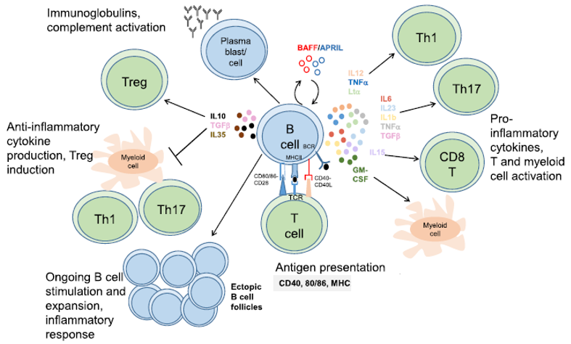
Figure 1: Roles of B cells in MS
: antigen presentation, immunomodulation through cytokine release and development into antibody-producing plasma cells (adapted from (28))

All of the above indicate an interaction between the peripheral immune system and the CNS. Furthermore, findings of leptomeningeal ectopic B cell follicles indicate that not only do peripheral immune cells cross the BBB but that there is also constant presence and maturation of B cells and antibody production within the brain of MS patients even with an intact BBB (15, 30, 31). The presence of B cell enriched tertiary lymphoid tissue within the CNS has been shown to be associated with grey matter pathology (diffuse meningeal inflammation, grey matter cortical demyelination, neuronal loss and microglial activation) and an exacerbated clinical course in SPMS patients (16, 17, 32).

B cell depletion therapy
The success of CD20 antibodies depleting B cells is particularly interesting as it is the first drug group beneficial in PPMS (33). Furthermore, it has been shown to have a particularly long-lasting effect (24, 34).
Therapy with the humanized monoclonal CD20 antibody ocrelizumab leads to a decrease in clinical progression represented by the expanded disability score (EDSS), gadolinium enhancing MRI lesions, displaying active inflammation, and decrease of the soluble neurofilament light chain (sNfl), a marker of neuronal destruction. Specifically, ocrelizumab was shown to exhibit a 45% reduction in relapse activity and clinical activity, a 40% reduction in disability progression with a 95% reduction in gadolinium-enhancing T1-lesions and 80% reduction in T2 lesions in MRI in RRMS patients in comparison to patients treated with the baseline therapy interferon beta-1a (35). In PPMS, ocrelizumab resulted in a 25% reduction in disability progression in comparison to placebo (36). This difference in effectiveness between RRMS and PPMS highlights different underlying pathogeneses including neuroinflammation and neurodegeneration to various extents depending on clinical courses. Whilst neurodegeneration is barely treatable with immunosuppressive treatment, flare-ups can nowadays be well controlled by suppressing the overactive immune system. CD20 B cell depletion therapy acting through cellular toxicity and apoptosis has no impact on plasma cells as these do not present CD20 on their surface (37). Therefore, a major aspect of the role of B cells in the pathogenesis of MS seems to be antibody independent. Surface markers representing the different steps of B cell maturation will be further discussed below. B cell depletion in blood 2-8 weeks and in CSF 24 weeks after treatment indicates a peripheral and central effect (38, 39).

B cell maturation and subtypes
B cells can be subdivided by their surface markers, cytokine or antibody release and stage of maturity (Figure 2). They originate from multipotent haematopoietic precursor cells within the bone marrow, which then develop into Pro B cells (34, 37). From that point on, CD19 is presented on each subgroup of B cells (34, 37). From the following stage of maturation, Pre B cell, surface marker CD20 is present, except on plasma cells. CD20 is of particular interest as being targeted by B cell depletion therapy. Immature B cells characterised by IgM presentation then exit the bone marrow, multiply by tonic B cell receptor (BCR) signalling and further develop into transitional B cells within the spleen (37, 40, 41). This transitional B cell type is characterised by a co-expression of CD38 and CD24 and a lack of CD27 (42, 43). It belongs to the interleukin 10 releasing B cell subtypes that are collectively alleged as regulatory B cells (44).

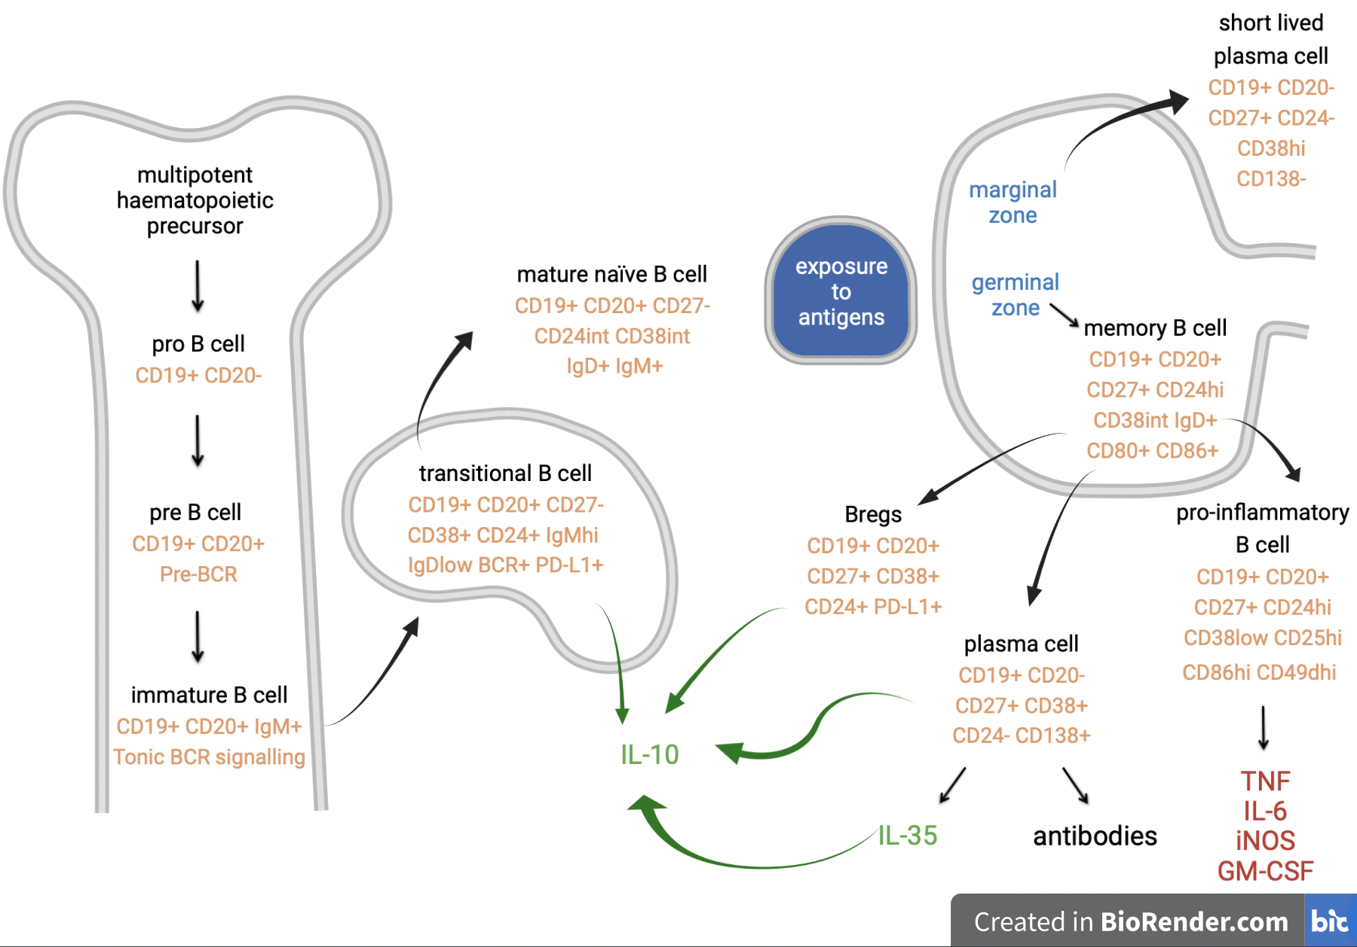
Figure 2: B Cell Maturation
: Different stages of maturation represented by surface marker (orange) and cytokine (green: anti-inflammatory, red: pro-inflammatory) and antibody (black) release. TNF = tumour necrosis factor, iNOS = inducible nitric oxide synthase, PD-L1 = programmed cell death ligand 1, hi = high, int = intermediate.

Further maturation results in mature naïve B cells presenting IgM and IgD, with intermediate levels of CD24 and CD38, that exit the spleen and enter the blood stream (37). Exposure to antigens prompts further maturation within secondary lymphoid tissue. Memory B cells expressing, among other markers, CD27 and an intermediate level of CD38 and high levels of CD24 develop (45). In the marginal zone, short-lived plasma cells develop whilst in the germinal centre memory B cells can further differentiate into pro-inflammatory B cells releasing pro-inflammatory cytokines, plasma cells releasing antibodies or a subgroup generally appreciated as part of the regulatory B cell subgroup (“Breg”) (9, 45). The latter express, among others, high levels of CD24 and CD38, whilst also expressing CD27 (45).
B cell maturation, including the collective specific surface marker expression and the most important released cytokines of B cell subgroups are displayed in Figure 2.

Regulatory B cells and interleukin 10
In recent years, it has been established that autoimmune diseases result from a disbalance between pro- and anti-inflammatory mediators of the immune system. With a reinforced role of B cells in MS development, decreasing their detrimental role has become of interest. However, approaching it from the other point of view, it would be desirable to promote their known regulatory aspects as well.
Primarily, these are enacted by the release of the regulatory cytokine interleukin 10 (IL-10) (28).
IL-10 inhibits pro-inflammatory cytokine production by monocytes/macrophages (46). Selective IL-10 knockout on B cells has been shown to result in more severe EAE whilst the transfer of IL-10-releasing B cells in B cell-deficient mice resulted in alleviation of EAE symptoms (47, 48). In line with this regulatory effect of B cells, CD20 B cell depletion before initiation of EAE exaggerated symptoms and enabled influx of T cells into the CNS. IL-10 transgenic mice, expressing human IL-10 transgene under the control of a class II major histocompatibility complex (MHC) promotor, were shown to be resistant to EAE (49) whilst a lack of IL-10-producing B cells prevented recovery from EAE.(50)
In contrast to this stands another study documenting that the IL-10 B cell receptor is essential for scar formation in disease progression shown by effective symptom suppression through B cell depletion during disease progression and an exacerbation of chronic relapsing MS through the intravenous (IV) administration of IL-10 (51). Supporting this is the finding of IL-10 and IL-4 and their receptors in close proximity to chronic active MS lesions in post-mortem brain tissue (52). Interestingly, it was demonstrated that intranasal IL-10 administration inhibited acute and protracted relapsing EAE, once more representing the complexity and dichotomous role of B cells in the development of different clinical courses of MS (51, 53).
In line with the presumed inflammatory disbalance present in MS, IL-10 blood levels were shown to be decreased in disease compared to healthy controls (54). Low IL-10 levels at first event of CIS were also correlated with the occurrence of a second event of a demyelinating CNS disorder, as well as with high leucocyte levels in CSF, number of T2 and gadolinium-enhancing lesions on MRI. However, no difference in correlation could be drawn between the progression into MS or neuromyelitis optica spectrum disease, a group of illnesses associated with demyelinating events but with a nowadays proven separate underlying pathogenesis from MS (55).
IL-10 exerts regulatory functions by influencing the shift of Th cells into regulatory T cells (Tregs) and prevents the pro-inflammatory cytokine release from Th1, Th17 cells and macrophages (Figure 1) (44, 56). It also acts through autoregulation by promoting IL-10-releasing B cells (57).
B cells releasing IL-10 are grouped as regulatory B cells. They can be subdivided again according to their expression of surface markers. The most important two groups present high levels of CD24 and CD38 on their surface and can be differentiated by their expression of CD27: transitional B cells belong to the naïve B cell pool (CD27-), whilst “Breg” are mature B cells (CD27+) (20, 42, 44). Controversies exist regarding which of those two and other IL-10-producing B cells is the most important with the greatest release of IL-10 (44, 54).
CD19+ CD24^{hi} CD38^{hi} B cells were shown to suppress the differentiation of Th1 cells from naïve T cells (20). This anti-inflammatory shift was shown to be IL-10 dependent and less functional in MS (58). Promotion of Tregs, which themselves are usually malfunctioning in MS patients, is another anti-inflammatory role of regulatory B cells (59, 60).
B cells derived from MS patients have been shown to display a lower production of IL-10 after activation than cells received from healthy donors with no difference present between MS subtypes (54). Transitional B cells have been shown to be particularly low during relapse compared to remission (61). Therefore, a special interest lies in the process of how regulatory B cells are promoted.

BAFF and B cells
A special role in B cell maturation has been assigned to the B cell-activating factor of the tumour necrosis family (BAFF, also known as B cell survival factor, B lymphocyte stimulator [BLyS]) (62-64). This protein exists in a membrane-bound or secreted biologically active soluble form (65-68). BAFF is expressed by immune cells as well as by non-haematopoietic stromal cells and binds to three different receptors (65): BAFF-receptor (BAFF-R), TACI (T cell activator and calcium-modulating ligand interactor) and BCMA (B cell maturation antigen)(41, 68). BAFF is the sole ligand for BAFF-R, whilst TACI and BCMA are also receptors for a proliferation-inducing ligand (APRIL). The three receptors can be expressed on all subtypes of B cells (69). However, throughout different stages of maturity, BAFF-R is highly expressed on immature, whilst TACI and BCMA mainly on mature B cells and plasma cells (7, 41, 69).
Generally, the BAFF/APRIL system plays an important role in survival, function and maturation of B cells by activating NF-κB signalling pathways (70, 71). In vitro assays showed that recombinant human BAFF promoted the survival of CD19+ cells retrieved from humans and mice (41, 72-74).
In this matter, a deficiency or complete lack of BAFF-R results in retained B cells at immature / transitional stage resulting in immune deficiency (75). Overexpression of, or increased exposure to BAFF, such as by the administration of soluble BAFF or in BAFF transgenic mice, has been shown to result in augmented levels of mature B cells, hyperglobulinemia and association with autoimmune disease development (66, 76-78).

BAFF and T cells
Interestingly, BAFF has not only been shown to influence B cell maturation and survival but seems to play a multifactorial role in MS by influencing T cells as well. Thus, T cells and B cells extracted from MS patients were revealed to express a higher level of BAFF-R mRNA compared to controls (68).
Furthermore, it has been shown that Th17 cells were increased in BAFF transgenic mice in line with severe EAE, whilst reduced levels of Th17 cells in BAFF knockout mice correlated with a delayed onset and diminished peak severity of EAE (79). This effect was shown to be independent from B cells’ antigen presentation (79). Administration of recombinant BAFF in mice resulted in raised CD4+ and CD3+ T cells (80). In vitro experiments confirmed an increase in vitality, activation state, identified by specific surface markers (CD69+, CD154+, CD25+), and cytokine release including IFNγ by T cells through BAFF exposure, all reversible through the application of recombinant human TACI Ig fusion protein binding BAFF (81-83).
Treg levels, on the other hand, were shown to remain unchanged by in vitro BAFF exposure in contrast to their increased level in transgenic BAFF mice (81, 84). However, direct comparison between mice and human immune cells must be made carefully as for example, mouse T cells were demonstrated to express BAFF-R and TACI whilst human T cells only expressed BAFF-R (84). This is deemed important as different effects were shown to be promoted through activating different receptors. As such, in mice, silencing TACI promoted T cell vitality whilst silencing BAFF-R resulted in a decrease in vitality, acting through the PI3K-Akt signalling pathway (85). Human in vitro experiments showed that recombinant human BAFF did not promote survival of CD4+ T cells but rather CD8+ T cells, which were not influenced in mice (72).

BAFF and MS
Increased BAFF levels have been shown to associate with autoimmune diseases (86-88). Correlating data from MS patients show high BAFF levels in demyelinating plaques within the CNS and the CSF (89, 90).
In coherence with this, patients with a variant of the TNFSF13B gene, which results in increased soluble BAFF release, showed a greater risk of developing MS and systemic lupus erythematosus (SLE) (87). In addition, high expression of BAFF and CXCL13, a chemokine involved in B cell recruitment to lymphoid tissue, has been found in the CNS in EAE (91). Here, BAFF was particularly high during relapse and peak but low in the remission phase of the relapsing-remitting and chronic-relapsing models of the disease (91). During chronic progressive EAE, high BAFF levels quickly returned to normal after disease onset (91).

Even though BAFF level has been shown to be significantly higher in MS patients compared to healthy controls, it also correlates with a more stable clinical course of the disease (92).
Interestingly BAFF levels were shown to increase under disease-modifying therapy with interferon β and other immunosuppressive therapy (mitoxantrone, cyclophosphamide) (92). In line with this, Gommerman et al. showed that overexpression of BAFF correlated with high levels of IgA-producing plasma cells in the gut that produce IL-10 and were shown to be protective against EAE when transferred into mice lacking IL-10 (93, 94).
Due to the detrimental associations of BAFF with disease development and maintenance and effectiveness in the treatment of SLE, blockage of BAFF had become a target of interest in MS therapy. However, trials of the BAFF/APRIL neutralizing antibody atacicept, as well as tabalumab, neutralizing soluble and membrane bound BAFF, and belimumab, targeting soluble trimeric BAFF molecules and licensed for SLE therapy, had to be stopped in phase II due to a rise in MS disease activity (7, 95-98).
Multiple groups have shown that B cell depletion therapy induces an increase in BAFF serum levels (99, 100). This was inversely proportionate to the consecutive rise in regulatory transitional B cells. This leads to the conclusion that BAFF influences the composition of B cell subgroups directly and possibly influences the inflammatory potential of B cells persistently.

Aim of this work
Multiple sclerosis is one of the most disabling diseases in young adults. It is known that underlying pathogenesis includes an interaction of the immune system and the CNS. However, the role of one player, namely B cells, is still not completely clear but seems to be an important one.
In the construct of complex immune-nerve interaction, the B cell stimulating factor BAFF seems to exert a peculiar role. This work therefore aims to shed more light on the direct interaction of this mediator with immune cells. As BAFF has been shown to be particularly important in premature B cells inducing a B cell shift towards maturity, the influence BAFF exerts on the composition of B cells will be in focus.
Whilst B cells at first have been thought to induce an immune response in the CNS through antibodies, a major role has nowadays been attained towards their released cytokines. The BAFF effect on cytokine release will also be investigated in B and T cells. Especially BAFF’s dichotomous role in whether to induce a pro-inflammatory or regulatory B or T cell shift will be discussed in depth.

Material and Methods

Material

Reagents, buffers, chemicals
Compound | Company
Acridine Orange/Propidium Iodide Stain | Logos Biosystems, Simindaero (South Korea)
Brefeldin A | Sigma-Aldrich Corp., St. Louis (USA)
Dulbecco's Phosphate-buffered saline with Ca 2+ & Mg2+ (PBS+) | Sigma Aldrich Corp. ST. Louis (USA)
Dulbecco's Phosphate-buffered saline without Ca 2+ & Mg2+ (PBS-) | Sigma Aldrich Corp. ST. Louis (USA)
Ethanol 70% (EtOH) | AppliChem GmbH, Darmstadt (Germany)
Ficoll Paque Plus | GE HealthCare, Chicago (USA)
Gibco RPMI | Thermo Fisher Scientific, Waltham (USA)
HEPES | Carl Roth GmbH, Karlsruhe (Germany)
Ionomycin | Sigma-Aldrich Corp., St. Louis (USA)
Penicillin / Streptomycin (P/S) (10000 units penicillin and 10mg streptomycin per ml) | Sigma Aldrich Corp., St. Louis (USA)
Percoll | Sigma-Aldrich Corp., St. Louis (USA)
Permeabilisation and Fixation | Thermo Fisher Scientific, Waltham (USA)
Permeabilisation Buffer | Thermo Fisher Scientific, Waltham (USA)
Phorbol-12-myristat-13-acetat (PMA) | Sigma-Aldrich Corp., St. Louis (USA)
Propidium iodide (PI) | Sigma-Aldrich Corp., St. Louis (USA)
Xvivo | Lonza Group AG, Basel (Switzerland)

Buffer and media preparations
Custom buffer and media | Ingredients
FACS Buffer | PBS (+) +5g 0,5% BSA
Human Medium | 485ml Xvivo + 5ml 1% Penicillin+ 5ml 1% Streptomycin + 5ml 1% L-Glutamine
MACS Buffer | PBS (+) +5g 0,5%BSA + 4ml 0,5M EDTA

Kits
Compound | Company
CD19 Microbeads, human | Miltenyi Biotec GmbH, Bergisch Gladbach (Germany)
CD27 Microbeads, human | Miltenyi Biotec GmbH, Bergisch Gladbach (Germany)
CD38 Microbeads, human | Miltenyi Biotec GmbH, Bergisch Gladbach (Germany)
Human IL-10 ELISA | Enzo Life Sciences GmbH, Lörrach (Germany)

Cytokines and Ligands
Compound | Company
BCR cross linking anti-goat IgM | Jackson Immunology
Mega CD40L | Enzo Life Sciences GmbH, Lörrach (Germany)
Recombinant Human BAFF (carrier-free) | BioLegend San Diego (USA)
rh sCD40L | ImmunoTools GmbH, Friesoythe (Germany)

FACS Antibodies
Compound | Company
CD19 | BD Bioscience, Franklin Lakes (USA)
CD19 | Thermo Fisher Scientific Inc., Waltham (USA)
CD19 | BD Bioscience, Franklin Lakes (USA)
CD20 | BD Bioscience, Franklin Lakes (USA)
CD24 | BioLegend, San Diego (USA)
CD27 | BioLegend, San Diego (USA)
CD3 | BioLegend, San Diego (USA)
CD38 | BD Bioscience, Franklin Lakes (USA)
FC-Block (Purified Rat Anti Mouse CD16/CD32) | BD Bioscience, Franklin Lakes (USA)
Fixable viability staining APC / Horizon | BD Bioscience, Franklin Lakes (USA)
GM-CSF | BD Bioscience, Franklin Lakes (USA)
IFNy | BioLegend, San Diego (USA)
IgD | BD Bioscience, Franklin Lakes (USA)
IL-10 | BD Bioscience, Franklin Lakes (USA)
IL-4 | BD Bioscience, Franklin Lakes (USA)
Mouse BALB/c IgG2a, κ | BD Bioscience, Franklin Lakes (USA)
Mouse IgG1, κ | BD Bioscience, Franklin Lakes (USA)
Mouse IgG1, κ | BioLegend, San Diego (USA)
Mouse IgG2a, κ | BioLegend, San Diego (USA)
Rat IgG2a,κ | BD Bioscience, Franklin Lakes (USA)
CD45 RA | BD Bioscience, Franklin Lakes (USA)
CD45 RO | Thermo Fisher Scientific Inc., Waltham (USA)
CD4 | BD Bioscience, Franklin Lakes (USA)

Labware & Equipment
Compound | Company
96 Well Suspension Culture Plate, F-bottom | Greiner Bio-One GmbH, Frickenhausen (Germany)
Analog Vortex Mixer | VWR International GmbH, Darmstadt (Germany)
Autoclave Heraeus | Thermo Fisher Scientific, Waltham (USA)
BD FACS Canto II | BD Bioscience, Franklin Lakes (USA)
Bioanalyzer Chip Vortexer (IKA MS 3) | Agilent, Santa Clara (USA)
Cell Culture Incubator | Binder GmbH, Tuttlingen (Germany)
Cell Culture Microscope, bright field | Hund, Wetzlar (Germany)
Centrifuge Heraeus Fresco 21 | Thermo Fisher Scientific Inc., Waltham (USA)
Centrifuge Multifuge Heraeus XIR | Thermo Fisher Scientific, Waltham (USA)
Eppendorf Research Adjustable-volume Pipettes | Eppendorf GmbH, Wesseling-Berzdorf (Germany)
Eppendorf tubes 1.5ml + 2ml | Eppendorf GmbH, Wesseling-Berzdorf (Germany)
Falcons 15ml + 50ml | Greiner Bio-One GmbH, Frickenhausen (Germany)
Freezer (Sanyo) | EWALD Innovationstechnik GmbH, Rodenberg (Germany)
Fridges and Freezers | Liebherr, Bulle (Switzerland)
Luna Cell Counting Slides | Logos Biosystems, Simindaero (South Korea)
Luna- FL Dual Fluorescence Cell Counter | Logos Biosystems, Simindaero (South Korea)
MACS LS Columns | Miltenyi Biotec GmbH, Bergisch-Gladbach (Germany)
Multifuge Heraeus XIR | Thermo Fisher Scientific Inc., Waltham (USA)
Multiwell Plate, tissue-culture treated polystyrene, 6-well, 24-well, 48-well, 96-well | Starlab, Hamburg (Germany)
Pipette tips 10µl, 200µl, 1000µl | Starlab, Hamburg (Germany)
Pipetus | Hirschmann Laborgeräte GmbH & Co.KG, Eberstadt (Germany)
Pipetus | Hirschmann Laborgeräte GmbH & Co. KG, Eberstadt (Germany)
Polystryrene Round Bottom Test Tubes 5ml (FACS tubes) | BD Bioscience, Franklin Lakes (USA)
Quadro MACS Separating Magnet | Miltenyi Biotec GmbH, Bergisch Gladbach (Germany)
Serological Pipettes, polystyrene, 5ml + 10ml + 25ml | Greiner Bio-One GmbH, Frickenhausen (Germany)
Tissue culture plate 96 U | TPP Techno Plastic Products AG, Trasadingen (Switzerland)
Vertical Laminar Flow Hood SAFE 2020 | Thermo Fisher Scientific Inc., Waltham (USA)
Water bath Aqualine AL18 | Lauda GmbH & CO. KG, Lauda-Königshofen (Germany)

Software
Compound | Company
FACSDiva | BD Bioscience, Franklin Lakes (USA)
FlowJo10.6.1 | FACS Analysis, Ashland (USA)
GraphPad Prism 8 | GraphPad Software, Inc., La Jolla (USA)
Office 2007/2010 | Microsoft Corp., Redmond (USA)

Methods

Lymphocyte isolation
Blood was taken from healthy donors after receiving their written informed consent. This was then mixed with Dulbecco’s Phosphate Buffered Saline modified without calcium or magnesium (PBS-) (Sigma Aldrich) supplemented with ethylenediaminetetraacetic acid (EDTA) and then layered on 15 ml of Ficoll Paque Plus (GE Healthcare). After gradual centrifugation with low acceleration and deceleration at 800g for 30 min the peripheral blood mononuclear cell layer was retrieved into a Falcon tube, which was then filled up with PBS-. Centrifugation at 300g with quick acceleration and deceleration for 15 min revealed a cell pellet that was the taken up into MACS buffer and counted using the fluorescence cell counter LUNA-FL (Logos Biosystems).

Magnetic activated cell sorting
Cell subpopulations were isolated using magnetic activated cell sorting (MACS). This technique enables isolation of specific subgroups by labelling surface markers with magnetic beads. By running the solution through specific columns in a magnetic field, cells can be separated. For this, cells were resuspended in pre-cooled MACS buffer and labelled with either MACS microbeads or antibodies with subsequent microbead labelling (Miltenyi) according to protocol in relation to cell number (4°C for 5-15min). Falcons containing magnetically labelled cells were then filled up with MACS buffer and centrifuged at 300g at 4°C for 10 min. LS columns were placed into a pre-cooled QuadroMacs Separator magnet (Miltenyi) and rinsed with 3 ml MACS buffer before the cells resuspended in 1 ml MACS buffer were added. Falcons that previously contained cell suspensions were rinsed twice with 3 ml MACS buffer and run through the magnet before a final 3 ml of MACS buffer. Flow through was collected. When cells within the column were those desired, columns were removed from the magnet and 5 ml of MACS buffer was pushed through the columns and collected in a separate Falcon. This procedure was then performed once more. Cell suspensions were then centrifuged at 300g at 4°C for 10 min and the cell pellet was collected in XVivo (Lonza) supplemented with 1%Pen/Strep/L-Glut, counted and seeded as described below.
B cell subpopulations were isolated using human CD19 microbeads for general B cell population and naïve B cell isolation kit (CD19+CD27-). Memory CD4+ T cells were isolated with the CD4+ T cell kit and consecutive naïve CD4+ T cell (CD45RA) for negatively sorting for memory T cells (CD45RO). All kits were used according to the manufacturer’s protocol (Miltenyi); the purity of sort was evaluated by flow cytometry analysis.

Cell cultivation
Cells were finally cultured at a concentration of 1 Mio cells per ml in XVivo medium (Lonza) supplemented with 1% streptomycin/penicillin and 1% L-Glutamine. For B cell stimulation soluble CD40ligand (sCD40L) (1 μg/ml) (Enzo or ImmunoTools) and goat anti-human IgM B cell receptor cross-linking antibody (10 μg/ml) (Jackson Immunology) were added (9, 54, 101).
Th1/Th17-like cell differentiation was achieved by the addition of anti-CD28 (2.5 µg/ml), IL-23 (10 ng/ml), anti-IFNy (5 µg/ml) and antil-IL-4 (5 µg/ml) after seeding the memory cell pool of T cells (CD4+ CD45RO) on OKT3 (anti-CD3) (2.5 µg/ml) coated culture plates for seven days with subsequent addition of IL-23 (10 ng/ml) on day 3.
Cells were then treated with recombinant human BAFF (BioLegend) at different concentrations (2.5 ng/ml, 25 ng/ml, 50 ng/ml, 100 ng/ml, 500 ng/ml) and cultivated at 37°C 5% CO₂ for three and six days (B cells) or treated on day six of the seven-day protocol for T cells.

Flow cytometry
Flow cytometry is a common technique to identify expression of surface markers, cytokine production and transcription markers of cells that are previously labelled with fluorescent antibodies and permeabilised if necessary (for the detection of intracellular / intranuclear markers and cytokines). By a single-cell suspension running through the flow cytometer, fluorochrome-coupled markers are excited by three different laser beams at the corresponding wavelengths. Thereby, cell size is detected by forward scatter, cell granularity by sideward scatter and further markers by respective fluorochrome coupled markers resulting in a digital display of concomitant markers identifying specific cell subgroups. For all of the experiments the FACS Canto II (BD Biosciences) in combination with the FACS Diva software (BD Biosciences) was used. Analysis was performed after compensation for spectral overlap using the FlowJo software version 10.6.1 (FlowJo LLC. USA). Within one experiment, laser settings remained the same. To ensure correct identification of population antibody isotypes, fluorescence minus one (antibody master mix without the antibody in question) and unstained controls were used.
Surface marker staining: Cells were washed in FACS buffer at 4°C 550g 5 min followed by antibody staining for B cells (CD19, CD27, CD24, CD38, CD3) or T cells (CD4, CD3) for 15 min at 4°C and then washed in FACS buffer. For live/dead staining propidium iodide (PI) was added just before recording with the FACS Canto II. Dead cells were excluded, lymphocytes identified through forward and sideward scatter and B cell / T cells gated according to their surface markers.
Intracellular staining: To optimize cytokine detection, cells were stimulated by the addition of PMA (Phorbol-12-myristat-13-acetat) (20 ng/ml) and ionomycin (500 ng/ml); to ensure intracellular retainment of cytokines, brefeldin A was added for 5 h in XVivo 1% Pen/Strep/L-Glut at 37°C 5% CO₂. For the unstimulated control, only brefeldin A was added. Cells were then washed in PBS- (550g 4°C 5 min) before fixable viability staining (BD Biosciences) was performed (15 min 4°C) in PBS-. Cells were then washed in FACS buffer before staining of surface markers by adding the antibody mix for 15 min at 4°C. Cells were then washed, before 150 μl Permeabilization/Fixation (1:4) (Thermo Fisher) was added for 30 min up to 18 h. Afterwards, cells were washed in Permeabilization Buffer (1:10) (Thermo Fisher) at 1000g 4°C for 5 min. Then to minimize unspecific binding, Fc blockage was performed in Permeabilization Buffer for 10 min at 4°C before the intracellular antibody mix was incubated for 15 min at 4°C. Cells were then washed once more before their uptake into FACS buffer and acquisition by FACS Canto II.

ELISA
Enzyme-linked immunosorbent assay (ELISA) is a technique through which released factors can be evaluated in suspension. For this, fluorescent labelling of the cytokine in question is performed and absolute values calculated using a standard curve.
Supernatants of naïve B cells were stimulated with PMA (20 ng/ml) and ionomycin (500 ng/ml) for 5 h before collection whilst CD19+ B cell supernatants were handled without stimulation. Supernatants were then kept at -80°C until analysis of IL-10 levels by IL-10 ELISA (Enzo Life) according to manufacturer’s protocol. All samples were analysed in duplicates and values then calculated using a standard curve.

Statistical analysis
All data was analysed and displayed using Graph Pad Prism 8 software. Data is shown as mean ± standard error of the mean. Statistical significance was assumed with a p < 0.05. After distribution analysis for normality of the values (Shapiro-Wilk), we performed analysis of variance (ANOVA) to evaluate parametric distributed values and compare each value with the untreated condition, corrected by multiple comparison, unpaired t-test or Mann-Whitney test when comparing two. All normalisation was performed to the untreated condition. Statistically significant outliers were identified and removed from the analysis if reasonable. Significance is always displayed with a p-value of * p < 0.05, ** p < 0.01, *** p < 0.001 or **** p < 0.0001. Figures 2 and 12 were created with Biorender.

Ethics
The study was performed in compliance with the Declaration of Helsinki; participants gave written informed consent.

Results

Descriptive analysis of B cells
Our first aim was to identify subgroups of B cells through the expression of their surface markers as described in Figure 2. Gating strategy is shown in Figure 3. Gating for lymphocytes was performed through side and forward scatter, for living cells through the lack of propidium iodide uptake and B cells through representation of CD19 and lack of CD3 on surface. All of the following named percentages in this paragraph account for the proportion of specific subgroups out of CD19+ CD3- B cells from the untreated condition of previously sorted B cells through MACS sort for CD19.
B cells were gated for CD27 and IgD expression identifying a mean of 17.06% on day 3 (D3) and 19.76% on day 6 (D6) as CD27+ IgD- switched memory B cells (D3 95% confidence interval (95%CI) [8.124; 25.99]; D6 95%CI [4.724; 34.8], n = 7). A mean of 47.86% on day 3 and 43.23% on day 6 (D3 95%CI [32.93; 62.79]; D6 95%CI [28.92; 57.54]) lacked CD27 and displayed IgD, thereby identifying as naïve B cells (CD27- IgD+).
Cells expressing a mean of 25.22% on day 3 and 24.79% on day 6 (mean; D3 95%CI [15.34; 35.10]; D6 95%CI [15.08; 34.49] lacked CD27 and IgD (CD27- IgD-) were described as double negative.
Memory B cells can also be identified by the high expression of CD24 with co-expression of intermediate levels of CD38 (D3 mean: 18.63, 95%CI [12.22; 25.03], n = 6; D6 mean: 20.29, 95%CI [10.34; 30.25], n = 7). The proportion was comparable to memory B cells identified through CD27 expression and lack of IgD.
A mean of 14.69% on day 3 and 13.36% on day 6 (D3 95%CI [9.792; 19.58], n = 6, D6 95%CI [3.401; 23.32], n = 7) were regulatory B cells, co-expressing high levels of CD24 and CD38, including CD27- transitional B cells and CD27+ Bregs.
A mean of 51.78% on day 3 and 44.81% on day 6 (D3 95%CI [41.47, 62.10.]; n = 6, D6 95%CI [36.29; 53.33], n = 7) of CD19+ CD3- B cells displayed intermediate levels of CD24 and CD38 on their surface, and thereby were identified as mature naïve B cells.
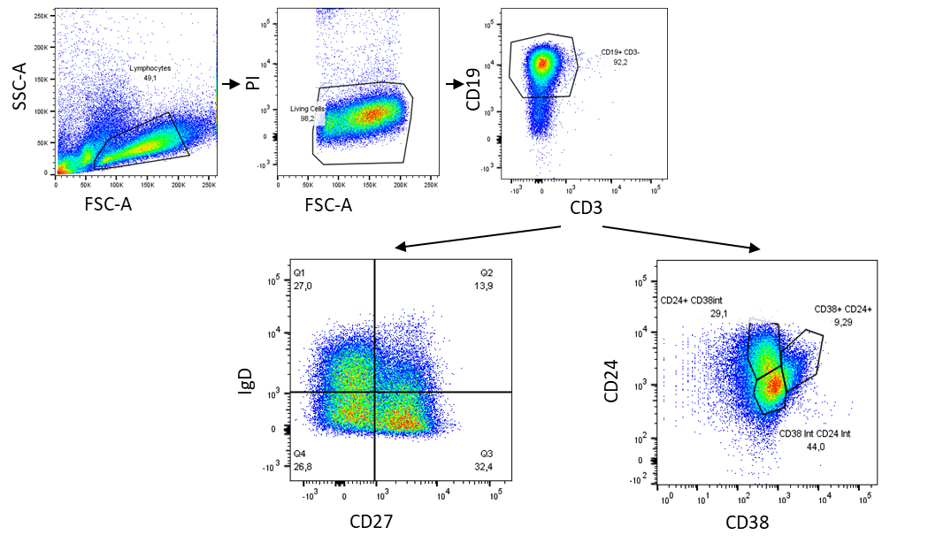
Figure 3: Gating of B cell subgroups
: Gating for lymphocytes by sideways scatter (SSC-A) and forwards scatter (FSC-A), then for living cells by the lack of propidium iodide (PI) uptake. B cell gating by CD19+ and CD3-. Then gating was performed for either IgD and CD27 or CD24 and CD38 identifying: CD27- IgD+ naïve B cells, CD27- IgD- double negative B cells, CD27+ IgD- switched memory B cells, CD27+ IgD+ non-switched memory B cells; CD24+ CD38int memory B cells, CD24+ CD38+ regulatory B cells, CD24int CD38int mature naïve B cells.

BAFF increases IL-10 release of naïve B cells
It was previously suggested that IL-10 release in murine splenic B cells was increased by BAFF treatment (102). Therefore, we treated human naïve B cells (CD19+CD27-) and cells from the general B cell pool (CD19+) with different concentrations of BAFF for three and six days. Then ELISA of the supernatants was performed. Here, we could show a significant increase in IL-10 release by naïve B cells treated with 50 ng/ml of BAFF on day 3 (mean difference to untreated: -0.2087, 95%CI [-0.4, -0.01733], p = 0.0398, n = 5) when normalised to the untreated condition. This effect was not present with any other concentration of BAFF, nor on day 6 (Figure 4). Viability was only significantly decreased when comparing untreated day 3 to treated with 500 ng/ml on day 6 (mean difference: 0.76%, p = 0.0394, not shown). For all other conditions, no difference in viability was detected. Viability was determined by the percentage of lymphocytes not taking up PI.
In contrast to naïve B cells, IL-10 release was not significantly influenced by BAFF independent of concentration within the general pool of B cells (not shown). Here one must take into account that the general B cell pool experiments were performed without stimulation with PMA and ionomycin. There was no significant difference in viability between the treatment conditions.
Figure 4: IL-10 release in B cell subgroups treated with BAFF: IL-10 release in naïve B cells treated with different concentration of BAFF on day 3 and day 6, normalised to untreated. *p < 0.05.

BAFF decreases memory and pro-inflammatory B cells
Not only cytokine release but also surface markers can identify different stages of maturity and inflammatory potential of B cells. This is especially important, as different subgroups carry various importance in disease development. Li et al. identified B cells representing CD27+ IgD- CD24+ CD38int as the pro-inflammatory B cell type most common in MS (9). Therefore, we sorted lymphocytes for CD19 or CD19 and lack of CD27 (CD19+ CD27-) and treated those cells with different concentrations of BAFF (untreated, 50 ng/ml, 100 ng/ml, 500 ng/ml) in culture for three and six days, when FACS analysis for subgroups was performed. Exemplary gating strategy for subgroups identified by surface markers is shown in Figure 3.
Treatment with 500 ng/ml of BAFF significantly decreased the proportion of switched memory B cells (CD27+ IgD-) within the general B cell population on day 6 (mean difference 0.3302, 95%CI [0.2242, 0.4362], p = 0.0008) and nearly significantly on day 3 (mean difference: 0.09271, 95%CI [-0.01603, 0.02015], p = 0.0805) Figure 5A. Moreover, BAFF significantly decreases the proportion of switched memory B cells (CD27+ IgD-) of the naïve B cell population with lower concentrations of BAFF as well, but solely on day 6 (with 50 ng/ml; mean difference: 0.4217, 95%CI [0.06432, 0.7791], p = 0.0293; with 100 ng/ml; mean difference 0.4157 95%CI [0.07863, 0.7528], p = 0.0252), not reaching significance with 500 ng/ml (mean difference: 0.3223, 95%CI: [-0.08474, 0.7293], p = 0.0999) (Figure 5C).
As described above, memory B cells can also be identified by a high representation of surface marker CD24 with intermediate levels of CD38. Even though the drop in the proportion of memory B cells when applying these markers is not as clear, it seems to follow the same tendency with a drop on day 6 when B cells are exposed to a high concentration of BAFF (500 ng/ml mean difference 0.2424, 95%CI [-0.02168, 0.5064], p = 0.0651) (Figure 5B). This effect seems not to be as strong in naïve B cells (Figure 5D).
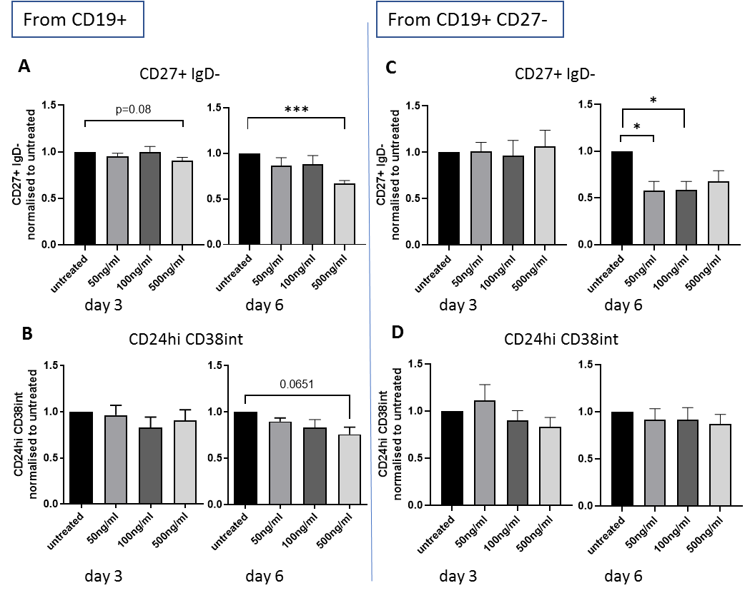
Figure 5: Influence of BAFF on proportion of memory and pro-inflammatory B cells: Proportion of memory B cells defined by co-expression of CD27+ IgD- (A&C) or CD24hi CD38int (B&D) after exposure of CD19+ (A&B) or CD19+ CD27- (C&D) B cells with different concentrations of BAFF for three or six days normalised to untreated. *p < 0.05, ***p< 0.001

BAFF increases proportion of mature naïve B cells
Further investigating the influence of BAFF on the proportion of B cell subgroups, BAFF was shown to decrease regulatory B cells (CD24+ CD38+) on day 3 within the general B cell pool (CD19+) treated with 50 ng/ml BAFF (mean difference: 1.372, 95%CI [0.09362, 2.650], p = 0.0387) (Figure 6A). However, this cell type could include naïve and memory B cells.
Therefore, we investigated which subgroups concomitantly increased with BAFF treatment. Naïve B cells representing IgD expression whilst lacking CD27, were raised on day 3 (mean difference: -1.9, 95%CI [-2.677, -1.123], p = 0.0006) (Figure 6B) whilst the proportion of B cells expressing intermediate levels of CD24 and CD38 (CD24int CD38int) increased on day 6 (mean difference: -4.014, 95%CI [-7.256, -0.7723], p = 0.0207) (Figure 6C), both with 50 ng/ml BAFF. Combining these markers identify mature naïve B cells (Figure 2), therefore most likely indicating an increase in mature naïve B cells through BAFF exposure. These dynamics could not be shown in naïve B cells treated with BAFF (data not shown).
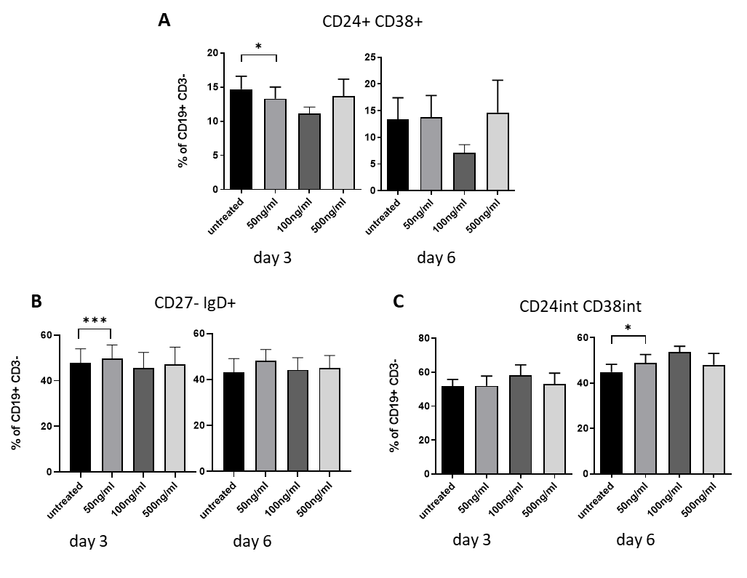
Figure 6: Influence of BAFF on proportion of subgroups of B cells: Change of percentage of (A) regulatory B cells (CD24+ CD38+), (B&C) mature naïve B cells representing IgD on their surface, intermediate levels of CD24 and CD38 and lacking CD27. All presented as percentage of CD19+ CD3- cells from pre-sorted B cells (CD19+) after three and six days of BAFF treatment. *p < 0.05, ***p < 0.001

BAFF increases double negative B cells
On another note, 50 ng/ml BAFF also increased double negative B cells (CD27- IgD-) on day 6 from the general B cell pool (CD19+) (mean difference: 0.1794, 95%CI [-0.3362, -0.02271], p = 0.03231) (Figure 7). Double negative B cells are thought to have undergone class switch but were unable to gain CD27 on their surface. These are associated with autoimmune diseases such as SLE and rheumatoid arthritis but have not been associated with a unique role in the development in multiple sclerosis (103).
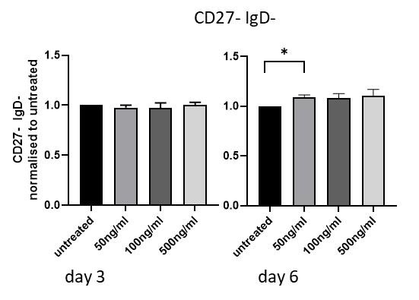
Figure 7: Influence of BAFF on proportion of double negative B cells: Proportion of CD27- IgD- B cells (of CD19+ CD3- cells) after treatment with different concentrations of BAFF for 3 or 6 days normalised to untreated. *p < 0.05

BAFF has no effect on cytokine release by Th1/Th17-like cells nor on the GM-CSF release by B cells
BAFF not only has been shown to influence B cells but also T cells. Therefore, CD4+ CD45RO- memory T cells shifted to a Th1/Th17-like type for seven days were treated with different concentrations of BAFF (untreated, 50 ng/ml, 500 ng/ml) for the final 24 h. The cytokine profile was then investigated by FACS analysis. The percentages of GM-CSF, IFNγ and IL-17A positive T cells were not significantly changed by BAFF (Figure 8).

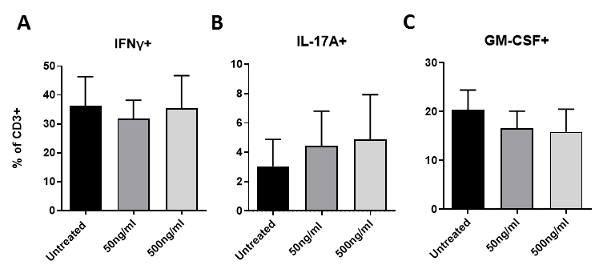
Figure 8: Cytokine profile in Th1/Th17-like cells treated with BAFF: (A) IFNγ, (B) IL-17A and (C) GM-CSF positive Th1/Th17-like cells from shifted T cells exposed to different concentrations of BAFF.

As described above, GM-CSF releasing B cells were displayed to be of high prevalence and importance in MS pathogenesis (9, 25). A role of BAFF on these has to our knowledge not been discovered, yet. Therefore, we also investigated the impact of BAFF on the proportion of GM-CSF positive B cells. Exposure to different concentrations of BAFF (50ng/ml, 100ng/ml, 500ng/ml) for 3 or 6 days did not change the percentage of GM-CSF releasing B cells in neither pre-sorted naïve (CD19+CD27-) nor the general pool of B cells (CD19+) (Figure 9 A,B).

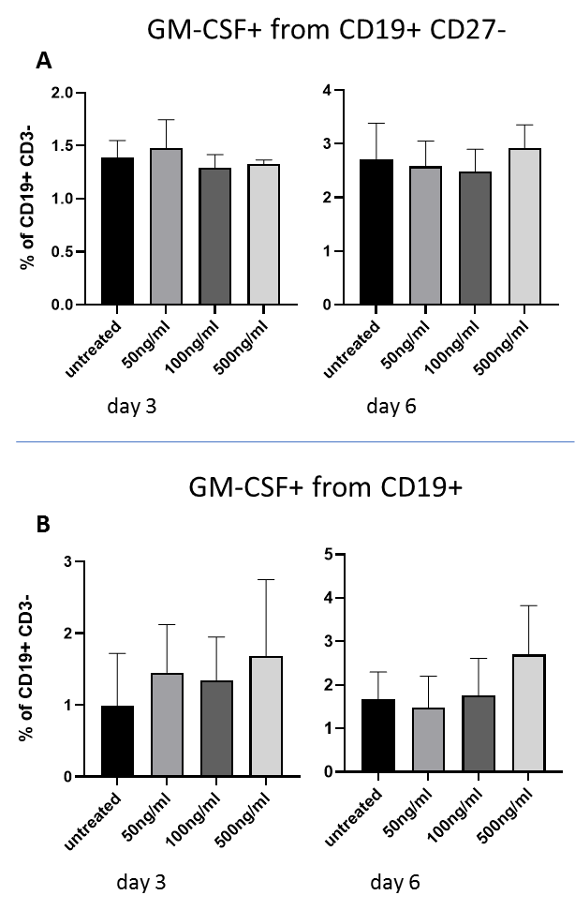
Figure 9: Proportion of GM-CSF positive B cells after treatment with BAFF: (A) Pre-sorted naïve B cells (CD19+ CD27-) or (B) CD19+ B cells treated with different concentration of BAFF for 3 or 6 days. All displayed as percentage of B cells (CD19+CD3-).

Discussion
Multiple sclerosis patients present a disbalance with a burden of pro-inflammatory cell functions. In terms of this, not only a lack of regulatory B cells but also a dysfunction of these in inflammatory T cell suppression have been shown in disease (104, 105).
The long-term effect of B cell depletion therapy, acting through cellular cytotoxicity and apoptosis, with data showing protection even after repopulation of B cells supports the theory of a ‘reset’ in B cell biology (24, 34). Previous studies show an increase in BAFF correlating with B cell depletion, making it a possible factor in this ‘reset’ (19, 106, 107). BAFF has been shown to be important in B cell maturation and its role is accounted pro-inflammatory in multiple autoimmune diseases (108, 109). Even though the antagonization of BAFF showed efficiency in the treatment of the murine MS model EAE, it had devastating effects in MS patients reflecting a possibly regulatory function in multiple sclerosis (96, 98, 110, 111). However, the underlying reasons are still unclear.
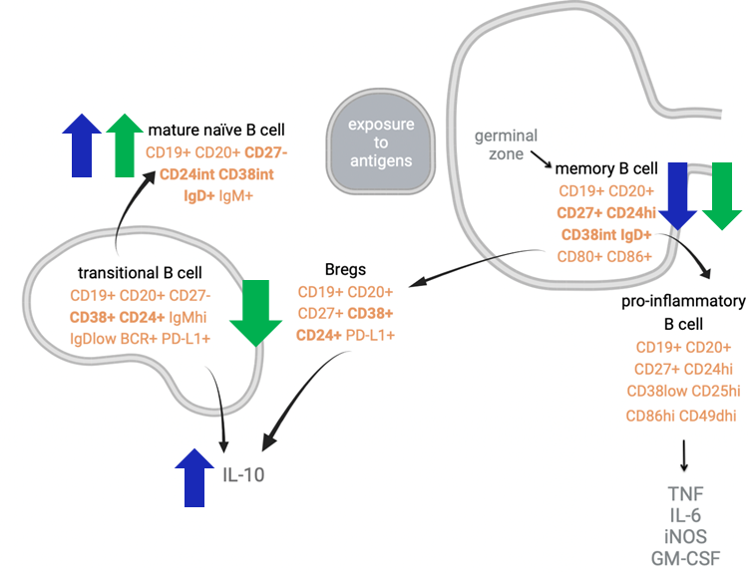
Figure 10: Effect of BAFF on the proportions of B cell subgroups and IL-10 release: Schematic display of BAFF effect on the different B cell subgroups. Effect in CD19+ pre-sorted B cells indicated by blue arrows, in CD19+CD27- pre-sorted naïve B cells by green arrows, markers used in this work for identification of subgroups in bold.
We could show that the percentage of the mature naïve B cell type (CD27- IgD+ & CD38Int CD24Int) from B cells (CD19+) is greater when exposed to BAFF. Furthermore, the proportion of memory B cells (CD27+ IgD- ; CD24hi CD38int), from naïve B cells and within the general B cell pool, was decreased by BAFF exposure. A schematic overview of the BAFF effect is displayed in Figure 10.
This dynamic is mirrored in previous clinical data displaying repopulating B cells after depletion through rituximab to be predominantly less mature but highly activated (19). Repopulating B cells after depletion through the monoclonal antibody against the lymphocytic surface protein CD52 (alemtuzumab) that demolishes B and T cells, were mostly mature naïve B cells correlating with high BAFF levels (112, 113). Alemtuzumab has been shown to be greatly efficient in therapy resistant MS leading to a long-term stabilisation of the disease. Moreover, the blockage of BAFF through the medication atacicept was shown to limit the survival of naïve B cells as well as plasmablasts while it had no impact on memory B cells (41). All this supports the important role of BAFF in maintaining naïve B cells, which seems to play an important role in MS flare control (96).
The drop of memory B cells through BAFF exposure is of particular interest as CD27+ IgD- CD24hi CD38int memory B cells were described to be the major pro-inflammatory B cell type present in MS (9). Generally, memory B cells are accepted as disease driving and have been shown to correlate positively with clinical activity (displayed by high EDSS) under interferon therapy (114).

We could also show that in line with previous data of murine splenic cells, BAFF leads to an increase in IL-10 release by naïve B cells (102). The regulatory cytokine IL-10 is particularly decreased in patients with MS and replacement in EAE showed promising results (46-49). Comparing all this to naïve B cells from people with MS would be particularly interesting as there have been suggestions that their release of IL-10 is malfunctioning (104). Nevertheless, IL-10 plays a dichotomous role in disease, as it has for example been shown to be responsible for scar formation in chronic MS (51).
The surge in IL-10 was not present in the CD19 general B cell pool treated with BAFF. This might be explained through a role of different ligand stimulation in inducing IL-10 release. For example, multiple studies suggest an induction of IL-10 in naïve B cells through CD40 activation, usually by activated T cells (34, 44, 54). In memory IL-10-releasing B cells (‘Bregs’), this was shown to be triggered through toll-like-receptor 4 and 9 activation that is usually pathogen-induced (34, 44, 54, 115, 116). We stimulated B cell receptor and CD40 to represent antigen binding and stimulation through T cell interaction, respectively (29). Even though not directly triggered, evidence proves interlacing of toll-like-receptor with B cell receptor (BCR) response (117). Further co-stimulation through CD80/86 coupling by T cells’ CD28 is another trigger point that should be investigated in future studies. CD80 positive B cells are shown to be elevated in MS, indicating future importance in investigation (118).

In literature, a great variability on specific markers of B cell subgroups can be found. Therefore, part of this work was also to define the different subgroups of B cells according to the greatest cross over between publications on B cell subgroup defining markers in humans. Memory B cells were identified by the expression of CD27 and lack of IgD, and by the expression of high levels of CD24 and intermediate levels of CD38 (37, 119). A measurement of the co-expression would have been preferential, but proportions were comparable applying both definitions.
Naïve B cells are generally defined by the lack of CD27 and expression of IgD on their surface (37). Mature naïve B cells, the stage between transitional and memory B cells, are identified by an intermediate level of CD24 and CD38, as well as displaying IgD whilst lacking CD27 (120). Regulatory B cells highly express CD24 and CD38 on surface, including CD27 negative transitional and CD27 positive ‘Bregs’, both accounted for as main producers of IL-10 (20, 42, 44, 60). Double negatives, a cell type associated with autoimmune disease, are defined by a lack of CD27 and IgD expression on surface (103).
The percentages of memory B cells, mature naïve and naïve B cells from CD19+ B cells were comparable to, whilst the proportion of double negative and regulatory B cells in this work were around 5 -10 % greater than in previously described ex vivo proportions (119-122). Subgroups were previously shown to be different depending on the age of the donor. Two out of three previous papers describing ex vivo proportions did not pre-sort for B cells, and did not apply intracultural stimulation; moreover, their cohorts were of Asian and Hispanic ethnicity, whilst our cohort was Caucasian, possibly explaining minor differences (119, 121, 122).

CD20 antibody therapy (rituximab and ocrelizumab) has also been shown to influence highly activated, migratory and pro-inflammatory CD20+ CD3+ T cells and lead to an increase in naïve / effector T cell ratio. Furthermore, ocrelizumab was found to induce Tregs and increase IL-10-expressing T cells whilst decreasing IFNγ-releasing T cells.
Lastly, we therefore investigated the influence of BAFF exposure on the release of the pro-inflammatory cytokines GM-CSF, IFNγ and IL-17A by Th1/Th 17-like cells but could not show any significant direct effect. In contrast, previous studies showed greater activation and cytokine release by murine and human T cells (CD3+) in vitro and greater proliferation in memory (CD45RO) and naïve (CD45RA) T cells through BAFF exposure (82, 85). However, cytokine profiles were to our knowledge not previously investigated in subgroups of T cells treated with BAFF. Using our pre-established protocol, we tried to investigate the effect of BAFF on pro-inflammatory Th1/Th17-like cells. The fact that fully developed T cells do not depend as much on external activation signals could explain these observations.

Summary & Outlook
It seems clear that B cells carry an important role in the pathogenesis of MS. However, it is still unclear how this role is exerted and influenced. We aimed to shed more light on the direct effect of BAFF on the proportion of different B cell subgroups by categorising these based on previous research and identifying particularities of the BAFF-immune cell interaction.
There has been a great discussion on the role of BAFF influencing immune cells and disease activity in MS. For years, the perception of a pro-inflammatory role of BAFF was carried by its clinical correlation with autoimmune diseases including its role in promoting B cell survival, proliferation and prevention of apoptosis of antibody-secreting cells from the memory B cell pool (74). The surprising detrimental effect of antagonising BAFF signalling in MS stands in great contrast to the effect in other autoimmune diseases. This points out that there must be other underlying aspects specific to this inflammatory disease of the CNS.
In this study, no pro-inflammatory impact on B cells through BAFF exposure in terms of memory B cell proliferation or GM-CSF, IFNγ, or IL-17A release could be shown. Pro-inflammatory cytokine profiles from Th1/Th17-like cell were also not influenced by BAFF.
In contrast, we could show that BAFF induces particular effects on B cells, by maintaining mature naïve B cells, increasing IL-10 release and reducing the proportion of disease-promoting memory B cells. Therefore, we argue for a rather anti-inflammatory role BAFF enacts on B cells and possibly in MS pathogenesis.
Identifying markers specific for B cell subgroups has been a difficulty due to dynamic changes of surface markers during maturation, cell interaction and immune activation. Human B cells in MS also seem to be greatly heterogeneous in phenotype and those inhabiting the CNS are almost impossible to investigate (19). We display a clear overview of the B cells subgroups and the roles they enact. Future clinical studies will more closely define their specific roles in MS induction and maintenance.
This study displays a great variance of the BAFF effect in human cell culture. This makes us believe that the B cell / BAFF interaction is greatly susceptible to minor changes in BAFF concentrations and part of a very complex interplay of specific receptor-ligand interaction and the primary B cell type present. Only little is known for example about the effect of specific BAFF receptor activation / dimer development and blockage. In the pathogenically related disease rheumatoid arthritis, BAFF-R levels were significantly reduced in those relapsing after repopulation of B cells after CD20 treatment, interestingly independent of the BAFF serum levels (123).
Furthermore, one should not underestimate the interaction between different immune cells, not represented in this work. This study was performed on B cells retrieved from healthy donors and the ‘setting’ of B cells in MS could be unalike (29). The pathogenesis of MS certainly differs from other autoimmune diseases but even from the murine antibody or T cell mediated MS model EAE. Furthermore, statements made on the basis of peripheral immune cells should be made carefully as the correlation between cytokine levels in CSF and serum is for example weak and multiple factors within the CNS are difficult to investigate (31). A great impact might also be displayed by the direct interaction of B cells and BAFF with cells of the CNS. As such, activation by APRIL, binding to two of the three BAFF receptors, has shown to induce an anti-inflammatory reaction and IL-10 release by astrocytes (124).
In the future, long-term repopulation studies on cell types and BAFF levels in connection with clinical phenotypes (EDSS) and relapse rates will be particularly interesting. Intrinsic signalling explaining the influence BAFF exerts on phenotype and cytokine release from B and T cells is also still to be explored.

Altogether, this work begins to find an explanation for the possibly protective effect BAFF enacts in development and maintenance of MS, by promoting anti-inflammatory B cell types and cytokines whilst reducing pro-inflammatory memory B cells. The novel perception of BAFF as a regulatory player, that our findings support, offers the opportunity for a future use in personalized therapy, possibly further reducing side effects whilst suppressing disease activity.

References
1. Love S. Demyelinating diseases. J Clin Pathol. 2006;59(11):1151-9.
2. Noseworthy JH, Lucchinetti C, Rodriguez M, Weinshenker BG. Multiple sclerosis. N Engl J Med. 2000;343(13):938-52.
3. Marrie RA. Environmental risk factors in multiple sclerosis aetiology. Lancet Neurol. 2004;3(12):709-18.
4. Miller DH, Chard DT, Ciccarelli O. Clinically isolated syndromes. Lancet Neurol. 2012;11(2):157-69.
5. Hou Y, Jia Y, Hou J. Natural Course of Clinically Isolated Syndrome: A Longitudinal Analysis Using a Markov Model. Sci Rep. 2018;8(1):10857.
6. Miller DH, Weinshenker BG, Filippi M, Banwell BL, Cohen JA, Freedman MS, et al. Differential diagnosis of suspected multiple sclerosis: a consensus approach. Mult Scler. 2008;14(9):1157-74.
7. Magliozzi R, Marastoni D, Calabrese M. The BAFF / APRIL system as therapeutic target in multiple sclerosis. Expert Opin Ther Targets. 2020;24(11):1135-45.
8. Kebir H, Kreymborg K, Ifergan I, Dodelet-Devillers A, Cayrol R, Bernard M, et al. Human TH17 lymphocytes promote blood-brain barrier disruption and central nervous system inflammation. Nat Med. 2007;13(10):1173-5.
9. Li R, Rezk A, Miyazaki Y, Hilgenberg E, Touil H, Shen P, et al. Proinflammatory GM-CSF-producing B cells in multiple sclerosis and B cell depletion therapy. Sci Transl Med. 2015;7(310):310ra166.
10. Trojano M, Lucchese G, Graziano G, Taylor BV, Simpson S, Jr., Lepore V, et al. Geographical variations in sex ratio trends over time in multiple sclerosis. PLoS One. 2012;7(10):e48078.
11. Lublin FD, Reingold SC. Defining the clinical course of multiple sclerosis: results of an international survey. National Multiple Sclerosis Society (USA) Advisory Committee on Clinical Trials of New Agents in Multiple Sclerosis. Neurology. 1996;46(4):907-11.
12. Eshaghi A, Prados F, Brownlee WJ, Altmann DR, Tur C, Cardoso MJ, et al. Deep gray matter volume loss drives disability worsening in multiple sclerosis. Ann Neurol. 2018;83(2):210-22.
13. Thompson AJ, Banwell BL, Barkhof F, Carroll WM, Coetzee T, Comi G, et al. Diagnosis of multiple sclerosis: 2017 revisions of the McDonald criteria. Lancet Neurol. 2018;17(2):162-73.
14. Bar-Or A. The immunology of multiple sclerosis. Semin Neurol. 2008;28(1):29-45.
15. Obermeier B, Lovato L, Mentele R, Bruck W, Forne I, Imhof A, et al. Related B cell clones that populate the CSF and CNS of patients with multiple sclerosis produce CSF immunoglobulin. J Neuroimmunol. 2011;233(1-2):245-8.
16. Howell OW, Reeves CA, Nicholas R, Carassiti D, Radotra B, Gentleman SM, et al. Meningeal inflammation is widespread and linked to cortical pathology in multiple sclerosis. Brain. 2011;134(Pt 9):2755-71.
17. Serafini B, Rosicarelli B, Magliozzi R, Stigliano E, Aloisi F. Detection of ectopic B-cell follicles with germinal centers in the meninges of patients with secondary progressive multiple sclerosis. Brain Pathol. 2004;14(2):164-74.
18. Siffrin V, Radbruch H, Glumm R, Niesner R, Paterka M, Herz J, et al. In vivo imaging of partially reversible th17 cell-induced neuronal dysfunction in the course of encephalomyelitis. Immunity. 2010;33(3):424-36.
19. Nissimov N, Hajiyeva Z, Torke S, Grondey K, Bruck W, Hausser-Kinzel S, et al. B cells reappear less mature and more activated after their anti-CD20-mediated depletion in multiple sclerosis. Proc Natl Acad Sci U S A. 2020;117(41):25690-9.
20. Blair PA, Norena LY, Flores-Borja F, Rawlings DJ, Isenberg DA, Ehrenstein MR, et al. CD19(+)CD24(hi)CD38(hi) B cells exhibit regulatory capacity in healthy individuals but are functionally impaired in systemic Lupus Erythematosus patients. Immunity. 2010;32(1):129-40.
21. Warren KG, Catz I. Autoantibodies to myelin basic protein within multiple sclerosis central nervous system tissue. J Neurol Sci. 1993;115(2):169-76.
22. Warren KG, Catz I, Johnson E, Mielke B. Anti-myelin basic protein and anti-proteolipid protein specific forms of multiple sclerosis. Ann Neurol. 1994;35(3):280-9.
23. O'Connor KC, Appel H, Bregoli L, Call ME, Catz I, Chan JA, et al. Antibodies from inflamed central nervous system tissue recognize myelin oligodendrocyte glycoprotein. J Immunol. 2005;175(3):1974-82.
24. von Budingen HC, Bar-Or A, Zamvil SS. B cells in multiple sclerosis: connecting the dots. Curr Opin Immunol. 2011;23(6):713-20.
25. Lotfi N, Thome R, Rezaei N, Zhang GX, Rezaei A, Rostami A, et al. Roles of GM-CSF in the Pathogenesis of Autoimmune Diseases: An Update. Front Immunol. 2019;10:1265.
26. Rasouli J, Ciric B, Imitola J, Gonnella P, Hwang D, Mahajan K, et al. Expression of GM-CSF in T Cells Is Increased in Multiple Sclerosis and Suppressed by IFN-beta Therapy. J Immunol. 2015;194(11):5085-93.
27. Blauth K, Soltys J, Matschulat A, Reiter CR, Ritchie A, Baird NL, et al. Antibodies produced by clonally expanded plasma cells in multiple sclerosis cerebrospinal fluid cause demyelination of spinal cord explants. Acta Neuropathol. 2015;130(6):765-81.
28. Staun-Ram E, Miller A. Effector and regulatory B cells in Multiple Sclerosis. Clinical Immunology. 2017;184:11-25.
29. Bar-Or A, Fawaz L, Fan B, Darlington PJ, Rieger A, Ghorayeb C, et al. Abnormal B-cell cytokine responses a trigger of T-cell-mediated disease in MS? Ann Neurol. 2010;67(4):452-61.
30. Lovato L, Willis SN, Rodig SJ, Caron T, Almendinger SE, Howell OW, et al. Related B cell clones populate the meninges and parenchyma of patients with multiple sclerosis. Brain. 2011;134(Pt 2):534-41.
31. Lepennetier G, Hracsko Z, Unger M, Van Griensven M, Grummel V, Krumbholz M, et al. Cytokine and immune cell profiling in the cerebrospinal fluid of patients with neuro-inflammatory diseases. J Neuroinflammation. 2019;16(1):219.
32. Magliozzi R, Howell OW, Reeves C, Roncaroli F, Nicholas R, Serafini B, et al. A Gradient of neuronal loss and meningeal inflammation in multiple sclerosis. Ann Neurol. 2010;68(4):477-93.
33. Wolinsky JS, Montalban X, Hauser SL, Giovannoni G, Vermersch P, Bernasconi C, et al. Evaluation of no evidence of progression or active disease (NEPAD) in patients with primary progressive multiple sclerosis in the ORATORIO trial. Ann Neurol. 2018;84(4):527-36.
34. Li R, Patterson KR, Bar-Or A. Reassessing B cell contributions in multiple sclerosis. Nat Immunol. 2018;19(7):696-707.
35. Hauser SL, Bar-Or A, Comi G, Giovannoni G, Hartung HP, Hemmer B, et al. Ocrelizumab versus Interferon Beta-1a in Relapsing Multiple Sclerosis. N Engl J Med. 2017;376(3):221-34.
36. Hauser SL, Belachew S, Kappos L. Ocrelizumab in Primary Progressive and Relapsing Multiple Sclerosis. N Engl J Med. 2017;376(17):1694.
37. Murphy K. Janeway's Immunobiology 2012;8th Edition.
38. Lee DSW, Rojas OL, Gommerman JL. B cell depletion therapies in autoimmune disease: advances and mechanistic insights. Nat Rev Drug Discov. 2021;20(3):179-99.
39. Gingele S, Jacobus TL, Konen FF, Hummert MW, Suhs KW, Schwenkenbecher P, et al. Ocrelizumab Depletes CD20(+) T Cells in Multiple Sclerosis Patients. Cells. 2018;8(1).
40. Pieper K, Grimbacher B, Eibel H. B-cell biology and development. J Allergy Clin Immunol. 2013;131(4):959-71.
41. Smulski CR, Eibel H. BAFF and BAFF-Receptor in B Cell Selection and Survival. Front Immunol. 2018;9:2285.
42. Flores-Borja F, Bosma A, Ng D, Reddy V, Ehrenstein MR, Isenberg DA, et al. CD19+CD24hiCD38hi B cells maintain regulatory T cells while limiting TH1 and TH17 differentiation. Sci Transl Med. 2013;5(173):173ra23.
43. Vincent FB, Saulep-Easton D, Figgett WA, Fairfax KA, Mackay F. The BAFF/APRIL system: emerging functions beyond B cell biology and autoimmunity. Cytokine Growth Factor Rev. 2013;24(3):203-15.
44. Iwata Y, Matsushita T, Horikawa M, Dilillo DJ, Yanaba K, Venturi GM, et al. Characterization of a rare IL-10-competent B-cell subset in humans that parallels mouse regulatory B10 cells. Blood. 2011;117(2):530-41.
45. Oleinika K, Mauri C, Salama AD. Effector and regulatory B cells in immune-mediated kidney disease. Nat Rev Nephrol. 2019;15(1):11-26.
46. Moore KW, O'Garra A, de Waal Malefyt R, Vieira P, Mosmann TR. Interleukin-10. Annu Rev Immunol. 1993;11:165-90.
47. Matsushita T, Yanaba K, Bouaziz JD, Fujimoto M, Tedder TF. Regulatory B cells inhibit EAE initiation in mice while other B cells promote disease progression. J Clin Invest. 2008;118(10):3420-30.
48. Yoshizaki A, Miyagaki T, DiLillo DJ, Matsushita T, Horikawa M, Kountikov EI, et al. Regulatory B cells control T-cell autoimmunity through IL-21-dependent cognate interactions. Nature. 2012;491(7423):264-8.
49. Cua DJ, Groux H, Hinton DR, Stohlman SA, Coffman RL. Transgenic interleukin 10 prevents induction of experimental autoimmune encephalomyelitis. J Exp Med. 1999;189(6):1005-10.
50. Fillatreau S, Sweenie CH, McGeachy MJ, Gray D, Anderton SM. B cells regulate autoimmunity by provision of IL-10. Nat Immunol. 2002;3(10):944-50.
51. Cannella B, Gao YL, Brosnan C, Raine CS. IL-10 fails to abrogate experimental autoimmune encephalomyelitis. J Neurosci Res. 1996;45(6):735-46.
52. Hulshof S, Montagne L, De Groot CJ, Van Der Valk P. Cellular localization and expression patterns of interleukin-10, interleukin-4, and their receptors in multiple sclerosis lesions. Glia. 2002;38(1):24-35.
53. Xiao BG, Bai XF, Zhang GX, Link H. Suppression of acute and protracted-relapsing experimental allergic encephalomyelitis by nasal administration of low-dose IL-10 in rats. J Neuroimmunol. 1998;84(2):230-7.
54. Duddy M, Niino M, Adatia F, Hebert S, Freedman M, Atkins H, et al. Distinct effector cytokine profiles of memory and naive human B cell subsets and implication in multiple sclerosis. J Immunol. 2007;178(10):6092-9.
55. Wei Y, Chang H, Feng H, Li X, Zhang X, Yin L. Low Serum Interleukin-10 Is an Independent Predictive Factor for the Risk of Second Event in Clinically Isolated Syndromes. Front Neurol. 2019;10:604.
56. Pestka S, Krause CD, Sarkar D, Walter MR, Shi Y, Fisher PB. Interleukin-10 and related cytokines and receptors. Annu Rev Immunol. 2004;22:929-79.
57. Heine G, Drozdenko G, Grun JR, Chang HD, Radbruch A, Worm M. Autocrine IL-10 promotes human B-cell differentiation into IgM- or IgG-secreting plasmablasts. Eur J Immunol. 2014;44(6):1615-21.
58. <Flores-Borja, 2019, B-cell impact on Tcells.pdf>.
59. Viglietta V, Baecher-Allan C, Weiner HL, Hafler DA. Loss of functional suppression by CD4+CD25+ regulatory T cells in patients with multiple sclerosis. J Exp Med. 2004;199(7):971-9.
60. Mielle J, Audo R, Hahne M, Macia L, Combe B, Morel J, et al. IL-10 Producing B Cells Ability to Induce Regulatory T Cells Is Maintained in Rheumatoid Arthritis. Front Immunol. 2018;9:961.
61. Kim Y, Kim G, Shin HJ, Hyun JW, Kim SH, Lee E, et al. Restoration of regulatory B cell deficiency following alemtuzumab therapy in patients with relapsing multiple sclerosis. J Neuroinflammation. 2018;15(1):300.
62. Thompson JS, Bixler SA, Qian F, Vora K, Scott ML, Cachero TG, et al. BAFF-R, a newly identified TNF receptor that specifically interacts with BAFF. Science. 2001;293(5537):2108-11.
63. Thompson JS, Schneider P, Kalled SL, Wang L, Lefevre EA, Cachero TG, et al. BAFF binds to the tumor necrosis factor receptor-like molecule B cell maturation antigen and is important for maintaining the peripheral B cell population. J Exp Med. 2000;192(1):129-35.
64. Gross JA, Johnston J, Mudri S, Enselman R, Dillon SR, Madden K, et al. TACI and BCMA are receptors for a TNF homologue implicated in B-cell autoimmune disease. Nature. 2000;404(6781):995-9.
65. Schneider P, MacKay F, Steiner V, Hofmann K, Bodmer JL, Holler N, et al. BAFF, a novel ligand of the tumor necrosis factor family, stimulates B cell growth. J Exp Med. 1999;189(11):1747-56.
66. Moore PA, Belvedere O, Orr A, Pieri K, LaFleur DW, Feng P, et al. BLyS: member of the tumor necrosis factor family and B lymphocyte stimulator. Science. 1999;285(5425):260-3.
67. Hahne M, Kataoka T, Schroter M, Hofmann K, Irmler M, Bodmer JL, et al. APRIL, a new ligand of the tumor necrosis factor family, stimulates tumor cell growth. J Exp Med. 1998;188(6):1185-90.
68. Thangarajh M, Gomes A, Masterman T, Hillert J, Hjelmstrom P. Expression of B-cell-activating factor of the TNF family (BAFF) and its receptors in multiple sclerosis. J Neuroimmunol. 2004;152(1-2):183-90.
69. Darce JR, Arendt BK, Wu X, Jelinek DF. Regulated expression of BAFF-binding receptors during human B cell differentiation. J Immunol. 2007;179(11):7276-86.
70. Hatzoglou A, Roussel J, Bourgeade MF, Rogier E, Madry C, Inoue J, et al. TNF receptor family member BCMA (B cell maturation) associates with TNF receptor-associated factor (TRAF) 1, TRAF2, and TRAF3 and activates NF-kappa B, elk-1, c-Jun N-terminal kinase, and p38 mitogen-activated protein kinase. J Immunol. 2000;165(3):1322-30.
71. Do RK, Hatada E, Lee H, Tourigny MR, Hilbert D, Chen-Kiang S. Attenuation of apoptosis underlies B lymphocyte stimulator enhancement of humoral immune response. J Exp Med. 2000;192(7):953-64.
72. Zhu XJ, Shi Y, Peng J, Guo CS, Shan NN, Qin P, et al. The effects of BAFF and BAFF-R-Fc fusion protein in immune thrombocytopenia. Blood. 2009;114(26):5362-7.
73. Hobeika E, Levit-Zerdoun E, Anastasopoulou V, Pohlmeyer R, Altmeier S, Alsadeq A, et al. CD19 and BAFF-R can signal to promote B-cell survival in the absence of Syk. EMBO J. 2015;34(7):925-39.
74. Avery DT, Kalled SL, Ellyard JI, Ambrose C, Bixler SA, Thien M, et al. BAFF selectively enhances the survival of plasmablasts generated from human memory B cells. J Clin Invest. 2003;112(2):286-97.
75. Warnatz K, Salzer U, Rizzi M, Fischer B, Gutenberger S, Bohm J, et al. B-cell activating factor receptor deficiency is associated with an adult-onset antibody deficiency syndrome in humans. Proc Natl Acad Sci U S A. 2009;106(33):13945-50.
76. Mackay F, Woodcock SA, Lawton P, Ambrose C, Baetscher M, Schneider P, et al. Mice transgenic for BAFF develop lymphocytic disorders along with autoimmune manifestations. J Exp Med. 1999;190(11):1697-710.
77. Khare SD, Sarosi I, Xia XZ, McCabe S, Miner K, Solovyev I, et al. Severe B cell hyperplasia and autoimmune disease in TALL-1 transgenic mice. Proc Natl Acad Sci U S A. 2000;97(7):3370-5.
78. Groom J, Kalled SL, Cutler AH, Olson C, Woodcock SA, Schneider P, et al. Association of BAFF/BLyS overexpression and altered B cell differentiation with Sjogren's syndrome. J Clin Invest. 2002;109(1):59-68.
79. Zhou X, Xia Z, Lan Q, Wang J, Su W, Han YP, et al. BAFF promotes Th17 cells and aggravates experimental autoimmune encephalomyelitis. PLoS One. 2011;6(8):e23629.
80. Shan X, Chen L, Cao M, Xu L, Zhang S. Effects of human soluble BAFF synthesized in Escherichia coli on CD4+ and CD8+ T lymphocytes as well as NK cells in mice. Physiol Res. 2006;55(3):301-7.
81. Walters S, Webster KE, Sutherland A, Gardam S, Groom J, Liuwantara D, et al. Increased CD4+Foxp3+ T cells in BAFF-transgenic mice suppress T cell effector responses. J Immunol. 2009;182(2):793-801.
82. Huard B, Schneider P, Mauri D, Tschopp J, French LE. T cell costimulation by the TNF ligand BAFF. J Immunol. 2001;167(11):6225-31.
83. Kahn P, Ramanujam M, Bethunaickan R, Huang W, Tao H, Madaio MP, et al. Prevention of murine antiphospholipid syndrome by BAFF blockade. Arthritis Rheum. 2008;58(9):2824-34.
84. Chen M, Lin X, Liu Y, Li Q, Deng Y, Liu Z, et al. The function of BAFF on T helper cells in autoimmunity. Cytokine Growth Factor Rev. 2014;25(3):301-5.
85. Hu S, Wang R, Zhang M, Liu K, Tao J, Tai Y, et al. BAFF promotes T cell activation through the BAFF-BAFF-R-PI3K-Akt signaling pathway. Biomed Pharmacother. 2019;114:108796.
86. Zhang Y, Tian J, Xiao F, Zheng L, Zhu X, Wu L, et al. B cell-activating factor and its targeted therapy in autoimmune diseases. Cytokine Growth Factor Rev. 2022;64:57-70.
87. Steri M, Orru V, Idda ML, Pitzalis M, Pala M, Zara I, et al. Overexpression of the Cytokine BAFF and Autoimmunity Risk. N Engl J Med. 2017;376(17):1615-26.
88. Comabella M. Neuroimmunology: B cells and variant BAFF in autoimmune disease. Nat Rev Neurol. 2017;13(8):453-4.
89. Magliozzi R, Howell OW, Nicholas R, Cruciani C, Castellaro M, Romualdi C, et al. Inflammatory intrathecal profiles and cortical damage in multiple sclerosis. Ann Neurol. 2018;83(4):739-55.
90. Krumbholz M, Theil D, Derfuss T, Rosenwald A, Schrader F, Monoranu CM, et al. BAFF is produced by astrocytes and up-regulated in multiple sclerosis lesions and primary central nervous system lymphoma. J Exp Med. 2005;201(2):195-200.
91. Magliozzi R, Columba-Cabezas S, Serafini B, Aloisi F. Intracerebral expression of CXCL13 and BAFF is accompanied by formation of lymphoid follicle-like structures in the meninges of mice with relapsing experimental autoimmune encephalomyelitis. J Neuroimmunol. 2004;148(1-2):11-23.
92. Kannel K, Alnek K, Vahter L, Gross-Paju K, Uibo R, Kisand KV. Changes in Blood B Cell-Activating Factor (BAFF) Levels in Multiple Sclerosis: A Sign of Treatment Outcome. PLoS One. 2015;10(11):e0143393.
93. Rojas OL, Probstel AK, Porfilio EA, Wang AA, Charabati M, Sun T, et al. Recirculating Intestinal IgA-Producing Cells Regulate Neuroinflammation via IL-10. Cell. 2019;177(2):492-3.
94. Gommerman JL, Rojas OL, Fritz JH. Re-thinking the functions of IgA(+) plasma cells. Gut Microbes. 2014;5(5):652-62.
95. Navarra SV, Guzman RM, Gallacher AE, Hall S, Levy RA, Jimenez RE, et al. Efficacy and safety of belimumab in patients with active systemic lupus erythematosus: a randomised, placebo-controlled, phase 3 trial. Lancet. 2011;377(9767):721-31.
96. Kappos L, Hartung HP, Freedman MS, Boyko A, Radu EW, Mikol DD, et al. Atacicept in multiple sclerosis (ATAMS): a randomised, placebo-controlled, double-blind, phase 2 trial. Lancet Neurol. 2014;13(4):353-63.
97. Baker D, Pryce G, James LK, Schmierer K, Giovannoni G. Failed B cell survival factor trials support the importance of memory B cells in multiple sclerosis. Eur J Neurol. 2020;27(2):221-8.
98. Isenberg DA, Petri M, Kalunian K, Tanaka Y, Urowitz MB, Hoffman RW, et al. Efficacy and safety of subcutaneous tabalumab in patients with systemic lupus erythematosus: results from ILLUMINATE-1, a 52-week, phase III, multicentre, randomised, double-blind, placebo-controlled study. Ann Rheum Dis. 2016;75(2):323-31.
99. Vallerskog T, Heimburger M, Gunnarsson I, Zhou W, Wahren-Herlenius M, Trollmo C, et al. Differential effects on BAFF and APRIL levels in rituximab-treated patients with systemic lupus erythematosus and rheumatoid arthritis. Arthritis Res Ther. 2006;8(6):R167.
100. Lavie F, Miceli-Richard C, Ittah M, Sellam J, Gottenberg JE, Mariette X. Increase of B cell-activating factor of the TNF family (BAFF) after rituximab treatment: insights into a new regulating system of BAFF production. Ann Rheum Dis. 2007;66(5):700-3.
101. Banko Z, Pozsgay J, Szili D, Toth M, Gati T, Nagy G, et al. Induction and Differentiation of IL-10-Producing Regulatory B Cells from Healthy Blood Donors and Rheumatoid Arthritis Patients. J Immunol. 2017;198(4):1512-20.
102. Yang M, Sun L, Wang S, Ko KH, Xu H, Zheng BJ, et al. Novel function of B cell-activating factor in the induction of IL-10-producing regulatory B cells. J Immunol. 2010;184(7):3321-5.
103. Li Y, Li Z, Hu F. Double-negative (DN) B cells: an under-recognized effector memory B cell subset in autoimmunity. Clin Exp Immunol. 2021;205(2):119-27.
104. Cencioni MT, Ali R, Nicholas R, Muraro PA. Defective CD19+CD24(hi)CD38(hi) transitional B-cell function in patients with relapsing-remitting MS. Mult Scler. 2021;27(8):1187-97.
105. Okada Y, Ochi H, Fujii C, Hashi Y, Hamatani M, Ashida S, et al. Signaling via toll-like receptor 4 and CD40 in B cells plays a regulatory role in the pathogenesis of multiple sclerosis through interleukin-10 production. J Autoimmun. 2018;88:103-13.
106. Colucci M, Carsetti R, Cascioli S, Casiraghi F, Perna A, Rava L, et al. B Cell Reconstitution after Rituximab Treatment in Idiopathic Nephrotic Syndrome. J Am Soc Nephrol. 2016;27(6):1811-22.
107. Leandro MJ, Cambridge G, Ehrenstein MR, Edwards JC. Reconstitution of peripheral blood B cells after depletion with rituximab in patients with rheumatoid arthritis. Arthritis Rheum. 2006;54(2):613-20.
108. Melchers F. Actions of BAFF in B cell maturation and its effects on the development of autoimmune disease. Ann Rheum Dis. 2003;62 Suppl 2:ii25-7.
109. Zhang X, Park CS, Yoon SO, Li L, Hsu YM, Ambrose C, et al. BAFF supports human B cell differentiation in the lymphoid follicles through distinct receptors. Int Immunol. 2005;17(6):779-88.
110. Wang X, Xiao H, Wei Y, Liu X, Han G, Chen G, et al. Blockade of B-cell activating factor with TACI-IgG effectively reduced Th1 and Th17 cells but not memory T cells in experimental allergic encephalomyelitis mice. Cent Eur J Immunol. 2015;40(2):142-8.
111. Huntington ND, Tomioka R, Clavarino C, Chow AM, Linares D, Mana P, et al. A BAFF antagonist suppresses experimental autoimmune encephalomyelitis by targeting cell-mediated and humoral immune responses. Int Immunol. 2006;18(10):1473-85.
112. Thompson SA, Jones JL, Cox AL, Compston DA, Coles AJ. B-cell reconstitution and BAFF after alemtuzumab (Campath-1H) treatment of multiple sclerosis. J Clin Immunol. 2010;30(1):99-105.
113. Coles AJ, Cox A, Le Page E, Jones J, Trip SA, Deans J, et al. The window of therapeutic opportunity in multiple sclerosis: evidence from monoclonal antibody therapy. J Neurol. 2006;253(1):98-108.
114. Maimaitijiang G, Watanabe M, Shinoda K, Isobe N, Nakamura Y, Masaki K, et al. Long-term use of interferon-β in multiple sclerosis increases Vδ1−Vδ2−Vγ9− γδ T cells that are associated with a better outcome. Journal of Neuroinflammation. 2019;16(1):179.
115. Correale J, Farez M, Razzitte G. Helminth infections associated with multiple sclerosis induce regulatory B cells. Ann Neurol. 2008;64(2):187-99.
116. Correale J, Farez M. Association between parasite infection and immune responses in multiple sclerosis. Ann Neurol. 2007;61(2):97-108.
117. Suthers AN, Sarantopoulos S. TLR7/TLR9- and B Cell Receptor-Signaling Crosstalk: Promotion of Potentially Dangerous B Cells. Front Immunol. 2017;8:775.
118. Genc K, Dona DL, Reder AT. Increased CD80(+) B cells in active multiple sclerosis and reversal by interferon beta-1b therapy. J Clin Invest. 1997;99(11):2664-71.
119. Morbach H, Eichhorn EM, Liese JG, Girschick HJ. Reference values for B cell subpopulations from infancy to adulthood. Clin Exp Immunol. 2010;162(2):271-9.
120. Girard MC, Acevedo GR, Ossowski MS, Fernandez M, Hernandez Y, Chadi R, et al. Ex vivo characterization of Breg cells in patients with chronic Chagas disease. Sci Rep. 2021;11(1):5511.
121. Feng R, Zhao J, Sun F, Miao M, Sun X, He J, et al. Comparison of the deep immune profiling of B cell subsets between healthy adults and Sjogren's syndrome. Ann Med. 2022;54(1):472-83.
122. Berron-Ruiz L, Lopez-Herrera G, Avalos-Martinez CE, Valenzuela-Ponce C, Ramirez-SanJuan E, Santoyo-Sanchez G, et al. Variations of B cell subpopulations in peripheral blood of healthy Mexican population according to age: Relevance for diagnosis of primary immunodeficiencies. Allergol Immunopathol (Madr). 2016;44(6):571-9.
123. de la Torre I, Moura RA, Leandro MJ, Edwards J, Cambridge G. B-cell-activating factor receptor expression on naive and memory B cells: relationship with relapse in patients with rheumatoid arthritis following B-cell depletion therapy. Ann Rheum Dis. 2010;69(12):2181-8.
124. Baert L, Benkhoucha M, Popa N, Ahmed MC, Manfroi B, Boutonnat J, et al. A proliferation-inducing ligand-mediated anti-inflammatory response of astrocytes in multiple sclerosis. Ann Neurol. 2019;85(3):406-20.

Acknowledgement
First of all, I would like to thank my supervisor, for giving me this opportunity to work in high quality neuroimmunology research and providing guidance on a career in medical research. I’d also like to extend my gratitude to my colleagues for initial drafting of the project, teaching me the necessary techniques, proofreading and constant support with their scientific knowledge and practical skills.
I would also like to all involved in enabling valuable protected research time to complete this thesis.
Last, but not least, I would like to express my gratitude to my family and friends for their endless encouragement and support.

