Gut microbiota activate Toll-like receptor 4
to trigger vascularization and BMP2 signalling
in the murine small intestine

Dissertation

zur Erlangung des Grades
“Doktor der Naturwissenschaften” (Dr. rer. nat.)

am Fachbereich Biologie
der Johannes Gutenberg-Universität Mainz



vorgelegt von
Maria Inês Simões Brandão
Geboren am 17.03.1988 in Coimbra (Portugal)

Mainz, 2016

Aus dem
Das Centrum für Thrombose und Hämostase (CTH)
Universitätsmedizin Mainz

Dekan:

- Berichterstatter:

- Berichterstatter:

Tag der mündlichen Prüfung:

Eidesstattliche Erklärung

Hiermit erkläre ich, die vorliegende Dissertation selbstständig und ohne fremde Hilfe angefertigt zu haben. Weiterhin versichere ich, örtlich übernommene Ausführungen anderer Autoren und an Gedankengänge Anderer anlehnende eigene Formulierungen entsprechend gekennzeichnet und die Quellen zitiert zu haben.

______________________ _____________________________________
(Ort, Datum) (Maria Inês Simões Brandão)

Table of Contents

Introduction 5
1. Characteristics and complexity of the microbiota 6
2. Factors that determine the development and composition of the microbial ecosystem along the gut 7
3. Functions of the microbiome 11
4. Gut microbiota and its implication in disease 11
5. Manipulation of gut microbiota and implications in health 12
6. Germ-free technology 13
7. Phenotypic differences between germ-free and conventional-raised mice 15
8. Experiments using germ-free technology 16
9. Small intestinal anatomy and function 17
10. Toll-like receptor signalling pathway 19
11. Expression of Toll-like receptors in the intestine 21
12. Microbial recognition by Toll-like receptors: impact on intestinal homeostasis 23
13. Hedgehog and Bone Morphogenetic Protein pathways determine intestinal development and homeostasis 23
14. The role of microbiota and innate immunity in intestinal vascularization 29
15. Angiogenesis 31
16. Hedgehog and Bone Morphogenetic Protein signalling pathways: impact on postnatal angiogenic processes 33
Aims 35
Materials 36
Methods 46
1. Mouse strains and housing conditions 46
2. Germ-free mouse isolator technology 46
3. Preparation of intestinal samples 47
4. Treatments with MAMPs, BMP and Hh pathways antagonist or agonist drugs 47
5. Cell culture 48
6. Construction of Escherichia coli (E. coli) mutants 49
7. Monocolonization of GF mice with bacterial strains 52
8. Quantitative real time PCR (qRT-PCR) analysis 52
9. Immunohistochemistry 53
10. Time-lapse microscopy and wound healing assay 53
11. Sprouting assay in matrigel 54
12. Statistical Analysis 54
Results 55
1. Regulation of small intestinal expression of Toll-like receptor signalling components by the gut microbiota. 55
1.1 Microbial colonization does not change TLR5 transcript levels in the small intestine 55
1.2 TLR5 transcript levels are dependent on the TLR adaptor proteins MyD88 and TRIF, which are upregulated by the gut microbiota. 56
1.3 Deficiency in the TLR adaptors MyD88 or TRIF suppresses the expression of the proliferation marker Cyclin D1 57
1.4 TLR5 mRNA expression neither depends nor impacts on TLR2 or TLR4 in the mid small intestine. 58
2. Impact of innate immune receptors on the vascularization of the small intestinal mucosa. 60
2.2. Small intestinal BMP2 mRNA expression is augmented by the gut microbiota and MyD88-dependent TLR4 signalling 62
2.3. BMP2 expression in the small intestine depends on TLR4 and PAR1 .64
2.4 Small intestinal BMP4 and BMP7 mRNA expression are unchanged by the presence of gut microbiota but depend on intact TLR5 and TNFα signalling…………………………………………………………………………....65
2.5. Monocolonization experiments with a WT Escherichia coli K12 strain and an isogenic flagellin deletion mutant suggest a role of the TLR5 ligand flagellin in the regulation of intestinal BMP4 and BMP7 expression. 67
2.6. Gut microbial colonization and TLR4- and TLR5- mediated innate immune signalling enhance the Hedgehog pathway in the small intestine. 68
3. BMP type I receptor signalling and Hedgehog signalling in a murine colon endothelial cell line (MCEC) and its role in angiogenesis. 70
3.1 Intestinal microvascular endothelial cells are responsive to inhibition of BMP type I receptors and to activation of Hedgehog signalling. 70
3.2 Inhibition of BMP type I receptor signalling decreases gap closure in a scratch assay on MCEC. Hedgehog modulation does not impact on migration of MCEC. 72
3.3 Inhibition of the Hedgehog pathway suppresses branching point formation of MCEC but BMP type I receptor inhibition does not impact tube formation of MCEC. 75
3.4 In vivo inhibition with LDN-193189 has no effect on vascularization of the small intestine 76
Discussion 78
1. Gut microbiota-induced innate immune pathways: TLRs and their adaptor expression. 79
2. TLR signalling promoted gut microbiota-induced vascularization of the small intestine. 82
3. Role of gut microbiota and TLR signalling on BMP expression in the small intestine. 84
4. Role of gut microbiota and TLR signalling on Hedgehog expression in the small intestine. 87
5. BMP receptor type I and Hh signalling pathways in intestinal vascularization………………………………………………………………………..88
Original Papers 91
References 92
Acknowledgements 107
Annex I: Score List 109
Annex II: 16s rDNA gene sequence from Escherichia coli K-12 strain JP313 110
Annex III: Electronic Supplementary Material 111
Annex IV: Curriculum Vitae 112

Abstract

Over the last years there is increasing evidence of the profound impact of gut microbiota in host physiology. Microbes promote renewal of the small intestinal mucosa and increase vascular networks in small intestinal villi. Despite rapid advances in exploring gut microbiota and host interactions, microbiota-induced signalling pathways remain elusive. By taking advantage of germ-free technology, this work reveals novel signalling pathways. Immune adaptors MyD88, TRIF and TOLLIP were affected by gut microbiota and are determinants of Toll-like receptor (TLR) mRNA expression in the small intestine. TLR5 transcripts were not changed by microbiota nor participated in TLR crosstalk but induced the expression of small intestinal Bone Morphogenetic Proteins BMP4 and BMP7, suggesting a novel pathway. Gut microbiota induces vascularization of the gut mucosa and upregulates small intestinal BMP2 levels. TLR4 was shown to be a pivotal pattern recognition receptor supporting mucosal angiogenesis in the small intestine. Inhibition of BMP type I receptors in in vitro and in vivo experiments did not show implications in angiogenesis, suggesting these receptors have other roles in the small intestine. Also, Hedgehog (Hh) signalling was found to be upregulated by gut microbiota and this seemed mediated by TLR4 and TLR5 immune signalling. In vitro experiments appoint for a crucial role of the Hh pathway in promoting angiogenesis of intestinal endothelial cells.

Zusammenfassung

In den vergangenen Jahren wurde erforscht, wie die Darmflora auf die Physiologie des Wirtes wirkt. Mikroorganismen fördern die Erneuerung der Dünndarmmukosa und fördern die Ausprägung vaskulärer Netzwerke in den Villusstrukturen des Dünndarms. Trotz der enormen Fortschritte in der Erforschung der Interaktionen zwischen Darmflora und Wirt sind die durch die Darmflora induzierten Signalwege noch weitgehend unerforscht.
Durch den Einsatz keimfreier Maustechnologie erkundet diese Arbeit neue Signalwege. Die Expression der Adaptormoleküle MyD88, TRIF und TOLLIP des angeborenen Immunsystems wurden durch die Darmflora beeinflusst. Diese Adaptormoleküle sind wichtige Determinanten der Toll-like Rezeptor (TLR) mRNA Expression im Dünndarm. TLR5 Transkripte wurden nicht durch die Darmflora beeinflusst und TLR5 war für die Expression anderer TLR Rezeptoren nicht essentiell. TLR5 hatte jedoch eine entscheidende Rolle bei der Induktion der Bone Morphogenetischen Proteine 4 und 7 im Dünndarm.
Die kommensale Darmflora induziert die verstärkte Vaskularisierung der Dünndarmmukosa und verstärkt die Expression von BMP2. Mit einer Tlr4-defizienten Mauslinie konnte gezeigt werden, dass dieser Rezeptor besonders wichtig für die Vaskularisierung der Dünndarmmukosa ist. Die Hemmung von BMP Typ I Rezeptoren in vitro und in vivo zeigte jedoch keine veränderte Angiogenese, was auf andere Funktionen dieser Rezeptoren im Dünndarm hindeutet. Komponenten des Hedgehog Signalwegs waren im keimfreien Mausmodell vermindert exprimiert und die Regulation dieses Signalwegs wurde über TLR4 und TLR5 vermittelt. In vitro Versuche unterstützen eine wichtige aktivatorische Rolle des Hedgehog-Signalwegs bei der Angiogenese intestinaler Endothelzellen.

Abbreviations

ALK-1: Activin receptor-like kinase 1
Ang-1: Angiopoietin-1
ASF: Altered Schaedler flora
BMPR: Bone Morphogenetic Protein Receptor
BMPs: Bone Morphogenetic Proteins
CONV-R: Conventional-raised
C-section: Cesarean section
Dhh: Desert Hedgehog
Dll4: Delta-like ligand 4
DMSO: Dimethyl sulfoxide
Dpp: Decapentaplegic
DSS: Dextran sodium sulfate
E. coli: Escherichia coli
EC: Endothelial cells
GF: Germ-free
GIT: Gastrointestinal tract
Hh: Hedgehog
HHT- Hereditary haemorrhagic telangiectasia
HIMEC: Human Intestinal Microvascular Endothelial Cells
HUVEC: Human Umbilical Vein Endothelial Cells
IBD: Inflammatory Bowel Disease
IEC: Intestinal Epithelial cells
IFN: Type I interferons
Ihh: Indian Hedgehog
IRAK: Interleukin receptor-associated kinase
LPS: Lipopolysaccharide
Mal: MyD88 adaptor-like protein
MAMPs: Microbe-associated molecular patterns
MAPK: MAP-Kinase
MyD88: Myeloid differentiation primary response gene 88
NF-κB: Nuclear factor-κB
NLR: NOD-like receptor, Nucleotide-binding oligomerization domain-like receptor
PAH: Pulmonary arterial hypertension
PAR1: Protease-activated receptor
PRR: Pattern recognition receptors
Ptch1: Patched
rDNA: Ribosomal DNA
S.e.m: Standard error of mean
Shh: Sonic Hedgehog
Smo: Smoothened
SPF: Specific-pathogen-free
ssRNA: Single-stranded RNA
TF: Tissue factor
TGF-β: Transforming growth factor-β
TIRAP: TIR-associated protein
TLR: Toll- like receptor
TOLLIP: Toll-interacting protein
TRAM: TRIF- related adaptor molecule
TRIF: TIR domain-containing adaptor protein-inducing Interferon (IFN)-β
VEGF-A: Vascular Endothelial Growth Factor-A

Introduction

The diverse microbial community composed of trillions of bacteria that reside within the mammalian gut (gastrointestinal tract) has coevolved with the host and strongly impacts host physiology (Ley, Peterson, et al. 2006).
Unravelling the molecular basis of intestinal host-microbial relationships constitutes an extraordinary challenge given the complexity of the involved parts. Germ-free (GF) mice, raised in plastic isolators under sterile conditions, are invaluable tools to investigate the effects of gut microbial communities on host physiology (Wostmann 1981; Smith et al. 2007).
Previous studies have demonstrated that colonization of GF mice is accompanied by profound changes in metabolism, intestinal remodelling, barrier function, immune system, hormone production, energy absorption, and behaviour, among others (Bäckhed et al. 2004; Reinhardt et al. 2012; Sommer & Bäckhed 2013; Arvidsson et al. 2012). Recent findings have shown that colonization of GF mice with a normal microbiota is associated with shortening and widening of the villus architecture and increased vascularization in the small intestine (Stappenbeck et al. 2002), therefore suggesting the activation of proangiogenic genes by the bacterial community. Despite a wealth of metagenomic studies that aim to resolve the intricate relationship between mammalian host and gut microbiota, the various microbiome-triggered pathways that lead to changes in host (patho)physiology remain largely unknown (Wang et al. 2015).
Assessing the various effects of gut microbiota on intestinal mucosal vascularization, intestinal morphogenesis and inflammation and the respective molecular pathways, gains relevance in pathophysiology given the increasing evidence on the microbiota´s contribution to the pathogenesis of widespread acute or chronic intestinal diseases such as inflammatory bowel disease (IBD) (Willing et al. 2010), colorectal cancer and polyposis (Scanlan et al. 2008).

Characteristics and complexity of the microbiota

“All disease begins in the gut” stated Hippocrates (460-370 B.C.), the father of western medicine, about 2000 years ago (Konturek et al. 2015). Already at those ancient times the notion of the vital importance of this organ was not ignored. The human gut microbiota has recently become the subject of extensive studies. The improvement in DNA-based molecular methods such as high-throughput and deep sequencing technologies along with advanced analysis methods allows a better understanding of the composition and functional implications of the microbiota (Wang et al. 2015).
The human microbiota potentially colonizes all body surfaces and cavities exposed to the external environment, among them skin, eyes, the urogenital system, and the epithelial surfaces of the respiratory system and gastrointestinal tract (Sekirov et al. 2010). The most densely colonized surface is undoubtedly the gastrointestinal tract. The colon alone is inhabited by roughly 70% of the total number of microbes in the body, in part derived from its extensive surface, but also from the favourable conditions for microbial development that include a vast number of molecules that can be used as nutrients by microbes (Ley, Peterson, et al. 2006; Whitman et al. 1998; Helander & Fändriks 2014).
Every human being carries an estimate weight of 1-2 kg of gut microbiota, which is composed of approximately 100 trillion (10¹⁴) bacterial cells thus surpassing by at least 10 fold the number of human cells in the body (Ley, Peterson, et al. 2006; Ostaff et al. 2013). The first approaches to investigate the composition of gut microbiota estimated the number of bacterial species was between 400 and 500 (Moore & Holdeman 1975). However, these classical approaches relied on microscopic observation and culture-based methods and therefore a great part of the gut microbiota remained undetected as a big portion of bacteria cannot be cultured in vitro (Lagier et al. 2012). More recently, metagenomics became an innovative and powerful DNA sequencing approach capable of studying the complex gut microbial ecosystem. Total DNA is extracted from faecal or intestinal samples and sheared into small fragments which are sequenced and analysed to discriminate on the species level (Sunagawa et al. 2013) or genomic profiles (Tringe et al. 2005). Metagenomics data can additionally provide information on the biological functions encoded in the genome (Lepage et al. 2013). With this comprehensive method the prevalence of 1100 bacterial species has been estimated in the human collective gut microbiota, from which only about 160 such species are colonizing each individual (Qin et al. 2010). Metagenomics still poses, however, multiple challenges nowadays as a large volume of complex data is generated and therefore, highly advanced computational analyses are required (Sharpton 2014).
Collectively, gut microbiota encode 3.3 million genes, outnumbering the number of human genes (genome) by a factor of 150 (Qin et al. 2010; Power et al. 2014).
Among the diversity of the gut microbiota, other microorganisms besides bacteria such as viruses, archaea and unicellular eukaryotes are present. However, very little is known about these elements that account for less than 1% of the microbiome (Qin et al. 2010).
The human intestine is colonized by nine divisions of bacteria: Firmicutes, Bacteroidetes, Actinobacteria, Fusobacteria, Proteobacteria, Verrumomicrobia, Cyanobacteria, Spirochaeates and VadinBE97. Studies in mice have revealed that these mammals have a similar number and set of divisions, with exception for Fusobacteria that were not detected and the presence of TM7 bacteria (Ley, Peterson, et al. 2006). Moreover, 541 bacterial species were found in the mouse gut microbiota by a metagenomics study comprising multiple mouse strains with diverse backgrounds and distinct housing and food conditions. Furthermore, it was described that only 4% of the mouse gut microbial genes were shared with those of the human gut microbiome (Xiao et al. 2015).

Factors that determine the development and composition of the microbial ecosystem along the gut

In addition to the remarkable diversity of microbiota present in the intestine, it is noteworthy to highlight the selectivity of this organ: despite the colossal microbial diversity of the outside world, the adult intestine is dominated by only two divisions of bacteria, the Bacteroidetes and Firmicutes which comprise over 98% of the intestinal phylogenetic categories, and one member of Archaea, Methanobrevibacter smithii (Ley, Peterson, et al. 2006). The intestinal habitat is a rigorous environment that restricts the growth of microorganisms. This permits selection on establishing microbiota in the gut. Microbes need the ability to adapt to anaerobic environment, hold the right set of enzymes for the available nutrients, escape bacteriophages, produce cell surface molecular components to attach the intestinal surface, fast growth to prevent washout, to undergo genetic rearrangements in order to stay well adapted and finally, tranquillize a reactive immune system (Ley, Peterson, et al. 2006; Frank & Pace 2008).
The intestinal microbiota is completely heterogeneous, varying in number and composition along the GIT length (Fig. 1) (Swidsinski et al. 2005). For instance, defining the small intestine microbiota content is rather challenging when comparing to colon, given the inaccessibility of this organ and the need of biopsies sampling, a particularly invasive method (Booijink et al. 2007).
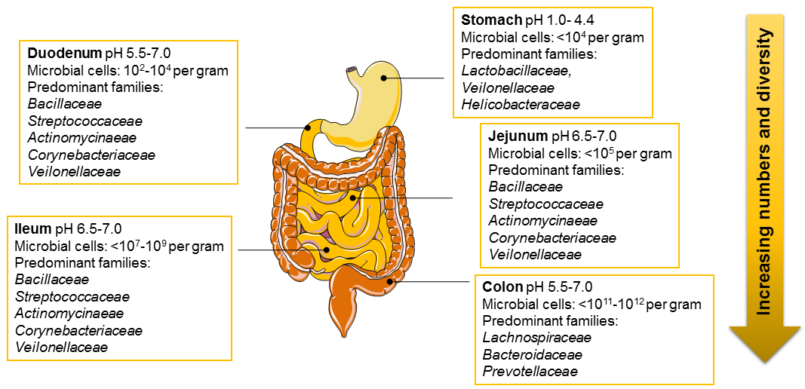
Figure 1. Composition of gut microbiota along the gastrointestinal tract length. Microbial numbers increase and composition varies along the length of the gut and depend on factors such as pH or presence of oxygen (adapted from the digestive system figures from Servier Medical Art)

The diverse conditions found along the gut determine the composition of the microbiota and give origin to distinct niches. These include factors such as motility, pH, redox potential, nutrient supplies and host secretions.
The microbial composition also varies in different latitudinal structures of the gut (Fig. 2). A study using fluorescence in situ hybridization observed that microbiota located in the intestinal lumen diverges significantly from the one found in the mucus layer as well as the microbiota present in the close vicinity of the epithelial lining. Furthermore, all bacterial groups that were detected within the crypt compartment could also be found in the mucus and lumen compartments. However, not all bacterial groups found in the lumen had access to the mucus (Swidsinski et al. 2005).
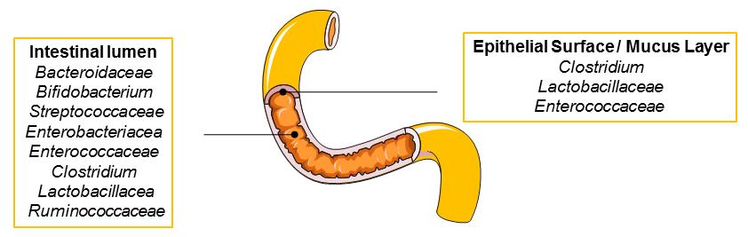
Figure 2. Composition of gut microbiota varies across latitudinal structures of the gut. Microbial composition in the intestinal lumen, the epithelial surface and the mucus layer (adapted from the digestive system figures from Servier Medical Art).

The assumption that the gut of human foetuses is completely sterile and that no bacterial transmission through the placental barrier can occur is widely accepted. However, in the last years this dogma is starting to be questioned. Few studies are arising on the potential for bacterial colonization of the placental tissue and foetal membranes through the placental barrier, although many limitations to pursue these tests occur, such as technical and ethical issues of sampling collection from healthy pregnancies before birth (Rodríguez et al. 2015; Jiménez et al. 2008; Rautava et al. 2012). The delivery method highly impacts the first colonizers composition (Table 1). Interestingly, elevated antibiotic resistance genes were found in the microbiome from caesarean delivered babies. The difference between delivery modes gradually diminishes with age (Bäckhed et al. 2015; Neu & Rushing 2011).
Additional perinatal factors also play an important role in the microbial colonization and include gestational age, genetics, hospitalisation, antibiotic use, hygienic conditions, intestinal mucin glycosylation and infant feeding (Penders et al. 2006; Guinane & Cotter 2013).
Another key source for colonization of the infant gut is through the mother´s milk during breast feeding. Breast milk stimulates the growth of a healthy, balanced and diverse microbiota, influencing the infant´s health status (Cabrera-Rubio et al. 2012). Several studies have pointed out the protective role of breast milk against infectious and immune-mediated diseases (Labbok et al. 2004; Rodríguez et al. 2015)
Table 1. Differences in composition of gut microbiota from infants delivered vaginally or by caesarean.
 | Vaginally | Caesarean
Initial microbiota  is primarily defined by | Mother´s vaginal and faecal microbes | Environment: mother´s skin, nursing staff, materials, and air
First colonizers (genera)  (Bäckhed et al. 2015) | Bacteroides, Bifidobacterium, Parabacteroides, Escherichia/Shigella | Enterobacter, Haemophilus  Staphylococcus, Streptococcus, Veillonella
Health | Normal development of the immune system | Increased risk for atopic diseases  (e.g. asthma or atopic dermatitis)

A very clean environment in early childhood leading to improper colonization is at the origin of the increasing incidence of both autoimmune and allergic diseases in developed countries (Neu & Rushing 2011; Renz-Polster et al. 2005).
Gut microbiota complexity rises following weaning, with enhanced colonization of butyrate producers, including Bacteroides and certain Clostridium species. A more established and stabilized microbiota community similar to the one found in adults is reached after weaning at the age of 2-3 years (Koenig et al. 2011; Bäckhed et al. 2015).
During adulthood, the composition of the gut microbiota is relatively stable and plays a crucial role in nutrition and health. However, it can suffer variations as consequence of antibiotic treatment, change in diet, lifestyle or bacterial infections (Fouhy et al. 2012). Ageing has also been reported to decrease diversity of the microbiota (Claesson et al. 2011). Dramatic shifts in the microbial content have been related to increased disease risk (Rodríguez et al. 2015).

Functions of the microbiome

The gut microbiota have a profound impact on host physiology, metabolism, immune function and nutrition. Thus, this superorganism is considered by some authors as a “forgotten organ” or according to others a “neglected metabolic organ” (O’Hara & Shanahan 2006; Bocci 1992).
This microbial “organ” brings enormous health benefits, for instance it exerts metabolic activities by synthetizing vitamins, amino acids and short-chain fatty acids (SCFA), and breaking down non-digestible products such as starch or dietary fibres, thus providing energy to the human body (Krajmalnik-Brown et al. 2012). Gut microbiota also plays a crucial role in the defence against pathogens as well as in the development, maturation and maintenance of the intestinal barrier and the mucosal immune system (Round & Mazmanian 2009). Defects in the development of gut-associated lymphoid tissues in GF mice have been associated with increased susceptibility to infection by pathogens. These defects are, however, fully reversed to a normal development once the microbiota was established (Round & Mazmanian 2009; Tlaskalová-Hogenová et al. 2011).

Gut microbiota and its implication in disease

In recent years, multiple studies have focused in studying the association between improper colonization or dysbiosis and host health. Besides asthma and atopy, a rising number of diseases is being linked to dysbiosis (Table 2). (Frank & Pace 2008; Hold 2014; Fujimura & Lynch 2015).
IBD, obesity and type 2 diabetes (T2D) or cancer are among several disease states that show rising incidences in developed countries and have been associated with a disturbed gut microbiota (Willing et al. 2010; Karlsson et al. 2013; Scanlan et al. 2008) (Table 2).
Both phyla- Firmicutes and Bacteroidetes seem to be disturbed in all the diseases mentioned in Table 2.

Diseases | Diagnosis | Changes in gut microbiota | References
Inflammatory Bowel Disease | relapsing inflammation of the gut | Reduced microbial diversity and stability of the gut microbiota. Decreased abundance of Firmicutes (in particular Faecalibacterium prausnitzii) were associated with a greater chance of relapse after surgical resection. Increased number of species from Bacteroidetes phylum in patients with disease | (Frank et al. 2007; Guinane & Cotter 2013; Hold 2014; Walker et al. 2011; Andoh et al. 2012; Sokol et al. 2008)
Obesity | excess of body fat | Genetically obese and diet-induced obese mice: higher proportions of Firmicutes and lower levels of Bacteroidetes.  Reduced Firmicutes/ Bacteroidetes ratio following weight loss in humans. Other study shows reduction of Bacteroidetes with unchanged Firmicutes in obese people. | (Ley et al. 2005; Guinane & Cotter 2013; Turnbaugh et al. 2009; Ley, Turnbaugh, et al. 2006)
Type 2 diabetes | obesity-linked insulin resistance | Firmicutes (in particular the Clostridia class) are diminished. Bacteroidetes and Proteobacteria are enriched. | (Larsen et al. 2010)
Colorectal carcinomas | Cancer in colon or rectum | Significant increase of Fusobacteria and Bacteroidetes and, to a lesser extent, Proteobacteria. Decreased Actinobacteria. Firmicutes appeared depleted. | (Kostic et al. 2012)
Table 2: Pathologies associated with disturbed gut microbiota.

Despite increasing understanding of the relation between the gut microbiota and aetiopathogenesis, the question of what came first: either the diseased state or a change in the microbiota´s composition, remains unclear (Power et al. 2014).

Manipulation of gut microbiota and implications in health

Knowledge from host- microbiota relationship studies in the near future could aid to help prevent and fight epidemic diseases such as cancer and obesity or even non-alcoholic fatty liver disease. Targeted manipulation of the gut microbiota can be a valuable therapeutic tool. For instance, in 2003 a trial using faecal transplantation (from a healthy donor to an unhealthy receiver) successfully treated Clostridium difficile infectious diarrhoea (Kunde et al. 2013). Also, a very recent work reveals an unexpected role for commensal Bifidobacterium in enhancing antitumor immunity in vivo (Sivan et al. 2015).
Metagenomics will enable the acquisition of much more information in less time. Thus, it will become possible to obtain multiple hypotheses on the roles of microbiota in disease onset and progression (Wostmann 1981; Smith et al. 2007).

Germ-free technology

The idea of GF (microbiologically sterile animals) and gnotobiotic (organisms with defined microbial status) mouse technologies involving the use of microbiologically sterile animals, dates back to 1885 inspired by the debate between Louis Pasteur and Emile Duclaux. They questioned whether microbes were crucial or not for higher organisms to live, followed by Pasteur´s remarks to the French Academy of Sciences (Wostmann 1981):
“For several years during discussions with young scientists in my laboratory, I have spoken of an interest in feeding a young animal (rabbit, guinea pig, dog or chicken) from birth with pure nutritive products which have been artificially and totally deprived of the common microorganisms.
Without affirming anything, I do not conceal the fact that if I had the time, I would undertake such a study, with the preconceived idea that under these conditions life would have become impossible.
If this work could be developed simply, one could then consider the study of digestion by the systematic addition to the pure food, of one or another single microorganism or diverse microorganisms with well-defined relationships.”

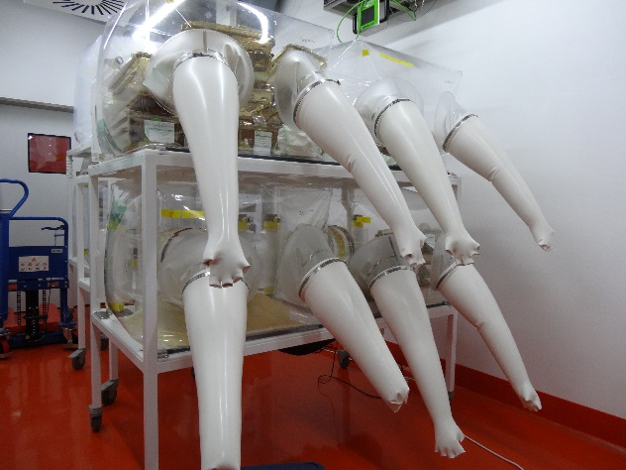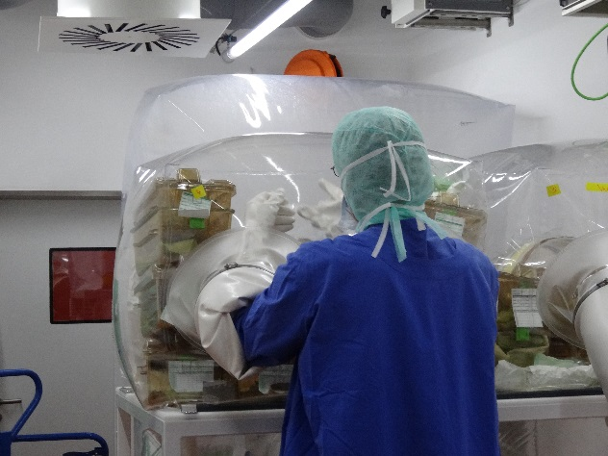
Figure 3. Germ-free mice technology established in the host laboratory.
Mice are kept in sterile plastic isolators and handled with gloves attached to isolators.

Pasteur´s preconceived idea about the requirement of microbes for life was refuted 10 years later with the first GF guinea pigs being generated by caesarean derivation into a sterile environment, as reported by Nuttal and Thierfelder in 1895 (Nuttall & Thierfelder 1895). During this first successful attempt, animals could only survive for the very short period of 13 days.
For decades, multiple attempts failed to produce GF organisms that could be maintained for generations. It was only during the 1940s that Reyniers and Trexler first achieved the routine production and standardization of GF animals (chickens and rats) that could be successfully maintained for multiple generations, at the University of Notre Dame (USA) (Wostmann 1981; Luckey 2012).
The methods used today for generating GF animals (Fig. 3), sterilizing isolators and for detecting contamination have not changed much since the 1940s (Gordon 1960; Arvidsson et al. 2012). GF mice are generated by aseptic hysterectomy followed by immediate transfer of full term foetuses into a GF isolator. The offspring are then removed from the uterine tissue and given to a surrogate mother (Giraud 2008).
Regardless the successful establishment of GF technology there are technical limitations. Back in time, Reyniers once wrote:
“The so-called germ-free animal is germ free only within the limits of the techniques used to determine its freedom from microbic contamination” (Reyniers et al. 1943).
Currently, despite advanced molecular methods, limitations in detecting bacterial contamination are still observed. For instance, Fontaine et al have revealed that methods involving culture, Gram stain and PCR are adequately accurate in detecting bacterial contamination. However, none of the methods is able to detect fewer than 10⁵ colony forming units per gram of faeces. Therefore, poorly colonizing bacterial non-culturable species below this number could potentially contaminate GF animals without being detected. Moreover, methods for screening contamination by fungi, eukaryote organisms or virus are also needed to assure as fairly as possible the GF status (Fontaine et al. 2015). The isolator sterility is jeopardized by incomplete sterilization of food, water or bedding, interruption in air flow or any breach in the isolator walls, filters or gloves. Contaminant microorganisms often derive from CONV-R animals that are being used in the laboratory, skin or fecal microbes from workers and inadequately sterilized food or bedding. Some of these microorganisms can potentially grow rapidly in GF animals due to the lack of competitors. Since these sources are most likely colonized by multiple species, it is expected that at least some are prone to be detected by culture methods (Fontaine et al. 2015; Packey et al.; Rezzonico et al.).

Phenotypic differences between germ-free and conventional-raised mice

Many studies have reported the differences between GF animals and their counterparts, the CONV-R animals (Table 3).
Table 3: Phenotype from germ-free compared with conventional-raised mice.
Characteristics | GF mice compared with CONV-R | References
Physical growth | Similar  40% less total body fat (Although higher caloric intake) | (Bäckhed et al. 2004).
Reproduction | Inferior due to abnormal oestrous cycles in females | (Shimizu et al. 1998)
Life expectancy | Longer | (Tazume et al. 1991)
Cardiovascular system | Smaller hearts and lower cardiac output. | (Wostmann 1981)
Immune system | Increased susceptibility to certain pathogens  Reduced circulating leukocytes  Defective development of gut associated lymphoid tissues: abnormal antibody production and smaller and scarce Peyer´s patches and mesenteric lymph nodes | (Round & Mazmanian 2009)
Gastrointestinal tract | Larger cecum  Slower intestinal transit time  Decreased surface area (by approximately two thirds)  Lower intestinal tract weight  Diminished renewal rate of ileal epithelial cells  Longer and thinner villi  Decreased vascularization in the small intestine | (Wostmann 1981; Abrams et al. 1963; Reinhardt et al. 2012; Stappenbeck et al. 2002; Hooper 2004)
Scientists have recognized that microbiota does not just help the host organism to digest food as differences in GF animals versus controls are seen at various levels, such as immune system, morphology or behaviour.

Experiments using germ-free technology

GF technology, since its establishment in the 1940s, has become a powerful experimental strategy to resolve bacterial-host interactions.
In the 1960s, Russell Schaedler selected several combinations of culturable dominant bacteria isolated from normal and specific-pathogen-free (SPF) mice and tested each combination in GF mice. Phenotypic restoration of GF to normal mice was best achieved using the combination designated “Schaedler flora” (Schaedler et al. 1965). Later, in the 1970s, this composition was revised and suffered some alterations to become “Altered Schaedler Flora” (ASF), composed of eight bacterial members: Lactobacillus acidophilus, Lactobacillus salivarius, Bacteroides distasonis, one spiral bacteria of the Flexistipes genus and four extremely oxygen sensitive Fusobacterium species (Wymore Brand et al. 2015). During more than thirty years, ASF has been used as a standard well-defined community of microbes that allowed to understand mechanisms involving the complex relationship between host and microbiota and between the microbial community members (Wymore Brand et al. 2015).
Besides the use of defined set of microbes, it is relatively easy to study the importance of a given bacterial component (e.g. lipopolysaccharide (LPS), flagellin) in the process of colonization of the intestinal tract. Bacterial mutants and the respective isogenic wild-type strains can be administered to GF mice and each strain can be quantified and compared for its ability to colonize (Lee et al. 2013).
GF technology in combination with genetically defined mouse models and specific bacterial strains, under controlled isolator conditions, creates the opportunity to understand the mechanisms of how a gene may be involved in controlling the microbiota composition and it allows to pinpoint the exact role of microbial species in the host organism.

Small intestinal anatomy and function

The small intestine contains a large number of immune cells and is the first intestinal place to encounter microbiota and dietary components and, therefore, represents a major place of the gut to perceive the complex microbiota-host interactions (Booijink et al. 2007).
The small intestine forms a long tube of 6 to 7 meters in length and divides into three major sections, the duodenum, the jejunum and finally the ileum.
Figure 4. Anatomy of the small intestine.
The small intestinal surface area is enlarged by the presence of large circular folds, villi and microvilli to maximize the absorptive capacity during digestion. Intestinal crypts support the permanent renewal of the adult intestine and have an important antimicrobial role. The blood and lymphatic vasculature of the intestine is necessary for nutrient absorption and gut immune function (OpenStax 2014).

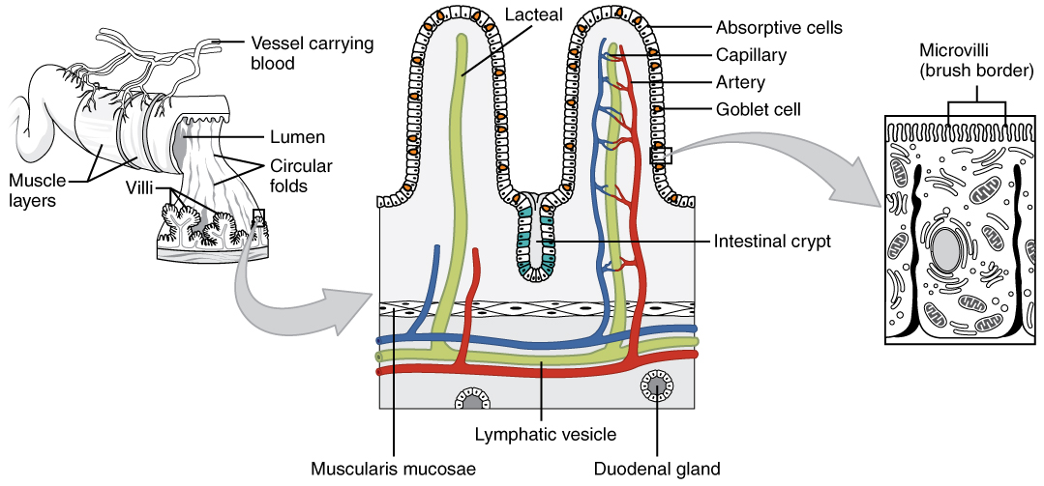

Internally, the small intestinal mucosa is highly folded in order to expand the surface area of absorption of nutrients and is characterized by: large circular folds that project into the lumen, smaller folds named villi which are finger-like projections and finally, a layer of microvilli (“brush border”) covers the apical surface of lining columnar absorptive epithelial cells (Fig. 4) (Mowat & Agace 2014).
The epithelium that lines the villi is composed of columnar absorptive cells called enterocytes, and a few goblet cells, that are responsible for secreting mucin, a mucus component necessary for proper lubrification of the intestinal contents and protection of the epithelium (Mowat & Agace 2014).
The adult intestine is in a permanent state of renewal. Epithelial turnover occurs every 4 to 5 days. The epithelium is renewed by stem cells arising from the crypts of Lieberkühn, invaginations located between the villi. Recently formed epithelial cells move upwards from the crypt to the tip of the villus and get mature, acquiring properties needed for digestion and absorption. Unlike enterocytes and goblet cells, Paneth cells migrate in the opposite direction after differentiating from stem cells and locate at the base of the crypts. These cells last longer and have a central antibacterial role by producing antimicrobial peptides following for instance stimulation of Toll-like receptors (TLRs) by bacterial ligands. Paneth cells also participate in the maintenance of normal crypt stem cell activity (Mowat & Agace 2014).
Additionally, lymphoid follicles termed Peyer´s patches are mainly found under the ileal submucosal layers in humans and are considered immune sensors of the intestine, given their ability to discriminate between pathogens and commensal bacteria. These follicles contain macrophages, dendritic cells, B-lymphocytes and T-lymphocytes, and are connected to lymphatic and endothelial vessels (Jung et al. 2010).
In the lamina propria, which underlies and supports the epithelium, several mesenchymal cells and immune cells are found, together with a rich vascular and lymphatic network (Mowat & Agace 2014).
The intestinal vasculature is crucial as it regulates nutrient absorption and gut immune function (Bernier-Latmani et al. 2015). The superior mesenteric artery divides into multiple branches and provides oxygen-rich blood to the jejunum and ileum. Within the villi, endothelial cells (ECs) form blood capillaries composed of one arteriole and one venule that are organized around a lacteal (lymphatic capillary) (Gray´s Anatomy 2015).
Amino acids and carbohydrates are absorbed by blood capillaries while lipids are taken up by the lacteals. Adult lacteals undergo constant remodelling which depends on Notch signalling, thus accompanying the permanent state of renewal of the adult intestine (Bernier-Latmani et al. 2015).

Toll-like receptor signalling pathway

The innate immune system forms the first line of defense against invading microbes and depends on signalling pattern recognition receptors (PRR) that provide the intestine the ability to discriminate between pathogenic and commensal bacteria by microbe-associated molecular patterns (MAMPs) (Abreu et al. 2005). PRR include two classes of detection molecules, the cytoplasmic NLRs (NOD-like receptors, nucleotide-binding oligomerization domain-like receptors) and the most extensively studied, the membrane-bound TLRs (Philpott & Girardin 2004).
TLRs are a large family of type I transmembrane proteins characterized by an extracellular domain containing leucine-rich repeats that mediate the recognition of MAMPs and a cytoplasmic tail containing the conserved region Toll/IL-1 receptor (TIR) domain responsible for triggering downstream signalling pathways. TLRs are located either on the cell surface or associated with intracellular vesicles and are mostly (not exclusively) associated with immune and epithelial cells including macrophages, dendritic cells, T lymphocytes and intestinal epithelial cells (Nishiya & DeFranco 2004; Abreu 2010).
Ten human and twelve murine TLRs have been identified. Each TLR recognizes distinct molecular patterns derived from viruses, bacteria, fungi, and parasites (Table 4) (Kawai & Akira 2011).
Table 4: Toll-like receptor ligand table
TLR | Recognized MAMPs  (Kawai & Akira 2011; Bryant et al. 2015)
TLR1 | Triacylated lipoproteins, GPI-anchored proteins
TLR2 | Lipoproteins, Peptidoglycan, LPS, Zymosan
TLR3 | viral double- stranded RNA
TLR4 | LPS, Fusion proteins
TLR5 | Flagellin
TLR6 | Diacylated lipoproteins, Zymosan
TLR7 | Single-stranded RNA (ssRNA), Imidazoquinolines
TLR8 | ssRNA, Imidazoquinolines, Guanine and Uracil- rich ssRNA oligonucleotides
TLR9 | Non-methylated CpG DNA

Specificity of TLR signalling derives from dimerization, adaptor combinations and expression within specific cell types. The majority of TLRs appear to function as homodimers, however the ability of some TLR components to heterodimerize increases the scope of MAMP specific recognitions. As examples, dimers of TLR2 and TLR6 are needed for responses to diacylated lipoproteins while TLR2 and TLR1 dimerize to detect triacylated lipoproteins (Kawai & Akira 2011; Abreu 2010).
Upon activation by the respective MAMPs, TLRs initiate multiple intracellular signalling cascades leading to the production of cytokines, chemokines and transcription factors. This revealed to be crucial in supporting the gut homeostasis and infection control (Akira et al. 2006).
TLR activation induces recruitment of adaptor proteins that harbour a TIR domain: Myeloid differentiation primary response gene 88 (MyD88), TIR-associated protein (TIRAP), Mal (MyD88 adaptor-like protein), TIR domain-containing adaptor protein-inducing Interferon (IFN)-β (TRIF) and TRAM (TRIF- related adaptor molecule) (O’Neill & Bowie 2007).
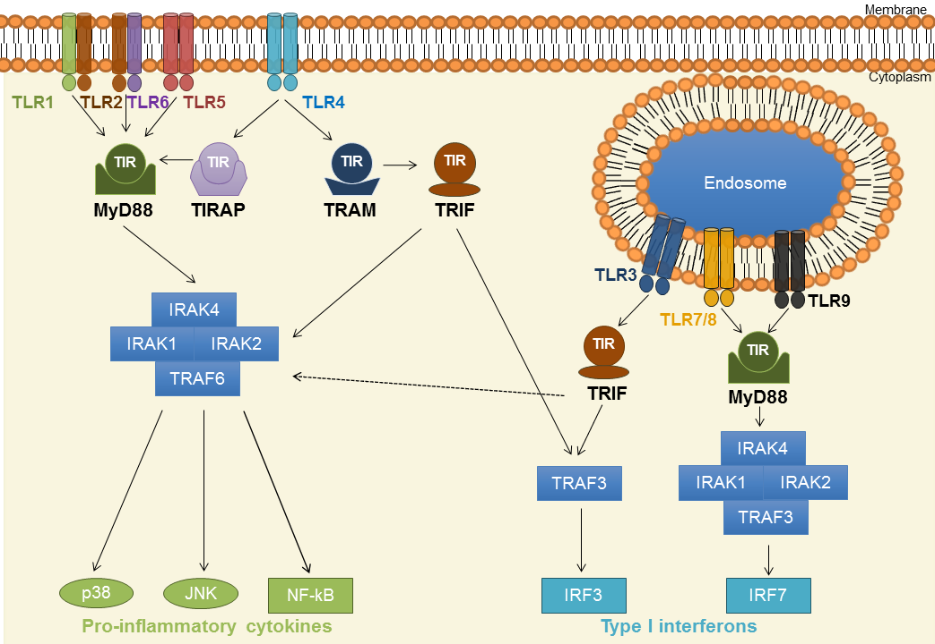

Figure 5. Toll-like receptor signalling pathway: representative scheme.
TLR signalling is mainly divided into two main pathways: MyD88- and TRIF-dependent pathways. Pro-inflammatory cytokines and type I interferons are produced through the activation of these pathways.

Each TLR may lead to different signalling responses by the use of different adaptor molecules and the physical location of each TLR also affects the responses. TLR signalling is mainly divided into two pathways: MyD88- and TRIF-dependent pathways (Fig. 5).
In the MyD88-dependent pathway, MyD88 forms a complex with IRAK (interleukin receptor-associated kinase) family members ultimately leading to activation of Nuclear factor-κB (NF-κB) and MAP-Kinase (MAPK) pathways and generating inflammatory cytokines necessary for inflammatory responses. The MyD88 pathway is used in the signalling cascade of all TLRs except for TLR3.
The TRIF-dependent pathway only interacts with TLR3 and TLR4 and contributes to the adaptive immunity by activation of immunomodulatory type I interferons (IFN), in addition to NF-κB and MAPK pathways (Kawai & Akira 2011).
A permanent activation of the TLR signalling cascades might lead to deleterious effects such as chronic inflammation, hence negative regulators of the TLR signalling are required. Toll-interacting protein (TOLLIP) is an intracellular protein that associates with TLR2 and TLR4 and suppresses TLR-mediated signalling by preventing IRAK´s autophosphorylation (Burns et al. 2000; Zhang & Ghosh 2002).

Expression of Toll-like receptors in the intestine

Studying how the expression of TLRs occurs along the small intestine and the crypt/villus axis and how the gradients of MAMPs occur in these regions is essential to understand how this organ senses the microbiota and how the regulation of gut innate immunity occurs.
In the duodenum of mice and pigs, TLRs were found to be generally low expressed (Gourbeyre et al. 2015; Ortega-Cava et al. 2003), which has been correlated to a poor presence of microbiota (Wang et al. 2005).
In distal parts of the small intestine, jejum and ileum, TLR2, TLR3 and TLR4 were highly expressed in humans (Cario & Podolsky 2000; Abreu 2010). Accordingly, TLR2 and TLR4 were elevated in porcine samples, while levels of TLR1-6, TLR9 and TLR10 were increased in the jejunum and ileum of pigs (Gourbeyre et al. 2015). This expression profile is associated with an abundance of microbes in number and diversity at these parts of the intestine (Wang et al. 2005).
Additionally, Peyer´s Patches from both jejunum and ileum of pigs were associated with increased TLR1, TLR2, TLR4, TLR7, and TLR9-10 expression which may result from the presence of several immune cells (e.g. macrophages, dendritic cells) in these lymphoid structures (Gourbeyre et al. 2015). Indeed, Peyer´s Patches have been recognized to participate more actively in the recognition of MAMPs when compared to the corresponding intestinal sections (Kawai et al. 2001).
Low levels of TLR1, TLR3-4 and TLR9 were observed in jejunal crypts of pigs, implying that these structures are not main participants of the microbial recognition (Gourbeyre et al. 2015). On the other hand, Paneth cells located in mouse colonic crypts were associated with augmented TLR9 expression levels (Rumio et al. 2004). These distinct results may result from species or organ- specificity of TLR9 expression (Gourbeyre et al. 2015).
Also, TLR1, TLR2, TLR4-6 and TLR9 were strongly expressed in the lamina propria, in pigs. These expression patterns may result from the associated immune cells and professional antigen presenting cells located in this structure, that are known for expressing high TLR levels themselves (Gourbeyre et al. 2015).
Finally, high expression of TLR3 and TLR5 were detected in the villus epithelium, in pigs. Accordingly, an increase of TLR3 and TLR5 genes was observed in intestinal segments that lack lymphoid structures, suggesting that epithelial cells are responsible for the elevated expression of these receptors (Gourbeyre et al. 2015). In the same line, primary cultures of mouse small intestinal epithelial cells expressed high levels of TLR5 (Choi et al. 2010), whereas in humans, TLR3 was found elevated in ileal epithelial cells (Cario & Podolsky 2000).
The negative regulator of the TLR signalling, TOLLIP, is widely expressed in intestinal epithelial cells (IEC), thus contributing to the hyporesponsiveness of IEC to commensal bacteria and preventing chronic inflammation in the gut (Melmed et al. 2003). In a previous study from the host laboratory, findings suggest that adaptor molecules MyD88 and TRIF are upregulated in the small intestine of CONV-R Swiss Webster mice and can alter expression of TLRs in this part of the gut (Hörmann et al. 2014; Brandão et al. 2015).

Microbial recognition by Toll-like receptors: impact on intestinal homeostasis

Bacterial recognition by TLRs has been implicated in the intestinal barrier function and consequently in repair of epithelial cell injury of the intestinal mucosa. For instance, several studies have shown that activation of TLR2 in the intestinal epithelium results in improved tight junction function and decreased epithelial cell apoptosis (Gibson et al. 2008; Cario et al. 2004). Moreover, some experiments involving radiation-induced injury have suggested that TLR activation might have a protective role against intestinal injury (Burdelya et al. 2008). Other reports using TLR2-, TLR4- and MyD88-deficient mice have shown that these mutations are associated with increased susceptibility to injury provoked by dextran sodium sulfate (DSS), which suggests that at least in part, TLR signalling cascades have a beneficial role in maintaining intestinal homeostasis (Cario et al. 2007). Other studies suggest a less positive role of TLR signalling in the particular case of colorectal cancer as TLRs activation appears to sustain the development of inflammation-associated neoplasia (Rakoff-Nahoum & Medzhitov 2007).
Interestingly, intestinal epithelial cells from patients with IBD present higher expression of TLR4 (Cario & Podolsky 2000) and fail to upregulate TOLLIP, suggesting the lack of this negative TLR adaptor may support inflammation (Steenholdt et al. 2009). It has been suggested that TLR4 participates in the pathological process by inflammation-induced angiogenesis. However, the exact mechanism involving TLR4 and blood vessel formation has not been clarified (Murad 2014).

Hedgehog and Bone Morphogenetic Protein pathways determine intestinal development and homeostasis

Besides the TLR signalling pathway, other pathways play a pivotal role for intestinal development and homeostasis.
The Hedgehog (Hh) pathway was recently shown to interact with Bone Morphogenetic Proteins (BMPs) to regulate intestinal epithelial homeostasis (Büller et al. 2012).
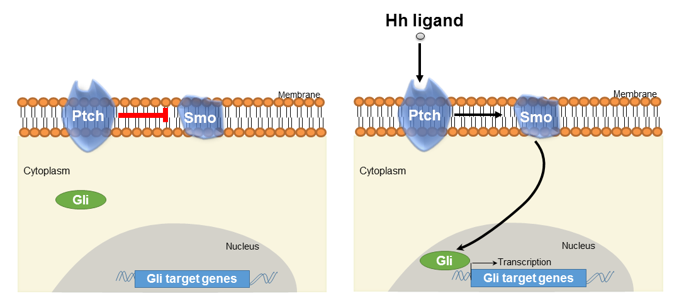
Figure 6. Hedgehog signalling pathway.
In the absence of Hh protein binding, Ptch1 inhibits Smo activity and prevents the activation of downstream targets. Once present, Hh ligand binds to and inhibits Ptch1, releasing the blockade of Smo, and leading to pathway activation through the proteolytic processing of glioma-associated oncogene (Gli) proteins.

The Hh pathway (Fig. 6) is widely used by mammalian cells and comprises three Hh proteins: Sonic Hedgehog (Shh), Indian Hedgehog (Ihh) and Desert Hedgehog (Dhh). These proteins trigger the same signalling cascade and bind the same receptor with equal affinity, only differing from each other in their tissue specific pattern of expression and levels of expression (Pathi et al. 2001; McMahon et al. 2003; Sagai et al. 2005; van den Brink 2007). The Hh receptor is a complex of two transmembrane proteins: Patched (Ptch1) and Smoothened (Smo). In the absence of Hh protein binding, Ptch1 inhibits Smo activity and prevents the activation of downstream targets. When extracellular Hh is present, it binds to and inhibits Ptch1, releasing the blockade of Smo, therefore allowing pathway activation through the proteolytic processing of glioma-associated oncogene (Gli) proteins (Carpenteret al. 1998). Once activated, Gli1 and Gli2 function as transcription factors leading to expression of target genes (e.g. Gli, Wnt, and Bmp) (Bai & Joyner 2001).
The Hh signalling is associated with a plethora of physiological important roles. This pathway is widely recognized to be essential for a normal embryonic development playing a critical role in controlling cell fate, proliferation, survival and differentiation. Furthermore, it also has important functions in adult tissue maintenance, renewal and regeneration (Varjosalo & Taipale 2008). Interestingly, the Smo antagonist vismodegib (GDC-0449) was the first drug targeting the Hh pathway, to be approved by the USA Food and Drug Administration as a treatment of basal-cell carcinoma by preventing expression of oncogenes otherwise activated by the Hh signalling pathway (Fellner 2012).
The GIT development during the embryonic phase is highly dependent on the expression and regulation of both Shh and Ihh by the endoderm along the gut extension (Ramalho-Santos et al. 2000; Apelqvist et al. 1997). BMP4 expression was shown to be induced in the mesoderm by endodermal Shh (Roberts et al. 1995). During villus development in mice, epithelial Hh leads to aggregation of sub-epithelial mesenchymal clusters. These clusters, which have been shown to express BMP2 and BMP4 (Karlsson et al. 2000), determine the correct patterning of villi. A very recent work revealed that changes in the normal BMP signalling of the mesenchyme result in disturbed mesenchymal cluster pattern, which in turn produces abnormal villi pattern (Walton et al. 2016).
Some studies have demonstrated the importance of Hh signalling for maintaining tissue homeostasis in the adult gut by signalling from the epithelium to the mesenchyme in a paracrine fashion (Kolterud et al. 2009).
Ihh is the main Hh protein to be expressed in the adult small intestine and colon (Batts et al. 2006; van Dop et al. 2009; van Dop et al. 2010; van den Brink et al. 2004). In the small intestine, Ihh transcript levels were found to be highly expressed in epithelial cells undergoing differentiation and located at the crypt-villus junction. These mRNA levels are gradually diminishing towards the tip of the villus (Batts et al. 2006). Also, Ihh protein was observed to be present mainly in differentiated enterocytes on the villi (Jones et al. 2006). The uneven Ihh expression between transcript and protein could be explained by the fact that cells rapidly proliferate out of the crypt and move up towards the top of the villus, while still expressing protein but no longer transcribing Ihh mRNA (van den Brink 2007). Shh levels are difficult to detect and therefore, it is not clear whether they are present or not. Some authors claim Shh can be expressed in low levels at the base of the small intestinal and colonic crypts (van den Brink 2002). Also, expression of Ptch1 and Gli1 was observed to be restricted to the mesenchyme (Kolterud et al. 2009; van Dop et al. 2009). Some reports demonstrate the relevant role of the Hh pathway in regulating positively the growth and expansion of the gut mesenchyme and in regulating the size of the precursor cell compartment located in the intestinal crypts by a negative feedback (van Dop et al. 2010; van den Brink et al. 2004).
In vivo blocking of Hh signalling results in increased precursor cell proliferation and disturbed differentiation of the enterocyte lineage in the colon of rat (van den Brink et al. 2004). Conversely, enhancement of Hh signalling by deleting Ptch1 leads to an accumulation of myofibroblasts, a reduction in the amount of epithelial precursor cells and disturbed colonic crypts with hypoplasia (van Dop et al. 2009). Another study further revealed that Hh signals from the epithelium to Ptch1- expressing myofibroblasts and smooth muscles cells. A strong inhibition of this paracrine signalling was shown to lead to disturbed epithelial remodelling and villus formation (Madison et al. 2005).
Increased Hh pathway activity was associated with an upregulation in BMP4 and
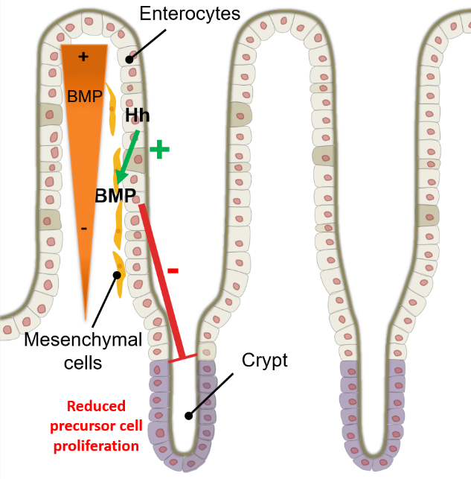
Figure 7. Epithelial Hedgehog signalling upregulates Bone Morphogenetic Proteins and controls epithelial proliferation in the small intestine.
Epithelial Hh pathway upregulates BMP4 and BMP7 expression in the mesenchyme and is associated with a larger range of epithelial BMPs from the top toward the base of the crypts. Hypothetically, the Hh pathway may trigger the expression of mesenchymal factors that in turn can restrict the size of the precursor cell compartment located in the intestinal crypt.

BMP7 expression in the mesenchyme as well as a larger range of epithelial BMP signalling from the top toward the base of the crypts.
This denotes the existence of a possible pathway, where Hh trigger the expression of mesenchymal factors (BMPs) that in turn can restrict and regulate epithelial proliferation (Fig. 7) (van Dop et al. 2009).
BMPs are members of the transforming growth factor-β (TGF-β) superfamily that bind serine/threonine kinase receptors on the cell membrane and signal through intracellular Smad mediators as well as through other pathways such as the MAPK pathway. So far, more than 20 BMPs have been identified and classified (Ye & Jiang 2015). For instance BMP2, BMP4 and drosophila Decapentaplegic (dpp) form one subgroup, while other members form other subgroups according to their amino acid sequence similarity and functional role (David et al. 2009).
These dimeric BMPs are always secreted in an active form and are mainly regulated through reversible interactions with extracellular antagonists including Noggin, Follistatin, Gremlin, Chordin, among others. The antagonists can compete with BMP ligands by binding to BMP receptors. This mechanism comprises a feedback regulation since expression of BMP antagonists can also be induced by BMP ligands (David et al. 2009; Ye & Jiang 2015).
BMPs exert their activity by binding to different receptor complexes (Fig. 8), each formed of two type I and two type II receptors composed of three domains: N-terminal extracellular ligand binding domain, a single transmembrane region, and a C-terminal serine/threonine kinase domain. BMP ligands bind independently to both types of receptors, although some ligands exhibit higher affinity with type I receptor (e.g. BMPR1A-BMP2) and others with type II receptor (e.g. ActRII-BMP7).
After binding, the type II receptors phosphorylate the conserved GS domain of the type I receptors. The activated type I receptor then propagates the signalling by phosphorylating the transcription factors Smad1, Smad 5, and/or Smad 8.
The activated Smads assemble into a heteromeric complex with Smad 4 in the cytoplasm and translocate into the nucleus activating the transcription of target genes that include Inhibitor of Differentiation 1 (ID1), ID3, Smad-6 and -7 (David et al. 2009).
The ligand-receptor complex can also include type III receptors or co-receptors (e.g. betaglycan, endoglin) that can modulate the BMP ligand affinity for the corresponding type I and type II receptors (David et al. 2009).
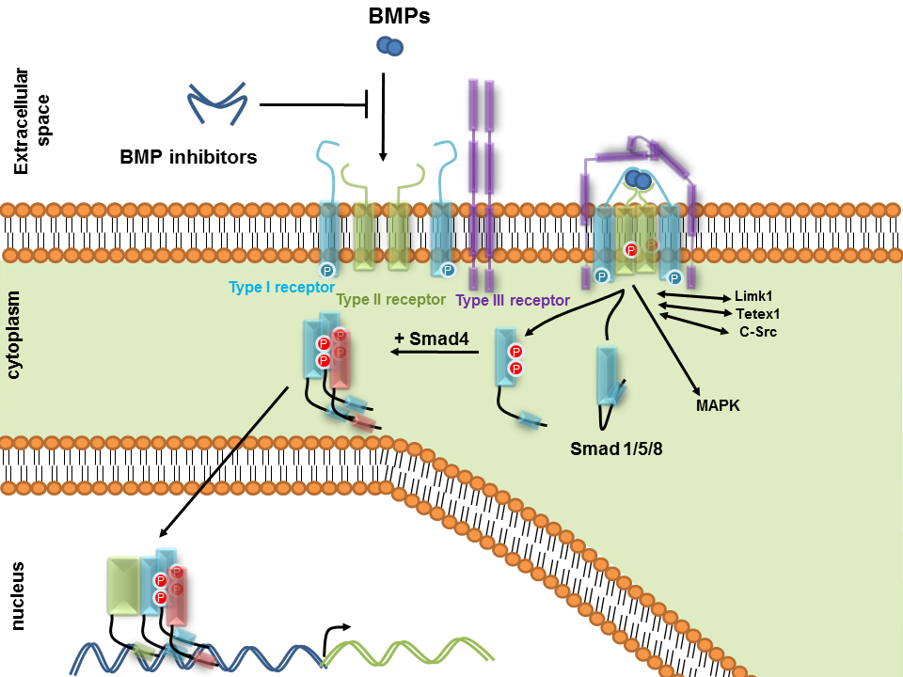
Figure 8. Bone morphogenetic protein signalling pathway.
After ligand binding to a pre-formed receptor complex, composed by type I and type II receptors, the type-II receptors phosphorylate the type-I receptors. Activated type I receptor then propagates the signalling by phosphorylating the transcription factors Smad1, Smad 5, and Smad 8. The activated Smads assemble into a heteromeric complex with Smad 4 in the cytoplasm and translocate into the nucleus activating the transcription of target genes.

Both epithelial and mesenchymal BMP signalling are required for the maintenance of the intestinal stem cell niche (Auclair et al. 2007).
The conditional ablation of BMP proteins in the epithelial and mesenchymal (stroma) intestinal compartments of mice showed that BMP signalling is necessary to repress de novo crypt formation and polyp growth, thus being necessary for a correct patterning of the intestinal epithelium (He et al. 2004; van Dop et al. 2009). Furthermore, mice lacking the BMP receptor 1A (BMPR1A) specifically in the intestinal epithelium are associated with impaired terminal differentiation and maturation of cells from the secretory lineage (Auclair et al. 2007). Some studies point out the role of BMPs in intestinal cancer. The selective loss of Smad4 in a stromal component has been suggested to induce the appearance of epithelial tumors throughout the GIT (Kim et al. 2006). Other studies reveal that loss of BMP signalling in the epithelium can be frequently associated with colorectal cancer and impact tumor progression, but does not act as a tumor initiator (Hardwick et al. 2008).

The role of microbiota and innate immunity in intestinal vascularization

The vasculature in the small intestine of mice is increased upon colonization with microbiota (Fig. 9) (Hooper 2004; Reinhardt et al. 2012; Stappenbeck et al. 2002).
Figure 9. Vascularization and shape of intestinal villi in germ-free (left) and conventional-raised (right) mice.
Colonization of GF mice with a normal microbiota is associated with shortening and widening of the villus architecture and increased vascularization in the small intestine.

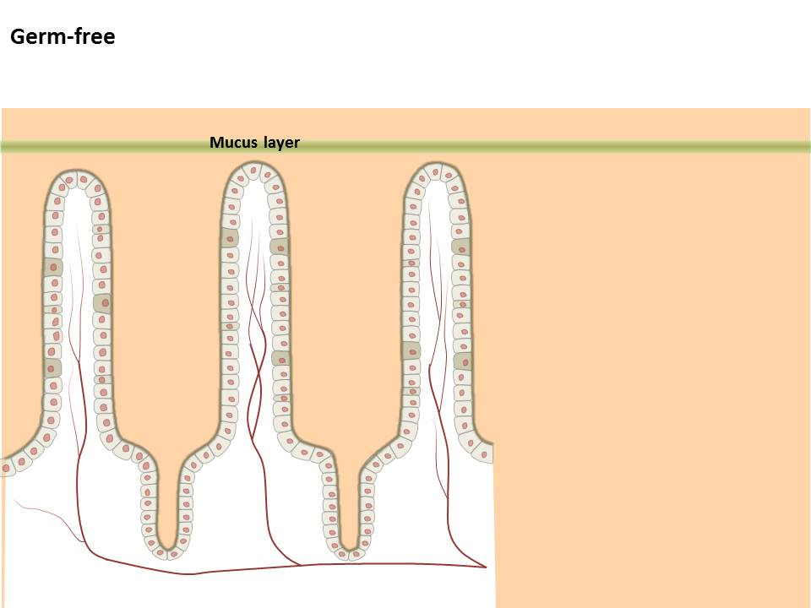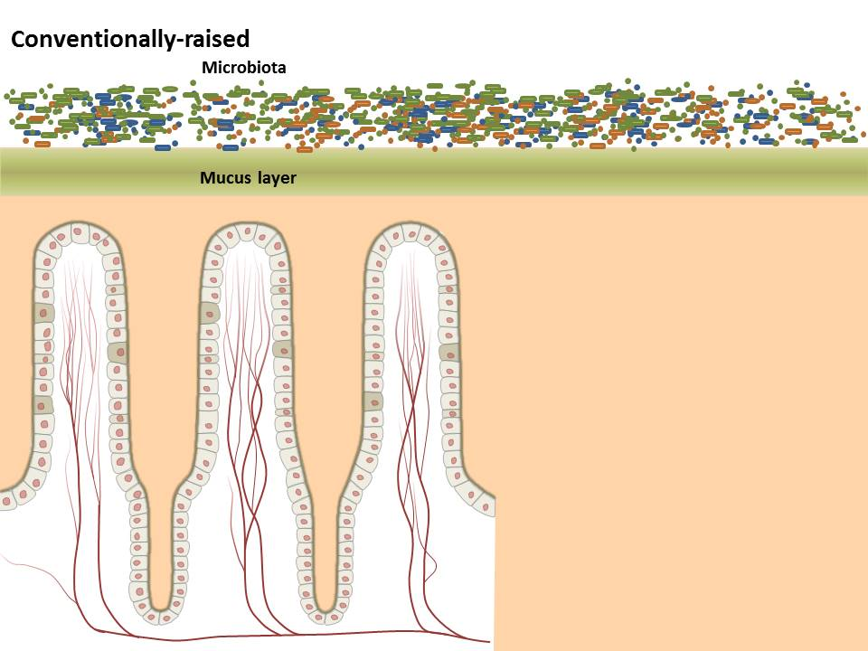

Only a few studies focused on the interaction and the signalling pathways that link the gut microbiota and the intestinal epithelium with the mesenchyme and the microvascular network of the intestinal villus structures.
A study from 2002 shows that adult GF mice have arrested capillary network formation and when colonized for 10 days with a normal microbiota or the gut resident bacterium Bacteroides thetaiotaomicron, the capillary networks become fully developed. Furthermore, vascularization triggered by B. thetaiotaomicron depends on Paneth cells that appear to be crucial mediators by producing pro-angiogenic factors (Stappenbeck et al. 2002).
An additional mechanism to explain microbiota-stimulated vascular remodelling was described by Reinhardt and coworkers in 2012. The study shows that intestinal bacteria stimulate glycosylation of the pro-angiogenic tissue factor (TF), thus targeting this receptor to the enterocyte cell surface. Treatment of conventionalized, ex-germ-free mice with a TF-specific antibody led to decreased vascularization and lower expression of the proangiogenic factor angiopoietin-1 (Ang-1) (Augustin et al. 2009) in the small intestine compared with isotype control treatment.
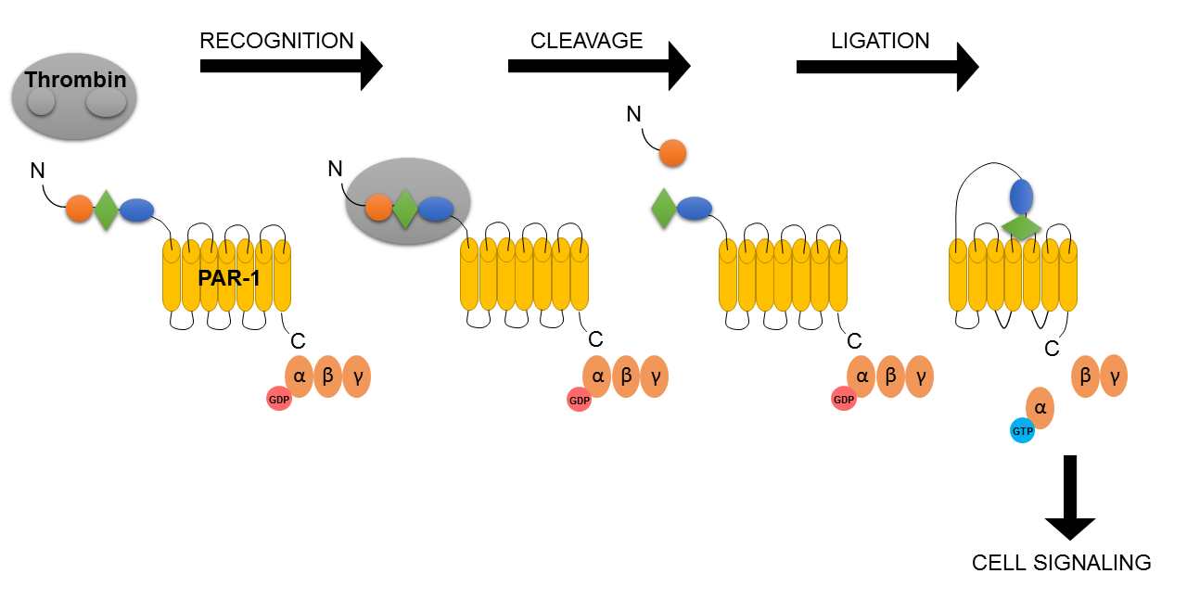
Figure 10. Mechanism of PAR1 activation.
Activation of PAR1 is an irreversible proteolytic mechanism. Thrombin recognizes the N-terminal exodomain of PAR1 and cleaves the peptide bond between receptor residues Arginine 41 and Serine 42. A new N terminus is unmasked and acts as a tethered ligand by docking intramolecularly with the body of the receptor to activate the G- protein and trigger intracellular signaling (Reinhardt et al. 2015).

Demonstrating a role for the TF cytoplasmic domain in the underlying signalling process, mutant mice that lack the TF cytoplasmic domain also showed diminished small intestinal vascular density. Moreover, signalling of the thrombin receptor protease-activated receptor-1 (PAR1) (Fig. 10), belonging to the family of heptahelical G-protein-coupled receptors (GPCRs) and downstream of TF (Reinhardt et al. 2015), was found reduced in GF mice.
Accordingly, phosphorylation of TF was impaired and vessel density was reduced in PAR1-deficient mice. (Reinhardt et al. 2012).
An additional publication from 2013 showed that bacterial microbe-associated molecular patterns (MAMPs) can directly activate an angiogenic response in human intestinal microvascular endothelial cells (HIMEC) and in a mouse aortic ring assay. HIMEC stimulated with TLR2/6 and TLR4 ligands showed increased tube formation with thinner and longer bridges when compared to control medium. In the murine aortic ring assay, all ligands led to induction of endothelial cell (EC) branching, with TLR4 activation showing the strongest effect. Authors suggest that these effects can be mediated by TLRs and NLRs-dependent production of pro-angiogenic factors by mucosal mesenchymal cells (Schirbel et al. 2013).
There is considerable evidence that abnormal intestinal angiogenesis is involved in IBD (Danese et al. 2006; Pousa et al. 2008). Chronically inflamed intestinal tissues in IBD patients reveal significant alterations in microvascular physiology and function when compared with intestinal tissues from healthy persons or even non affected tissues from IBD patients (Sandor et al. 2006; Scaldaferri et al. 2009; Papa et al. 2008).

Angiogenesis

Angiogenesis is the process involving the balanced action of pro- and anti-angiogenic molecules that lead to the formation of a new vasculature from a pre-existing vascular network. The formed vasculature supplies oxygen and nutrients to tissues, exchanges metabolites and supports immune surveillance.
ECs line the interior surface of vessels, forming an interface between circulating blood and the rest of the vessel wall. Besides ECs, mesenchymal cells in close vicinity of the microvasculature are also involved in the angiogenic process. For instance, fibroblasts express and release several pro-angiogenic factors (e.g. VEGF, FGF) upon cytokine stimulation (Adams & Alitalo 2007; Potente et al. 2011).
There are two types of angiogenesis (Fig. 11) occurring both during embryonic development and postnatally: sprouting angiogenesis which forms entirely new vessels and intussusceptive (i.e. “growth within itself”) angiogenesis that forms by splitting of existing vessels (Adair & Montani 2010; Potente et al. 2011). Both types can occur in the intestinal mucosa (Adair & Montani 2010; Franks 2012).
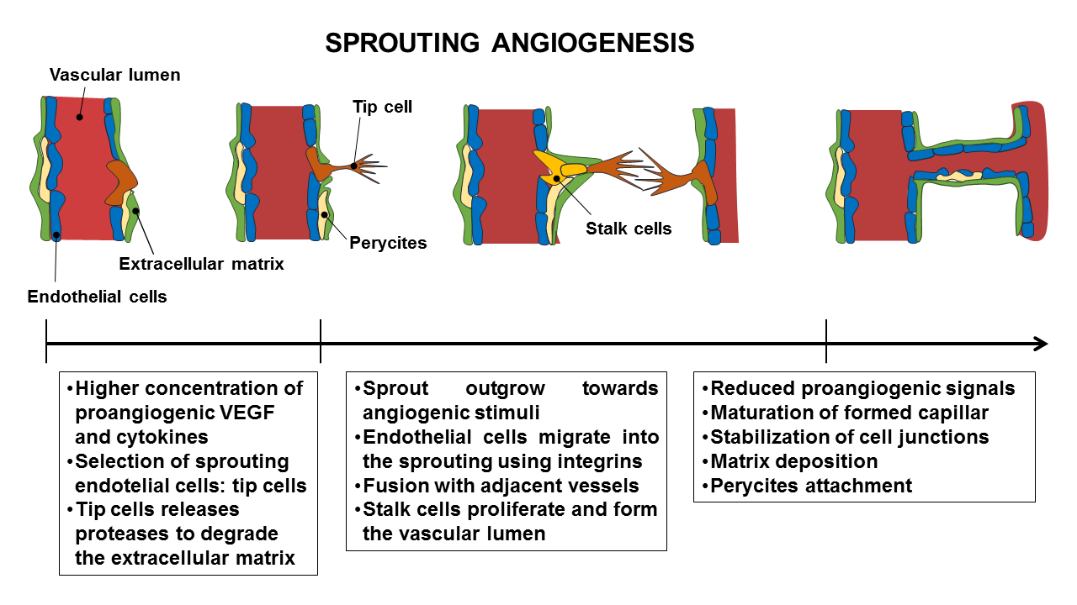
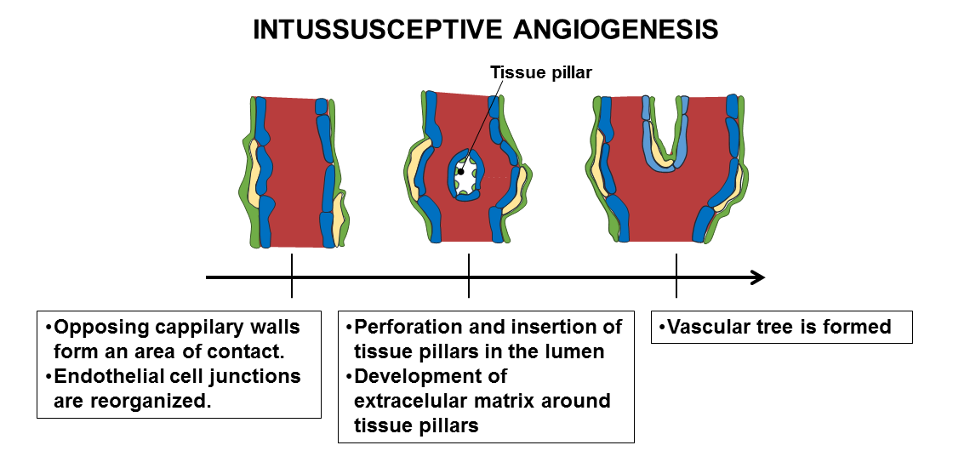

Figure 11. Types of angiogenesis: sprouting angiogenesis and intussusceptive angiogenesis.
Sprouting angiogenesis forms entirely new vessels and is characterized by sprouts formed by endothelial cells, which grow toward angiogenic stimuli. Intussusceptive (i.e. “growth within itself”) angiogenesis occurs by splitting of existing vessels. Elements of interstitial tissues invade existing vessels, forming tissue pillars that expand (Adams & Alitalo 2007).

Disturbed angiogenesis may lead to defective or excessive vascular growth, which can contribute to a myriad of clinical disorders (Potente et al. 2011).

Hedgehog and Bone Morphogenetic Protein signalling pathways: impact on postnatal angiogenic processes

During blood vessel formation in developing mouse gut, serosal mesothelial cells are responsive to Hh signals and undergo epithelial-to-mesenchymal transition, differentiating into ECs, vascular smooth muscle cells and pericytes (Wilm et al. 2005). Besides the main role of the Hh signalling pathway in early embryogenesis and in maintaining adult tissue homeostasis (e.g. tissue repair and cell turnover), several reports have appointed for the involvement of Hh pathway in the postnatal vascularization of tumoral tissues and ischemic tissues.
Pro-angiogenic factors, such as vascular endothelial growth factor (VEGF), are direct transcriptional targets of the Hh signalling pathway (Coultas et al. 2010). For instance, Smo inhibition in an in vivo orthotopic hepatocellular carcinoma model results in decreased VEGF expression and lower vascularization and tumor growth (Pinter et al. 2013). Furthermore, in breast cancer, Hh signalling augmented tumor angiogenesis by activating the cysteine-rich angiogenic inducer 61 (CYR61) (Harris et al. 2012). Despite most reports associate the activation of Hh signalling with increased tumor angiogenesis, a few studies show augmented vascularization in pancreatic cancer models upon inhibition of Hh signalling in pancreatic stroma (Hwang et al. 2012; Olive et al. 2009).
Moreover, the Hh pathway is activated in adult models of ischemic injury (e.g. myocardial infarction), and leads to revascularization of ischemic tissue by promoting angiogenesis and by recruiting endothelial progenitor cells. For instance, administration of Shh to aged mice has been reported to induce vascularization of ischemic hind-limbs. Shh-induced angiogenesis is associated by large-diameter vessels and is mediated by upregulation of the angiogenic factors VEGF and angiopoietins (Pola et al. 2001).
Recent reports suggest a prominent role for BMPs as regulators in developmental and tumor angiogenesis in the gut mucosa. For instance, two genetic vascular diseases, hereditary hemorrhagic telangiectasia (HTT) and pulmonary arterial hypertension (PAH) are caused by mutations in genes encoding components of the BMP signalling pathway (Mahmoud et al. 2009; David et al. 2009). Functional knockouts of elements of the BMP pathway imply a role in the angiogenic process. BMP-4 knockout in mice led to impaired mesoderm precursors necessary for vascular development (Winnier et al. 1995). Likewise, Smad 5 knockout mice reveal to be lethal and is accompanied with a defective angiogenesis (Yang et al. 1999). Also, loss of Smad8 function in mice resulted in abnormal vascular remodelling and augmented vascular inflammation (Huang et al. 2009). Moreover, other studies observed that BMP2 seems to induce blood vessel formation in tumors as well as directly stimulate ECs, leading to an angiogenic response in these cells (Langenfeld & Langenfeld 2004). The central role of BMP2 in developmental angiogenesis has also started to be uncovered (Jadlowiec et al. 2005). Effects of BMPs on the endothelium mainly rely on the central role of BMP receptor signalling in cell-cell and cell-matrix interactions (Liu et al. 2007). Germ-line mutations in BMP type II receptor (BMPR2) confer susceptibility to pulmonary arterial hypertension (PAH). The constitutive attenuation of BMP type II receptor expression in a mouse model has been reported to cause gastrointestinal hyperplasia, vascular lesions and impaired angiogenesis of ECs (Liu et al. 2007). Similarly, the BMP type I receptor Activin receptor-like kinase 1 (ALK-1) was shown to be expressed in ECs of highly vascularized tissues (lung and placenta) and has been implicated in angiogenesis in several in vivo studies. ALK-1 mutations are implicated in HHT and mouse embryos lacking ALK-1 died with strong defects in vascularization (Johnson et al. 1996; Oh et al. 2000).
As addressed here, a full panoply of different studies have focused on the role of Hh and BMP pathways in postnatal angiogenic processes. Yet, their physiologic context on vascular remodelling processes in adult intestinal tissues remains largely unexplored.

Aims

Normal microbiota initiates formation of capillary networks in the small intestinal villus structures of colonized GF mice, suggesting the activation of a proangiogenic gene repertoire by gut resident bacterial communities. The underlying molecular mechanisms that explain these angiogenic effects are still largely unexplored.
The present work aims to explore the signalling cues mediating the crosstalk between microbes and intestinal vascularization in the mid small intestine.
Major steps have been accomplished in order to perceive how TLRs are impacted by or have influence on microbiota and how this intricate relationship interferes with the host intestinal homeostasis. Nonetheless, the impact that TLR adaptors exert on TLR transcript expression is not yet understood and whether TLRs are involved in microbiota-induced intestinal vascularization remains unknown.
Given the role of the Hh and BMP pathways in maintaining gut homeostasis and the potential role of BMPs and Hh in inducing developmental and postnatal angiogenesis, it becomes relevant to explore the possible interactions between these pathways and the gut microbiota and their role for the vascularization of the small intestinal mucosa.

Materials

Table 5: List of equipment.
Equipment | Model | Company
Anaerobic jar | Anaerobic jar 2.5 liters volume | Merck, Darmstadt, Germany
Aspiration/ filtration system | FB70157 | Fisher Scientific, Loughborough, UK
Autoclavable cell culture pippettes | Finnpette F2 | Thermo Fisher Scientific, Waltham, MA, USA
Automated cell imaging system (kindly provided by Felix Herrmann (PEQLAB) | JuliStage | NanoEnTek, Seoul, Korea
Bead mill | Tissue Lyser | Qiagen, Hilden, Germany
Bench top shaker + Incubation Hood | Certomat R  Certomat H | Sartorius, Göttingen, Germany
Cell counting chamber | Neubauer Counting Chamber | Carl Roth GmbH, Karlsruhe, Germany
Centrifuges | Heraeus Fresco 21  Megafuge 16R  1814  Rotana RP | Thermo Fisher Scientific, Waltham, MA, USA  Thermo Fisher Scientific, Waltham, MA, USA  VWR Darmstadt, Germany  Hettich, Tuttlingen, Germany
CO2 Incubator | CO2-Incubator  C150 | Heraeus, Hanau, Germany  Binder, Tuttlingen, Germany
Cryostat | CM3050 S | Leica Biosystems, Wetzlar, Germany
Deep freezer -80°C | Hera Freeze BASIC | Thermo Scientific, Waltham, MA, USA
Electrophoresis power supply | Power Pac HC | Bio-Rad, Munich, Germany
Electroporator | Amaxa Nucleofector Device | Lonza, Basel, Switzerland
Flexible plastic film isolators | various | CBC Class Biologically Clean Ltd., Madison, WI, USA
Fluorescence microscope | Z1 Observer | Zeiss, Jena, Germany
Freezer -20°C | Premium No Frost und Premium | Liebherr, Bulle, Switzerland
Fridge 4ºC | Comfort | Liebherr, Bulle, Switzerland
Gel imaging and documentation | GelDoc EZ Imager | Bio-Rad, Munich, Germany
Gel/ western blot imaging | ChemoCam | Intas Science Imaging Instruments GmbH, Göttingen, Germany
Hamilton syringe | 1705 AD SYR | Hamilton Bonaduz AG, Bonaduz, Switzerland
Heating block | Thermomixer | Eppendorf, Hamburg, Germany
Incubator for bacterial cultures | Heratherm Incubator | Thermo Scientific, Waltham, MA, USA
Laminar flow cabinet | Herasafe KS15 und KS18 | Thermo Scientific, Waltham, MA, USA
Magnetic stirrer with heating function | Stirrer MR Hei-Standard | VWR, Darmstadt, Germany Heidolph, Schwabach, Germany
Microcentrifuge | Mini Star silverline | VWR, Darmstadt, Germany
Migration chamber | 28560-10  28559-10 | Cole Parmer, Vernon Hills, IL, USA
Mouse cages | Green Line IVC Sealsafe PLUS Mouse | Tecniplast, West Chester, PA, USA
PCR-Cycler | Vapo protect | Eppendorf, Hamburg, Germany
pH-Meter | 827 pH Lab | Metrohm Germany  Filderstadt, Germany
Photometer | Nanodrop | Thermo Fisher Scientific, Waltham, MA, USA
Pipet Filler | S1 Pipet Filler | Thermo Fisher Scientific, Waltham, MA, USA
Pipettes | Pipet Lite XPS LTS (1000, 100, 20, 10, 2 µl) | Rainin-Mettler-Toledo GmbH, Gießen, Germany
Platform shaker | KS260 | IKA, Staufen, Germany
Portable Bunsen Burner | Labogaz 206 | Camping Gaz GmbH, Hungen-Inheiden, Germany
qPCR-Cycler | CFX96 | Bio-Rad, Munich, Germany
Scales | R180  VWR-1502 | Sartorius, Göttingen, Deutschland  VWR, Darmstadt, Germany
SDS-PAGE System | Novex Mini-Cell | Thermo Fisher Scientific, Waltham, MA, USA
Tissue culture inverted phase contrast microscope | Diaphot 300 | Nikon, Chiyoda, Japan
Vortexer | Vortex-Genie 2 | Scientific Industries, New York, USA
Water bath | WB-500 | Digisystem Laboratory Instruments Inc., New Taipei City, Taiwan
Western-Blot System | Novex Xcell II Blot Module | Thermo Fisher Scientific, Waltham, MA, USA

Table 6: List of consumables.
Consumables | Company
Anaerocult A | Merck Millipore, Billerica, Massachusetts, USA
Butane gas cartridge C206 | Camping Gaz GmbH, Hungen-Inheiden, Germany
Cell culture filter cap flasks T75 Cellstar | Greiner Bio-One GmbH, Kremsmünster, Austria
Disposable cuvettes 1.5-3 ml | BrandTech Scientific Inc., Essex, CT, USA
Electroporation cuvette (0.1 cm) | Bio-Rad, Munich, Germany
Falcon conical centrifuge tubes: 50 and 15ml | BD Biosciences, Franklin Lakes, NJ, USA
Filtered Pipet Tip Rack (1000, 100, 20, 10, 2 µl), sterile | Rainin- Mettler-Toledo, Greifensee, Switzerland
Gloves sterile latex powder free | Sempermed, Singapore
Membrane Disc Filters 0.45 µm sterile | Pall Corporation, New York City, NY, USA
Microcentrifuge tubes: 1.5 and 2 ml | Sarstedt, Nümbrecht, Germany
Microscope Cover Glasses | Thermo Fisher Scientific, Waltham, MA, USA
Nitrocellulose membrane | Whatman, Little Chalfont, UK
Petri dishes 100mm x 15mm sterile | Greiner Bio-One GmbH, Kremsmünster, Austria
Positive charged microscope slides | Thermo Fisher Scientific, Waltham, MA, USA
Serological pipettes (5, 10, 25, 50 ml) | Greiner Bio-One GmbH, Kremsmünster, Austria
Single Edge Razor Blades | Personna, Verona, VA, USA
Uncoated µ-Slides Angiogenesis | Ibidi, Planegg / Martinsried, Germany

Table 7: List of chemicals and kits.
Chemical compounds and kits | Company
Accuprime Taq DNA Polymerase High Fidelity | Thermo Fisher Scientific, Waltham, MA, USA
Ampicillin sodium salt | Sigma-Aldrich, St. Louis, MO, USA
Bovine serum albumin (BSA), powder | Sigma-Aldrich, St. Louis, MO, USA
Bromophenol blue | Sigma-Aldrich, St. Louis, MO, USA
Calcium Chloride (CaCl2) dehydrated, powder | Carl Roth GmbH, Karlsruhe, Germany
Chlorine dioxide based sterilant Clydox-S | Pharmacal Research Labs, Waterbury, CT, USA
Chloroform anhydrous | Sigma-Aldrich, St. Louis, MO, USA
Citric acid (C6H8O7) | Sigma-Aldrich, St. Louis, MO, USA
Citric acid trisodium salt anhydrous (C6H5O7Na3) | Sigma-Aldrich, St. Louis, MO, USA
Dimethyl sulfoxide (DMSO) | Sigma-Aldrich, St. Louis, MO, USA
DNase I | Thermo Fisher Scientific, Waltham, MA, USA
Ethylenediamine tetraacetic acid disodium salt dehydrate (EDTA) dihydrate | Carl Roth GmbH, Karlsruhe, Germany
Fluoromount-G | eBioscience, San Diego, CA, USA
High Capacity cDNA Reverse Transcription Kit | Applied Biosystems, Foster City, CA, USA
iQ SYBR Green Supermix | Bio-Rad Laboratories, Berkeley, CA, USA
Kanamycin sulfate | Thermo Fisher Scientific, Waltham, MA, USA
Kit Wizard® SV Gel and PCR Clean-Up System | Promega, Madison, WI, USA
LumiGLO Reagent 20x and Peroxide 20x (chemiluminescent detection) | Cell Signalling, Danvers, MA, USA
Magnesium Chloride (MgCl2) dehydrated, powder | Carl Roth GmbH, Karlsruhe, Germany
Maxima Hot Start Green PCR Master Mix (2X) | Thermo Fisher Scientific, Waltham, MA, USA
Methanol anhydrous | Thermo Fisher Scientific, Waltham, MA, USA
Neomycin trisulfate salt hydrate | Sigma-Aldrich, St. Louis, MO, USA
NucleoSpin Soil Kit | Macherey Nagel, Düren, Germany
Phosphate-buffered formaldehyde solution 4 % - Roti-Histofix | Carl Roth GmbH, Karlsruhe, Germany
Pierce Protease and Phosphatase Inhibitor Mini Tablets | Thermo Fisher Scientific, Waltham, MA, USA
Pyrogen-free water sterile Aqua | B. Braun Melsungen AG, Melsungen, Germany
Rabbit serum | Invitrogen, Carlsbad, CA, USA
RNeasy Kit | Qiagen, Hilden, Germany
Skim Milk Powder | Carl Roth GmbH, Karlsruhe, Germany
Sodium chloride (NaCl) | Sigma-Aldrich, St. Louis, MO, USA
Syto 61 red fluorescent nucleic acid stain | Thermo Fisher Scientific, Waltham, MA, USA
Tris(hydroxymethyl)aminomethane | Merck Millipore, Billerica, Massachusetts, USA
Tris-HCl | Sigma-Aldrich, St. Louis, MO, USA
Triton X-100 | Sigma-Aldrich, St. Louis, MO, USA
Tween-20 | Sigma-Aldrich, St. Louis, MO, USA
β-Mercaptoethanol | Sigma-Aldrich, St. Louis, MO, USA

Table 8: List of media used for microbiology purposes.
Media for microbiology | Formulation | Company
2YT Broth (Bacto-yeast extract) | Sodium Chloride (NaCl) 5 mg/l  SELECT Peptone 140 (pancreatic digest of casein) 16 mg/l  SELECT Yeast Extract 10 mg/l | Thermo Fisher Scientific, Waltham, MA, USA
Brain Hearth Broth | Pig brain infusion 7,5 g/l  Pig heart infusion 10 g/l  Peptone 10 g/l  Glucose 2 g/l  Sodium chloride (NaCl) 5 g/l  Disodium phosphate 2,5 g/l  pH value 7,4 ±0,2 | Merck, Darmstadt, Germany
LB agar (Luria/Miller) | Tryptone 10 g/l  Yeast extract 5 g/l  Sodium chloride (NaCl) 10 g/l  Agar-Agar 15 g/l  pH value 7,0 ±0,2 | Carl Roth GmbH, Karlsruhe, Germany
LB broth (Luria/Miller) | Tryptone 10 g/l  Yeast extract 5 g/l  Sodium chloride (NaCl) 10 g/l  pH value 7,0 ±0,2 | Carl Roth GmbH, Karlsruhe, Germany
LB top agar 0.7% | LB broth (Luria/Miller) + Agar-Agar 7 g/l | Prepared in the laboratory
Nutrient Broth | Beef extract 3 g/l  Gelatine peptone 5 g/l  pH value 6,8 ±0,2 | Merck, Darmstadt, Germany
Sabouraud Dextrose Broth | Dextrose 20 g/l  Pancreatic digest of casein 5 g/l  Peptic digest of animal tissue 5 g/l  pH value 5.6 ± 0.2 | (Oxoid) Thermo Fisher Scientific, Waltham, MA, USA

Table 9: List of media and supplements used in cell culture.
Media and supplements for cell culture | Company
Accutase | Thermo Fisher Scientific/ Gibco, Waltham, MA, USA
DMEM high glucose | Thermo Fisher Scientific/ Gibco, Waltham, MA, USA
Fetal bovine serum | Thermo Fisher Scientific/ Gibco, Waltham, MA, USA
HEPES | Thermo Fisher Scientific/ Gibco, Waltham, MA, USA
L- glutamine | Thermo Fisher Scientific/ Gibco, Waltham, MA, USA
Matrigel basement membrane | BD Biosciences, New Jersey, USA
MEM vitamin | Thermo Fisher Scientific/ Gibco, Waltham, MA, USA
Non-essential amino acids | Thermo Fisher Scientific/ Gibco, Waltham, MA, USA
Penicillin-Streptomycin  with 10,000 units penicillin and 10 mg streptomycin per ml in 0.9% NaCl, sterile-filtered | Sigma-Aldrich, St. Louis, MO, USA
RPMI 1640, GlutamaxI | Thermo Fisher Scientific/ Gibco, Waltham, MA, USA
Sodium pyruvate | Thermo Fisher Scientific/ Gibco, Waltham, MA, USA
Trypsin/ EDTA | Sigma-Aldrich, St. Louis, MO, USA

Table 10: List of buffers.
Buffers | Formulation | Company
Cell lysis buffer | 50 Mm TRIS pH 8.0, 150 mM NaCl, 5 mM EDTA and 1% Triton X-100 | Prepared in the laboratory
Citric buffer | 73ml of 0.1M citric acid + 27 ml 0.1M trisodium citrate - pH= 3,34 | Prepared in the laboratory
Laemmli Buffer (3X) | 0.5M Tris-HCl pH 6.8  175 µl/ml  Glycerol 450 µl/ml  SDS 50 mg  0.5% Bromophenol blue 200 µl/ml  β-Mercaptoethanol 125 µl/ml  Distilled water until 1ml | Prepared in the laboratory
NuPAGE MOPS SDS Running Buffer (20X) | 50 mM MOPS, 50 mM Tris Base, 0.1% SDS, 1 mM EDTA, pH value 7.7 | Thermo Fisher Scientific, Waltham, MA, USA
NuPAGE Transfer Buffer (20X) | Bis-Tris 50 mM and Bicine 50 mM | Thermo Fisher Scientific, Waltham, MA, USA
Phosphate buffered saline (PBS) | Potassium Phosphate monobasic (KH2PO4) 1440.0 mg/l  Sodium Chloride (NaCl) 90000.0 mg/l  Sodium Phosphate dibasic (Na2HPO4-7H2O) 7950.0 mg/l  pH value 7.2 | Thermo Fisher Scientific/ Gibco, Waltham, MA, USA
TBS 10x (concentrated Tris-buffered saline) | 24 g Tris base  88 g NaCl  distilled water to a final volume of 1 L  pH value 7.6 | Prepared in the laboratory
TBS-T (Tris-buffered saline, 0.1% Tween 20) | 100 ml of TBS 10x/ l  900 ml distilled water/l  1 ml Tween 20/l | Prepared in the laboratory

Table 11: List of microbe-associated molecular patterns.
Microbe-associated molecular pattern | Source | Company
Flagellin- TLR5 ligand | Salmonella typhimurium | InvivoGen, San Diego, CA, USA
Lipopolysaccharide (LPS), ultrapure- TLR4 ligand | Escherichia coli 0111:B4 strain | InvivoGen, San Diego, CA, USA

Table 12: List of Bone Morphogenetic Proteins and Hedgehog inhibitors and agonists.
Inhibitors and agonists | Company
GDC-0449 (Vismodegib) | Selleckchem, Houston, TX, USA
LDN-193189 | Selleckchem, Houston, TX, USA
Purmorphamine | Tocris Bioscience, Bristol, UK

Table 13: List of antibodies.
Antibodies | Company
Anti-Actin (20-33), produced in rabbit | Sigma-Aldrich, St. Louis, MO, USA
anti-rabbit IgG HRP | Vector Labs, Burlingame, CA, USA
Goat anti-rat IgG Alexa Fluor 488 | Thermo Fisher Scientific, Waltham, MA, USA
Integrin β3 (4702), produced in rabbit | Cell Signalling, Danvers, MA, USA
Purified rat anti-mouse CD31 | BD Pharmingen, San Jose, CA, USA

Table 14: List of DNA and protein markers.
Markers | Company
1 kb DNA Ladder | New England Biolabs, Ipswich, MA, USA
100 bp DNA Ladder | New England Biolabs, Ipswich, MA, USA
Page Ruler Prestained Protein Ladder (26616) | Thermo Fisher Scientific, Waltham, MA, USA

Table 15: Formulation of sodium dodecyl sulphate (SDS)-polyacrylamide gels.
Acrylamide percentage | Stacking gel 3% | Running gel 8%
0.5 M Tris-HCl, pH 6.7 | 1,88 ml | -
10% (w/v) ammonium persulfate (APS) | 300 µl | 300 µl
10% (w/v) SDS | 150 µl | 300 µl
3 M Tris pH=8.9 | - | 3,76 ml
Acrylamide/Bis-acrylamide  (30%/0.8% w/v) | 1,5 ml | 8 ml
Distilled water | 10,88 ml | 18 ml
TEMED | 7,5 µl | 15 µl

Table 16: List of primers used for qRT-PCR.
Primer Abbreviation | Recognized cDNA | Amplicon length (bp) | Oligonucleotide Sequence
L32_for | murine 60S Ribosomal protein L32 | 146 | TGGCTCCTTCGTTGCTGCTG
L32_rev | murine 60S Ribosomal protein L32 | 146 | CTGGACGGCTAATGCTGGTG
PECAM1_for | murine Platelet endothelial cell adhesion molecule, CD31 | 218 | CTTCATCCACTGGGGCTATC
PECAM1_rev | murine Platelet endothelial cell adhesion molecule, CD31 | 218 | CTGCCAGTCCGAAAATGGAAC
VWF_for | murine von Willebrand Factor | 125 | CTTCTGTACGCCTCAGCTATG
VWF_rev | murine von Willebrand Factor | 125 | GCCGTTGTAATTCCCACACAAG
PAR1_for | murine Protease-activated receptor 1  murine Protease-activated receptor 1 | 105  105 | TGAACCCCCGCTCATTCTTTC
PAR1_rev |  | 105  105 | CCAGCAGGACGCTTTCATTTTT
Bmp2_for | murine Bone morphogenetic protein 2 | 126 | TCTTCCGGGAACAGATACAGG
Bmp2_rev | murine Bone morphogenetic protein 2 | 126 | TGGTGTCCAATAGTCTGGTCA
BMP4_for | murine Bone morphogenetic protein 4 | 114 | TTCCTGGTAACCGAATGCTGA
BMP4_rev | murine Bone morphogenetic protein 4 | 114 | CCTGAATCTCGGCGACTTTTT
BMP7_for | murine Bone morphogenetic protein 7 | 164 | ACGGACAGGGCTTCTCCTAC
BMP7_rev | murine Bone morphogenetic protein 7 | 164 | ATGGTGGTATCGAGGGTGGAA
BMPR1a_for | murine Bone morphogenetic protein receptor, type IA | 73 | AACAGCGATGAATGTCTTCGAG
BMPR1a_rev | murine Bone morphogenetic protein receptor, type IA | 73 | GTCTGGAGGCTGGATTATGGG
BMPR2_for | murine Bone morphogenetic protein receptor type 2 | 115 | TTGGGATAGGTGAGAGTCGAAT
BMPR2_rev | murine Bone morphogenetic protein receptor type 2 | 115 | TGTTTCACAAGATTGATGTCCCC
ID3_for | murine Inhibitor of DNA Binding 3 | 90 | CTGTCGGAACGTAGCCTGG
ID3_rev | murine Inhibitor of DNA Binding 3 | 90 | GTGGTTCATGTCGTCCAAGAG
MyD88_for | murine Myeloid differentiation primary response gene (88) | 104 | AGGACAAACGCCGGAACTTTT
MyD88_rev | murine Myeloid differentiation primary response gene (88) | 104 | GCCGATAGTCTGTCTGTTCTAGT
TRIF_ for | murine Toll/interleukin-1 receptor | 136 | TTGGGGACATACGTTACACTCC
TRIF_rev | murine Toll/interleukin-1 receptor | 136 | CGGTGTGTTACATAGCTTGCTG
Tollip_for | murine Toll Interacting Protein | 161 | CCCAGGACTTCCTCCGTATAA
Tollip_rev | murine Toll Interacting Protein | 161 | AGTCATGCCATAATTCTTTGCCA
CyclinD1_for | murine Cyclin-D1 | 183 | GCGTACCCTGACACCAATCTC
CyclinD1_rev | murine Cyclin-D1 | 183 | CTCCTCTTCGCACTTCTGCTC
TLR1_for | murine Toll-like receptor 1 | 56 | TCAAGCATTTGGACCTCTCCT
TLR1_rev | murine Toll-like receptor 1 | 56 | TTCTTTGCATATAGGCAGGGC
TLR2_for | murine Toll-like receptor 2 | 149 | ACAATAGAGGGAGACGCCTTT
TLR2_rev | murine Toll-like receptor 2 | 149 | AGTGTCTGGTAAGGATTTCCCAT
TLR4_for | murine Toll-like receptor 4 | 129 | ATGGCATGGCTTACACCACC
TLR4_rev | murine Toll-like receptor 4 | 129 | GAGGCCATTTTTGTCTCCACA
TLR5_for | murine Toll-like receptor 5 | 130 | GCAGGATCATGGCATGTCAAC
Tlr5_rev | murine Toll-like receptor 5 | 130 | ATCTGGGTGAGGTTACAGCCT
TLR6_for | murine Toll-like receptor 6 | 139 | TGAGCCAAGACAGAAAACCCA
TLR6_rev | murine Toll-like receptor 6 | 139 | GGGACATGAGTAAGGTTCCTGTT
Gli1_for | murine Glioma-Associated Oncogene 1 | 116 | TACCATGAGCCCTTCTTTAGGA
Gli1_rev | murine Glioma-Associated Oncogene 1 | 116 | GCATCATTGAACCCCGAGTAG
Smo_for | murine Smoothened | 200 | CTTGGTGCGAACAGACAACC
Smo_rev | murine Smoothened | 200 | GGTAGCGATTGGAGTTCCGC
Ihh_for | murine Indian Hedgehog | 171 | GACGAGGAGAACACGGGTG
Ihh_rev | murine Indian Hedgehog | 171 | GCGGCCCTCATAGTGTAAAGA

Methods

Mouse strains and housing conditions

All mice were housed in a barrier facility (TARC, Translational Animal Research Center, University Medical Center Mainz) with a 12-hour light-dark cycle and kept in EU Type II IVC cages with 2-5 mice per cage under specific pathogen-free (SPF) or germ-free (GF) conditions with standard autoclaved lab diet (PMI, St. Louis, MO, USA) and water ad libitum, 22°C +/- 2°C room. C57BL/6J (WT), Tlr2^{-/-} and Tlr5^{-/-} mice were originally purchased from The Jackson Laboratory (Bar Harbor, ME, USA). Tlr4^{-/-}, Myd88^{-/-} and Trif^{-/-} animals were kindly provided by Markus P. Radsak (III. Medical Clinic, Johannes Gutenberg University, Mainz, Germany). Intestinal tissues from F2r^{-/-} mice were kindly provided by Wolfram Ruf (Department of Immunology and Microbial Science, Scripps Institute, La Jolla, USA) and intestinal tissues from Tnfα^{-/-} mice were received from Kerstin Steinbrink (Department of Dermatology, University Medical Center Mainz, Germany). For decimation of colonizing bacteria, CONV-R Swiss Webster mice were treated with broad-spectrum antibiotics (1 g/L ampicillin and 0.5 g/L neomycin, protocol performed by Nives Hörmann). All mice used in the experiments were 8–14 week old male and female mice co-housed in the central laboratory animal facility (TARC) of the University Medical Center Mainz under SPF conditions. All groups of mice were sex and age matched. All mice used for experiments were free of clinical symptoms. All procedures performed on mice were approved by Institutional Animal Care and Use Committee (IACUC; Landesuntersuchungsamt Rheinland-Pfalz, Koblenz, Germany; G12-1-035).

Germ-free mouse isolator technology

GF Swiss Webster or C57BL/6 mice were maintained in flexible plastic film isolators. A diluted solution of chlorine dioxide was used to sterilize the isolators. Material, feces samples or bacterial cultures were transferred in or out of the isolators by airlocks that could be closed with plastic caps fixed with rubber bands. Assessment of the microbiologic sterility of mice was tested every two weeks by DNA and culture methods. Feces samples were collected from each isolator and purification of DNA from feces was done using the NucleoSpin Soil Kit. 16S rDNA-targeted PCR using universal primers 8F (5′- AGAGTTTGATCCTGGCTCAG-3′) (Turner et al. 1999) and 338R (5′-GCTGCCTCCCGTAGGAGT-3′) (Suzuki & Giovannoni 1996) was performed and the presence of 16S rDNA band was detected by agarose gel electrophoresis. Additionally, samples from isolators collected with cotton swabs were cultured anaerobically in Brain Hearth Broth, Nutrient Broth and Sabouraud Dextrose Broth, at 37ºC to verify the presence of bacteria.

Preparation of intestinal samples

The small intestine was divided into 8 equal segments. Segments 1, 3, 5 and 7 were flushed with PBS and immediately flash-frozen in liquid nitrogen. Segment 5 (si5) corresponding to proximal ileum was used for mRNA, Western blot and immunohistochemistry analysis (for the later analysis, the excess of liquid after PBS flushing was carefully removed with a paper towel prior flash freezing).

Treatments with MAMPs, BMP and Hh pathways antagonist or agonist drugs

Ultrapure LPS diluted in endotoxin-free water was added to MCEC at a final concentration of 10 µg/ml for qRT-PCR analysis (4 hours) and wound healing (30 hours) and sprouting (11 hours) assays.
Flagellin diluted in endotoxin-free water was added to MCEC at a final concentration of 50 ng/ml for wound healing and sprouting assays, and to MODE-K at a final concentration of 1 µg/ml for 6 hours for qRT-PCR analysis.
The BMP signalling inhibitor LDN-193189 was dissolved in DMSO and applied to MCEC at a final concentration of 0.5 µM for qRT-PCR analysis (2 hours) and wound healing (30 hours) and sprouting (11 hours) assays. To test BMP receptor type I inhibition in vivo, 7 WT C57BL/6 male mice were treated with LDN-193189 (dissolved in citric buffer) by oral gavage with a daily dose of 5 mg/kg over 5 days. Control mice were treated with citric buffer alone. During the period of treatment, 2 mice died of fight lesions, 1 mouse had a score of 3 points (“+” – see Table 18 –Annex I) by day 5, while the rest of the mice had a score of 0 points.
The hedgehog inhibitor GDC-0449 (Vismodegib) was dissolved in DMSO and applied to MCEC at a final concentration of 20 µM for scratch wound healing (30 hours) and sprouting (11 hours) assays.
The hedgehog activator Purmorphamine was dissolved in DMSO and applied to MCEC at a final concentration of 2 µM for qRT-PCR analysis (12 hours) and 4 µM for wound healing (30 hours) and sprouting (11 hours) assays.

Cell culture

Murine colon endothelial cell line (MCEC) (Langley et al. 2003) was kindly provided by Isaiah Fidler, Robert Langley and Dominic Fan (The University of Texas M. D. Anderson Cancer Center, Houston, USA). Cells were cultured in DMEM (high glucose) supplemented with 10% fetal bovine serum, 2 mM L- glutamine, 1 mM sodium pyruvate, 1% non-essential amino acids, 1% MEM vitamin and 1x penicillin/ streptomycin. MCEC were passed with trypsin/ EDTA and cultured in humidified atmosphere with 8-9% CO₂ at 33ºC.
The MODE-K cell line was kindly provided by Dominique Kaiserlian (INSERM, France). MODE-K cells were maintained as described (Vidal et al. 1993), in RPMI 1640, GlutamaxI supplemented with 1% sodium pyruvate, 1% HEPES, 1% MEM non-essential amino acids, 0.1% β-mercaptoethanol and 10% fetal bovine serum. Cells were cultured at 37°C in humidified atmosphere containing 5% CO2.
For qRT-PCR analysis, cells were seeded in 6-well plates at an approximate number of 4x 10⁵ cells per well. The following day cells presented between 80-90% of confluence. At this point, cells were washed once with PBS pH 7.2 and medium with or without MAMPs or drugs was added for the indicated times.

Construction of Escherichia coli (E. coli) mutants

The flagellin E. coli mutant fliC::kan was constructed by replacing the entire fliC gene, respectively, with a kanamycin (kan) cassette, as previously described (YU et al. 2000) (Fig. 12).
To do so, linear DNA fragments containing the antibiotic resistance cassette, flanked by sequences homologous to regions on either side of the genes to be deleted, were produced by PCR (kit Phusion High-Fidelity DNA Polymerase) (Fig. 12). PCR conditions were: 98ºC 30s/ 59ºC 30 s / 72ºC 2 min repeated for 35 cycles. The primers used are present on Table 17.
Table 17: Primers designed to produce DNA fragments with kanamycin cassette and flanking regions of the gene fliC.
Primer Forward (ΔfliC:: kan) | 5´TGAGCCGACGGGTGGAAACCCAATACGTAATCAACGACTTGCAATATAGGATAACGAATC TGTGTAGGCTGGAGCTGCTTC
Primer Reverse  (ΔfliC:: kan) | 5´AGCGCAGCGCATCAGGCAATTTGGCGTTGCCGTCAGTCTCAGTTAATCAGGTTACAACGA catatgaataTcctcctta

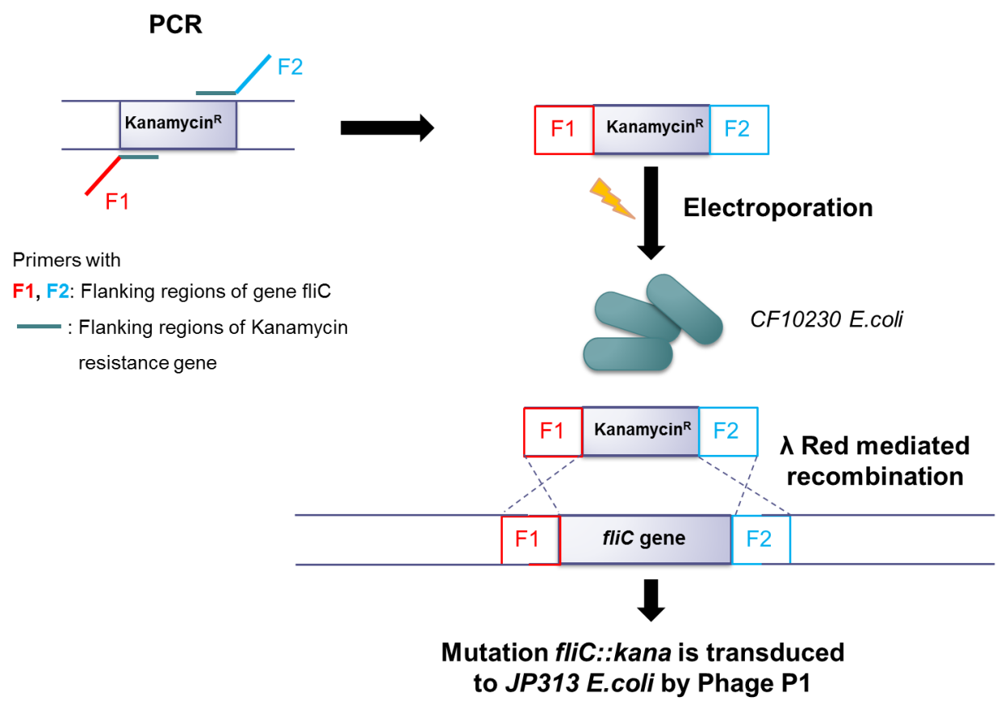
The obtained PCR fragment was purified using the Kit Wizard® SV Gel and PCR Clean-Up System, and then transformed into E. coli CF10230 (kindly provided by Evelyne Turlin – Institut Pasteur, Paris) to create the mutants by lambda Red-assisted recombination (Turlin et al. 2014). For the preparation of electroporation-competent E.coli CF10230, overnight (ON.) cultures grown at 30°C were diluted in 40 ml LB broth (Luria/Miller) medium to have an OD600≈ 0.05. Cultures were then grown at 30°C with shaking until an OD600 ≈ 0.5. Induction was performed on a 20-ml culture in a baffled conical flask (50 ml) by placing the flask in a water bath at 42°C with shaking (200 revolutions/min) for 15 min. Immediately after the 15-min induction, the flask was swirled in an ice water slurry to cool for 5 min. A non-induced control culture was also placed into the ice slurry. The cooled 20 ml cultures were centrifuged for 7 min at 4,600 × g at 4°C. Each cell pellet was suspended in 30 ml of ice-cold sterile water and centrifuged again under the same conditions. Resulting pellets were suspended again in 1ml of water, transferred to a 1.5-ml Eppendorf tube, and centrifuged for 1 min at 4°C at 6000 rpm in a microfuge.
Figure 12. Scheme: λ Red mediated recombination used to create deletion mutants in E.coli.
Lambda- Red mediated recombination is used to create mutants. Mutation is transduced to the recipient strain by Phage P1.

Finally, competent cells were suspended in 200 μl of ice-cold sterile water. For transformation of E. coli CF10230, purified linear DNA cassettes (2 μL) were mixed with 50 µL of competent cells in a precooled electroporation cuvette. Electroporation was performed by using an Amaxa Nucleofector Device (kindly provided by Matthias Klein from the Institute of Immunology, University Medical Center Mainz) set to Bacteria alternative program number 4. The electroporated cells were immediately diluted with 900 µl of 2YT (Bacto-yeast extract) medium, and incubated for 1–2 hours at 30°C before selecting for recombinants. After this time, aliquots were spread on LB agar supplemented with the antibiotic for selection, and were incubated at 30°C to determine total viable cells after electroporation. A P1vir phage was first grown on the strain CF10230 containing the deletions to be moved, and the resulting phage stock lysate was used to transfer the mutations to E. coli JP313 (kindly provided by Evelyne Turlin) 1 ml of the overnight, culture CF10230, containing the deletions, was centrifuged at maximum speed and the pellet suspended in 1 ml of aqueous solution 10 mM MgCl₂- CaCl₂. Phage P1 was diluted 10⁻² and 10⁻³ in the same solution. In a new 1.5 ml microcentrifuge tube, 100 µL of the diluted bacterial culture were added to 100 µL of the phage dilution, and incubated for 20 min at 37ºC. Triplicates were performed for each dilution. Each infection was transferred to 18 × 150–mm glass culture tubes containing 3.5 ml melted LB top agar 0.7%, and then immediately distributed onto LB plates supplemented with 2.5 mM CaCl₂. Plates were incubated upright ON at 37ºC. The next day, for the plates with confluent lysis, 500µL of LB were added and the top agar was scraped into a 15 ml Falcon tube. 500 µL of chloroform were added to each tube and vortexed hard. Tubes were centrifuged 30 min at 9000 rpm, 4ºC. Supernatant was filtrated (filter 0.45 µm) and stored at 4ºC. In order to transfer the deletion fliC::kan to the recipient E. coli strain JP313, a transduction protocol was performed. 1 ml of a 3 hours- liquid culture of the recipient strain was transferred to 1.5 ml-Eppendorf tube and centrifuged for 1 min at maximum speed. Cell pellet was resuspended in 1 ml solution 10 mM CaCl₂-MgCl₂ and 100 µL of lysate P1 phage stock were added, with 20 min incubation at 37ºC, no shaking. A control without phage was done. The mixture was centrifuged for 1 min at maximum velocity, room temperature (RT). Pellet was washed and resuspended with 1 ml of LB supplemented with 0.2% citrate, and then incubated for 1 hour at 37ºC with shaking. 100 µL of bacterial suspension was plated on LB supplemented with 0.2% citrate and kan. The remainder of bacterial suspension was concentrated 10 times and plated. The following day, colonies corresponding to transductants were reisolated in new plates. Verification of deletions was done by PCR using primers flanking the deleted gene. The size of the PCR product was evaluated by electrophoresis. Verified mutants were grown under aerobic conditions at 37ºC in LB medium (Luria-Miller) supplemented with 25 µg/ml kan.

Monocolonization of GF mice with bacterial strains

GF C57BL/6 mice were inoculated by oral gavage with 250 µL of overnight cultures of E. coli K-12 strain JP313 (WT) and flagellin mutant of E. coli strain JP313 in GF flexible film isolators. DNA was purified from feces samples of monocolonized mice with the NucleoSpin Soil kit. PCR was performed using 16S rDNA real-time universal PCR primer set 8F-338R targeting the variable regions V1 to V2 of the 16S rRNA gene. PCR product was then purified and sent to StarSEQ GmbH (Mainz, Germany) for DNA sequencing. Sequences were analysed and submitted to Basic Local Alignment Search Tool (BLAST) (www.ncbi.nlm.nih.gov/BLAST/) to verify the presence of the correspondent single pure bacterial strains. Animals were sacrificed 14 days after inoculum and organs were collected.

Quantitative real time PCR (qRT-PCR) analysis

Total RNA was purified from small intestinal tissues and cultured cells with the RNeasy Kit. On-column digestion of genomic DNA was performed according to the manufacturer's protocol. For cells, a QIAshredder spin column was used to homogenize the cell lysates. An optional on-column DNase digestion was performed. Total RNA was measured by Nanodrop and samples were diluted to 200 ng/µL. Complementary DNA (cDNA) was obtained by reverse transcription of 2 µg of RNA using the High Capacity cDNA Reverse Transcription Kit. For qRT-PCR amplification, a final reaction was prepared with 1x iQ SYBR Green Supermix mixed with 0.25 µM of both forward and reverse primers (Table 16- Materials) and 1 ng/µl of cDNA. Primers for the housekeeping gene coding for the 60S ribosomal protein L32 were used as an internal control to normalize expression levels. Reactions were run in triplicates using the CFX96 real-time PCR detection system, with a denaturation step at 95°C for 3 min, followed by 55 cycles of denaturation at 95°C for 2 s and primer annealing at 59°C for 5 s. Following completion of the cycling steps, a melt curve was generated by heating from 75 to 95°C with 0.2°C increments for 10s.

Immunohistochemistry

The small intestine was cut into 8 equally sized segments and the 5th segment was cryo-sectioned at 8 µm sections with a Leica cryostat kindly provided by Andreas Daiber (II. Medical Clinic, University Medical Center Mainz) and retained in microscope positively charged glass slides. Cryosections were air-dried for 1 hour at RT and outlined with a hydrophobic barrier pen, followed by fixation in paraformaldehyde solution 4% in PBS for 30 min. Sections were washed in PBS for 3 times for 5 min. For tissue permeabilization and blocking of nonspecific binding sites, sections were incubated for 1 hour at RT with 10% rabbit serum and 0.3% Triton X-100 in 1x PBS. Blocking buffer was removed and samples were incubated with 1.67 µg/ml of primary antibody purified rat anti-mouse CD31 in a solution of 5% rabbit serum in TBS-Tween O.N. at 4ºC in a humidified chamber. Sections were washed in TBS-T for 3 times for 10 min and incubated with 2 µg/ml of secondary antibody goat anti-rat IgG Alexa Fluor 488 in a solution of 5% rabbit serum in TBS-T for 2 hours in the dark at RT. Sections were washed in the dark as previously and cell nuclei was stained with 5 µM Syto 61 red fluorescent nucleic acid stain in TBS-T, for 20 min in the dark at RT. Sections were washed again in TBS-T as described before and finally dried in contact with air in the dark at RT. Slides were mounted with fluoromount-G. PECAM-1 vascular staining length from each villus was measured with Biopix imaging software (Gothenburg, Sweden). The software ImageJ was used to calculate the area per villus.

Time-lapse microscopy and wound healing assay

MCEC cells were seeded in 12-well plates and grown to 100% confluency. A scratch was made with a sterile 200 µl pipette tip on the middle of the well. Cells were gently washed with PBS and the respective treatments with PAMPs or drugs were performed (see section “Treatments with MAMPs, BMP and Hh pathways antagonist or agonist drugs”). After adding the respective drugs or vehicle controls to the medium, the time-lapse imaging started immediately. Images were captured every 10 min for 30 hours with the automated cell imaging system JuliStage (www.julistage.com). Data was analysed using ImageJ by measuring the area of scratch for the first 15 hours.

Sprouting assay in matrigel

Inner wells of uncoated µ-Slides Angiogenesis were filled with 10 µL of matrigel basement membrane and let polymerize for 30 min at 33ºC. MCEC cells were detached with accutase and approximately 8000 cells were added to each upper well in 50 µL of media supplemented with the respective drug or PAMP and vehicle controls. PAMPs and drug concentrations for this assay were the same as used in the wound healing assay. Photos of the forming sprouts were taken every 3 min for 11 h using the system JuliStage.

Statistical Analysis

Data are expressed as mean +/− s.e.m (standard error of mean). Statistical calculations were performed with GraphPad Prism 6 (GraphPad Software Inc, San Diego, CA) and SAS 9.4 (SAS Institute Inc, Cary, NC). Unpaired Student´s (2 Sample) t-test was used to compare independent groups. Values of P<0.05 were considered significant. *P<0.05, ** P<0.01, ***P<0.005 and **** P<0.001 indicate the strength of evidence against the null hypothesis. For the scratch assays linear mixed models were fitted with time as continuous covariate and treatment as binary covariate, taking into repeated measurements over time. The effect of LDN-193189 on log(proliferation) was also assessed using a linear mixed model with substance and concentration as fixed effects (cell assays: statistical analysis kindly provided by Irene Schmidtmann, Institut für Medizinische Biometrie, Epidemiologie und Informatik, Mainz).

Results

Regulation of small intestinal expression of Toll-like receptor signalling components by the gut microbiota.

Microbial colonization does not change TLR5 transcript levels in the small intestine

The presence of microbiota impacts on the innate immune signalling of the small intestine (Abreu 2010). Previously, it has been reported that expression of the epithelial pattern recognition receptor TLR2 and its co-receptor TLR1 in the small intestinal mucosa of Swiss Webster mice are regulated by MAMPs of the intestinal microbiota (Hörmann et al. 2014). Here, TLR5 transcript levels were analysed in mid small intestinal tissues of germ-free (GF) mice compared with conventionally-raised (CONV-R) C57BL/6 mice. Transcript levels of TLR5 were not changed in the presence of microbiota (Fig. 13 A).
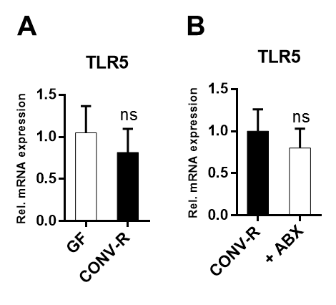
Figure 13. Small intestinal TLR5 expression is not directly regulated by the gut microbiota. A. Relative TLR5 mRNA levels in small intestinal tissues from GF and CONV-R mice (n=4-5 male C57BL/6 mice per group). B. Relative TLR5 mRNA levels in small intestinal tissues from CONV-R mice treated with a cocktail of ampicillin (1g/L) and neomycin (0.5 g/L) for 7 days (n=9-10 male C57BL/6 mice per group). Results are shown as means ± s.e.m. ns, not significant; independent samples Student’s t-test.
Modulation of TLRs by gut microbiota in the small intestine has been shown to be a fully reversible process as TLR2 and TLR4 are reduced upon depletion of gut microbes by a cocktail of broad-spectrum antibiotics (Hörmann et al. 2014). In contrast to TLR2 and TLR4, but in line with unchanged TLR5 mRNA levels in CONV-R mice compared with GF controls, TLR5 transcript levels were not reduced upon antibiotic treatment (Fig. 13 B).

TLR5 transcript levels are dependent on the TLR adaptor proteins MyD88 and TRIF, which are upregulated by the gut microbiota.
Next, it was analysed whether the small intestinal expression of TLR adaptors, TRIF, MyD88 and TOLLIP was changed in CONV-R male mice compared with their GF C57BL/6 counterparts. Transcript levels of all three adaptors were significantly upregulated in the presence of microbiota (Fig. 14 A-C), thus indicating that innate immune receptor pathways become active in the presence of colonizing gut microbes.
The number of TRIF-dependent genes has been described to far exceed the number of MyD88-dependent genes in primary small intestinal epithelial cells and it was suggested that TRIF-mediated innate immune signalling is essential for homeostasis in the small intestinal mucosa, in particular to the expression of Reg3γ and Paneth cell enteric antimicrobial peptides (Stockinger et al. 2014). It is interesting to analyse whether the expression of these adaptors can interfere with each other and whether mRNA expression of TLRs depends on the presence of TRIF and MyD88 in the small intestine. TOLLIP transcript levels depend on MyD88 (Fig. 14 D) but not on TRIF (Fig. 14 E). Moreover, TRIF expression levels were vastly decreased in the small intestine of mice deficient for MyD88 (Myd88^{-/-}) (Fig. 14 F), but the opposite was not observed as MyD88 levels remained unchanged in mice deficient in TRIF (Trif^{-/-}) (Fig. 14 G). These results indicate that both, the TRIF pathway and the inhibitory adaptor TOLLIP require intact MyD88 signalling.
To investigate the impact of TLR adaptors on TLR expression in the mid small intestine, our previous work revealed that Myd88^{-/-} mice had impaired expression of TLR2 and its co-receptor TLR1. Also, Trif^{-/-} was reported to suppress TLR2 and its co-receptors TLR1 and TLR6 as well as TLR4 transcript levels (Hörmann et al. 2014). Similar to TLR2, TLR5 mRNA levels were strikingly diminished in the small intestine of Myd88^{-/-} and Trif^{-/-} mice (Fig. 14 H, I) (Brandão et al. 2015).

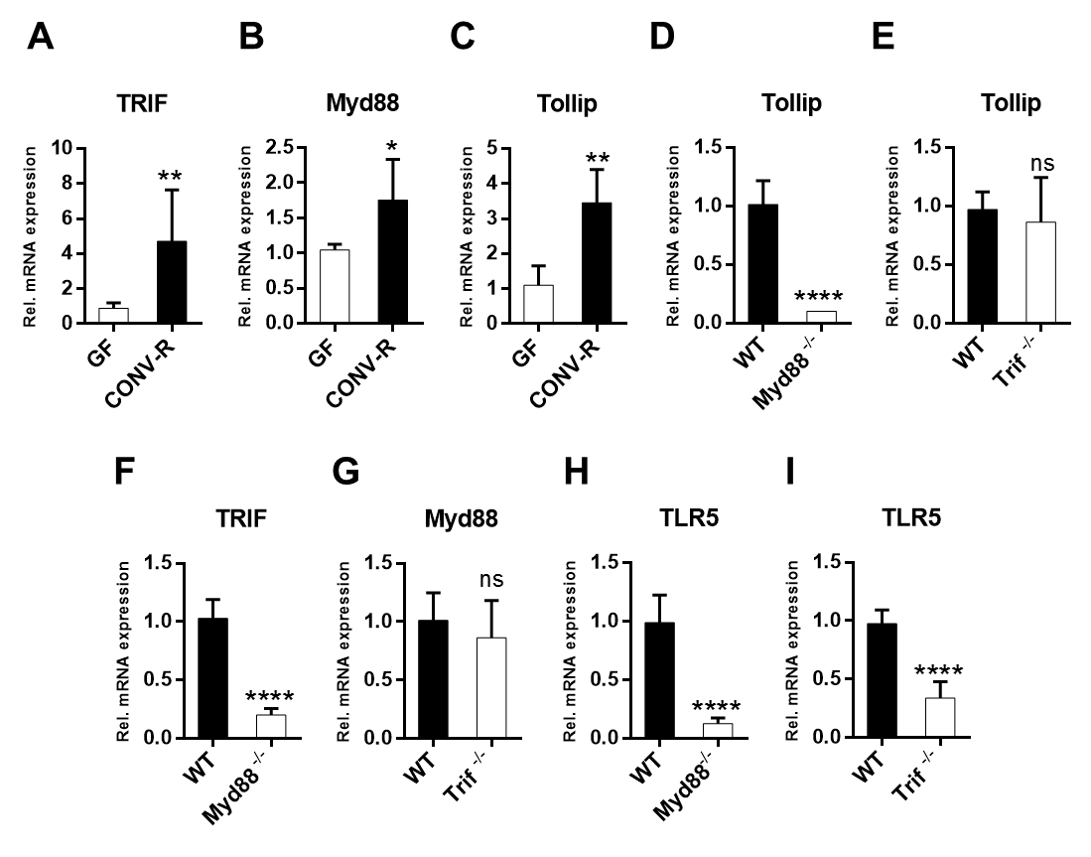
Figure 14. Signalling pathways of adaptors TRIF and TOLLIP require intact MyD88 and TLR5 expression depends on MyD88 and TRIF in the mid small intestine. A-C. Relative mRNA levels of TRIF, Myd88 and Tollip in small intestinal tissues from GF and CONV-R C57BL/6 mice (n=4-8 male mice per group). D, F, H. Relative TOLLIP, TRIF and TLR5 mRNA levels in WT C57BL/6 and Myd88^{-/-} mice (n=4-6 female per group). E, G, I. Relative TOLLIP, MyD88 and TLR5 mRNA levels in WT C57BL/6 and Trif^{-/-} mice (n=6-7 female per group). Results are shown as means ± s.e.m. One asterisk, P˂0.05; two asterisks, P˂0.01; three asterisks, P<0.005; four asterisks, P<0.001; ns, not significant; independent samples Student’s t-test.

Deficiency in the TLR adaptors MyD88 or TRIF suppresses the expression of the proliferation marker Cyclin D1
In support of a proposed role of TLR2 in mucosal renewal and in agreement with decreased TLR2 expression in the small intestine of Myd88^{-/-} and Trif^{-/-} mice (Hörmann et al. 2014), it could be shown that Cyclin D1 mRNA expression, a marker of G1/S phase transition (Resnitzky et al. 1994) and a target of the Hedgehog pathway (Duman-Scheel et al. 2002), was reduced in the small intestine of Myd88^{-/-} and Trif^{-/-} mice compared with WT controls (Fig. 15 A,B).
This indicates that both adaptors might be required for proliferation and small intestinal renewal under normal steady-state conditions.
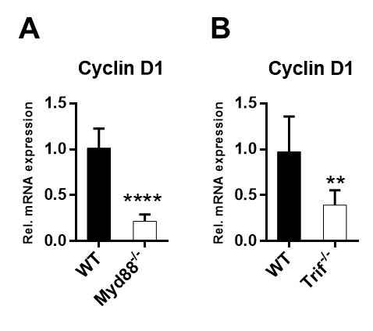
Figure 15. TLR adaptors MyD88 and TRIF are necessary for expression of proliferation marker Cyclin D1 in the small intestine. A. Relative Cyclin D1 mRNA levels in WT C57BL/6 and Myd8^{-/-} mice (n=6-7 female per group). B. Relative Cyclin D1 mRNA levels in WT C57BL/6 and Trif^{-/-} mice (n=7 female per group). Results are shown as means ± s.e.m. Two asterisks, P˂0.01; four asterisks, P<0.001; independent samples Student’s t-test.

TLR5 mRNA expression neither depends nor impacts on TLR2 or TLR4 in the mid small intestine.
TLR5 mRNA expression was unaltered in small intestinal tissues of Tlr2^{-/-} and Tlr4^{-/-} mice (Fig. 16 A, B). This is consistent with the previous results that pointed out that small intestinal TLR5 mRNA levels were not impacted by the gut microbiota (Fig. 13). Conversely, TLR5 deficiency did not lead to decreased TLR2, TLR1, TLR6 and TLR4 transcript levels (Fig. 16 C-F). These findings in whole small intestinal tissues were further corroborated by a sterile infection cell culture model on the murine small intestinal epithelial cell line MODE-K (Vidal et al. 1993). MODE-K cells that were stimulated with the TLR5 agonist flagellin did not show increased TLR2, TLR1, TLR6 and TLR4 mRNA levels (Fig. 16 G-J).
Altogether, these results indicate that TLR5 is not involved in the regulation of TLR2-mediated proliferation responses in the small intestine (Hörmann et al. 2014), but similar to TLR2, TLR1 and TLR4 mRNA expression also TLR5 transcript levels depend on MyD88 and TRIF adaptors.

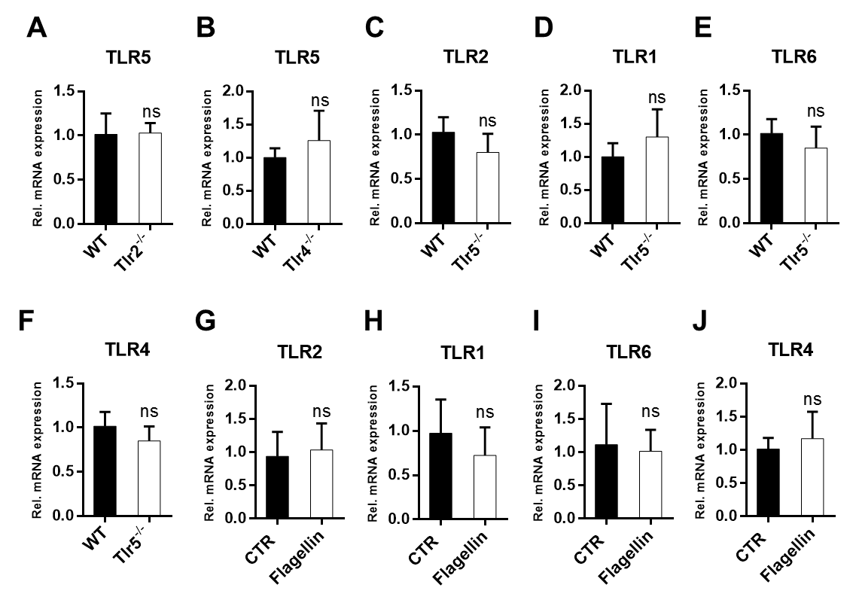
Figure 16. Small intestinal TLR5 mRNA expression neither depends nor impacts on TLR2 or TLR4. A. Relative TLR5 transcript levels in small intestinal tissues from WT C57BL/6 and Tlr2^{-/-} mice (n=7 female mice per group). B. Relative TLR5 transcript levels in small intestinal tissues from WT C57BL/6 and Tlr4^{-/-} mice (n=7 male C57BL/6 mice per group). C-F. Relative TLR1, TLR6 and TLR4 mRNA levels in WT C57BL/6 and Tlr5^{-/-} mice (n=5-7 male per group). G-J. Relative TLR2, TLR1, TLR6 and TLR4 mRNA levels in MODE-K cells stimulated with or without (CTR) flagellin (1µg/ml) for 6 hours (n=6-7). Results are shown as means ± s.e.m. ns, not significant; independent samples Student’s t-test.

Impact of innate immune receptors on the vascularization of the small intestinal mucosa.

  - Small intestinal vascularization is augmented by gut microbiota and depends on TRIF and MyD88-mediated TLR4 signalling.

Colonization of GF mice with a gut microbiota harvested from the cecum of CONV-R donor mice has been reported to increase vascularization of the small intestinal mucosa and to shorten and widen villus structures (Reinhardt et al. 2012; Stappenbeck et al. 2002). Although it has been shown that microbiota-induced coagulation factor signalling through protease-activated receptor-1 (PAR1) increases vascular remodelling of small intestinal villi (Reinhardt et al. 2012), the mechanisms that sense microbial colonization and trigger increased mucosal vascularization and remodelling remain poorly resolved.
In addition to female Swiss Webster mice (Reinhardt et al. 2012), the transcript levels of the vascular marker platelet-endothelial cell adhesion molecule-1 (PECAM-1, CD31) in mid small intestinal tissue of male CONV-R C57BL/6 mice were increased when compared with age-matched GF controls (Fig. 17 A). This demonstrates that vascularization of the small intestinal mucosa induced by commensal gut microbiota is not dependent on the strain or the sex of mice. To pinpoint the putative role of TLRs in gut mucosal vascularization, mice devoid of bacterial TLR sensing were analysed. Similar to GF mice, mice deficient in TLR4 signalling (Tlr4^{-/-}) showed decreased vascularization in the mid small intestine as indicated by PECAM-1 stained fixed-frozen tissue sections and the respective quantification of vessel length per villus area (Fig. 17B-C) and by qRT-PCR quantification of the vascular marker PECAM-1 (Fig. 17D). This suggests that bacterial LPS derived from the enteric microbiota triggers vascularization in small intestinal villus structures.
In contrast to TLR4, mice deficient in Tlr5 and Tlr2 did not show such pronounced changes in mucosal vascularization of the small intestine (Fig. 17 E-H).
Reduced PECAM-1 transcripts in small intestinal tissues of Myd88^{-/-} and Trif^{-/-} mice relative to WT controls suggest that both signalling components support mucosal vascularization (Fig. 17 I,J), which is in line with recent findings (Rakoff-Nahoum et al. 2015).
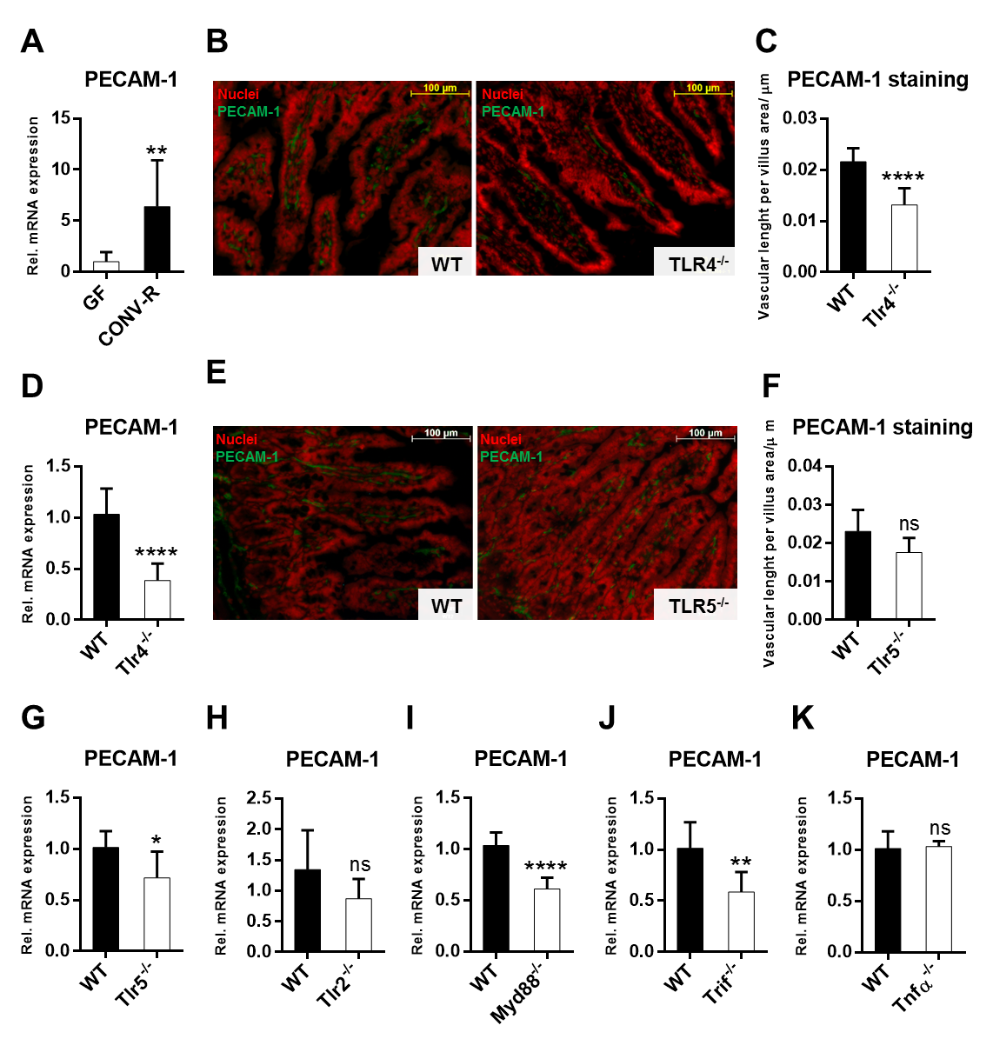Figure 17. Small intestinal vascularization is augmented by gut microbiota and depends on TLR4, MyD88, and TRIF. A. Relative mRNA levels of the vascular marker PECAM-1 in small intestinal tissues from GF and CONV-R C57BL/6 mice (n=4-10 male per group). B. PECAM-1 staining (green) of small intestinal sections from WT C57BL/6 and Tlr4^{-/-} male mice. Nuclei were stained with SYTO 61 (red). Images of representative tissue sections are shown. Scale bar: 100µm. C. Quantification of B (n=8 mice per group). D. Relative PECAM-1 mRNA levels in WT C57BL/6 and Tlr4^{-/-} mice (n=6-8 female mice per group). E. PECAM-1 staining (green) of small intestinal sections from WT C57BL/6 and Tlr5^{-/-} male mice. Nuclei were stained with SYTO 61 (red). Images of representative tissue sections are shown. Scale bar: 100µm. F. Quantification of B (n=5-6 mice per group). G-K. Relative PECAM-1 mRNA levels in G. WT C57BL/6 and Tlr5^{-/-} mice (n=6-7 male per group), H. WT C57BL/6 and Tlr2^{-/-} mice (n=7 female per group), I. WT C57BL/6 and Myd88^{-/-} mice (n=6-7 female per group), J. WT C57BL/6 and Trif^{-/-} mice (n=7 female per group), K. WT C57BL/6 and Tnfα^{-/-} mice (n=6-7 female per group). Results are shown as means ± s.e.m. One asterisk, P˂0.05; two asterisks, P˂0.01; four asterisks, P<0.001; One asterisk, P˂0.05; two asterisks, P˂0.01; four asterisks, P<0.001; ns, not significant; independent samples Student’s t-test.
Furthermore, the extent of mucosal vascularization in the small intestine was independent of tumor necrosis factor-α (TNFα) (Fig. 17 K), indicating that TLR induced TNFα signalling is dispensable in this innate immune receptor mediated process.
Overall, these results suggest that TLR4 plays a pivotal role in triggering postnatal angiogenesis in the small intestinal mucosa in a signalling process that also involves the adaptors TRIF and MyD88.

Small intestinal BMP2 mRNA expression is augmented by the gut microbiota and MyD88-dependent TLR4 signalling

TLR4 activation has been demonstrated to increase TGF-β signalling dependent on MyD88, but independent of TRIF (Seki et al. 2007). Bone Morphogenetic Proteins (BMPs) belong to the TGF-β superfamily and are negative regulators of intestinal epithelial proliferation (Hardwick et al. 2004). Opposite to their restrictive role in epithelial renewal (Hardwick et al. 2004), BMPs were shown to exert pro-angiogenic effects in cell culture and mouse models of angiogenesis (Langenfeld & Langenfeld 2004; Liu et al. 2007). In particular BMP2, an epithelial-derived morphogenic factor (Hardwick et al. 2004), has been identified to promote developmental angiogenesis (Shepherd & Nachtigal 2003) and tumor angiogenesis (Langenfeld & Langenfeld 2004). Whether BMP2 is implicated in vascular remodelling of the small intestinal mucosa remains unexplored.
Small intestinal BMP2 mRNA levels were vastly increased in CONV-R mice compared with their GF counterparts (Fig. 18 A). The activation of the Smad pathway by BMP2 signalling has been described to be dependent on BMP2 binding to heteromeric complexes expressed at the cell surface and composed of two types of receptors, BMP receptor type I and BMP receptor type II (Nohe et al. 2002). Therefore, mRNA levels of BMP receptor type I (BMPR1A) and BMP receptor type II (BMPR2) were compared in CONV-R versus GF mice. BMPR1A was unchanged between CONV-R mice and GF controls (Fig. 18 B) whereas BMPR2 was highly upregulated in the small intestine of CONV-R mice when compared with GF controls (Fig. 18 C). ID3, a downstream target gene of active BMP signalling (Ho et al. 2011), was also significantly enhanced in CONV-R mice compared with GF controls (Fig. 18 D).

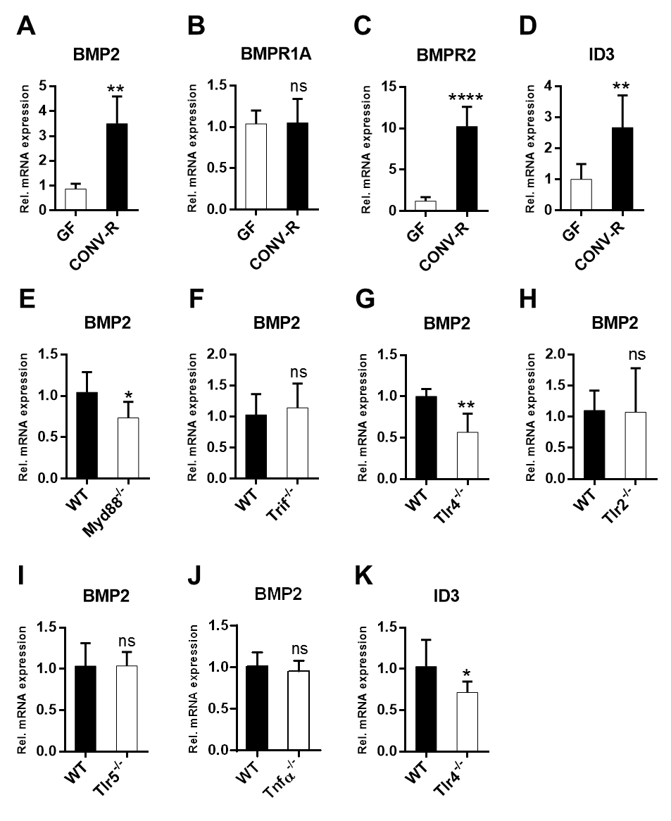
Figure 18. Small intestinal BMP2 mRNA expression is augmented by the gut microbiota and TLR4/MyD88 signalling. A-D. Relative mRNA levels of BMP2, BMPR1A, BMPR2 and ID3 in small intestinal tissues from GF and CONV-R mice (n=4-8 male C57BL/6 per group). E-J. Relative BMP2 mRNA levels in small intestinal tissues from E. WT C57BL/6 and Myd88^{-/-} mice (n=7-8 female C57BL/6 per group); F, WT C57BL/6 and Trif^{-/-} mice (n=6-7 female per group); G. WT C57BL/6 and Tlr4^{-/-} mice (n=7 mixed-sex per group); H. WT C57BL/6 and Tlr2^{-/-} mice (n=6 female per group); I. WT C57BL/6 and Tlr5^{-/-} mice (n=7 male per group); J. WT C57BL/6 and Tnfα^{-/-} mice (n=6-7 female per group). K. Relative ID3 mRNA levels in small intestinal tissues from WT C57BL/6 and Tlr4^{-/-} mice (n= 7 mixed-sex per group). Results are shown as means ± s.e.m. One asterisk, P˂0.05; two asterisks, P˂0.01; four asterisks, P<0.001; ns, not significant; independent samples Student’s t-test.
The reduction in small intestinal BMP2 expression was mediated through MyD88-dependent TLR signalling pathways, since deficiency of Myd88 suppresses BMP2 expression (Fig. 18 E). In contrast, Trif^{-/-} mice did not show reduced BMP2 transcript levels relative to WT controls (Fig. 18 F).
Tlr4^{-/-} mice had reduced BMP2 transcript levels in the small intestine (Fig. 18 G). In contrast, small intestinal tissues from Tlr2^{-/-} and Tlr5^{-/-} mice did not show altered BMP2 transcript levels, suggesting that specifically TLR4 impacts BMP2 expression (Fig. 18 H,I).
BMP2 mRNA expression was also not affected in the small intestine of Tnfα^{-/-} mice (Fig. 18 J). Furthermore, mRNA expression of ID3 was reduced in the small intestine of Tlr4^{-/-} mice compared with WT controls, confirming the impact of TLR4-mediated innate immune receptor signalling on the BMP pathway (Fig. 18 K).
Collectively, these results demonstrate a specific role for TLR4/MyD88 signalling in the regulation of BMP2 mRNA levels in the small intestine.

BMP2 expression in the small intestine depends on TLR4 and PAR1

As the commensal microbiota triggers tissue factor (TF)-dependent coagulation factor signalling and augments expression of PAR1 leading to increased vascularization of the small intestine (Reinhardt et al. 2012), transcript levels of PAR1 (F2r) in the small intestine were quantified in Tlr4^{-/-} mice compared with WT controls. PAR1 mRNA levels in the small intestine were significantly decreased in Tlr4^{-/-} mice (Fig. 19 A).
Interestingly, mice deficient in PAR1 (F2r^{-/-}), that show reduced small intestinal vascularization (Reinhardt et al. 2012), had reduced BMP2 transcript levels in the small intestine suggesting that BMP2 could support gut mucosal vascularization (Fig. 19 B). Furthermore, as previously seen with Tlr4^{-/-} mice, also F2r^{-/-} mice have reduced mRNA expression of the BMP target gene ID3 compared with WT controls, corroborating the impact of PAR1 on the BMP signalling pathway (Fig. 19 C).
These results are first indicators that suggest TLR4 could possibly be placed upstream of PAR1 in the regulation of BMP2 expression in the small intestine.
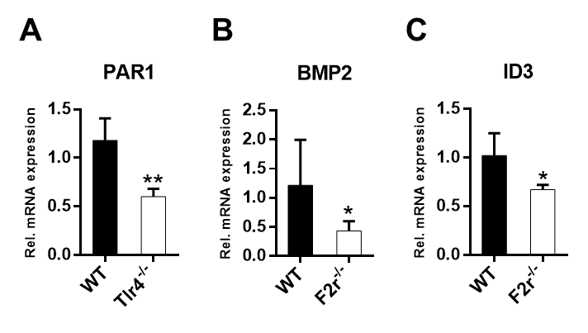
Figure 19. Small intestinal BMP2 mRNA expression is supported by PAR1 signalling. A. Relative PAR1 transcript levels in small intestinal tissues from WT C57BL/6 and Tlr4^{-/-} mice (n=4-5 female mice per group); B, C. Relative BMP2 and ID3 transcript levels in small intestinal tissues from WT C57BL/6 and F2r^{-/-} mice (n=5-7 male per group). Results are shown as means ± s.e.m. One asterisk, P˂0.05; two asterisks, P˂0.01; independent samples Student’s t-test.

Small intestinal BMP4 and BMP7 mRNA expression are unchanged by the presence of gut microbiota but depend on intact TLR5 and TNFα signalling

Besides BMP2, other BMP ligands were analysed for their expression response in the small intestine upon colonization by the gut microbiota. While BMP2 is of epithelial origin, both morphogens BMP4 and BMP7 that signal as either homodimers or heterodimers have been previously found to be expressed in the intestinal mesenchyme and regulated by the hedgehog (Hh) pathway (Neugebauer et al. 2015; van Dop et al. 2009). In the present work, the regulation of both ligands on the transcript level was briefly analysed.
In contrast to BMP2, the expression levels of the mesenchymal factor BMP7 were downregulated by the commensal microbiota (Fig. 20 B), whereas no change was observed in the levels of the mesenchymal factor BMP4 (Fig. 20 A).
Opposite to Tlr4^{-/-} mice, Tlr5^{-/-} mice display significantly decreased small intestinal BMP4 mRNA levels when compared with their WT counterparts, in the presence of microbiota (Fig. 20 C, D). In GF Tlr5^{-/-} mice the downregulation of BMP4 levels was still present but in a lesser degree (Fig. 20 E). BMP7 mRNA levels were downregulated in Tlr4^{-/-} and Tlr5^{-/-} mice in the presence of microbiota (Fig. 20 F, G), but in GF Tlr5^{-/-} mice this effect was no longer observed (Fig. 20 H).
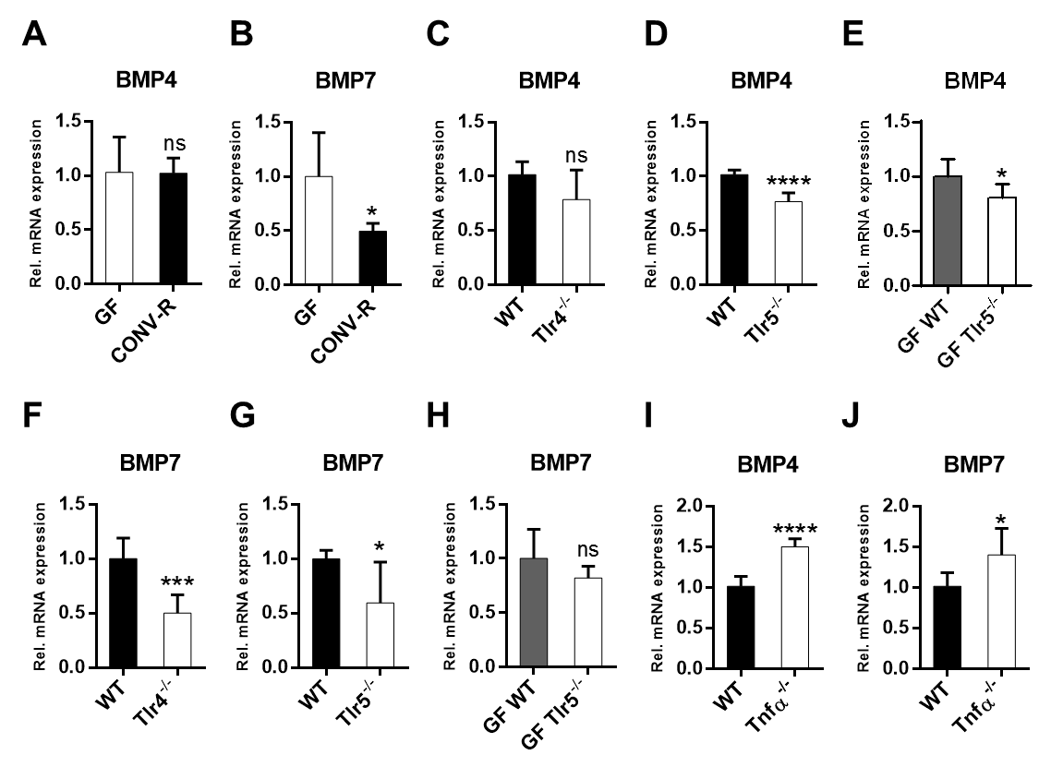
Figure 20. Small intestinal BMP4 and BMP7 mRNA expression depend on TLR5 and TNFα. A, B. Relative BMP4 and BMP7 mRNA levels from small intestinal tissues of GF and CONV-R mice (n=4-8 male C57BL/6 per group). C, D. Relative BMP4 mRNA levels from small intestinal tissues of WT C57BL/6 and C: Tlr4^{-/-}mice (n=6-8 female per group); D: Tlr5^{-/-}mice (n=7 male per group). E. Relative BMP4 mRNA levels from small intestinal tissues of WT C57BL/6 and Tlr5^{-/-}mice, both GF (n=5-6 male per group). F, G. Relative BMP7 mRNA levels from small intestinal tissues of WT C57BL/6 and F: Tlr4^{-/-}mice (n=7-8 female per group); G: Tlr5^{-/-}mice (n=5-6 male per group). H. Relative BMP7 mRNA levels from small intestinal tissues of WT C57BL/6 and Tlr5^{-/-}mice, both GF (n=4-5 male per group). I, J. Relative BMP4 and BMP7 mRNA levels from small intestinal tissues of WT C57BL/6 and Tnfα^{-/-}mice (n=7 female per group). Results are shown as means ± s.e.m. One asterisk, P˂0.05; three asterisks, P<0.005; four asterisks, P<0.001; ns, not significant; independent samples Student’s t-test.

Interestingly, transcript profiling of GF and CONV-R Tlr5^{-/-} mice that were obtained in a collaboration with Andrew Gewirtz (Atlanta, US) clearly demonstrate an involvement of the commensal microbiota and TLR5 on BMP4 and BMP7 mRNA levels in the small intestine (data not shown).
Small intestinal tissues from Tnfα^{-/-} mice revealed increased BMP4 and BMP7 transcript levels (Fig. 20 I, J), suggesting that TNFα situated downstream of TLR activation is a cytokine with a relevant role in restricting BMP4 and BMP7 in the small intestine.

Monocolonization experiments with a WT Escherichia coli K12 strain and an isogenic flagellin deletion mutant suggest a role of the TLR5 ligand flagellin in the regulation of intestinal BMP4 and BMP7 expression.

To pinpoint the role of a proteobacterial colonizer and of its TLR5 agonist flagellin, GF mice were colonized under isolator conditions for 14 days with the E. coli K12 strain JP313 and an isogenic flagellin gene fliC deletion mutant (E. coli ΔfliC).

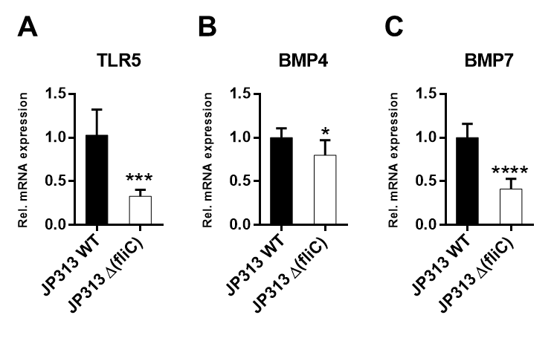
Figure 21. Monocolonization with an E.coli K12 and an isogenic flagellin deletion mutant supports the role of the TLR5 agonist flagellin in upregulating small intestinal BMP4 and BMP7. A-C. Relative TLR5, BMP4, and BMP7 mRNA levels from small intestinal tissues of GF WT C57BL/6 monocolonized for 14 days with either E. coli JP313 (WT) or E. coli JP313 ΔfliC (flagellin deletion mutant) (n=6-7 mice per group). Results are shown as means ± s.e.m. One asterisk, P˂0.05; three asterisks, P<0.005; four asterisks, P<0.001; independent samples Student’s t-test.

Monocolonization with the E. coli mutant significantly reduced TLR5 mRNA expression in the small intestine (Fig. 21 A) and led to decreased BMP4 (Fig. 21 B) and BMP7 (Fig. 21 C) mRNA expression levels in comparison with the monocolonization with the isogenic WT control. It is noteworthy to mention that bacterial counts isolated from feces from mice colonized with either the WT strain or the isogenic mutant strain did not present any significant difference at day 14 (approximately 2 x 10⁶ CFU per gram of feces), therefore suggesting that the capacity of colonizing the murine gut was similar for both strains.
These results are complementary to the data with the Tlr5-deficient mouse line and indicate that bacterial patterns can directly interfere with the BMP signalling pathway.

Gut microbial colonization and TLR4- and TLR5- mediated innate immune signalling enhance the Hedgehog pathway in the small intestine.

To investigate whether the presence of gut microbiota impacts on Hh signalling in the mid small intestine, transcript levels of the Hh signalling effector Gli1 were analysed in small intestinal tissues from CONV-R compared to GF C57BL/6 mice.
Gli1 mRNA levels were significantly increased in the presence of microbiota (Fig. 22 A). To explore the putative role of TLRs in intestinal Hh signalling, mice devoid of bacterial TLR sensing were analysed. Similar to GF mice, Tlr4^{-/-} mice showed decreased Gli1 transcript levels (Fig. 22 B). Furthermore, transcripts of the Hh Smoothened receptor (Smo) were decreased in the small intestine of Tlr4 deficient mice (Fig. 22 C). Interestingly, mRNA levels of the Hh pathway ligand Indian hedgehog homolog (Ihh) were significantly reduced in the small intestine of CONV-R Tlr5^{-/-} mice in comparison to WT controls (Fig. 22 D). In contrast, GF Tlr5^{-/-} mice showed no change in Ihh expression when compared to GF WT controls (Fig. 22 E).
Similar to the results obtained with Tlr5^{-/-} mice, the bacterial flagellin mutant resulted in diminished Ihh transcript levels in the small intestine (Fig. 22 F).
These results imply that both TLR4- and TLR5- mediated innate immune signalling have an activatory role in Hh signalling in the small intestine.
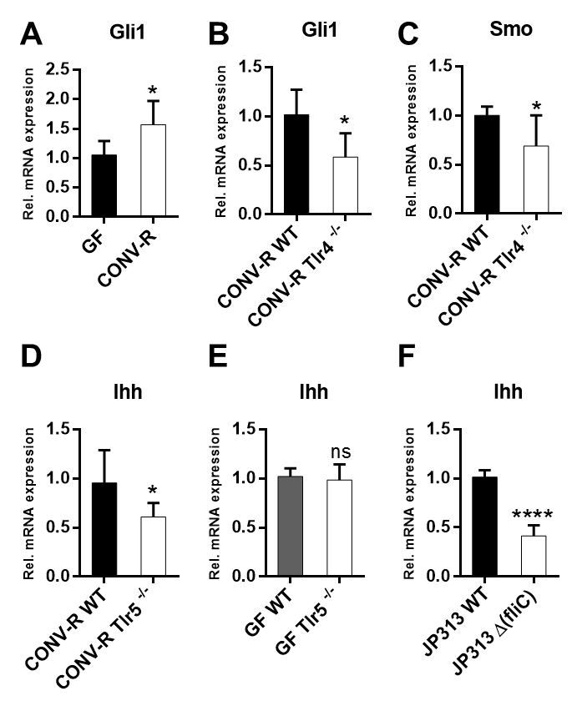
Figure 22. Gut microbiota and TLR4- and TLR5-mediated innate immune signalling enhance the expression of Hh pathway genes in the small intestine. A. Relative Gli1 mRNA levels from small intestinal tissues of GF and CONV-R C57BL/6 mice (n=6-7 mice per group), B. Relative Gli1 mRNA levels from small intestinal tissues of CONV-R WT C57BL/6 and CONV-R Tlr4^{-/-}mice (n=6-7 mice per group). C. Relative Smo mRNA levels from small intestinal tissues of CONV-R WT C57BL/6 and CONV-R Tlr4^{-/-}mice (n=6-7 mice per group). D. Relative Ihh mRNA levels from small intestinal tissues of CONV-R WT C57BL/6 and CONV-R Tlr5^{-/-}mice (n=6 mice per group). E,F. Relative Ihh mRNA levels from small intestinal tissues of E: GF WT C57BL/6 and GF Tlr5^{-/-}mice (n=5-6 mice per group); F: GF WT C57BL/6 monocolonized for 14 days with either E. coli JP313 (WT) or E. coli JP313 ΔfliC (flagellin deletion mutant) (n=7 mice per group). Results are shown as means ± s.e.m. One asterisk, P˂0.05; three asterisks, P<0.005; four asterisks, P<0.001; ns, not significant; independent samples Student’s t-test.

BMP type I receptor signalling and Hedgehog signalling in a murine colon endothelial cell line (MCEC) and its role in angiogenesis.

Intestinal microvascular endothelial cells are responsive to inhibition of BMP type I receptors and to activation of Hedgehog signalling.

Despite the canonic role of intestinal BMPs to control expansion of the epithelial lineage from the stem cell niche at the base of the Lieberkühn crypts (van Dop et al. 2009), the role of intestinal microvascular endothelium in sensing BMP signals remains elusive. The existence of the BMP signalling pathway has been reported in bovine aortic endothelial cells (ECs) (Valdimarsdottir 2002). Additionally, expression of BMP type I receptors BMPR1A and BMPR1B (but not ALK2) and BMP type II receptors has been detected by immunohistochemistry on sections from human colon (Valdimarsdottir 2002).
To explore the endothelial response to the TLR4 agonist LPS, immortalized mouse colon microvascular endothelial cells (MCEC) were used (Langley et al. 2003). LPS stimulation of the MCEC cell line led to increased mRNA levels of the TLR4 adaptor MyD88, indicating that this cell line is LPS-sensitive (Fig. 23 A) (Wang et al. 2011). However, stimulation of MCEC with LPS did not change BMP2 mRNA expression (Fig. 23 B), indicating that colonic ECs are not a major source of microbiota-triggered BMP2 expression.
Inhibition of the BMP type I receptors, BMPR1A, BMPR1B and ALK2, by LDN-193189 treatment, a potent chemical small molecule inhibitor that functions primarily through prevention of Smad1, Smad5, and Smad8 phosphorylation (Yu et al. 2008), resulted in vastly diminished transcript levels of ID3 (Fig. 23 C).
To further pinpoint the role of intestinal endothelial BMP type I receptor sensing, mRNA expression of both BMPR1A and BMPR2 was evaluated in LPS stimulated MCEC. Of note, the presence of BMPR1A and BMPR2 mRNA expression was confirmed in these cells (Ct values of both receptors were around 19), but it was not regulated by LPS stimulation (Fig. 23 D, E). The presence of BMP receptors and effective inhibition of BMP signalling imply that MCEC are responsive to BMP signals.
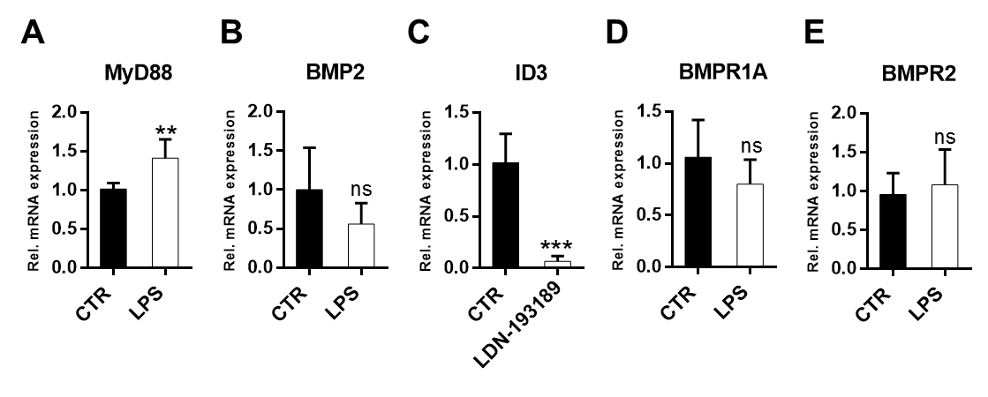Figure 23. MCEC cell line is responsive to LPS stimulation and to inhibition of BMP type I receptors. A. Relative MyD88 mRNA levels in LPS stimulated MCEC cell line. Cells were treated with or without (CTR) LPS for 4 hours (n=6-7). B. Relative BMP2 mRNA levels in LPS stimulated MCEC. Cells were treated with or without (CTR, endotoxin-free water) LPS for 4 hours (n=5 per group). C. Relative ID3 mRNA levels from MCEC treated with BMP type I receptor inhibitor LDN-193189 compared to untreated control cells (CTR, DMSO) (n=6). D. Relative BMPR1A mRNA levels in LPS stimulated MCEC. Cells were treated with or without (CTR) LPS for 4 hours (n=5-6 per group). E. Relative BMPR2 mRNA levels in LPS stimulated MCEC. Cells were treated with or without (CTR) LPS for 4 hours (n=5-7). Results are shown as means ± s.e.m. Two asterisks, P˂0.01; three asterisks, P<0.005; ns, not significant; independent samples Student’s t-test.

Multiple studies report the involvement of the Hh pathway in promoting the postnatal vascularization of tumoral and ischemic tissues (Coultas et al. 2010; Pinter et al. 2013; Harris et al. 2012; Pola et al. 2001). However, despite the well explored function of the Hh signalling in regulating intestinal epithelial homeostasis (Büller et al. 2012), it remains unexplored whether the Hh signalling plays a role in intestinal angiogenesis.
To explore the endothelial response to activation of Hh signalling, MCEC were treated with an agonist of the Hh signalling pathway, Purmorphamine. This drug is an agonist of the SMO receptor (Sinha & Chen 2006).
Upon treatment with 2 µM of Purmorphamine for 12h, MCEC had increased Gli1 mRNA levels, indicating that these intestinal endothelial cells are responsive to activation of Hh signalling (Fig. 24 A).
There is increasing evidence for a role of the Hh pathway in the control of BMP expression in the intestinal mesenchyme, which was suggested to contribute to the negative regulation of intestinal epithelial proliferation (van Dop et al. 2009). Treatment of MCEC with Purmorphamine did not reveal any difference in transcript levels of the BMP target gene ID3 when compared to control cells (Fig. 24 B), suggesting that Hh activation does not increase BMP signalling in MCEC.

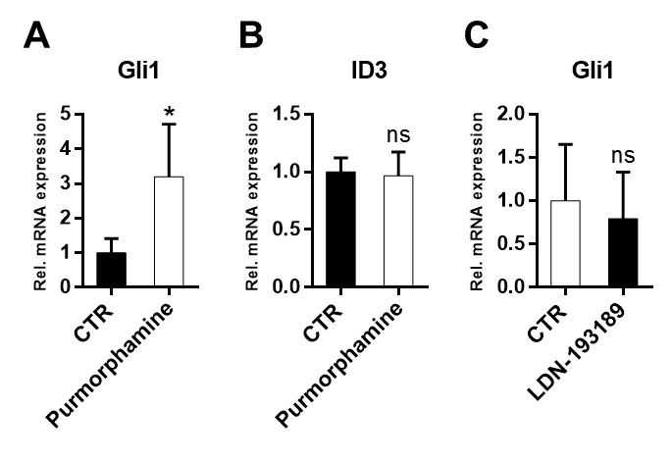
Figure 24. MCEC are responsive to activation of Hh signalling. A-B. Relative Gli1 and ID3 mRNA levels in Purmorphamine treated MCEC cell line. Cells were treated with or without (DMSO, CTR) 2 µM Purmorphamine for 12 hours (n=5-6). C. Relative Gli1 mRNA levels from MCEC treated with BMP type I receptor inhibitor LDN-193189 compared to untreated control cells (CTR) (n=6). Results are shown as means ± s.e.m. One asterisk, P˂0.05; ns, not significant; independent samples Student’s t-test.

On the contrary, it was explored whether the inhibition of BMP type I receptors by LDN-193189 could impact on the Hh signalling in the MCEC cell line. Again, no differences were observed in the Gli1 transcript levels between LDN-193189 treated cells or control cells (Fig. 24 C).
Together, these results indicate MCEC are responsive to both inhibition of BMP type I receptors by LDN-193189 and to activation of Hh by Purmorphamine, but these signalling pathways are most likely not active in a cell autonomous fashion.

Inhibition of BMP type I receptor signalling decreases gap closure in a scratch assay on MCEC. Hedgehog modulation does not impact on migration of MCEC.

Since intestinal ECs respond to inhibition of BMP type I receptors, and given that LPS has previously been implicated in cell culture models of angiogenesis (Pollet et al. 2003), the impact of MAMPs and of BMP signals on angiogenesis in MCEC was tested. In the in vitro scratch assay, cell migration was evaluated. Neither treatment of MCEC with LPS nor with flagellin provoked gap closure over time, as evaluated with a linear mixed regression model (Fig. 25 A, B). Interestingly, inhibition of BMP type I receptors of MCEC with LDN-193189 showed a tendency of decreased gap closure, suggesting a role of BMPs in the migration behavior of MCEC (Fig. 25 C).
C
B
A
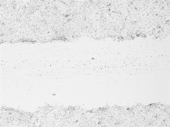


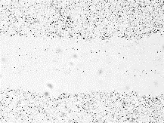
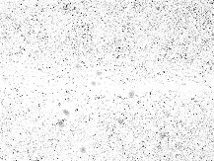


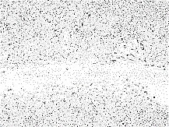

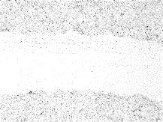


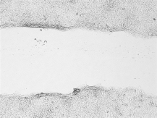


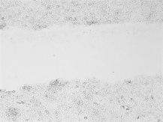


Flagellin
CTR
Time points (hours)
10 µg/ml LPS
50 ng/ml Flagellin
0.5 µM LDN-193189
Time points (hours)
Time points (hours)
Flagellin
Vehicle CTR: endotoxin-free water
LDN
CTR
LPS
Vehicle CTR: endotoxin-free water
LDN-193189
Vehicle CTR: DMSO
LPS
CTR
Figure 25. BMP type I receptor signalling but not LPS or flagellin support gap closure of MCEC. A-C. Confluent MCEC cells cultured in 12- well tissue culture plates were wounded using sterile pipette tips (0h) and then re-cultured in medium containing or not A: LPS, B: flagellin, C: LDN-193189. Percentage of reduction of gap along time is shown for the first 15 hours. Images were captured every 10 min for 30 hours with a phase contrast microscope (n=3). The automated cell imaging system JuliStage was used. Representative images are shown.
Given that MCEC are responsive to activation of Hh signalling, the impact of Hh signalling was also investigated in the scratch wound healing assay. MCEC were either treated with Purmorphamine or with an antagonist of the Hh signalling pathway, GDC-0449 (Vismodegib).
In a scratch assay, treatment of MCEC with GDC-0449 showed only a tendency to reduce gap closure over time, whereas treatment with Purmorphamine did not impact gap closure, as evaluated with a linear mixed regression model (Fig. 26 A, B).
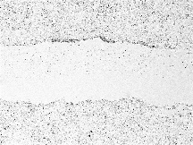





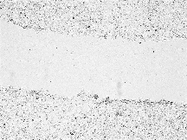

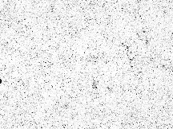
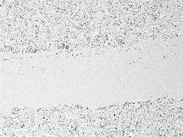


A
0h
15h
30h
Time points:
Time points (hours)
20 µM GDC-0449
GDC-0449
GDC-0449
Vehicle CTR: DMSO
CTR
4 µM Purmorphamine
Time points (hours)
Purmorphamine
Vehicle CTR: DMSO
B
Purmorphamine
CTR

Figure 26. Inhibition of the Hh pathway by GDC-0449 supports delay of MCEC gap closure. A, B. Confluent MCEC cells cultured in 12-well tissue culture plates were wounded using sterile pipette tips (0h) and then re-cultured in medium containing A: 20 µM GDC-0449, B: 4 µM Purmorphamine. Controls (CTR) correspond to medium containing the respective volume of DMSO for each condition. Images were captured every 10 min for 30 hours with JuliStage cell imaging system (n=3).

Inhibition of the Hedgehog pathway suppresses branching point formation of MCEC but BMP type I receptor inhibition does not impact tube formation of MCEC.

Since previous work has suggested that BMP signalling through BMP type II receptors is implicated in developmental angiogenesis (Jadlowiec et al. 2005), and that BMP receptor type I activation in bovine aortic endothelial cells can stimulate migration and tube formation behavior (Valdimarsdottir 2002), the focus was to investigate if selective inhibition of BMP type I receptor signal transduction could impair angiogenesis in the MCEC line. In cell culture experiments, LDN-193189 inhibitor treatment of MCEC showed no impact on tube formation in a matrigel assay, as indicated by the quantification of branching points (Fig. 27). Inhibitor treatment of MCEC did not point to an involvement of the BMP type I receptors in the tube formation angiogenesis assay.
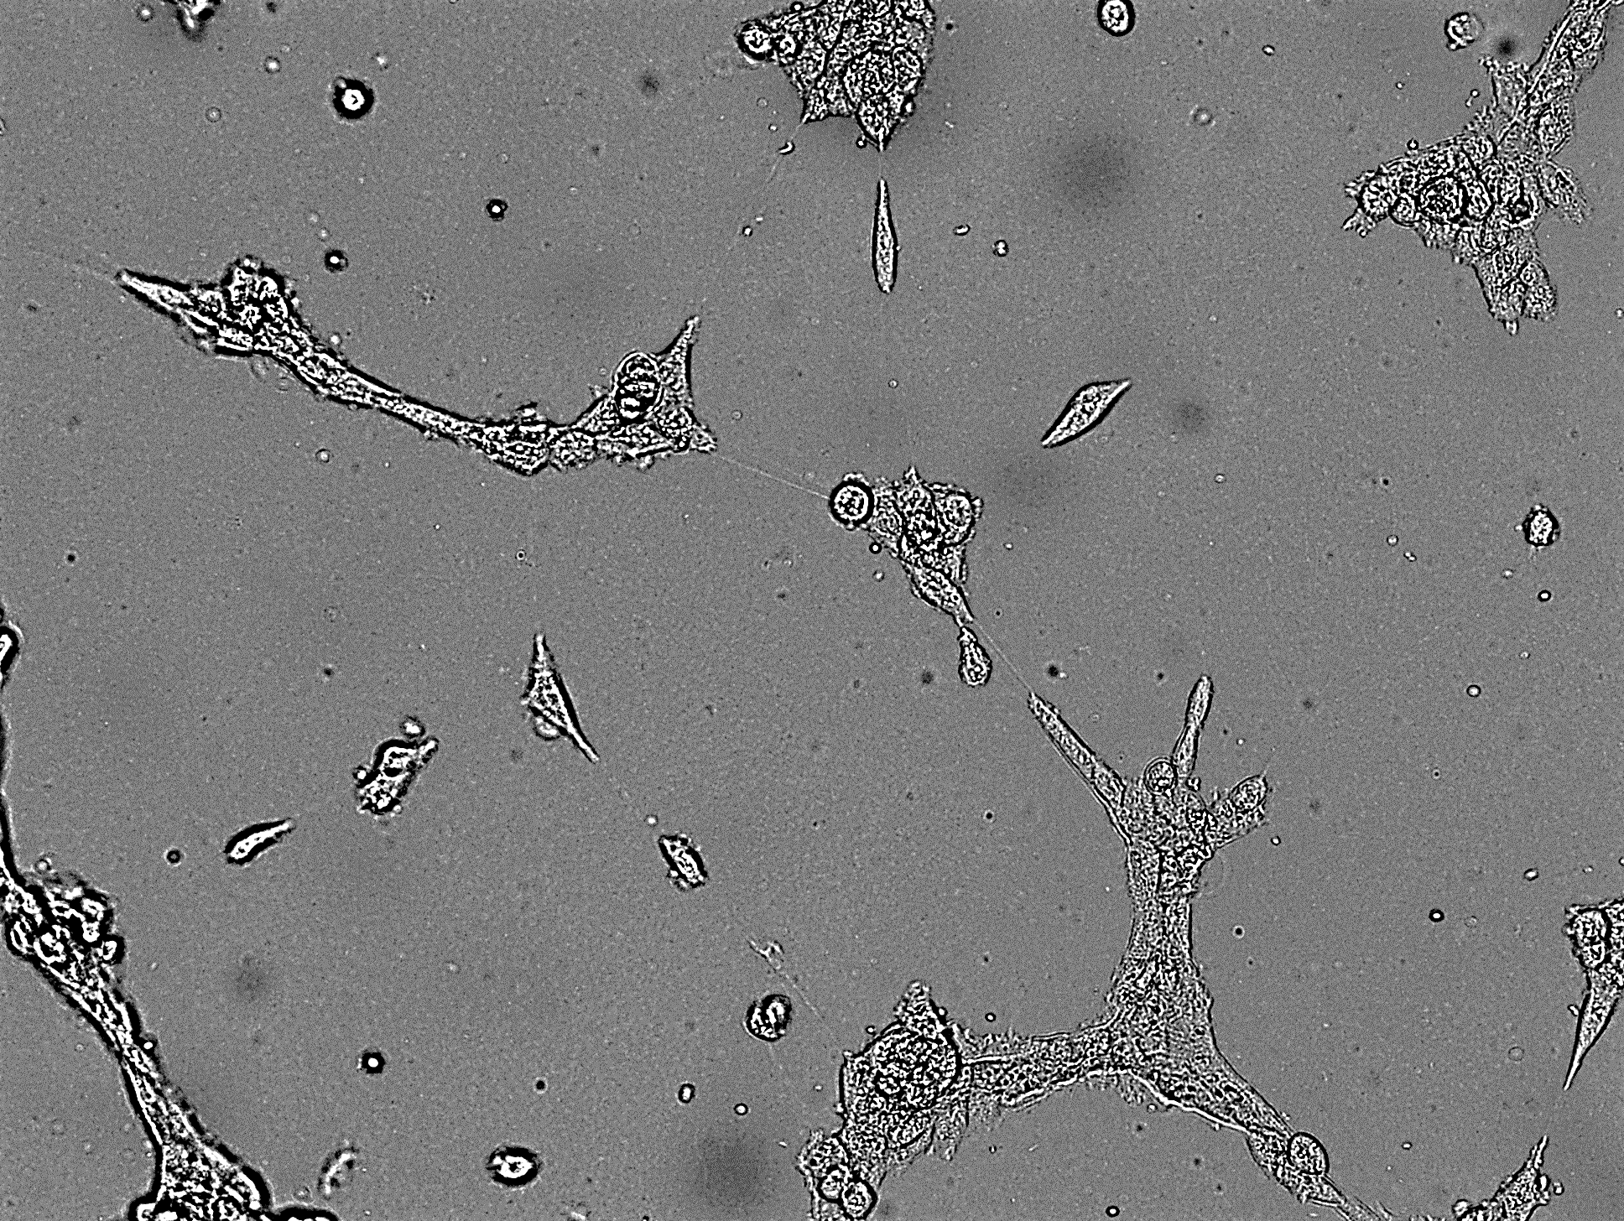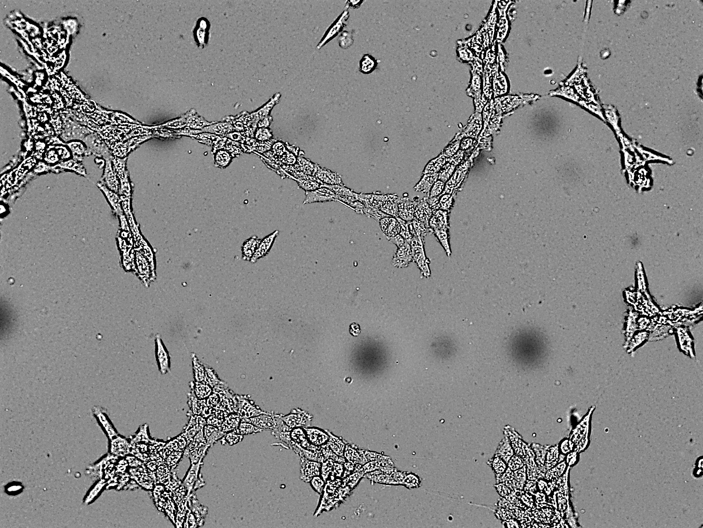
LDN-193189
CTR DMSO
Figure 27. BMP receptor type I activation does not influence tube formation of MCEC. Quantification of branching points in a tube formation assay of MCEC treated with LDN-193189 and comparison with the vehicle control (CTR, DMSO) (n=4). Results are shown as means ± s.e.m. ns, not significant; independent samples Student’s t-test.

Hh signalling has been described to be essential for endothelial tube formation during vasculogenesis (Vokes et al. 2004). Therefore, it was assessed whether Hh signalling could affect tube formation in the matrigel assay. To this means, MCEC were incubated with 20 µM GDC-0449 and 4 µM Purmorphamine and the number of branching points formed was quantified. Remarkably, the number of branching points is dramatically reduced upon treatment with GDC-0449, whereas with Purmorphamine the number of branching points was unchanged (Fig. 28 A, B). These results from in vitro angiogenesis assays suggest that blockade of the Hh pathway in endothelial cells could be an effective anti-angiogenic strategy.
Together, these results imply that the activation of the Hh signalling pathway through microbiota induced-TLR4 and -TLR5 sensing potentially contributes to angiogenic processes of the intestinal endothelium.

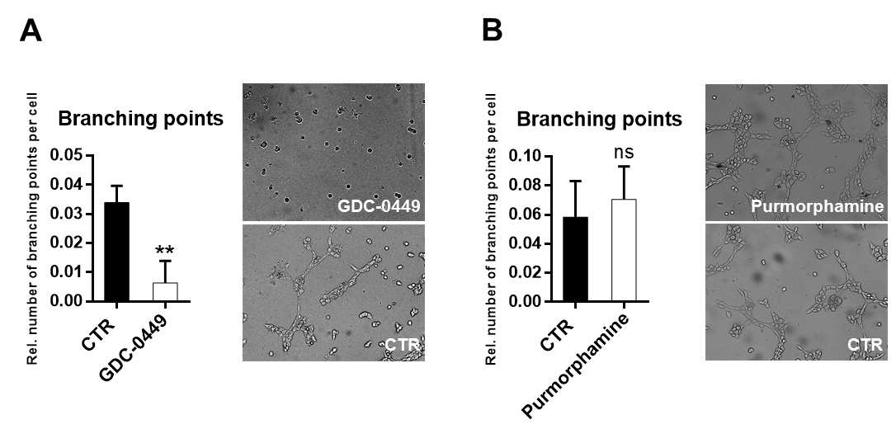
Figure 28. Inhibition of the Hh pathway suppresses branching point formation of MCEC. A,B. Quantification of branching points in a tube formation assay of vehicle DMSO treated MCEC (CTR) or treated with A: 20 µM GDC-0449 (n=4), B: 4 µM Purmorphamine (n=4). Results are shown as means ± s.e.m. Two asterisks, P˂0.01; ns, not significant; independent samples Student’s t-test.

In vivo inhibition with LDN-193189 has no effect on vascularization of the small intestine

To further assess the potential role of BMP type I receptors for mucosal vascularization in vivo, male C57BL/6J mice were treated by oral gavage with a daily dose of 5 mg/kg LDN-193189 over 5 days (Mayeur et al. 2014). This resulted in a significant reduction in small intestinal transcript levels of the BMP target gene ID3 demonstrating that blocking of BMP signalling was effective (Fig. 29A).
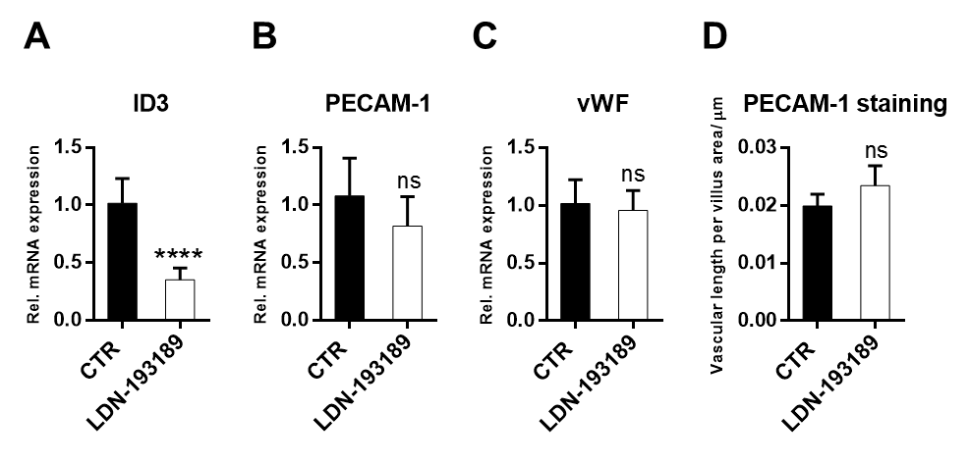
However, BMP type I receptor blockade did not result in signs of reduced small intestinal vascularization as expression levels of the vascular markers PECAM-1 and VWF remained unchanged by LDN-193189 treatment (Fig. 29 B, C).

Figure 29. Blockade of BMP receptor type I signalling has no effect on small intestinal vascularization. A. Relative ID3 mRNA levels from male C57BL/6 mice treated by oral gavage with a daily dose of 5 mg/kg LDN-193189 over 5 days and comparison with the corresponding control mice (treated with citric buffer, CTR) (n=6 male per group). B. Relative PECAM-1 mRNA levels from male C57BL/6 mice treated with LDN-193189 and comparison with the corresponding untreated mice (CTR) (n=5-6 male per group). C. Relative vWf mRNA levels from male C57BL/6 mice treated with LDN-193189 compared with the corresponding untreated mice (CTR) (n=6-7 male per group). D. Quantification of length of vessels stained with PECAM-1 per villus area from small intestinal sections from WT C57BL/6 treated or not (CTR) with LDN-193189 (n=5). Results are shown as means ± s.e.m. Four asterisks, P<0.001; ns, not significant; independent samples Student’s t-test.

Also, quantification of vessel length per villus area from mice treated with LDN-193189 revealed no changes when compared to untreated control (Fig. 29 D). These in vivo mouse experiments demonstrate that BMP receptor type I mediated signals are most likely not pivotal for vascularization of the small intestinal mucosa.

Discussion

In the past few years, the host-microbiota relationship has been a subject of many studies. However, many of the various microbial-triggered pathways that lead to changes in host physiology remain unexplored. To date, most of the studies have been focused on the colon or fecal microbiota. However, the less explored small intestine is the first intestinal place to encounter significant colonization densities with microbiota and effective resorption of dietary components and, therefore, represents a major place of the gut to perceive complex microbiota-host interactions (Booijink et al. 2007). The small intestinal vasculature is increased upon colonization with microbiota and so far the signalling pathways mediating this process remain largely unexplored (Stappenbeck et al. 2002; Hooper 2004; Reinhardt et al. 2012).
Given the crucial role of the intestinal vasculature in regulating nutrient absorption and gut immune function (Bernier-Latmani et al. 2015), it becomes relevant to gain insight on the signalling pathways involved during the microbiota-induced intestinal vascularization process.
In this work, regulation of the small intestinal expression of innate immune Toll-like receptors (TLRs) by the microbiota and whether these receptors could impact intestinal angiogenesis was firstly explored. Since Bone Morphogenetic Protein (BMP) and Hedgehog (Hh) signalling pathways participate in maintaining the gut homeostasis (Büller et al. 2012) and have been shown to participate in developmental and postnatal vascularization processes (Hong et al. 2013; Harris et al. 2012; Hwang et al. 2012; Pola et al. 2001; Mahmoud et al. 2009; Oh et al. 2000; Johnson et al. 1996), here it was investigated whether these signalling pathways can be controlled by the microbiota to impact on the vascularization of the intestinal mucosa.
First, MyD88 and TRIF adaptors were identified as important determinants of TLR5 transcript levels in the small intestine. In contrast to TLR2 or TLR4 (Hörmann et al. 2014), the small intestinal TLR5 mRNA levels were not directly affected by the gut microbiota nor influenced through TLR receptor cross-talk. Additionally, results with Tlr4^{-/-} and Myd88^{-/-} mice imply that TLR4/MyD88 signalling supports small intestinal vascularization.
Furthermore, expression of epithelial-derived BMP2 in the small intestine is dependent on the enteric microbiota and on TLR4/MyD88, as well as on intact PAR1 signalling. To explore the role of BMP signalling in angiogenesis, BMPR type I signal transduction was shown here not to regulate angiogenesis in culture models of MCEC or in vascularization of the small intestine of inhibitor-treated C57BL/6J WT mice in vivo. This work did not find a significant contribution of BMP2 in microbiota-induced postnatal vascular development of the small intestinal mucosa despite the documented role of BMP2 in the control of the epithelial lineage (Hardwick et al. 2004).
Here, also a novel signalling pathway, the regulation of BMP4 and BMP7 transcript levels via TLR5/TNFα signalling in the small intestine was proposed and this work provided the first evidence of the role of TLR4- and TLR5-mediated innate immune signalling in regulating Ihh transcripts and its Gli1 downstream target in the small intestine. In contrast to BMPR type I blockade, inhibition of Hh signalling in vitro could reduce angiogenic processes of MCEC.

Gut microbiota-induced innate immune pathways: TLRs and their adaptor expression.

The small intestine is associated with a vast surface area constantly exposed to antigens derived from dietary products and commensal and pathogenic microbes. In healthy intestine, an adequate response is generated against these antigens to maintain homeostasis (Booijink et al. 2007). Innate immune sensors, such as TLRs, play a central role in this balanced process. Environment, genetics and host immunity regulate TLR function and a failure in this balance may lead to disturbed TLR signalling which may contribute to acute or chronic intestinal inflammatory processes, such as IBD (Abreu et al. 2005). Therefore, exploring the interactions between TLRs and gut microbiota will expand the knowledge on gut homeostasis and gut inflammatory processes.
To pinpoint the role of bacteria sensing TLRs expressed on the small intestinal epithelium under conditions of unperturbed steady-state intestinal tissue homeostasis, the potential role of TLR5 in the orchestration of the expression profile of TLRs was explored. In contrast to TLR2 and its co-receptor TLR1, which were previously found upregulated by gut microbiota colonization (Hörmann et al. 2014), mRNA expression of TLR5 in the small intestine was not regulated by microbiota. Accordingly, decimation of gut microbes by administration of a broad-spectrum antibiotic cocktail did not change TLR5 mRNA levels. This finding is in line with unchanged TLR5 transcript levels in small intestinal tissues of Tlr2^{-/-} and Tlr4^{-/-} mice, suggesting that small intestinal activation of TLR2 and TLR4 signalling by gut microbial communities does not impact TLR5 mRNA expression. Conversely, mice deficient in TLR5 did not show altered TLR1, TLR6, and TLR4 mRNA levels. These results were confirmed by a sterile infection cell culture model with flagellin-stimulated intestinal epithelial MODE-K cells that did not reveal any impact of flagellin-triggered TLR5 activation on the different TLRs.
The fact that microbiota does not cause a direct impact on TLR5 transcript levels in the small intestine does not exclude other possible regulatory interactions between these two. Although TLR5 transcript levels are not regulated by microbes under normal intestinal homeostatic conditions as shown here, mice lacking TLR5 have been reported to show spontaneous development of a colitis phenotype dependent on microbiota composition (Chassaing et al. 2014; Singh et al. 2015). Also, epithelial barrier integrity seems to have a role in restricting TLR5 activation, as it has been reported that colonic flagellin administration following disruption of the epithelium results in stimulation of basolaterally localized TLR5 (Rhee et al. 2005). Accordingly, in mouse intestine, TLR2 and TLR4 were described to be apically distributed in ileal epithelium (Chabot et al. 2006), which might support their expression regulation by the presence of gut microbiota.
Similar to TLR2, TLR1 and TLR4 expression (Hörmann et al. 2014), also TLR5 transcript levels markedly depend on the adaptor molecules MyD88 and TRIF. TLRs are critical for maintaining epithelial homeostasis and for protection against direct epithelial injury (Rakoff-Nahoum et al. 2004; Araki et al. 2005), therefore it is possible that the increased susceptibility to dextran sodium sulfate colitis observed in Myd88-deficient mice is partially caused by reduced TLR expression.
Interestingly, MyD88 and TRIF transcript levels were upregulated in the presence of microbiota in C57BL/6 mice. As previously reported in Swiss Webster female mice, MyD88 was also upregulated in CONV-R mice when compared with GF, an effect that seems to be strain and sex independent.
Despite the overlap in the downstream pathways and in the expression of inflammatory mediators activated through TRIF and MyD88 signalling, it has been assumed that both adaptors function independently (Biswas et al. 2007). Importantly, in the present work, MyD88 is shown to impact on TRIF expression but the opposite is not observed, which is consistent with a recent study indicating that epithelial TRIF signalling requires intact MyD88 signal transduction (Petnicki-Ocwieja et al. 2013).
Short-term stimulation with LPS has been associated with activation of proinflammatory signalling cascades in IEC whereas long-term incubation leads to hyporesponsiveness with minimal reaction by the IEC. Interestingly, upregulation of the TLR inhibitory adaptor molecule TOLLIP in IEC contributes to this state of hyporesponsiveness (Otte et al. 2004). Consistently, as observed here, the increased TOLLIP expression in the small intestine of CONV-R mice compared with GF controls could result from a prolonged stimulation of IEC by the gut microbiota. Also, TOLLIP mRNA expression depends on intact MyD88, which in turn is upregulated by microbiota and has been shown to act as a marker of TLR4 activation in primary HUVEC upon LPS stimulation (Wang et al. 2011).
In accordance with reports that have implicated TLR2 and TLR5 signalling in cell migration, wound repair, proliferation and survival of human airway epithelial cells (Shaykhiev et al. 2008), microbiota-dependent intestinal epithelial TLR2 signalling was appointed as a determinant of small intestinal epithelial renewal under regular steady-state conditions (Hörmann et al. 2014). In agreement with the previous results, cyclin D1 mRNA expression, a marker of G1/S phase transition, was reduced in the small intestine of Myd88^{-/-} and Trif^{-/-} mice compared with WT controls.
Compensatory proliferation upon injury was found impaired in Myd88^{-/-} mice (Rakoff-Nahoum et al. 2004) and deletion of Myd88 and Tlr2 in the intestinal epithelium of mice dramatically reduces DSS-induced colitis regeneration and spontaneous tumor development (Scheeren et al. 2014). According to the results presented here, it is conceivable that the impaired proliferation response in Myd88^{-/-} mice may partially result from decreased TLR expression (Fig. 30), a hypothesis that needs to be tested in future research.
Together, these results contribute to previous published findings in clarifying the role of microbiota-induced pathways in regulating expression of bacteria sensing TLRs and intestinal epithelial TLR adaptors.
Since mice lacking TLR5 are prone to develop gut inflammation, it is clearly relevant to further explore in future studies the effects of this receptor on the orchestration of TLR innate immunity and understand how this affects intestinal homeostasis under conditions of acute intestinal inflammation and perturbed barrier function.
Figure 30. Cell intrinsic TLR2 signalling in the small intestinal epithelium is induced by gut microbiota (Brandão et al. 2015).
TLR adaptors MyD88 and TRIF upregulate TLR2 and TLR5 transcript levels and appear to be necessary for TLR2- induced proliferation and renewal of the small intestinal mucosa.

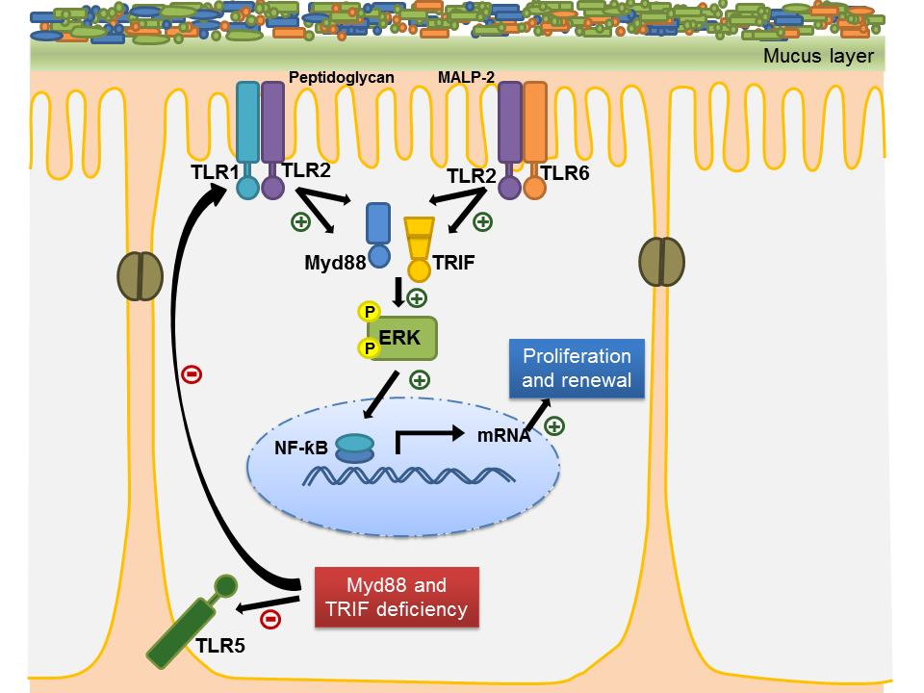

TLR signalling promoted gut microbiota-induced vascularization of the small intestine.

GF mice have been associated with arrested vascular development in the small intestinal villus structures of GF mice (Stappenbeck et al. 2002; Reinhardt et al. 2012). Although some work has implicated bacterial ligands in proliferation, migration, transmigration and tube formation of HIMEC, microbiota-induced mechanisms that support mucosal vascularization in the intestine remain poorly resolved (Schirbel et al. 2013).
According to the results displayed here, dampened TLR4/MyD88/TRIF signalling might in part explain the poor vascularization observed in the small intestine of GF mice. In addition to previous findings, showing that PAR1 signalling supports vascularization of the intestinal mucosa (Reinhardt et al. 2012) and TIR-domain containing proteins (e.g. TLRs, MyD88, TRIF) are postnatal regulators of small intestinal angiogenesis (Rakoff-Nahoum et al. 2015), here it was reported that small intestinal PAR1 mRNA levels depend on intact TLR4. Corroborating these results, Klytaimnistra Kiouptsi from the Reinhardt laboratory has shown that the expression of the PAR1 target gene CCL2 (Monocyte Chemoattractant Protein-1, MCP-1) (Riewald et al. 2002) in the small intestine is dependent on enteric microbiota and on TLR4/MyD88 (unpublished data). Hence, a novel pathway involving TLR4/MyD88/TRIF and the regulation of PAR1 might explain an impaired vascularization in the absence of microbial communities (Fig. 31). Likewise, TLR5 appears to play a role in inducing intestinal vascularization but to a lesser extent than TLR4. Curiously, TLR4 has been implicated in retinal neovascularization since the release of TLR4 endogenous ligand high-mobility group box-1 in ischemic neural tissue triggers TLR4-dependent responses that contribute to neovascularization (He et al. 2013). Also, activation of TLR5 by flagellin has been associated with increased angiogenic processes during rheumatoid arthritis (Kim et al. 2013).
Future research with primary intestinal endothelial cells (ECs) from GF and conventionalized Tlr4^{-/-} and Tlr5^{-/-} mice, and with reporter mouse lines of the microvascular endothelium that can be crossed with Tlr-deficient mouse lines should further elucidate the signalling pathways that are activated by the gut microbiota and that are required to evoke a vascular remodelling response in the small intestinal mucosa.

Role of gut microbiota and TLR signalling on BMP expression in the small intestine.

It is widely reported that BMP signalling from intestinal epithelium and mesenchyme is necessary for the correct patterning of the intestinal epithelium and the maintenance of the intestinal stem cell niche (van Dop et al. 2009; He et al. 2004; Auclair et al. 2007). In particular, the synthesis of BMP2 by intestinal epithelial cells, its primary intestinal source, has been defined and it was shown to act via autocrine signalling routes to restrict expansion of the epithelial lineage (Hardwick et al. 2004).
A few studies have pointed out pro-angiogenic effects of BMPs in cell culture and mouse models of angiogenesis (Langenfeld & Langenfeld 2004; Liu et al. 2007) and the involvement of this signalling pathway in developmental and tumor angiogenesis (Hardwick et al. 2008; David et al. 2009). For instance, BMP2 has been described to induce angiogenesis both in tumors and pre-natal development, as well as to be able to directly stimulate ECs (Langenfeld & Langenfeld 2004; Jadlowiec et al. 2005). Effects orchestrated by BMPs occur via BMP receptor signalling in cell-cell and cell-matrix interactions (Liu et al. 2007). To illustrate the impact of BMP receptor signalling in vascular development, BMP receptor type II expression has been described to impact angiogenic processes during pre- and post-natal stages (Liu et al. 2007), whereas mutations or lack of BMP receptor type I, ALK1, have been implicated in vascular diseases and lethal vascular defects in mouse embryos (Johnson et al. 1996; Oh et al. 2000).
Despite the current advances on exploring the diverse roles of intestinal BMP signalling, its role on the intestinal endothelium and vascular remodelling remains elusive.
Remarkably, an unexpected novel role for enteric microbiota, TLR4/MyD88 and PAR1 signalling axis in stimulating BMP2 mRNA expression in the small intestine was found in the present work (Fig. 31). Decreased BMP signal transduction in GF, Tlr4^{-/-} and F2r ^{-/-} mice was supported by diminished small intestinal ID3 transcript levels, a well-known BMP target gene (David et al. 2009).
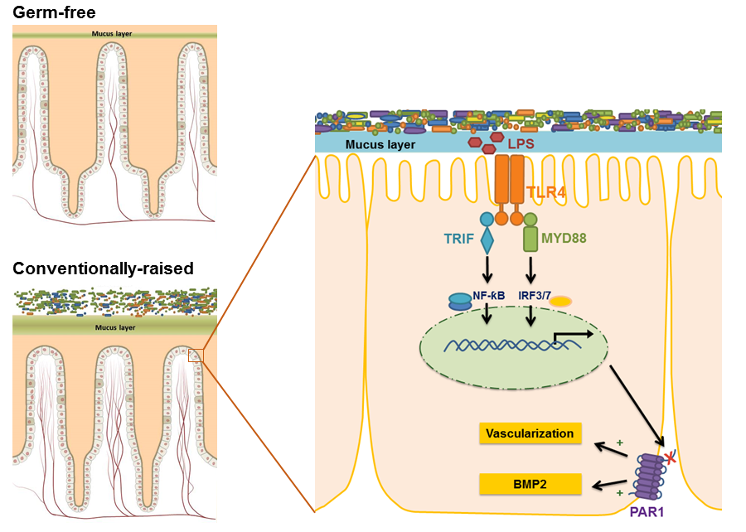
Figure 31. Gut microbiota induce vascularization of the gut mucosa and upregulate small intestinal BMP2 levels through TLR4/MyD88/TRIF and PAR1 signalling axes.

Interestingly, work developed by Julia Mohr and Sven Jäckel from the Reinhardt group has found upregulation of BMP2 protein expression in FACS-sorted primary intestinal epithelial cells from small intestinal tissues of CONV-R mice compared with GF controls. This is in line with the increased BMP2 transcript levels in whole small intestine from CONV-R mice and pinpoints the epithelium as an important cellular source of microbiota-regulated BMP2. It remains unresolved whether intestinal immune cells such as macrophages may contribute as significant sources of microbiota-regulated BMP2.
In contrast to BMP2, the morphogens BMP4 and BMP7 were not regulated by the commensal microbiota, when comparing the mid small intestine from CONV-R and GF mice. It was not determined, however, if shorter time points of colonization would translate into a regulation of these morphogens. BMP4 expression levels were dependent on TLR5 but not on TLR4, while BMP7 mRNA levels were dependent on TLR4 and TLR5. Interestingly, the regulation of BMP7 via TLR5 seemed to occur only in the presence of microbiota.
Accordingly, the dependence of BMP4 and BMP7 transcript levels on TLR5 in the small intestine was corroborated using either Tlr5^{-/-} or C57BL/6J GF mice monocolonized with a flagellin deletion mutant of E. coli K12 that was generated by lambda Red mediated recombination and that was equally efficient in colonizing the murine gastrointestinal tract as the isogenic WT strain. However, the ability for the mutant and corresponding WT E. coli to colonize the intestinal mucus layers was not determined and should be assessed in future studies to infer if flagellin could interfere with the colonizing process and the proximity of E. coli to the epithelial cell layer. In support of these results, transcript profiling of GF and CONV-R Tlr5^{-/-} mice obtained in a collaboration with Andrew Gewirtz (Georgia State University, Atlanta, US), revealed a link between commensal microbiota and TLR5 on BMP4 and BMP7 mRNA levels in the small intestine. Curiously, also TNFα was shown here to be associated with decreased BMP4 and BMP7 transcript levels.
The robust effects revealed by monocolonization experiments performed here are in line with previous studies. For instance, monocolonization by WT E.coli K12 alone of polarized intestinal epithelial cell lines and murine ileal biopsies was shown to be sufficient to induce strong NF-kB-dependent inflammatory responses, an effect that relies on the interaction of flagellin with TLR5 expressed in situ in the ileum, both at the basolateral and apical compartments of enterocytes (Bambou et al. 2004).
Despite this work showing BMP4 and BMP7 transcript levels to be regulated by TLR5 and revealing that these morphogens are most likely not involved in the vascularization process of the small intestine, their functional role has not been clarified yet. Some studies have described TNFα and BMP4 to be involved in regulation of intestinal epithelial tight junction permeability (Ma et al. 2004; Clayburgh et al. 2006; Chen et al. 2014). In addition, it was observed that BMP7 administration confers intestinal mucosal protection, preserves intestinal function and prevents intestinal inflammation (Radhakrishnan et al. 2008). Therefore, in future studies, it would be of interest to explore a hypothetical mechanism of BMP4 and BMP7 in the microbiota-dependent regulation of the mucosal barrier. Furthermore, exploring these factors should be of clinical relevance as BMP4, BMP7 and TLR5 have also been associated with colorectal cancer progression (Klimosch et al. 2013; Hardwick et al. 2008). The development of BMP4 and BMP7 conditional knockout mouse models could offer excellent resources in future research to study in detail the impact of both morphogens in the small intestine.
Also, the impact of microbiota-triggered TLR4/MyD88 signals in inducing BMPs in order to restrict renewal of the epithelial lineage should be addressed. This may also be reflected by the observation of significantly increased spontaneous polyposis in the small intestine of GF mice (Anitha et al. 2012; Mizutani et al. 1984).

Role of gut microbiota and TLR signalling on Hedgehog expression in the small intestine.

The Hedgehog (Hh) pathway interacts with Bone Morphogenetic Proteins (BMPs) to regulate intestinal epithelial homeostasis (Büller et al. 2012). The involvement of the Hh pathway in postnatal vascularization of tumor and ischemic tissues has been widely reported. However, whether Hh components have an active role in angiogenesis in the intestine remains unknown.
A hypothetical regulation of the Hh signalling in the mid small intestine of mice by the microbiota and TLR signalling was investigated in this work. Results reveal that gut microbiota, TLR4 and TLR5 mediated innate immune signalling are able to induce transcripts of the Ihh ligand and the downstream target Gli1 in the mid small intestine of C57BL/6 mice. Interestingly, the positive regulation of the Hh signalling by the microbiota and TLR signalling follows a different line from previous findings that demonstrate the role of Hh signalling in restricting intestinal epithelial cell proliferation (van den Brink et al. 2004; van Dop et al. 2009). It is conceivable that the disparate studies on the regulation of the Hh signalling by microbiota and TLR signalling may result from the involvement of distinct Hh ligands such as Shh or Ihh, differing from each other in their tissue specific pattern of expression and levels of expression (Ramalho-Santos et al. 2000; van den Brink 2007).
.

BMP receptor type I and Hh signalling pathways in intestinal vascularization

To elucidate whether intestinal endothelial cells (MCEC) are responsive to BMP and Hh signals, modulation of BMPR type I and Hh signalling pathways were investigated in cell culture models.
MCEC were found to be responsive to LPS, which is in line with previous findings showing the activation of ECs by LPS leads to recruitment of MyD88- dependent and independent pathways which ultimately results in the production of various proinflammatory mediators (Dauphinee & Karsan 2006). Nevertheless, the lack of LPS induction of BMP2 in this cell line argues against a contribution of MCEC to microbiota-induced small intestinal BMP2 synthesis. Since BMP2 protein was found increased in FACS-sorted primary intestinal epithelial cells from small intestinal tissues of CONV-R mice compared with GF controls (as shown by Sven Jäckel and Julia Mohr from the Reinhardt group), it is most likely that the small intestinal epithelium is the microbiota-dependent source of BMP2. Stimulation of intestinal epithelial cells with LPS could be performed in future studies to address whether TLR4 activation in these cells could lead to increased BMP2 levels.
Opposite to studies indicating LPS is involved in cell culture models of angiogenesis (Pollet et al. 2003), treatment of MCEC with LPS did not show changes in proliferation and tube formation. Likewise, flagellin did not impact angiogenesis in this cell line. Whether LPS and flagellin can directly activate the intestinal epithelium to signal to the endothelium in a paracrine fashion and trigger angiogenesis remains unclear.
MCEC were responsive to the BMPR type I inhibitor LDN-193189 and to activation of the Hh signalling, implying that these cells display active BMP and Hh signalling pathways. So far, a few studies have reported active BMP and Hh signalling cues in EC. Endothelial expression of BMPR type 1A (BMPR1A) was identified to be essential for normal heart formation (Kaneko et al. 2008). Furthermore, expression of components of the canonical Hh signalling pathway, such as the receptor Ptch1 and its co-receptor Smo, were detected in freshly isolated liver sinusoidal EC (LSEC) (Xie et al. 2013). Shh was described to induce capillary morphogenesis by human umbilical vein ECs (HUVEC) as well as immortalized murine brain capillary ECs (IBE) (Kanda et al. 2003).
In contrast to previous reports that implicated BMP receptor-mediated signalling in angiogenesis (Valdimarsdottir 2002; Shepherd & Nachtigal 2003; Jadlowiec et al. 2005; Liu et al. 2007), it was not possible to observe significant changes on MCEC tube formation and proliferation following BMPR type I inhibition with LDN-193189. Although not significant, there was a slight tendency of defective gap closure in the scratch assay upon treatment with this inhibitor. This is in line with the work of Schirbel et al., that did not find a positive effect of TLR4 stimulation on HIMEC proliferation, but rather found that stimulation of innate immune receptors supports EC transmigration (Schirbel et al. 2013). BMP2 has previously been shown to down-regulate the expression of α₃β₁ and α₂ integrins, key receptors that mediate cell adhesion (Nissinen et al. 1997). In particular, the interaction of BMPR1B with α_{v}β₃ integrins has been described to support EC proliferation (Zhou et al. 2013). Future studies are needed to test whether the defective gap closure effect observed upon BMPR type I inhibition is due to increased expression of integrins in treated MCEC. Also, it is unresolved whether the lack of stimulation of MCEC with BMPs prior to treatment with inhibitor can explain the absence of a significant effect in these cells, and this should be assessed in future experiments.
According to the in vitro experiments, in vivo inhibition with LDN-193189 did not impact on mucosal vascularization of the small intestine, suggesting that BMPR type I signalling has other functional implications in the small intestine. Interestingly, unpublished data from the Reinhardt group (Eivor Wilms) reveals a tendency of increased transcript levels of the macrophage marker F4/80 and the pan-leucocyte marker CD45 in lysates from the small intestine of LDN-193189 treated mice when comparing to control mice. This suggests that BMP type 1 receptor signalling belongs to an immunoregulatory pathway that prevents inflammatory cell infiltration into the lamina propria.
In vitro, both activation or inhibition of the Hh pathway reveal no impact on the migration of MCEC as observed in the wound healing assay, which is in line with a report showing Sonic hedgehog (Shh) has no effect on migration or proliferation of HUVEC, but instead it induces expression of two families of angiogenic cytokines (vascular endothelial growth factor-1 isoforms and angiopoietins-1 and -2) from interstitial mesenchymal cells (Pola et al. 2001). Most importantly, inhibition of the Hh pathway in the MCEC cell line dramatically suppresses branching point formation in a tube formation assay, thus suggesting Hh signalling as an important pathway involved in angiogenesis of intestinal ECs. This finding follows multiple published work, revealing the impact of Hh in angiogenesis. In a previous study, endodermally derived Shh is shown to be required for vascular tube formation in avian and mouse embryos and for vascular cord formation in cultured mouse ECs (Vokes et al. 2004). For instance, inhibition of Hh significantly decreased microvessel density in an in vivo model of hepatocellular carcinoma (Pinter et al. 2013). Also, Shh was confirmed to have angiogenic activity as it induces robust neovascularization following induced hind-limb ischemia in aged mice (Pola et al. 2001). Despite the extensive work on exploring the impact of Hh signalling in angiogenesis, none of the studies published identified or established a role of Hh in vascularization in the small intestine. Therefore, given the importance of Hh signalling in maintaining the normal tissue homeostasis in the adult gut, it is of interest in future studies, to pinpoint the exact role of the Hh signalling pathway in small intestinal vascularization and to further explore if this is linked to colonization with a gut microbiota. In vivo inhibition of the Hh signalling in future studies shall contribute to clarify the impact of Hh in intestinal angiogenesis.
Understanding further the interplay between microbiota and intestinal signalling will provide an exceptional model to dissect the effects of commensal and pathogenic microorganisms on the host vascular system and help elucidate the pathogenesis of intestinal disorders associated with disturbed angiogenesis such as intestinal bowel disease (IBD) or colorectal cancer.

Original Papers

This thesis is based on the following communications:

Karbach S., Schönfelder T., Brandão I., Wilms E., Hörmann N., Jäckel S., Schüler R., Finger S., Knorr M., Lagrange J., Brandt M., Waisman A., Kossmann S., Schäfer K., Münzel T., Reinhardt C., Wenzel P. 2016. Gut Microbiota Promote Angiotensin II–Induced Arterial Hypertension and Vascular Dysfunction. Journal of the American Heart Association 5 (9). doi:10.1161/JAHA.116.003698

Brandão I., Hörmann N., Jäckel S., and Reinhardt C. 2015. TLR5 Expression in the Small Intestine Depends on the Adaptors MyD88 and TRIF, but Is Independent of the Enteric Microbiota. Gut Microbes 6 (3), pp. 202–6. doi:10.1080/19490976.2015.1034417.

Hörmann N., Brandão I., Jäckel S., Ens N., Lillich M., Walter U., and Reinhardt C. 2014. Gut Microbial Colonization Orchestrates TLR2 Expression, Signalling and Epithelial Proliferation in the Small Intestinal Mucosa. PloS One 9 (11). doi:10.1371/journal.pone.0113080.

References

Abrams, G.D., Bauer, H. & Sprinz, H., 1963. Influence of the normal flora on mucosal morphology and cellular renewal in the ileum. A comparison of germ-free and conventional mice. Laboratory Investigation; a Journal of Technical Methods and Pathology, 12, pp.355–64.
Abreu, M.T., 2010. Toll-like receptor signalling in the intestinal epithelium: how bacterial recognition shapes intestinal function. Nature Reviews. Immunology, 10(2), pp.131–44.
Abreu, M.T., Fukata, M. & Arditi, M., 2005. TLR signaling in the gut in health and disease. Journal of Immunology (Baltimore, Md. : 1950), 174(8), pp.4453–60.
Adair, T.H. & Montani, J.-P., 2010. Overview of Angiogenesis. Angiogenesis Morgan & Claypool. San Rafael (CA). Available from: http://www.ncbi.nlm.nih.gov/books/NBK53242/
Adams, R.H. & Alitalo, K., 2007. Molecular regulation of angiogenesis and lymphangiogenesis. Nature Reviews Molecular Cell Biology, 8(6), pp.464–478.
Akira, S., Uematsu, S. & Takeuchi, O., 2006. Pathogen recognition and innate immunity. Cell, 124(4), pp.783–801.
Andoh, A. et al., 2012. Multicenter analysis of fecal microbiota profiles in Japanese patients with Crohn’s disease. Journal of Gastroenterology, 47(12), pp.1298–307.
Anitha, M. et al., 2012. Gut microbial products regulate murine gastrointestinal motility via Toll-like receptor 4 signaling. Gastroenterology, 143(4), p.1006–16.e4.
Anon, 2015. Gray’s Anatomy: The Anatomical Basis of Clinical Practice, Elsevier Health Sciences UK.
Apelqvist, A., Ahlgren, U. & Edlund, H., 1997. Sonic hedgehog directs specialised mesoderm differentiation in the intestine and pancreas. Current Biology, 7(10), pp.801–4.
Araki, A. et al., 2005. MyD88-deficient mice develop severe intestinal inflammation in dextran sodium sulfate colitis. Journal of Gastroenterology, 40(1), pp.16–23.
Arvidsson, C., Hallén, A. & Bäckhed, F., 2012. Generating and Analyzing Germ-Free Mice. Current Protocols in Mouse Biology, 2(4), pp.307–16.
Auclair, B. a. et al., 2007. Bone Morphogenetic Protein Signaling Is Essential for Terminal Differentiation of the Intestinal Secretory Cell Lineage. Gastroenterology, 133(3), pp.887–896.
Augustin, H.G. et al., 2009. Control of vascular morphogenesis and homeostasis through the angiopoietin–Tie system. Nature Reviews Molecular Cell Biology, 10(3), pp.165–177.
Bäckhed, F. et al., 2015. Dynamics and Stabilization of the Human Gut Microbiome during the First Year of Life. Cell Host & Microbe, 17(5), pp.690–703.
Bäckhed, F. et al., 2004. The gut microbiota as an environmental factor that regulates fat storage. Proceedings of the National Academy of Sciences of the United States of America, 101(44), pp.15718–23.
Bai, C.B. & Joyner, A.L., 2001. Gli1 can rescue the in vivo function of Gli2. Development (Cambridge, England), 128(24), pp.5161–72.
Bambou, J.-C. et al., 2004. In vitro and ex vivo activation of the TLR5 signaling pathway in intestinal epithelial cells by a commensal Escherichia coli strain. The Journal of biological chemistry, 279(41), pp.42984–92.
Batts, L.E. et al., 2006. Bmp signaling is required for intestinal growth and morphogenesis. Developmental Dynamics : an Official Publication of the American Association of Anatomists, 235(6), pp.1563–70.
Bernier-Latmani, J. et al., 2015. DLL4 promotes continuous adult intestinal lacteal regeneration and dietary fat transport. The Journal of Clinical Investigation, 2015(12), pp.4572–4586.
Biswas, S.K. et al., 2007. Role for MyD88-Independent, TRIF Pathway in Lipid A/TLR4-Induced Endotoxin Tolerance. The Journal of Immunology, 179(6), pp.4083–4092.
Bocci, V., 1992. The neglected organ: bacterial flora has a crucial immunostimulatory role. Perspectives in Biology and Medicine, 35(2), pp.251–60.
Booijink, C.C.G.M. et al., 2007. Microbial communities in the human small intestine: coupling diversity to metagenomics. Future Microbiology, 2(3), pp.285–95.
Brandão, I. et al., 2015. TLR5 expression in the small intestine depends on the adaptors MyD88 and TRIF, but is independent of the enteric microbiota. Gut Microbes, 6(3), pp.202–6.
van den Brink, G.R., 2007. Hedgehog signaling in development and homeostasis of the gastrointestinal tract. Physiological Reviews, 87(4), pp.1343–75.
van den Brink, G.R. et al., 2004. Indian Hedgehog is an antagonist of Wnt signaling in colonic epithelial cell differentiation. Nature Genetics, 36(3), pp.277–82.
van den Brink, G.R., 2002. Sonic hedgehog expression correlates with fundic gland differentiation in the adult gastrointestinal tract. Gut, 51(5), pp.628–633.
Bryant, C.E. et al., 2015. Advances in Toll-like receptor biology: Modes of activation by diverse stimuli. Critical Reviews in Biochemistry and Molecular Biology, 50(5), pp.359–79.
Büller, N.V.J.A. et al., 2012. Hedgehog signaling and maintenance of homeostasis in the intestinal epithelium. Physiology (Bethesda, Md.), 27(3), pp.148–55.
Burdelya, L.G. et al., 2008. An agonist of toll-like receptor 5 has radioprotective activity in mouse and primate models. Science (New York, N.Y.), 320(5873), pp.226–30.
Burns, K. et al., 2000. Tollip, a new component of the IL-1RI pathway, links IRAK to the IL-1 receptor. Nature Cell Biology, 2(6), pp.346–51.
Cabrera-Rubio, R. et al., 2012. The human milk microbiome changes over lactation and is shaped by maternal weight and mode of delivery. The American Journal of Clinical Nutrition, 96(3), pp.544–51.
Cario, E., Gerken, G. & Podolsky, D.K., 2007. Toll-like receptor 2 controls mucosal inflammation by regulating epithelial barrier function. Gastroenterology, 132(4), pp.1359–74.
Cario, E., Gerken, G. & Podolsky, D.K., 2004. Toll-like receptor 2 enhances ZO-1-associated intestinal epithelial barrier integrity via protein kinase C. Gastroenterology, 127(1), pp.224–38.
Cario, E. & Podolsky, D.K., 2000. Differential alteration in intestinal epithelial cell expression of toll-like receptor 3 (TLR3) and TLR4 in inflammatory bowel disease. Infection and Immunity, 68(12), pp.7010–7.
Chabot, S. et al., 2006. TLRs regulate the gatekeeping functions of the intestinal follicle-associated epithelium. Journal of Immunology (Baltimore, Md. : 1950), 176(7), pp.4275–83.
Chassaing, B., Ley, R.E. & Gewirtz, A.T., 2014. Intestinal Epithelial Cell Toll-like Receptor 5 Regulates the Intestinal Microbiota to Prevent Low-Grade Inflammation and Metabolic Syndrome in Mice. Gastroenterology, 147(6), p.1363–1377.e17.
Chen, K. et al., 2014. Intestinal mucosal barrier is injured by BMP2/4 via activation of NF-κB signals after ischemic reperfusion. Mediators of Inflammation, p.901530.
Choi, Y.J. et al., 2010. TRIF modulates TLR5-dependent responses by inducing proteolytic degradation of TLR5. The Journal of Biological Chemistry, 285(28), pp.21382–90.
Claesson, M.J. et al., 2011. Composition, variability, and temporal stability of the intestinal microbiota of the elderly. Proceedings of the National Academy of Sciences of the United States of America, 108 Suppl, pp.4586–91.
Clayburgh, D.R. et al., 2006. Coordinated epithelial NHE3 inhibition and barrier dysfunction are required for TNF-mediated diarrhea in vivo. The Journal of Clinical Investigation, 116(10), pp.2682–94.
Coultas, L. et al., 2010. Hedgehog regulates distinct vascular patterning events through VEGF-dependent and -independent mechanisms. Blood, 116(4), pp.653–60.
Danese, S. et al., 2006. Angiogenesis as a novel component of inflammatory bowel disease pathogenesis. Gastroenterology, 130(7), pp.2060–73.
Dauphinee, S.M. & Karsan, A., 2006. Lipopolysaccharide signaling in endothelial cells. Laboratory Investigation, 86(1), pp.9–22.
David, L., Feige, J. & Bailly, S., 2009. Emerging role of bone morphogenetic proteins in angiogenesis. Cytokine & Growth Factor Reviews, 20(3), pp.203–212.
van Dop, W.A. et al., 2010. Loss of Indian Hedgehog activates multiple aspects of a wound healing response in the mouse intestine. Gastroenterology, 139(5), pp.1665–76, 1676–10.
van Dop, W. a et al., 2009. Depletion of the colonic epithelial precursor cell compartment upon conditional activation of the hedgehog pathway. Gastroenterology, 136(7), pp.2195-2203–7.
Duman-Scheel, M. et al., 2002. Hedgehog regulates cell growth and proliferation by inducing Cyclin D and Cyclin E. Nature, 417(6886), pp.299–304.
Fellner, C., 2012. Vismodegib (erivedge) for advanced Basal cell carcinoma. P & T : a Peer-reviewed Journal for Formulary Management, 37(12), pp.670–82.
Fontaine, C.A. et al., 2015. How free of germs is germ-free? Detection of bacterial contamination in a germ free mouse unit. Gut Microbes, 6(4), pp.225–33.
Fouhy, F. et al., 2012. High-Throughput Sequencing Reveals the Incomplete, Short-Term Recovery of Infant Gut Microbiota following Parenteral Antibiotic Treatment with Ampicillin and Gentamicin. Antimicrobial Agents and Chemotherapy, 56(11), pp.5811–5820.
Frank, D.N. et al., 2007. Molecular-phylogenetic characterization of microbial community imbalances in human inflammatory bowel diseases. Proceedings of the National Academy of Sciences of the United States of America, 104(34), pp.13780–5.
Frank, D.N. & Pace, N.R., 2008. Gastrointestinal microbiology enters the metagenomics era. Current Opinion in Gastroenterology, 24(1), pp.4–10.
Franks, I., 2012. Gut microbes might promote intestinal angiogenesis. Nature Reviews Gastroenterology & Hepatology, 10(1), p.3.
Fujimura, K.E. & Lynch, S.V., 2015. Microbiota in Allergy and Asthma and the Emerging Relationship with the Gut Microbiome. Cell Host & Microbe, 17(5), pp.592–602.
Gibson, D.L. et al., 2008. Toll-like receptor 2 plays a critical role in maintaining mucosal integrity during Citrobacter rodentium-induced colitis. Cellular Microbiology, 10(2), pp.388–403.
Giraud, A., 2008. Axenic mice model. Methods in Molecular Biology (Clifton, N.J.), 415, pp.321–36.
Gordon, H.A., 1960. The germ-free animal. The American Journal of Digestive Diseases, 5(10), pp.841–867.
Gourbeyre, P. et al., 2015. Pattern recognition receptors in the gut: analysis of their expression along the intestinal tract and the crypt/villus axis. Physiological Reports, 3(2).
Guinane, C.M. & Cotter, P.D., 2013. Role of the gut microbiota in health and chronic gastrointestinal disease: understanding a hidden metabolic organ. Therapeutic Advances in Gastroenterology, 6(4), pp.295–308.
Hardwick, J.C. et al., 2008. Bone morphogenetic protein signalling in colorectal cancer. Nature Reviews. Cancer, 8(10), pp.806–12.
Hardwick, J.C.H. et al., 2004. Bone morphogenetic protein 2 is expressed by, and acts upon, mature epithelial cells in the colon. Gastroenterology, 126(1), pp.111–121.
Harris, L.G. et al., 2012. Increased vascularity and spontaneous metastasis of breast cancer by hedgehog signaling mediated upregulation of cyr61. Oncogene, 31(28), pp.3370–80.
He, C. et al., 2013. Angiogenesis mediated by toll-like receptor 4 in ischemic neural tissue. Arteriosclerosis, Thrombosis, and Vascular Biology, 33(2), pp.330–8.
He, X.C. et al., 2004. BMP signaling inhibits intestinal stem cell self-renewal through suppression of Wnt-beta-catenin signaling. Nature Genetics, 36(10), pp.1117–21.
Helander, H.F. & Fändriks, L., 2014. Surface area of the digestive tract - revisited. Scandinavian Journal of Gastroenterology, 49(6), pp.681–9.
Ho, C.C. et al., 2011. Mechanisms of bone morphogenetic protein 2 (BMP2) stimulated inhibitor of DNA binding 3 (Id3) transcription. Molecular and Cellular Endocrinology, 332(1–2), pp.242–52.
Hold, G.L., 2014. Role of the gut microbiota in inflammatory bowel disease pathogenesis: What have we learnt in the past 10 years? World Journal of Gastroenterology, 20(5), p.1192.
Hong, K.D. et al., 2013. Expression of GLI1 correlates with expression of lymphangiogenesis proteins, vascular endothelial growth factor C and vascular endothelial growth factor receptor 3, in colorectal cancer. The American Surgeon, 79(2), pp.198–204.
Hooper, L. V, 2004. Bacterial contributions to mammalian gut development. Trends in Microbiology, 12(3), pp.129–34.
Hörmann, N. et al., 2014. Gut microbial colonization orchestrates TLR2 expression, signaling and epithelial proliferation in the small intestinal mucosa. PloS One, 9(11), p.e113080.
Huang, Z. et al., 2009. Defective pulmonary vascular remodeling in Smad8 mutant mice. Human Molecular Genetics, 18(15), pp.2791–801.
Hwang, R.F. et al., 2012. Inhibition of the hedgehog pathway targets the tumor-associated stroma in pancreatic cancer. Molecular Cancer Research : MCR, 10(9), pp.1147–57.
Jadlowiec, J. et al., 2005. Pregnancy-associated plasma protein-a is involved in matrix mineralization of human adult mesenchymal stem cells and angiogenesis in the chick chorioallontoic membrane. Endocrinology, 146(9), pp.3765–72.
Jiménez, E. et al., 2008. Is meconium from healthy newborns actually sterile? Research in Microbiology, 159(3), pp.187–93.
Johnson, D.W. et al., 1996. Mutations in the activin receptor-like kinase 1 gene in hereditary haemorrhagic telangiectasia type 2. Nature Genetics, 13(2), pp.189–95.
Jones, R.G. et al., 2006. Conditional deletion of beta1 integrins in the intestinal epithelium causes a loss of Hedgehog expression, intestinal hyperplasia, and early postnatal lethality. The Journal of Cell Biology, 175(3), pp.505–14.
Jung, C., Hugot, J.-P. & Barreau, F., 2010. Peyer’s Patches: The Immune Sensors of the Intestine. International Journal of Inflammation, 2010, p.823710.
Kanda, S. et al., 2003. Sonic Hedgehog Induces Capillary Morphogenesis by Endothelial Cells through Phosphoinositide 3-Kinase. Journal of Biological Chemistry, 278(10), pp.8244–8249.
Kaneko, K. et al., 2008. Endothelial Expression of Bone Morphogenetic Protein Receptor Type 1a is Required for Atrioventricular Valve Formation. The Annals of Thoracic Surgery, 85(6), pp.2090–2098.
Karlsson, F.H. et al., 2013. Gut metagenome in European women with normal, impaired and diabetic glucose control. Nature, 498(7452), pp.99–103.
Karlsson, L. et al., 2000. Abnormal gastrointestinal development in PDGF-A and PDGFR-(alpha) deficient mice implicates a novel mesenchymal structure with putative instructive properties in villus morphogenesis. Development (Cambridge, England), 127(16), pp.3457–66.
Kawai, T. et al., 2001. Lipopolysaccharide stimulates the MyD88-independent pathway and results in activation of IFN-regulatory factor 3 and the expression of a subset of lipopolysaccharide-inducible genes. Journal of Immunology (Baltimore, Md. : 1950), 167(10), pp.5887–94.
Kawai, T. & Akira, S., 2011. Toll-like Receptors and Their Crosstalk with Other Innate Receptors in Infection and Immunity. Immunity, 34(5), pp.637–650.
Kim, B.-G. et al., 2006. Smad4 signalling in T cells is required for suppression of gastrointestinal cancer. Nature, 441(7096), pp.1015–9.
Kim, S.-J. et al., 2013. Angiogenesis in rheumatoid arthritis is fostered directly by toll-like receptor 5 ligation and indirectly through interleukin-17 induction. Arthritis and Rheumatism, 65(8), pp.2024–36.
Klimosch, S.N. et al., 2013. Functional TLR5 genetic variants affect human colorectal cancer survival. Cancer Research, 73(24), pp.7232–42.
Koenig, J.E. et al., 2011. Succession of microbial consortia in the developing infant gut microbiome. Proceedings of the National Academy of Sciences of the United States of America, 108 Suppl 1, pp.4578–85.
Kolterud, A. et al., 2009. Paracrine Hedgehog signaling in stomach and intestine: new roles for hedgehog in gastrointestinal patterning. Gastroenterology, 137(2), pp.618–28.
Konturek, P.C. et al., 2015. Emerging Role of Fecal Microbiota Therapy in the Treatment. Journal of Physiology and Pharmacology , 3, pp.483–491.
Kostic, A.D. et al., 2012. Genomic analysis identifies association of Fusobacterium with colorectal carcinoma. Genome Research, 22(2), pp.292–8.
Krajmalnik-Brown, R. et al., 2012. Effects of gut microbes on nutrient absorption and energy regulation. Nutrition in Clinical Practice : official publication of the American Society for Parenteral and Enteral Nutrition, 27(2), pp.201–14.
Kunde, S. et al., 2013. Safety, tolerability, and clinical response after fecal transplantation in children and young adults with ulcerative colitis. Journal of Pediatric Gastroenterology and Nutrition, 56(6), pp.597–601.
Labbok, M.H., Clark, D. & Goldman, A.S., 2004. Breastfeeding: maintaining an irreplaceable immunological resource. Nature Reviews. Immunology, 4(7), pp.565–72.
Lagier, J.-C. et al., 2012. Human gut microbiota: repertoire and variations. Frontiers in Cellular and Infection Microbiology, 2, p.136.
Langenfeld, E.M. & Langenfeld, J., 2004. Bone morphogenetic protein-2 stimulates angiogenesis in developing tumors. Molecular Cancer Research, 2(3), pp.141–149.
Langley, R.R. et al., 2003. Tissue-specific Microvascular Endothelial Cell Lines from H-2K b - tsA58 Mice for Studies of Angiogenesis and Metastasis. Cancer Research, 63(11), pp. 2971-6.
Larsen, N. et al., 2010. Gut microbiota in human adults with type 2 diabetes differs from non-diabetic adults. PloS One, 5(2), p.e9085.
Lee, S.M. et al., 2013. Bacterial colonization factors control specificity and stability of the gut microbiota. Nature, 501(7467), pp.426–9.
Lepage, P. et al., 2013. A metagenomic insight into our gut’s microbiome. Gut, 62(1), pp.146–58.
Ley, R.E., Turnbaugh, P.J., et al., 2006. Microbial ecology: human gut microbes associated with obesity. Nature, 444(7122), pp.1022–3.
Ley, R.E. et al., 2005. Obesity alters gut microbial ecology. Proceedings of the National Academy of Sciences of the United States of America, 102(31), pp.11070–5.
Ley, R.E., Peterson, D.A. & Gordon, J.I., 2006. Ecological and evolutionary forces shaping microbial diversity in the human intestine. Cell, 124(4), pp.837–48.
Liu, D. et al., 2007. Dosage-dependent requirement of BMP type II receptor for maintenance of vascular integrity. Blood, 110(5), pp.1502–10.
Luckey, T., 2012. Germfree Life And Gnotobiology, Elsevier.
Ma, T.Y. et al., 2004. TNF-alpha-induced increase in intestinal epithelial tight junction permeability requires NF-kappa B activation. American Journal of Physiology. Gastrointestinal and Liver Physiology, 286(3), pp.G367-76.
Madison, B.B. et al., 2005. Epithelial hedgehog signals pattern the intestinal crypt-villus axis. Development (Cambridge, England), 132(2), pp.279–89.
Mahmoud, M. et al., 2009. Endoglin and activin receptor-like-kinase 1 are co-expressed in the distal vessels of the lung: implications for two familial vascular dysplasias, HHT and PAH. Laboratory Investigation; a Journal of Technical Methods and Pathology, 89(1), pp.15–25.
Mayeur, C. et al., 2014. The type I BMP receptor Alk3 is required for the induction of hepatic hepcidin gene expression by interleukin-6. Blood, 123(14), pp.2261–8.
McMahon, A.P., Ingham, P.W. & Tabin, C.J., 2003. Developmental roles and clinical significance of hedgehog signaling. Current Topics in Developmental Biology, 53, pp.1–114.
Melmed, G. et al., 2003. Human intestinal epithelial cells are broadly unresponsive to Toll-like receptor 2-dependent bacterial ligands: implications for host-microbial interactions in the gut. Journal of Immunology (Baltimore, Md. : 1950), 170(3), pp.1406–15.
Mizutani, T. et al., 1984. Spontaneous polyposis in the small intestine of germ-free and conventionalized BALB/c mice. Cancer Letters, 25(1), pp.19–23.
Moore, W.E.C. & Holdeman, L. V., 1975. Discussion of Current Bacteriological Investigations of the Relationships Between Intestinal Flora, Diet and Colon Cancer. Cancer Research, 35(11 Part 2).
Mowat, A.M. & Agace, W.W., 2014. Regional specialization within the intestinal immune system. Nature Reviews Immunology, 14(10), pp.667–685.
Murad, S., 2014. Toll-like receptor 4 in inflammation and angiogenesis: a double-edged sword. Frontiers in Immunology, 5, p.313.
Neu, J. & Rushing, J., 2011. Cesarean versus vaginal delivery: long-term infant outcomes and the hygiene hypothesis. Clinics in Perinatology, 38(2), pp.321–31.
Neugebauer, J.M. et al., 2015. The prodomain of BMP4 is necessary and sufficient to generate stable BMP4/7 heterodimers with enhanced bioactivity in vivo. Proceedings of the National Academy of Sciences of the United States of America, 112(18), pp.E2307-16.
Nishiya, T. & DeFranco, A.L., 2004. Ligand-regulated Chimeric Receptor Approach Reveals Distinctive Subcellular Localization and Signaling Properties of the Toll-like Receptors. Journal of Biological Chemistry, 279(18), pp.19008–19017.
Nissinen, L., Pirilä, L. & Heino, J., 1997. Bone morphogenetic protein-2 is a regulator of cell adhesion. Experimental Cell Research, 230(2), pp.377–85.
Nohe, A. et al., 2002. The mode of bone morphogenetic protein (BMP) receptor oligomerization determines different BMP-2 signaling pathways. The Journal of Biological Chemistry, 277(7), pp.5330–8.
Nuttall, G.H.F. & Thierfelder, H., 1895. Thierisches Leben ohne Bakterien im Verdauungskanal. Hoppe-Seyler´s Z. Physiol. Chem., 21, pp.109–121.
O’Hara, A.M. & Shanahan, F., 2006. The gut flora as a forgotten organ. EMBO reports, 7(7), pp.688–93.
O’Neill, L.A.J. & Bowie, A.G., 2007. The family of five: TIR-domain-containing adaptors in Toll-like receptor signalling. Nature Reviews. Immunology, 7(5), pp.353–64.
Oh, S.P. et al., 2000. Activin receptor-like kinase 1 modulates transforming growth factor-beta 1 signaling in the regulation of angiogenesis. Proceedings of the National Academy of Sciences of the United States of America, 97(6), pp.2626–31.
Olive, K.P. et al., 2009. Inhibition of Hedgehog signaling enhances delivery of chemotherapy in a mouse model of pancreatic cancer. Science (New York, N.Y.), 324(5933), pp.1457–61.
OpenStax, C., Overview of Anatomy and Physiology - Anatomy & Physiology with Concept Coach - OpenStax CNX. 2014. Available at: https://cnx.org/contents/meEn-Pci@2.2:raNQgZ7E@3/Overview-of-Anatomy-and-Physio
Ortega-Cava, C.F. et al., 2003. Strategic compartmentalization of Toll-like receptor 4 in the mouse gut. Journal of Immunology (Baltimore, Md. : 1950), 170(8), pp.3977–85.
Ostaff, M.J., Stange, E.F. & Wehkamp, J., 2013. Antimicrobial peptides and gut microbiota in homeostasis and pathology. EMBO Molecular Medicine, 5(10), pp.1465–83.
Otte, J.-M., Cario, E. & Podolsky, D.K., 2004. Mechanisms of cross hyporesponsiveness to Toll-like receptor bacterial ligands in intestinal epithelial cells. Gastroenterology, 126(4), pp.1054–70.
Packey, C.D. et al., Molecular detection of bacterial contamination in gnotobiotic rodent units. Gut Microbes, 4(5), pp.361–70.
Papa, A. et al., 2008. Vascular involvement in inflammatory bowel disease: pathogenesis and clinical aspects. Digestive Diseases (Basel, Switzerland), 26(2), pp.149–55.
Pathi, S. et al., 2001. Comparative biological responses to human Sonic, Indian, and Desert hedgehog. Mechanisms of Development, 106(1–2), pp.107–17.
Penders, J. et al., 2006. Factors influencing the composition of the intestinal microbiota in early infancy. Pediatrics, 118(2), pp.511–21.
Petnicki-Ocwieja, T. et al., 2013. TRIF mediates Toll-like receptor 2-dependent inflammatory responses to Borrelia burgdorferi. Infection and Immunity, 81(2), pp.402–10.
Philpott, D.J. & Girardin, S.E., 2004. The role of Toll-like receptors and Nod proteins in bacterial infection. Molecular Immunology, 41(11), pp.1099–108.
Pinter, M. et al., 2013. Hedgehog inhibition reduces angiogenesis by downregulation of tumoral VEGF-A expression in hepatocellular carcinoma. United European Gastroenterology Journal, 1(4), pp.265–75.
Pola, R. et al., 2001. The morphogen Sonic hedgehog is an indirect angiogenic agent upregulating two families of angiogenic growth factors. Nature Medicine, 7(6), pp.706–11.
Pollet, I. et al., 2003. Bacterial lipopolysaccharide directly induces angiogenesis through TRAF6-mediated activation of NF-kappaB and c-Jun N-terminal kinase. Blood, 102(5), pp.1740–2.
Potente, M., Gerhardt, H. & Carmeliet, P., 2011. Basic and therapeutic aspects of angiogenesis. Cell, 146(6), pp.873–887.
Pousa, I.D., Maté, J. & Gisbert, J.P., 2008. Angiogenesis in inflammatory bowel disease. European Journal of Clinical Investigation, 38, pp.73–81.
Power, S.E. et al., 2014. Intestinal microbiota, diet and health. British Journal of Nutrition, 111(3), pp.387–402.
Qin, J. et al., 2010. A human gut microbial gene catalogue established by metagenomic sequencing : Article : Nature. Nature, 464(7285), pp.59–65.
Radhakrishnan, R.S. et al., 2008. Pretreatment with bone morphogenetic protein-7 (BMP-7) mimics ischemia preconditioning following intestinal ischemia/reperfusion injury in the intestine and liver. Shock (Augusta, Ga.), 30(5), pp.532–6.
Rakoff-Nahoum, S. et al., 2015. Analysis of gene-environment interactions in postnatal development of the mammalian intestine. Proceedings of the National Academy of Sciences of the United States of America, 112(7), pp.1929–36.
Rakoff-Nahoum, S. et al., 2004. Recognition of commensal microflora by toll-like receptors is required for intestinal homeostasis. Cell, 118(2), pp.229–41.
Rakoff-Nahoum, S. & Medzhitov, R., 2007. Regulation of spontaneous intestinal tumorigenesis through the adaptor protein MyD88. Science (New York, N.Y.), 317(5834), pp.124–7.
Ramalho-Santos, M., Melton, D.A. & McMahon, A.P., 2000. Hedgehog signals regulate multiple aspects of gastrointestinal development. Development (Cambridge, England), 127(12), pp.2763–72.
Rautava, S. et al., 2012. Probiotics modulate host-microbe interaction in the placenta and fetal gut: a randomized, double-blind, placebo-controlled trial. Neonatology, 102(3), pp.178–84.
Reinhardt, C. et al., 2012. Tissue factor and PAR1 promote microbiota-induced intestinal vascular remodelling. Nature, 483(7391), pp.1–6.
Reinhardt, C., Manukyan, D. & Ruf, W., 2015. The Role of Coagulation Factor Signaling in Angiogenesis and Vascular Remodeling. Endothelial Signaling in Development and Disease. New York, NY: Springer New York, pp. 233–256.
Renz-Polster, H. et al., 2005. Caesarean section delivery and the risk of allergic disorders in childhood. Clinical and Experimental Allergy : Journal of the British Society for Allergy and Clinical Immunology, 35(11), pp.1466–72.
Resnitzky, D. et al., 1994. Acceleration of the G1/S phase transition by expression of cyclins D1 and E with an inducible system. Molecular and Cellular Biology, 14(3), pp.1669–79.
Reyniers, J. et al., 1943. Micrugical and germ-free methods. Charles C. Thomas, 125.
Rezzonico, E. et al., 2011. Bacterial adaptation to the gut environment favors successful colonization: microbial and metabonomic characterization of a simplified microbiota mouse model. Gut Microbes, 2(6), pp.307–18.
Rhee, S.H. et al., 2005. Pathophysiological role of Toll-like receptor 5 engagement by bacterial flagellin in colonic inflammation. Proceedings of the National Academy of Sciences of the United States of America, 102(38), pp.13610–5.
Riewald, M. et al., 2002. Activation of endothelial cell protease activated receptor 1 by the protein C pathway. Science (New York, N.Y.), 296(5574), pp.1880–2.
Roberts, D.J. et al., 1995. Sonic hedgehog is an endodermal signal inducing Bmp-4 and Hox genes during induction and regionalization of the chick hindgut. Development (Cambridge, England), 121(10), pp.3163–74.
Rodríguez, J.M. et al., 2015. The composition of the gut microbiota throughout life, with an emphasis on early life. Microbial Ecology in Health and Disease, 26, p.26050.
Round, J.L. & Mazmanian, S.K., 2009. The gut microbiota shapes intestinal immune responses during health and disease. Nature Reviews. Immunology, 9(5), pp.313–23.
Rumio, C. et al., 2004. Degranulation of paneth cells via toll-like receptor 9. The American Journal of Pathology, 165(2), pp.373–81.
Sagai, T. et al., 2005. Elimination of a long-range cis-regulatory module causes complete loss of limb-specific Shh expression and truncation of the mouse limb. Development (Cambridge, England), 132(4), pp.797–803.
Sandor, Z. et al., 2006. Altered angiogenic balance in ulcerative colitis: a key to impaired healing? Biochemical and Biophysical Research Communications, 350(1), pp.147–50.
Scaldaferri, F. et al., 2009. VEGF-A links angiogenesis and inflammation in inflammatory bowel disease pathogenesis. Gastroenterology, 136(2), p.585–95.e5.
Scanlan, P.D. et al., 2008. Culture-independent analysis of the gut microbiota in colorectal cancer and polyposis. Environmental Microbiology, 10(3), pp.789–98.
Schaedler, R.W., Dubs, R. & Costello, R., 1965. Association of germfree mice with bacteria isolated from normal mice. The Journal of Experimental Medicine, 122, pp.77–82.
Scheeren, F.A. et al., 2014. A cell-intrinsic role for TLR2-MYD88 in intestinal and breast epithelia and oncogenesis. Nature Cell Biology, 16(12), pp.1238–48.
Schirbel, A. et al., 2013. Pro-angiogenic activity of TLRs and NLRs: a novel link between gut microbiota and intestinal angiogenesis. Gastroenterology, 144(3), p.613–623.e9.
Seki, E. et al., 2007. TLR4 enhances TGF-beta signaling and hepatic fibrosis. Nature Medicine, 13(11), pp.1324–32.
Sekirov, I., Russell, S. & Antunes, L., 2010. Gut microbiota in health and disease. Physiological Reviews, 90(3), pp.859–904.
Sharpton, T.J., 2014. An introduction to the analysis of shotgun metagenomic data. Frontiers in Plant Science, 5, p.209.
Shaykhiev, R., Behr, J. & Bals, R., 2008. Microbial patterns signaling via Toll-like receptors 2 and 5 contribute to epithelial repair, growth and survival. PloS One, 3(1), p.e1393.
Shepherd, T.G. & Nachtigal, M.W., 2003. Identification of a putative autocrine bone morphogenetic protein-signaling pathway in human ovarian surface epithelium and ovarian cancer cells. Endocrinology, 144(8), pp.3306–14.
Shimizu, K. et al., 1998. Normalization of reproductive function in germfree mice following bacterial contamination. Experimental Animals / Japanese Association for Laboratory Animal Science, 47(3), pp.151–8.
Singh, V. et al., 2015. Proneness of TLR5 deficient mice to develop colitis is microbiota dependent. Gut Microbes, 6(4), pp. 279-83.
Sinha, S. & Chen, J.K., 2006. Purmorphamine activates the Hedgehog pathway by targeting Smoothened. Nature chemical biology, 2(1), pp.29–30.
Sivan, A. et al., 2015. Commensal Bifidobacterium promotes antitumor immunity and facilitates anti-PD-L1 efficacy. Science, 350(6264), pp.1084–1089.

Smith, K., McCoy, K.D. & Macpherson, A.J., 2007. Use of axenic animals in studying the adaptation of mammals to their commensal intestinal microbiota. Seminars in Immunology, 19(2), pp.59–69.
Sokol, H. et al., 2008. Faecalibacterium prausnitzii is an anti-inflammatory commensal bacterium identified by gut microbiota analysis of Crohn disease patients. Proceedings of the National Academy of Sciences of the United States of America, 105(43), pp.16731–6.
Sommer, F. & Bäckhed, F., 2013. The gut microbiota--masters of host development and physiology. Nature Reviews. Microbiology, 11(4), pp.227–38.
Stappenbeck, T.S., Hooper, L. V & Gordon, J.I., 2002. Developmental regulation of intestinal angiogenesis by indigenous microbes via Paneth cells. Proceedings of the National Academy of Sciences of the United States of America, 99(24), pp.15451–15455.
Steenholdt, C. et al., 2009. Expression and function of toll-like receptor 8 and Tollip in colonic epithelial cells from patients with inflammatory bowel disease. Scandinavian Journal of Gastroenterology, 44(2), pp.195–204.
Stockinger, S. et al., 2014. TRIF signaling drives homeostatic intestinal epithelial antimicrobial peptide expression. Journal of Immunology (Baltimore, Md. : 1950), 193(8), pp.4223–34.
Sunagawa, S. et al., 2013. Metagenomic species profiling using universal phylogenetic marker genes. Nature Methods, 10(12), pp.1196–9.
Suzuki, M. & Giovannoni, S., 1996. Bias caused by template annealing in the amplification of mixtures of 16S rRNA genes by PCR. Applied and Environmental Microbiology, 62(2), pp.625–630.
Swidsinski, A. et al., 2005. Spatial organization of bacterial flora in normal and inflamed intestine: a fluorescence in situ hybridization study in mice. World Journal of Gastroenterology, 11(8), pp.1131–1140.
Tazume, S. et al., 1991. Effects of germfree status and food restriction on longevity and growth of mice. Jikken dobutsu. Experimental animals, 40(4), pp.517–22.
Tlaskalová-Hogenová, H. et al., 2011. The role of gut microbiota (commensal bacteria) and the mucosal barrier in the pathogenesis of inflammatory and autoimmune diseases and cancer: contribution of germ-free and gnotobiotic animal models of human diseases. Cellular & Molecular Immunology, 8(2), pp.110–20.
Tringe, S.G. et al., 2005. Comparative metagenomics of microbial communities. Science, 308(5721), pp.554–7.
Turlin, E. et al., 2014. Protoporphyrin (PPIX) efflux by the MacAB-TolC pump in Escherichia coli. MicrobiologyOpen, 3(6), pp.849–59.
Turnbaugh, P.J. et al., 2009. A core gut microbiome in obese and lean twins. Nature, 457(7228), pp.480–4.
Turner, S. et al., 1999. Investigating Deep Phylogenetic Relationships among Cyanobacteria and Plastids by Small Subunit rRNA Sequence Analysis. The Journal of Eukaryotic Microbiology, 46(4), pp.327–338.
Universitätsmedizin Berlin Tierschutzbeauftragter, A., 2013. Score Sheets und Abbruchkriterien: Empfehlung des Arbeitskreises Berliner Tierschutzbeauftragte (Stand: 01.06.2013). Die Tierschutzbeauftragten der Charité - Universitätsmedizin Berlin. Available at: https://tierschutz.charite.de/tierversuche/formularedownloads/abbruchkriterienscore_sheet/.
Valdimarsdottir, G., 2002. Stimulation of Id1 Expression by Bone Morphogenetic Protein Is Sufficient and Necessary for Bone Morphogenetic Protein-Induced Activation of Endothelial Cells. Circulation, 106(17), pp.2263–2270.
Varjosalo, M. & Taipale, J., 2008. Hedgehog: functions and mechanisms. Genes & Development, 22(18), pp.2454–72.
Vidal, K. et al., 1993. Immortalization of mouse intestinal epithelial cells by the SV40-large T gene. Journal of Immunological Methods, 166(1), pp.63–73.
Vokes, S.A. et al., 2004. Hedgehog signaling is essential for endothelial tube formation during vasculogenesis. Development (Cambridge, England), 131(17), pp.4371–80.
Walker, A.W. et al., 2011. High-throughput clone library analysis of the mucosa-associated microbiota reveals dysbiosis and differences between inflamed and non-inflamed regions of the intestine in inflammatory bowel disease. BMC Microbiology, 11(1), p.7.
Walton, K.D. et al., 2016. Villification in the mouse: Bmp signals control intestinal villus patterning. Development (Cambridge, England), 143(3), pp.427–36.
Wang, M. et al., 2005. Comparison of bacterial diversity along the human intestinal tract by direct cloning and sequencing of 16S rRNA genes. FEMS Microbiology Ecology, 54(2), pp.219–31.
Wang, W. et al., 2011. TLR4 activation induces nontolerant inflammatory response in endothelial cells. Inflammation, 34(6), pp.509–18.
Wang, W.-L. et al., 2015. Application of metagenomics in the human gut microbiome. World Journal of Gastroenterology : WJG, 21(3), pp.803–14.
Whitman, W.B., Coleman, D.C. & Wiebe, W.J., 1998. Prokaryotes: The unseen majority. Proceedings of the National Academy of Sciences, 95(12), pp.6578–6583.
Willing, B.P. et al., 2010. A pyrosequencing study in twins shows that gastrointestinal microbial profiles vary with inflammatory bowel disease phenotypes. Gastroenterology, 139(6), p.1844–1854.e1.
Wilm, B. et al., 2005. The serosal mesothelium is a major source of smooth muscle cells of the gut vasculature. Development (Cambridge, England), 132(23), pp.5317–28.
Winnier, G. et al., 1995. Bone morphogenetic protein-4 is required for mesoderm formation and patterning in the mouse. Genes & Development, 9(17), pp.2105–16.
Wostmann, B.S., 1981. The germfree animal in nutritional studies. Annual Review of Nutrition, 1, pp.257–79.
Wymore Brand, M. et al., 2015. The Altered Schaedler Flora: Continued Applications of a Defined Murine Microbial Community. ILAR journal / National Research Council, Institute of Laboratory Animal Resources, 56(2), pp.169–78.
Xiao, L. et al., 2015. A catalog of the mouse gut metagenome. Nature Biotechnology, 33(10), pp.1103–8.
Xie, G. et al., 2013. Hedgehog signalling regulates liver sinusoidal endothelial cell capillarisation. Gut, 62(2), pp.299–309.
Yang, X. et al., 1999. Angiogenesis defects and mesenchymal apoptosis in mice lacking SMAD5. Development (Cambridge, England), 126(8), pp.1571–80.
Ye, L. & Jiang, W.G., 2015. Bone morphogenetic proteins in tumour associated angiogenesis and implication in cancer therapies. Cancer Letters, 380(2):586-97.
Yu, P.B. et al., 2008. BMP type I receptor inhibition reduces heterotopic ossification. Nature Medicine, 14(12), pp.1363–1369.
Zhang, G. & Ghosh, S., 2002. Negative Regulation of Toll-like Receptor-mediated Signaling by Tollip. Journal of Biological Chemistry, 277(9), pp.7059–7065.
Zhou, J. et al., 2013. BMP receptor-integrin interaction mediates responses of vascular endothelial Smad1/5 and proliferation to disturbed flow. Journal of Thrombosis and Haemostasis, 11(4), pp.741–55.

Acknowledgements

Annex I: Score List

Score list: The objective evaluation of the scoring list (Universitätsmedizin Berlin Tierschutzbeauftragter 2013) in association with the subjective impression of the animal´s general attitude results in a 3 level classification.
+ corresponds to a score of 2-5 points. This score is accepted over a period of 10 days maximum.
++ corresponds to a score of 6-9 points. This score is accepted for 3 days. If no improvement can be observed the following day, mice have to be euthanized immediately.
+++ corresponds to a score of 10 or more points. Mice have to be euthanized immediately.

Table 18: Evaluation of adverse effects in mice- scoring list.
Area | Symptoms | Score
Appearance | Ruffled fur  Sunken chest  Fecal stains  Weight loss/ dehydration:  Loss of 5-10%  Loss of 10-20%  Loss of >20%  Hollowed chest  Heavily bleeding wounds  Ulcers | 1  2  1  3  5  10  3  10  10
Breathing | Increased breathing frequency  Breathing difficulty  Breathing noises, Nasal discharges  Breath type enhanced thoracic / abdominal | 1  2  1  3
Eyes | Eyelids wide open, half closed  Closed eyelids  Lacrimation | 1  2  1
Vibrissae | Signs of neurosis, high energy  Stress, anxiety, pain, low energy | 2  3
Behaviour | Retreat away from stimuli  Apathetic  No reaction to stimuli  Defensive behaviour  Self-mutilation  Disturbed sleep  No body care | 1  3  4  1  10  3  2
Posture | curved sleeping position away from light source  Raised abdomen , stiff | 3  2  4
Locomotion | Cautious, incomplete movement  Uncertain movement transition, ataxia  No directional stability | 4  4  4
Feces/ urine | Excrement/ urine output increased/ reduced | 2
General | Abnormal body cooling | 3

Annex II: 16s rDNA gene sequence from Escherichia coli K-12 strain JP313
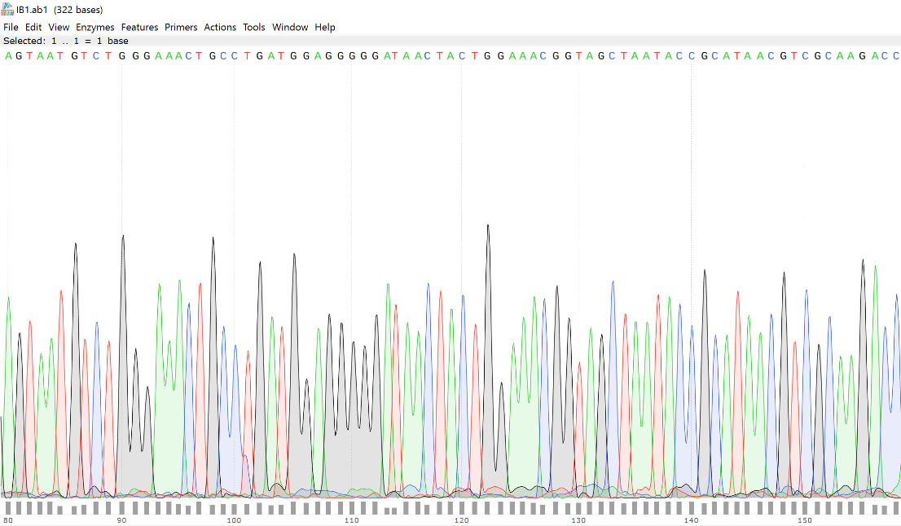

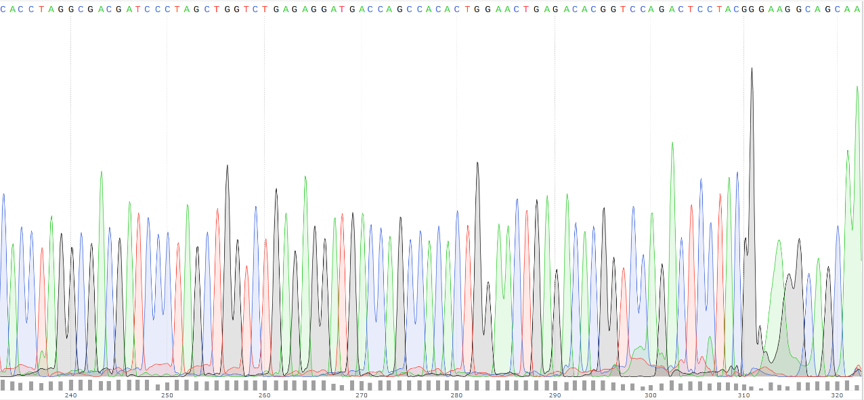
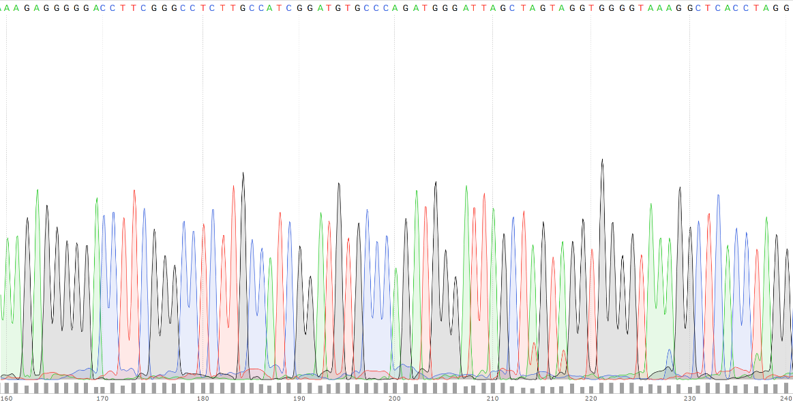

Annex III: Electronic Supplementary Material

The electronic supplementary material (attached as a CD) contains the following file:

- A PDF version of the present thesis.

Annex IV: Curriculum Vitae

