Supplementary Material (Figures S1–S6)

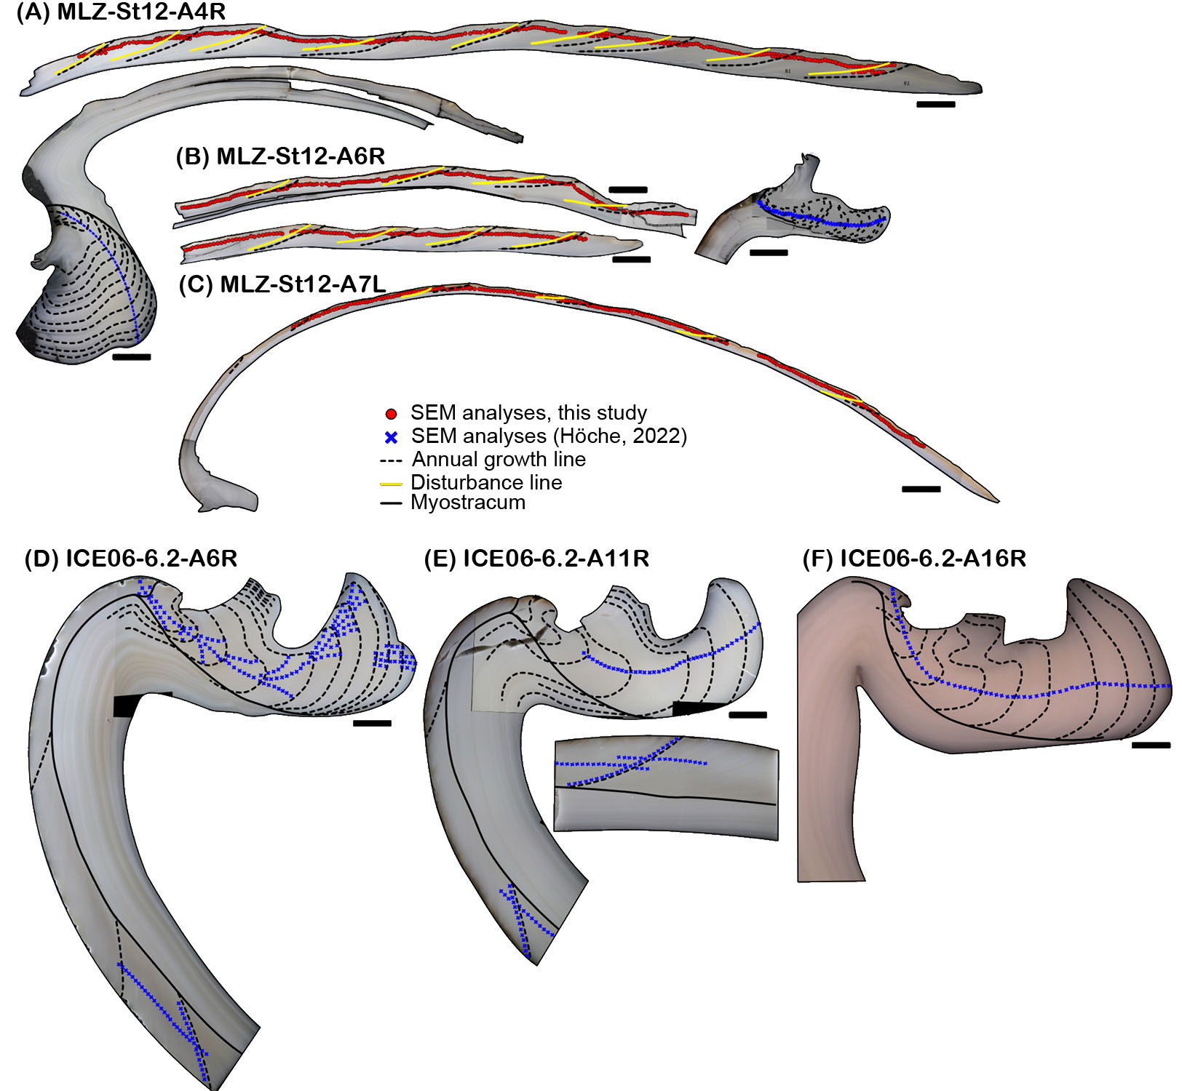
Figure S1. Cross-sectioned shells of Arctica islandica used in present study. To fit on the SEM sample holders (1” diameter), shell slabs were broken into multiple pieces. Dashed black lines indicate annual growth lines and solid yellow lines indicate Mn-rich disturbance lines. All scale bars are 1 mm. Direction of growth is to the right in all images. Small red circles and blue crosses denote positions of SEM images. Note difference in shell thickness between specimens from the western Baltic Sea (A-C; < 1.5 mm) and NE Iceland (D-F; > 3 mm).
Figure S2. Automated measurement of BMU shape. Illustration of the measurement of BMU morphology. SEM images (A) were first segmented using Ilastik, resulting in color-coded BMUs (B). For each BMU, several morphological measures are computed (C). BMU area and perimeter can be computed from the BMU pixel outline alone (black line and gray area). The convex hull (red) is constructed for the calculation of BMU solidity. The ellipse fit (blue) is used to determine BMU length and width (dark blue lines) as well as BMU elongation (length / width).

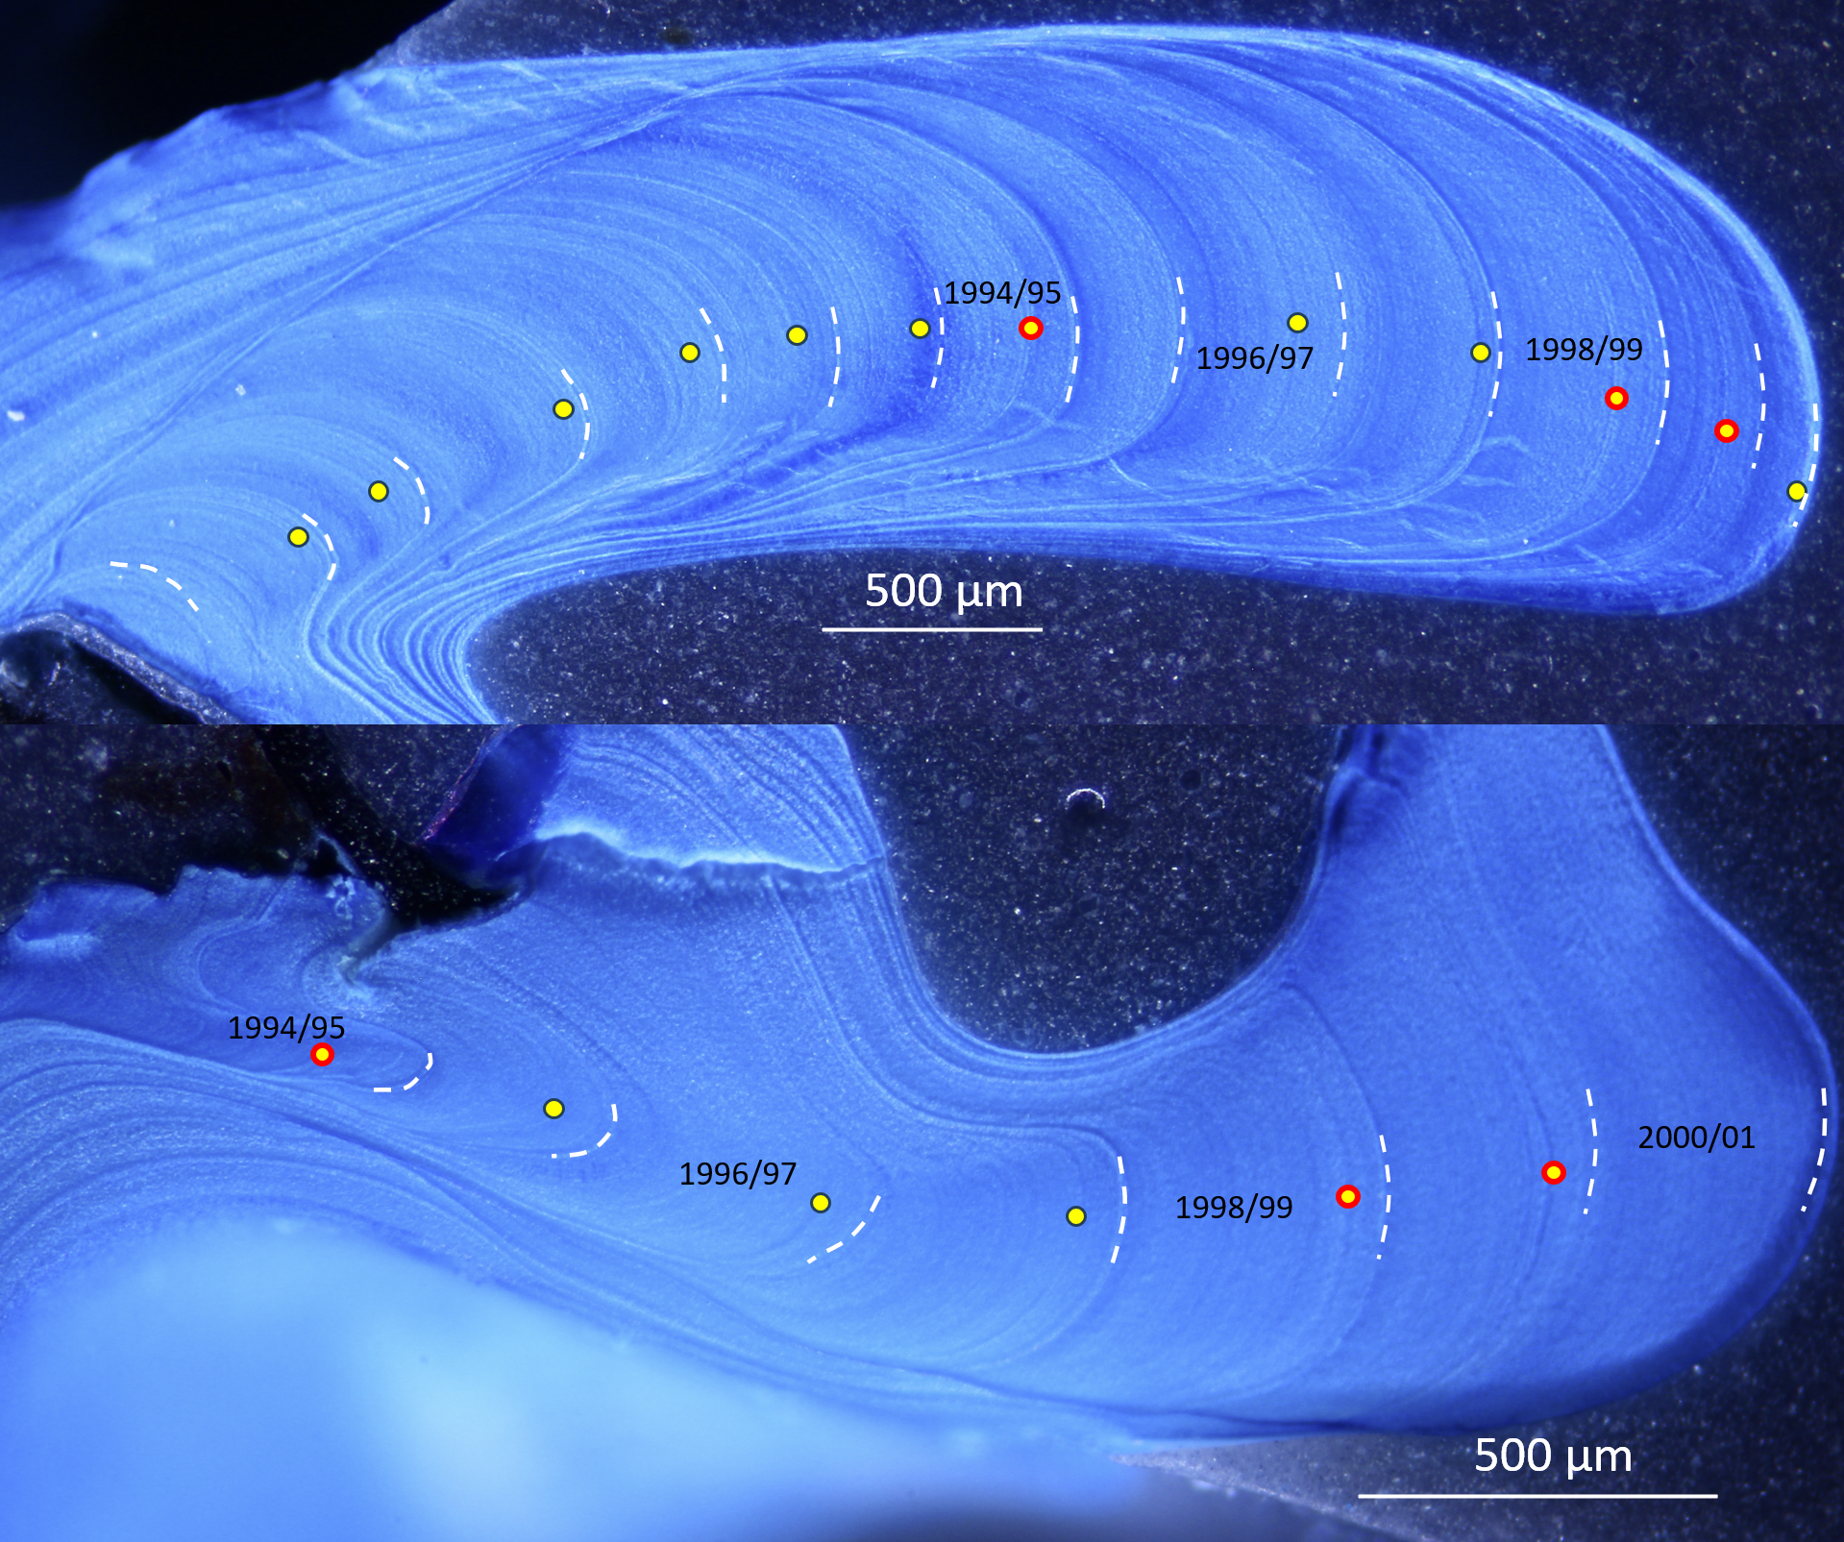
Figure S3. Mutvei-stained cross-section of Arctica islandica specimens MLZ-St12-A6R (upper panel) and MLZ-St12-A7L (lower panel) from Mecklenburg Bight showing annual growth lines (dashed white lines) and disturbance lines (yellow circles) in the hinge. Circles with red outline denote particularly prominent disturbance lines.

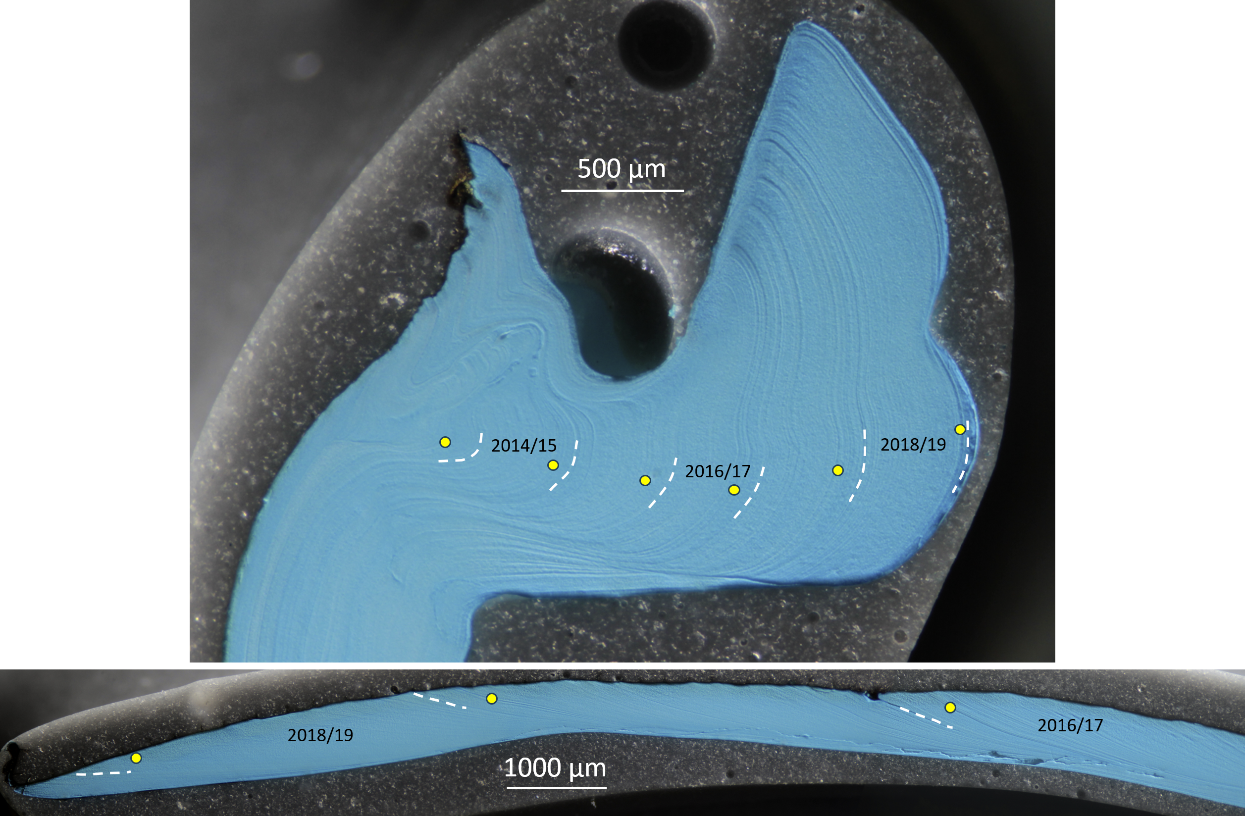
Figure S4. Mutvei-stained cross-section of an Arctica islandica specimen from Fehmarn Belt (MLZ-FBR36-A6R) showing annual growth lines (dashed white lines) and disturbance lines (yellow circles) in the hinge (upper panel) and the ventral margin (lower panel).

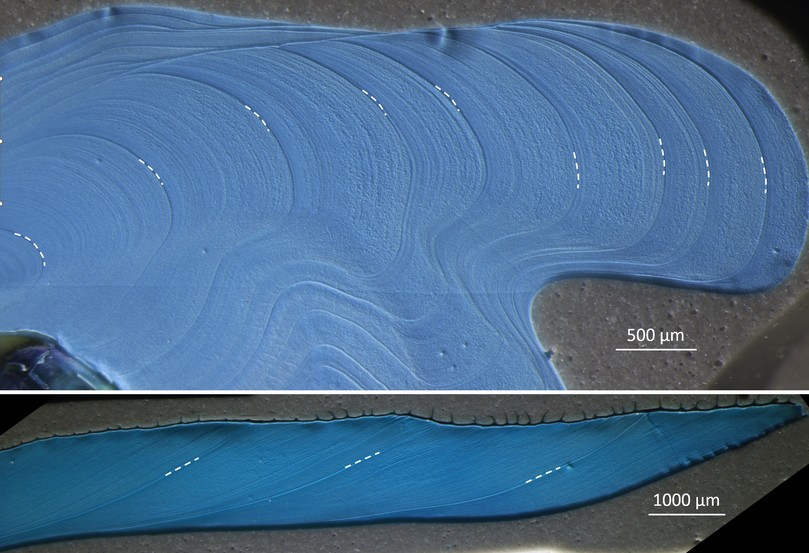Figure S5. Mutvei-stained cross-section of an Arctica islandica specimen from NE Iceland (ICE06-6.2-A6R; upper panel: hinge, lower panel: ventral margin) showing distinct annual growth lines (dashed white lines), but not disturbance lines.

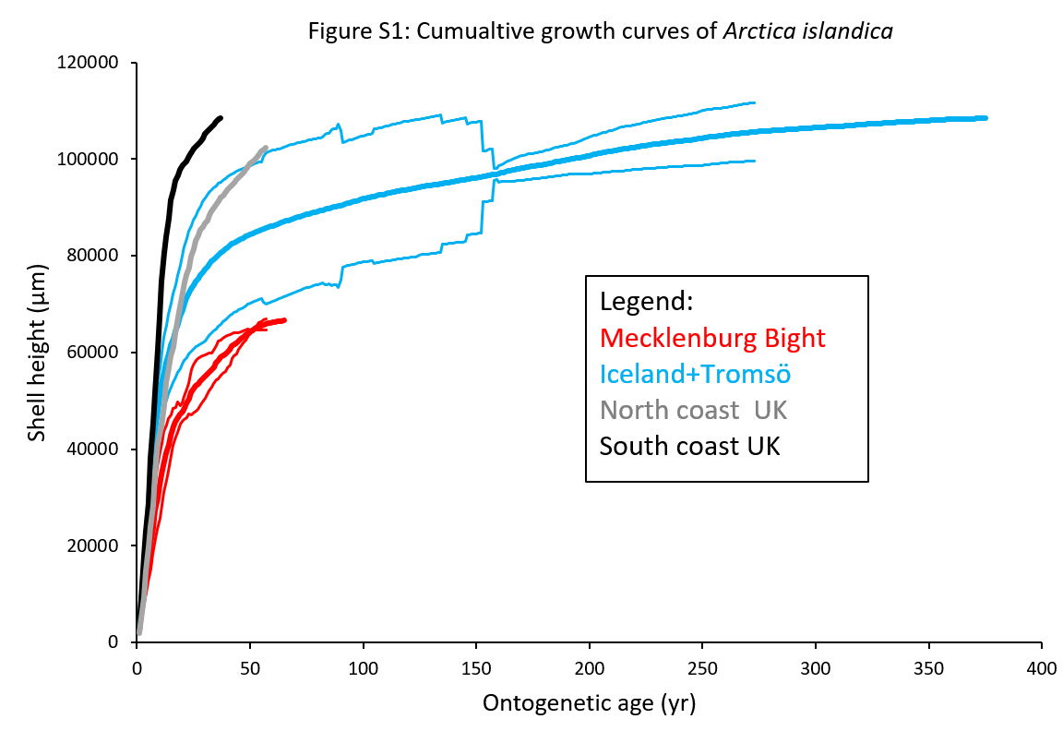Figure S6. Cumulative growth curves of Arctica islandica.

