Supplement:

Material S1) Questionnaire
Question 1:
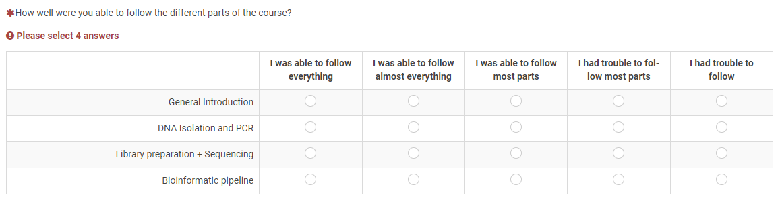
Question 2:
Question 3:
Question 4:

Question 5:
Question 6:

Figure S1) Phylogeny of GER Samples: Comparison of Oxford Nanopore sequencing and Sanger sequencing
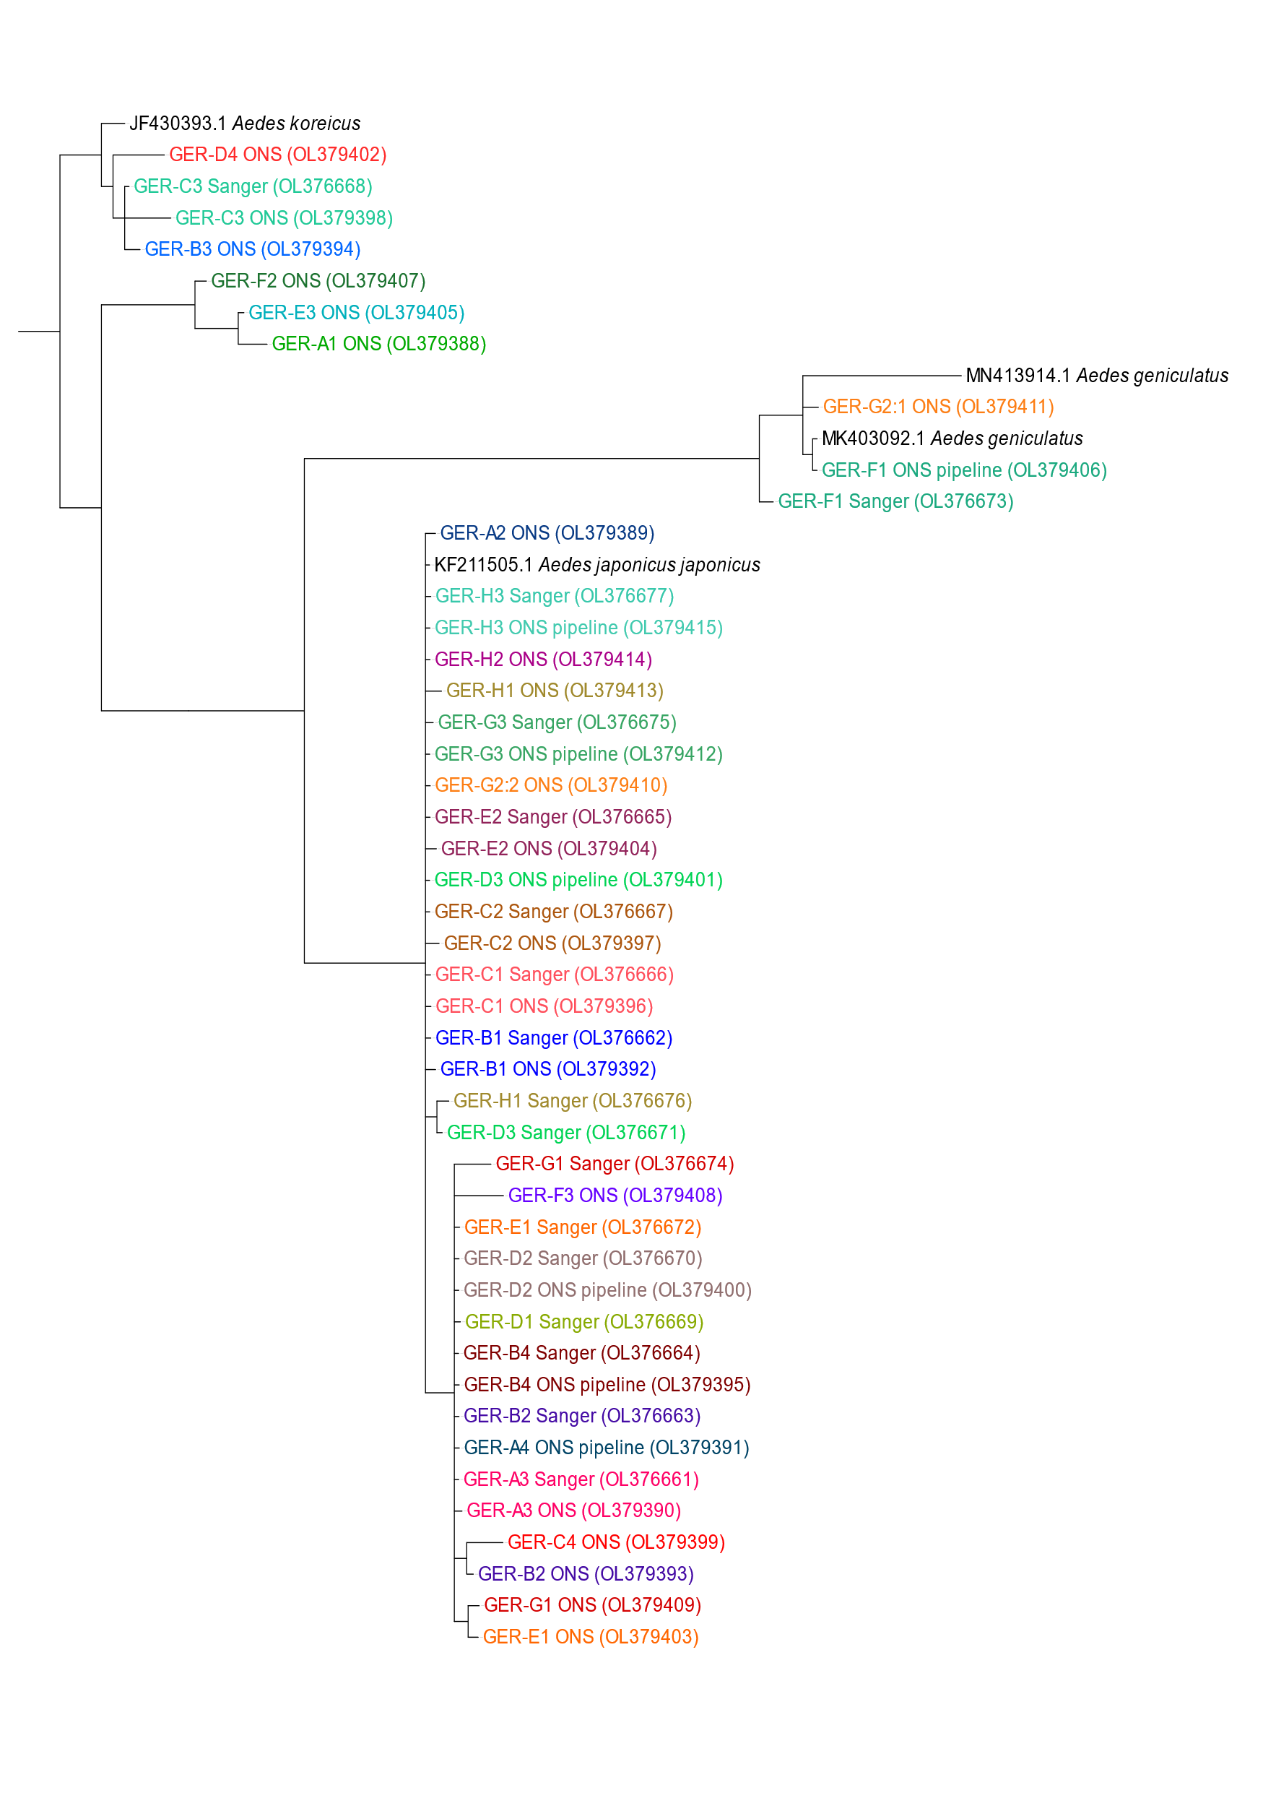
Supplement B: Phylogenetic comparison of sequences obtained by Sanger or Oxford Nanopore sequencing (ONS). Matching colors refer to the same individual. Sequence names depicted in black color refer to reference sequences that were added for species identification. GenBank accession numbers of the produced sequences are included in brackets.
Table S1) Comparison of Oxford Nanopore sequencing and morphological identification of the BEL samples

Supplement C: Results of morphological identification and Oxford Nanopore barcoding pipeline. Sequences were BLASTed against the GenBank database. Accession numbers are given for Oxford Nanopore sequences (ONS).
Sample | Species (morphological identification) | Species (ONS sequence) | Percent ident. (BLAST) | Matching of results | Accession number (ONS)
BEL-S1 | Aedes sticticus | Ae. sticticus | 99.39 | Y | OL348195
BEL-S2 | Aedes caspius | Ae. caspius | 99.85 | Y | OL348196
BEL-S3 | Aedes sticticus | Ae. sticticus | 99.39 | Y | OL348197
BEL-S4 | Aedes vexans | Ae. vexans | 99.70 | Y | OL348198
BEL-S5 | Aedes rusticus | Ae. rusticus | 99.54 | Y | OL348199
BEL-S6 | Aedes geniculatus | Ae. geniculatus | 98.78 | Y | OL348200
BEL-S7 | Aedes koreicus | Ae. koreicus | 99.54 | Y | OL348201
BEL-S8 | Aedes japonicus | Ae. japonicus | 99.70 | Y | OL348202

