Supplementary
Tables
Table S1. Phytoplankton groups that were used in the first set of simulations including the years 2011, 2012 and 2019.
Identified phytoplankton group | Max. cell concentration in 2011  (cells L⁻¹) | Max. cell concentration in 2012  (cells L⁻¹) | Max. cell concentration in 2019  (cells L⁻¹) |  | Index
Alexandrium spp. | 0 | 46,310 | 200 |  | 0
Cerataulina pelagica | 190,900 | 0 | 7,000 |  | 1
Chaetoceros curvisetus + debilis | 37,170 | 200 | 135,360 |  | 2
Chaetoceros danicus | 0 | 4,000 | 4,560 |  | 3
Chaetoceros didymus | 70,350 | 85,100 | 1,200 |  | 4
Chaetoceros pseudobrevis | 17,110 | 0 | 0 |  | 5
Chaetoceros socialis | 1,080 | 0 | 12,360 |  | 6
Chaetoceros sp. (chains) | 0 | 46,310 | 0 |  | 7
Chaetoceros spp. | 4,060,000 | 1,230,000 | 92,160 |  | 8
Coscinodiscus wailesii | 400 | 44,310 | 0 |  | 9
Cyclotella sp. | 26,180 | 10,100 | 0 |  | 10
Dactyliosolen fragilissimus | 222,880 | 2,500 | 58,080 |  | 11
Diatoma vulgare | 0 | 1,510 | 0 |  | 12
Dinophysis acuminata | 1,500 | 120 | 200 |  | 13
Guinardia delicatula | 129,900 | 302,100 | 166,080 |  | 14
Guinardia flaccida | 3,000 | 2,300 | 42,000 |  | 15
Guinardia striata | 1,250 | 500 | 7,200 |  | 16
Gymnodinium spp. | 110,770 | 207,440 | 63,840 |  | 17
Gyrodinium spp. | 1,200 | 26,180 | 1,560 |  | 18
Haslea wawrickae | 1,750 | 1,760 | 0 |  | 19
Heterocapsa minima | 292,000 | 47,330 | 14,560 |  | 20
Heterocapsa triqueta | 3,250 | 0 | 240 |  | 21
Lauderia annulata | 0 | 21,650 | 400 |  | 22
Lepidodinium chlorophorum | 69,480 | 28,190 | 0 |  | 23
Leptocylindrus danicus | 144,720 | 0 | 2,011,200 |  | 24
Leptocylindrus minimus | 0 | 0 | 20,160 |  | 25
Lithodesmium undulatum | 0 | 120 | 4,000 |  | 26
Minidiscus sp. | 2,000 | 30,210 | 0 |  | 27
Navicula spp. | 0 | 4,000 | 1,840 |  | 28
Naviculoides spp. | 320 | 2,250 | 0 |  | 29
Nitzschia longissima + Cylindrotheca closterium | 1,630 | 1,500 | 6,280 |  | 30
Nitzschia spp. | 1,630 | 1,000 | 720 |  | 31
Prorocentrum micans | 2,500 | 2,250 | 1,120 |  | 32
Prorocentrum minimum + cordatum + balticum | 1,200 | 8,060 | 160 |  | 33
Prorocentrum triestinum | 5,880 | 80 | 1,400 |  | 34
Protoperidinium bipes | 1,000 | 5,000 | 6,240 |  | 35
Protoperidinium depressum | 1,350 | 0 | 760 |  | 36
Pseudo-nitzschia delicatissima | 22,610 | 5,750 | 2,760 |  | 37
Pseudo-nitzschia pungens | 1,960 | 830 | 0 |  | 38
Pseudo-nitzschia seriata | 7,540 | 45,130 | 2,360 |  | 39
Rhizosolenia imbricata | 2,800 | 32,530 | 560 |  | 40
Rhizosolenia setigera | 2,750 | 1,380 | 1,880 |  | 41
Scrippsiella spp. + Pentapharsodinium spp. + Ensiculifera spp. | 20,270 | 3,500 | 2,920 |  | 42
Skeletonema marinoi | 2,400 | 12,100 | 0 |  | 43
Thalassionema nitzschioides | 12,560 | 51,350 | 13,000 |  | 44
Thalassiosira spp. | 44,310 | 88,620 | 298,760 |  | 45
Tripos kofoidii | 1,120 | 7,510 | 2,160 |  | 46

Table S2. Phytoplankton groups that were utilized in the second set of simulations including the years 2011 and 2012.
Identified phytoplankton group | Max. cell concentration in 2011  (cells L⁻¹) | Max. cell concentration in 2012  (cells L⁻¹) | Index
Alexandrium spp. | 0 | 46,310 | 0
Cerataulina pelagica | 190,900 | 0 | 1
Chaetoceros curvisetus | 8,760 | 0 | 2
Chaetoceros danicus | 0 | 4,000 | 3
Chaetoceros debilis | 37,170 | 200 | 4
Chaetoceros didymus | 70,350 | 85,100 | 5
Chaetoceros pseudobrevis | 17,110 | 0 | 6
Chaetoceros socialis | 1,080 | 0 | 7
Chaetoceros sp. (chains) | 0 | 46,310 | 8
Chaetoceros spp. | 4,060,000 | 1,230,000 | 9
Coscinodiscus wailesii | 400 | 44,310 | 10
Cyclotella sp. | 26,180 | 10,100 | 11
Cylindrotheca closterium | 1,500 | 1,500 | 12
Dactyliosolen fragilissimus | 222,880 | 2,500 | 13
Diatoma vulgare | 0 | 1,510 | 14
Dinophysis acuminata | 1,500 | 120 | 15
Guinardia delicatula | 129,900 | 302,100 | 16
Guinardia flaccida | 3,000 | 2,300 | 17
Guinardia striata | 1,250 | 500 | 18
Gymnodinium spp. <20 µm | 0 | 207,440 | 19
Gymnodinium spp. >20 µm | 110,770 | 11,070 | 20
Gyrodinium flagellare | 8,060 | 13,250 | 21
Gyrodinium spp. | 1,200 | 26,180 | 22
Haslea wawrickae | 1,750 | 1,760 | 23
Heterocapsa minima | 292,000 | 47,330 | 24
Heterocapsa triqueta | 3,250 | 0 | 25
Lauderia annulata | 0 | 21,650 | 26
Lepidodinium chlorophorum | 69,480 | 28,190 | 27
Leptocylindrus danicus | 144,720 | 0 | 28
Minidiscus sp. | 2,000 | 30,210 | 29
Navicula sp. (8-10 µm) | 0 | 4,000 | 30
Naviculoides spp. | 320 | 2,250 | 31
Nitzschia longissima | 1,630 | 0 | 32
Nitzschia spp. | 0 | 1,000 | 33
Prorocentrum balticum | 1,200 | 8,060 | 34
Prorocentrum micans | 2,500 | 2,250 | 35
Prorocentrum triestinum | 5,880 | 80 | 36
Protoperidinium bipes | 1,000 | 5,000 | 37
Protoperidinium depressum | 1,350 | 0 | 38
Pseudo-nitzschia delicatissima | 22,610 | 5,750 | 39
Pseudo-nitzschia pungens | 1,960 | 830 | 40
Pseudo-nitzschia seriata | 7,540 | 45,130 | 41
Rhizosolenia imbricata | 2,800 | 32,530 | 42
Rhizosolenia setigera | 1,750 | 1,380 | 43
Rhizosolenia setigera (fine) | 1,000 | 0 | 44
Scrippssiella sp. | 20,270 | 3,500 | 45
Skeletonema marinoi | 2,400 | 12,100 | 46
Thalassionema nitzschioides | 12,560 | 51,350 | 47
Thalassiosira spp. | 44,310 | 88,620 | 48
Tripos kofoidii | 1,120 | 7,510 | 49

Figures
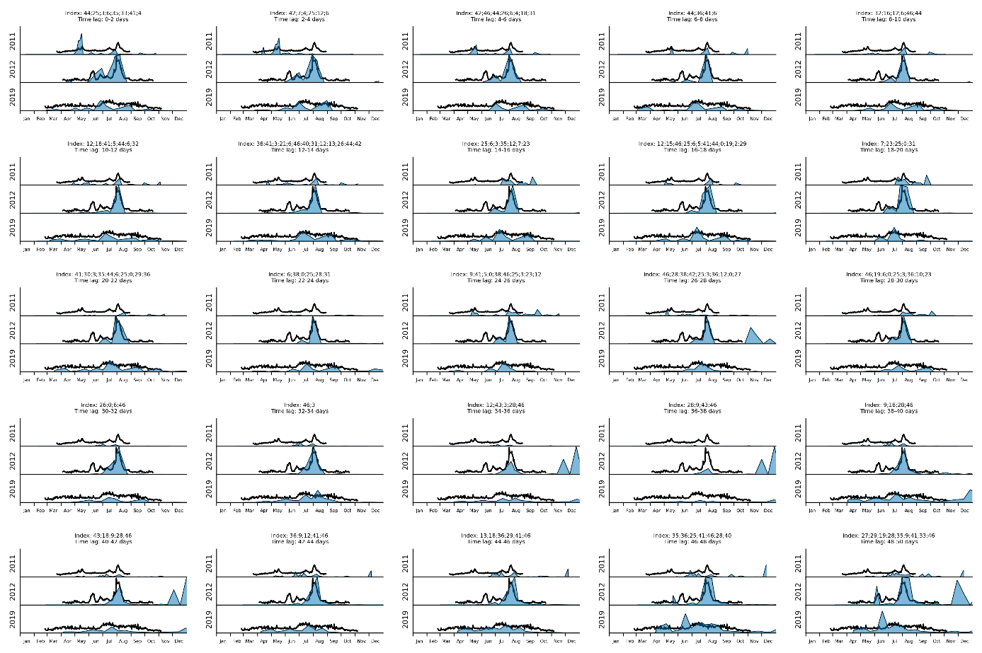
Figure S1. Ba/Ca_{shell} profiles Set1 – 3days interval.
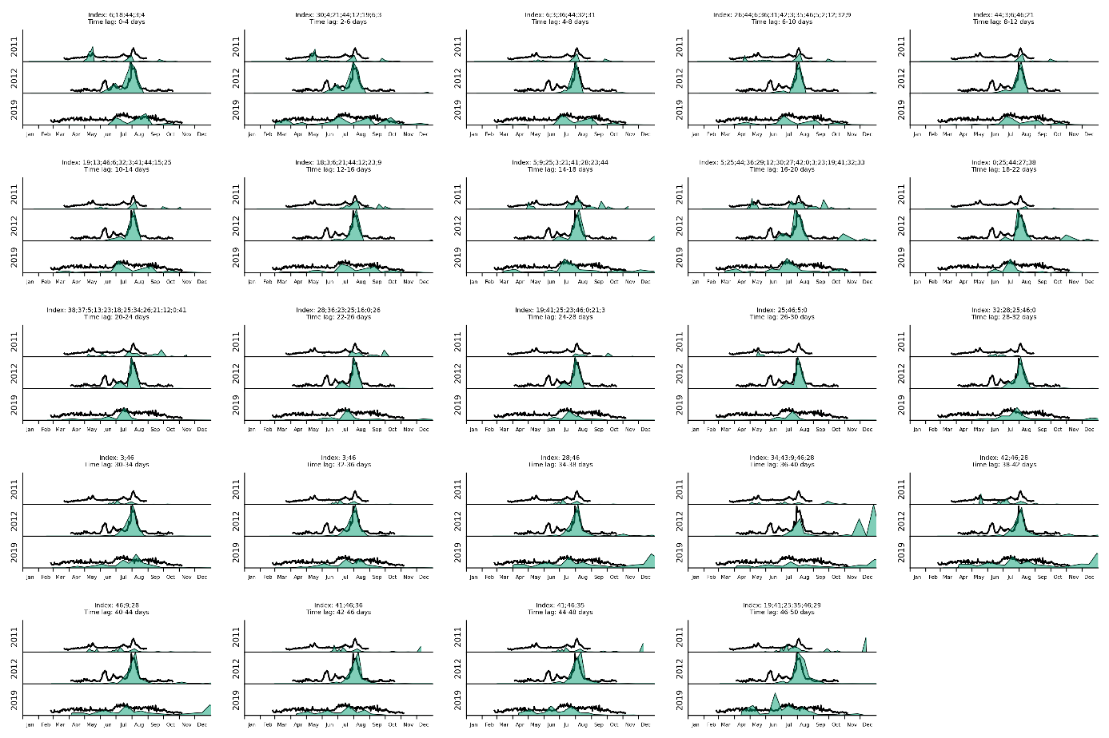
Figure S2. Ba/Ca_{shell} profiles Set1 – 5days interval.
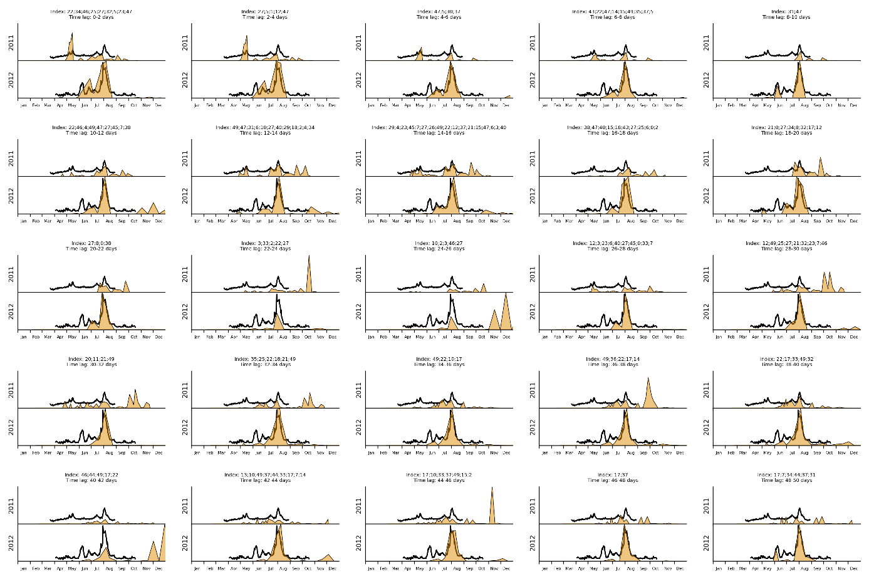
Figure S3. Ba/Ca_{shell} profiles Set2 – 3days interval.
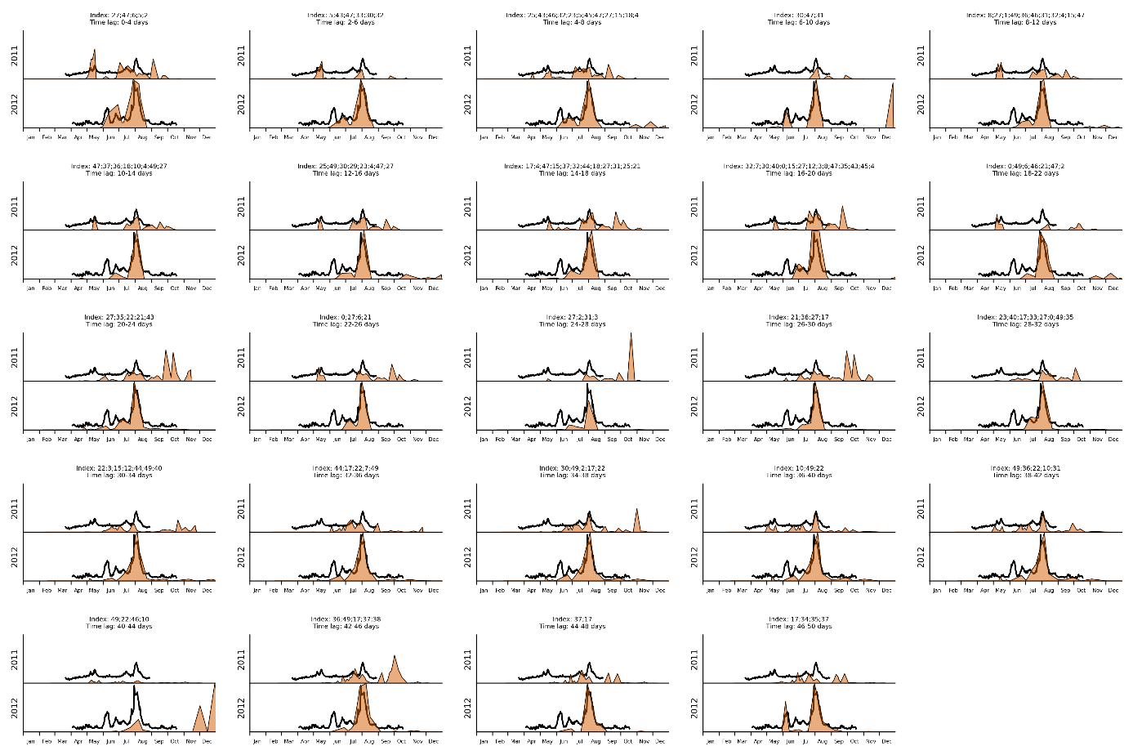
Figure S4. Ba/Ca_{shell} profiles Set2 – 5days interval.

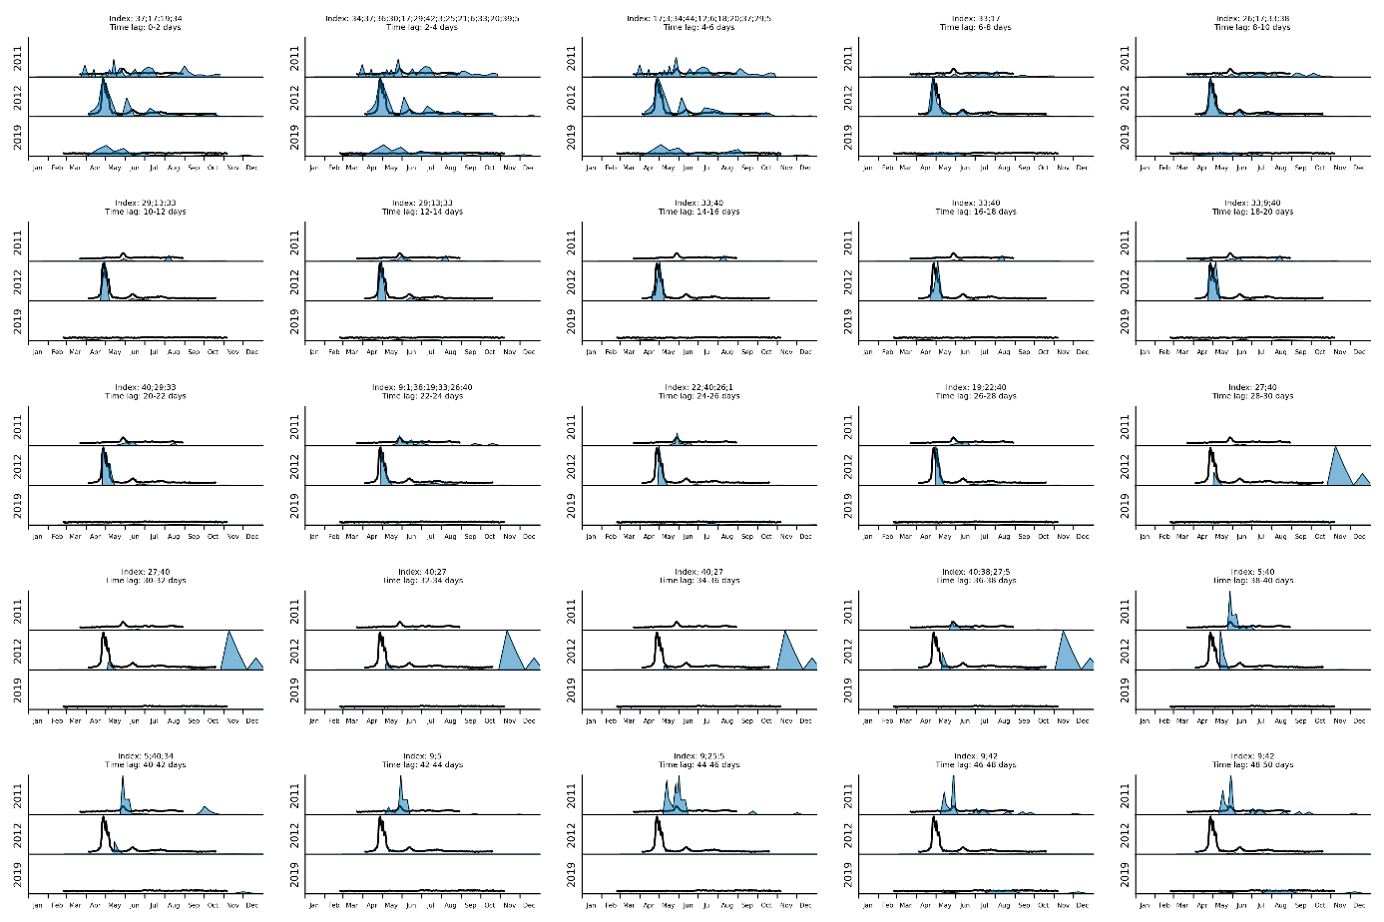
Figure S5. Mo/Ca_{shell} profiles Set1 – 3days interval.
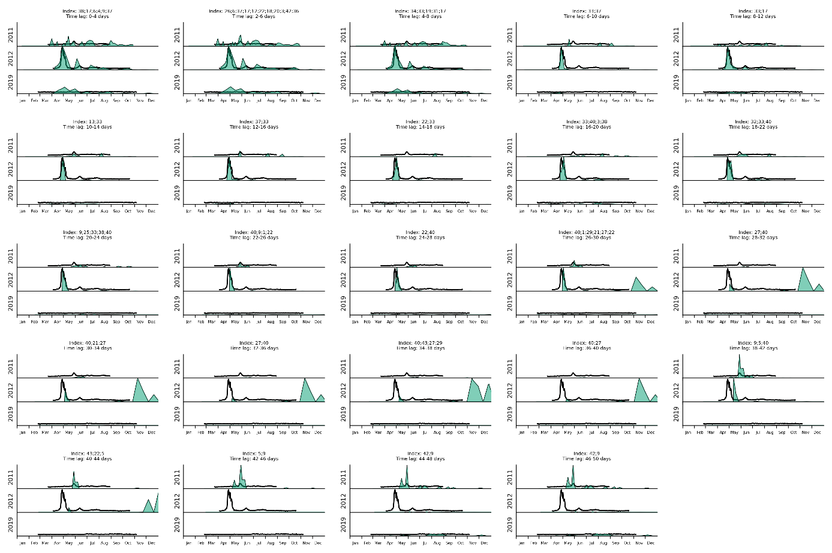
Figure S6. Mo/Ca_{shell} profiles Set1 – 5days interval.
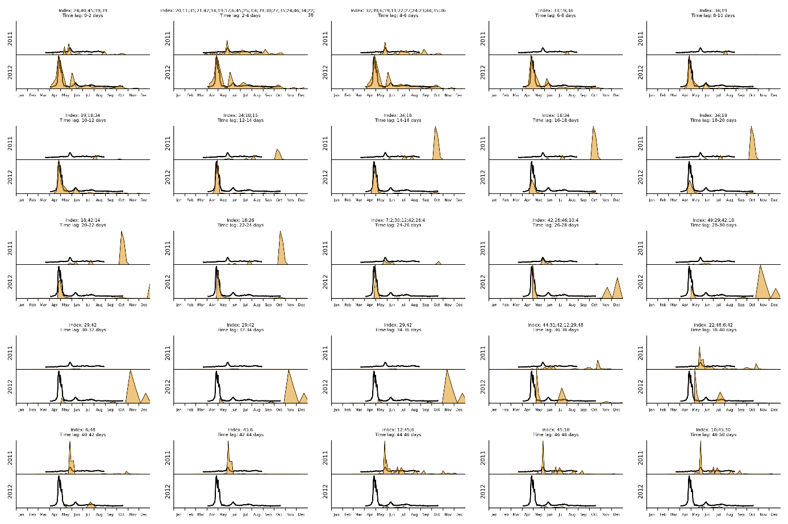
Figure S7. Mo/Ca_{shell} profiles Set2 – 3days interval.
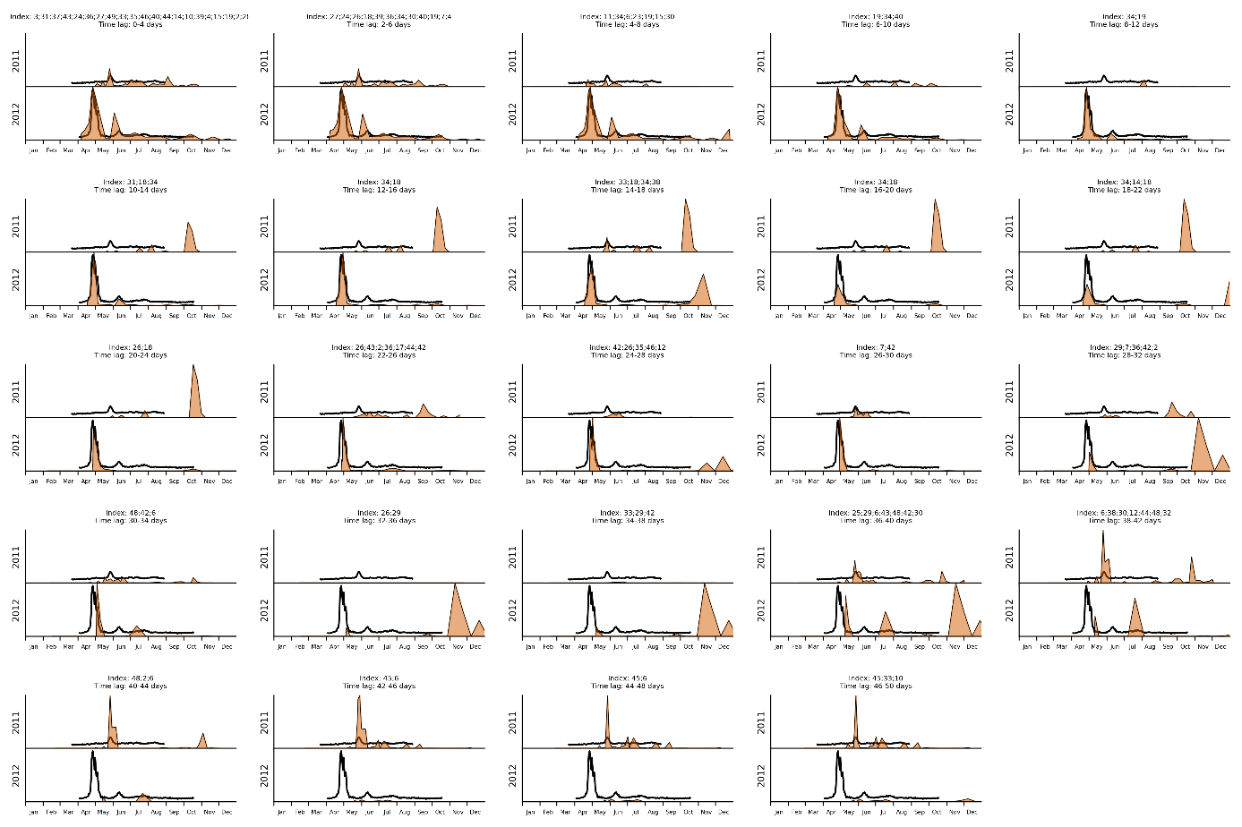
Figure S8. Mo/Ca_{shell} profiles Set2 – 5days interval.

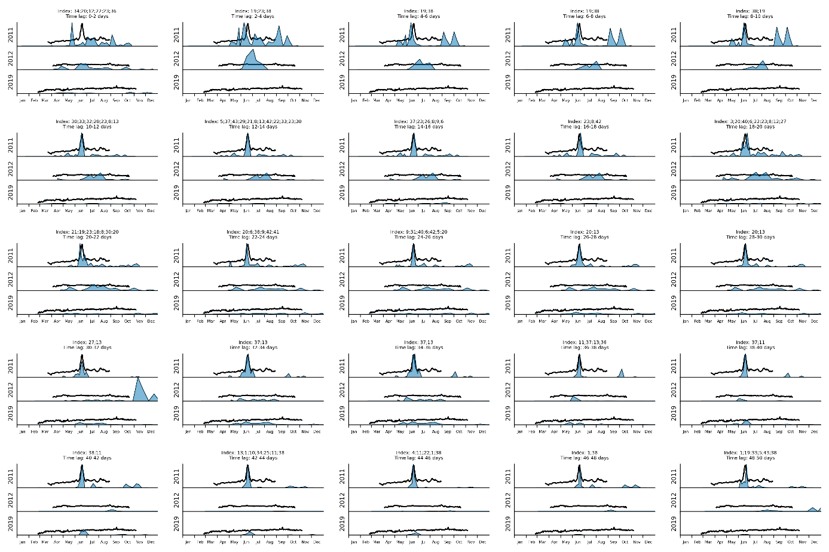
Figure S9. Li/Ca_{shell} profiles Set1 – 3days interval.
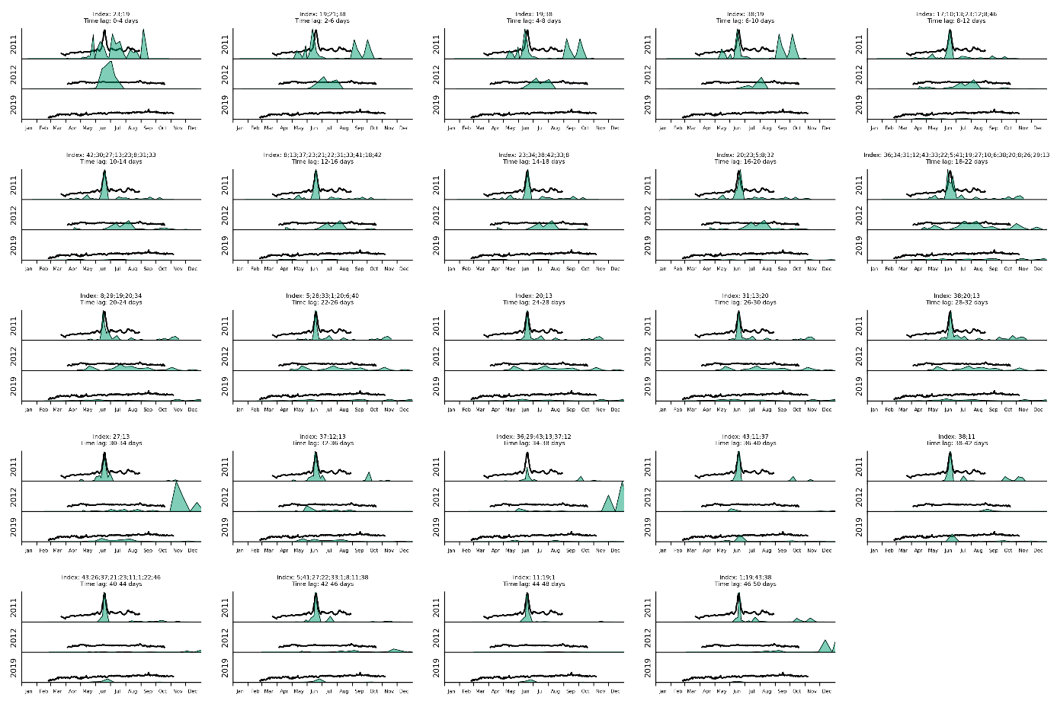
Figure S10. Li/Ca_{shell} profiles Set1 – 5days interval.
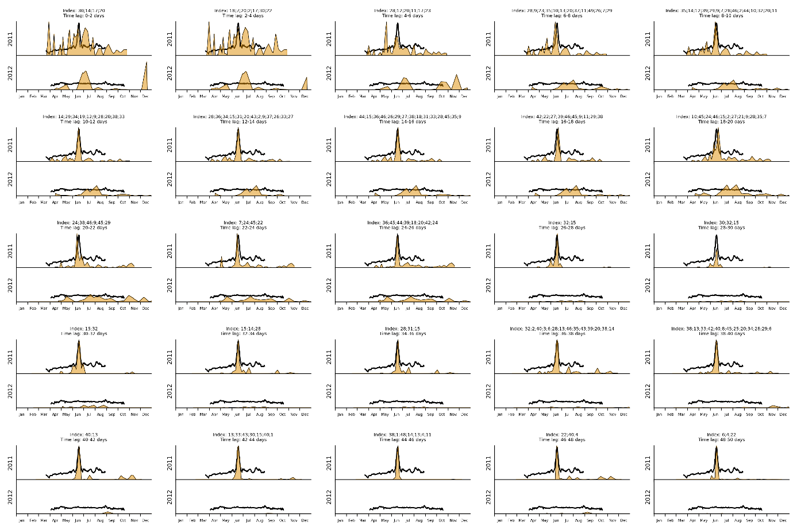
Figure S11. Li/Ca_{shell} profiles Set2 – 3days interval.
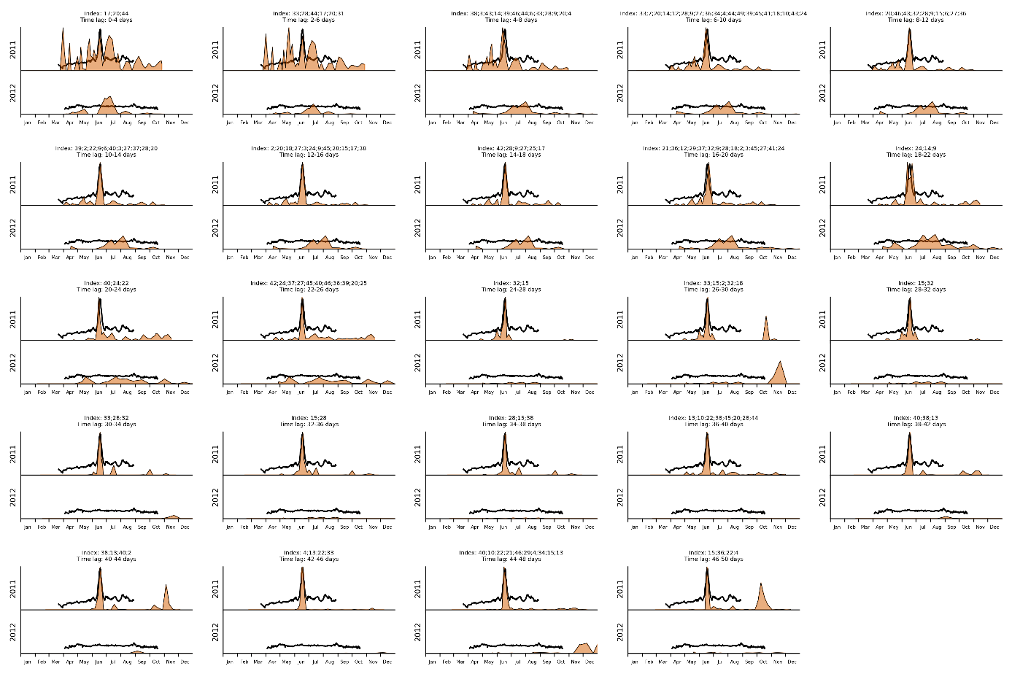
Figure S12. Li/Ca_{shell} profiles Set2 – 5days interval.

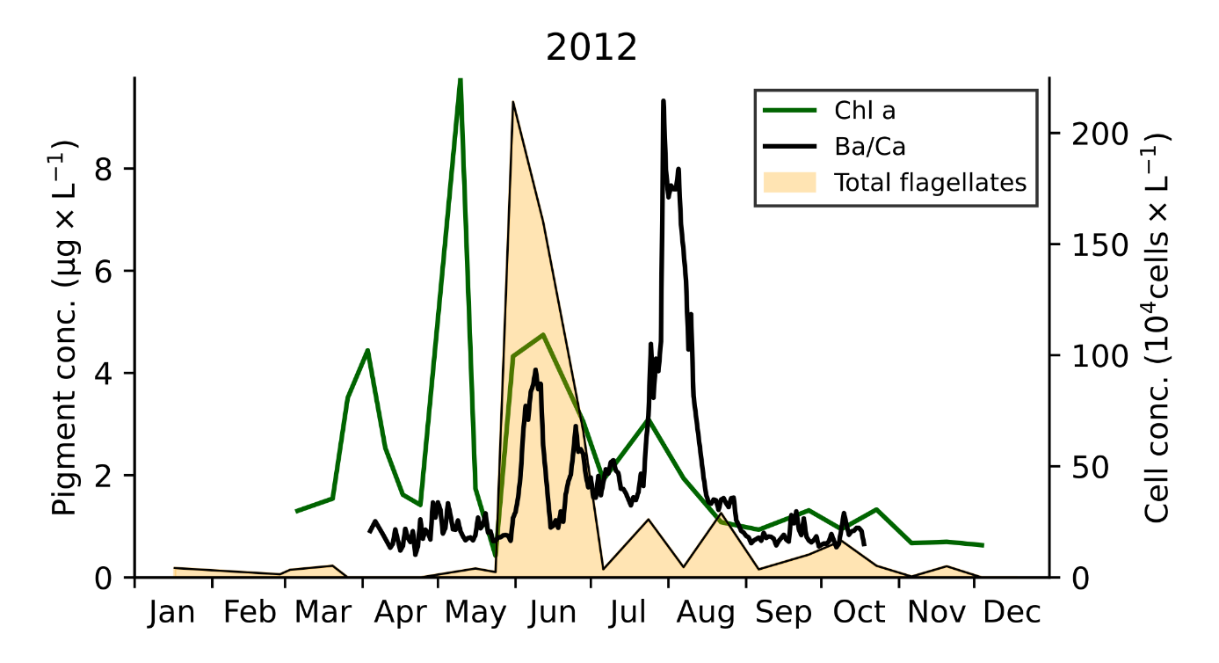
Figure S13. Chlorophyll a pigment concentration and total flagellates cell concentration recorded in 2012 at the sampling site in Lanvéoc. Average Ba/Ca_{shell} profile (black graph) measured in three contemporaneous shells.
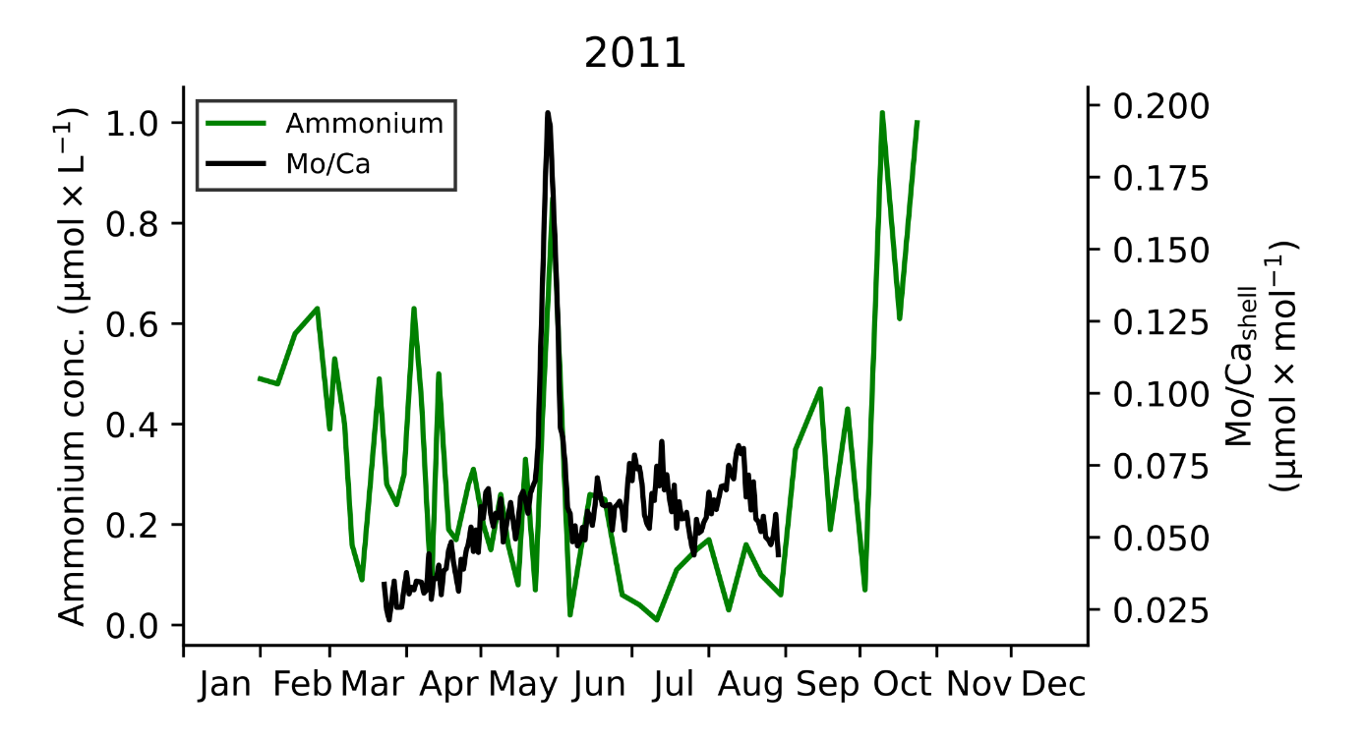
Figure S14. Ammonium (NH₄⁺) concentration in 2011 in relation to the average Mo/Ca_{shell} profile.

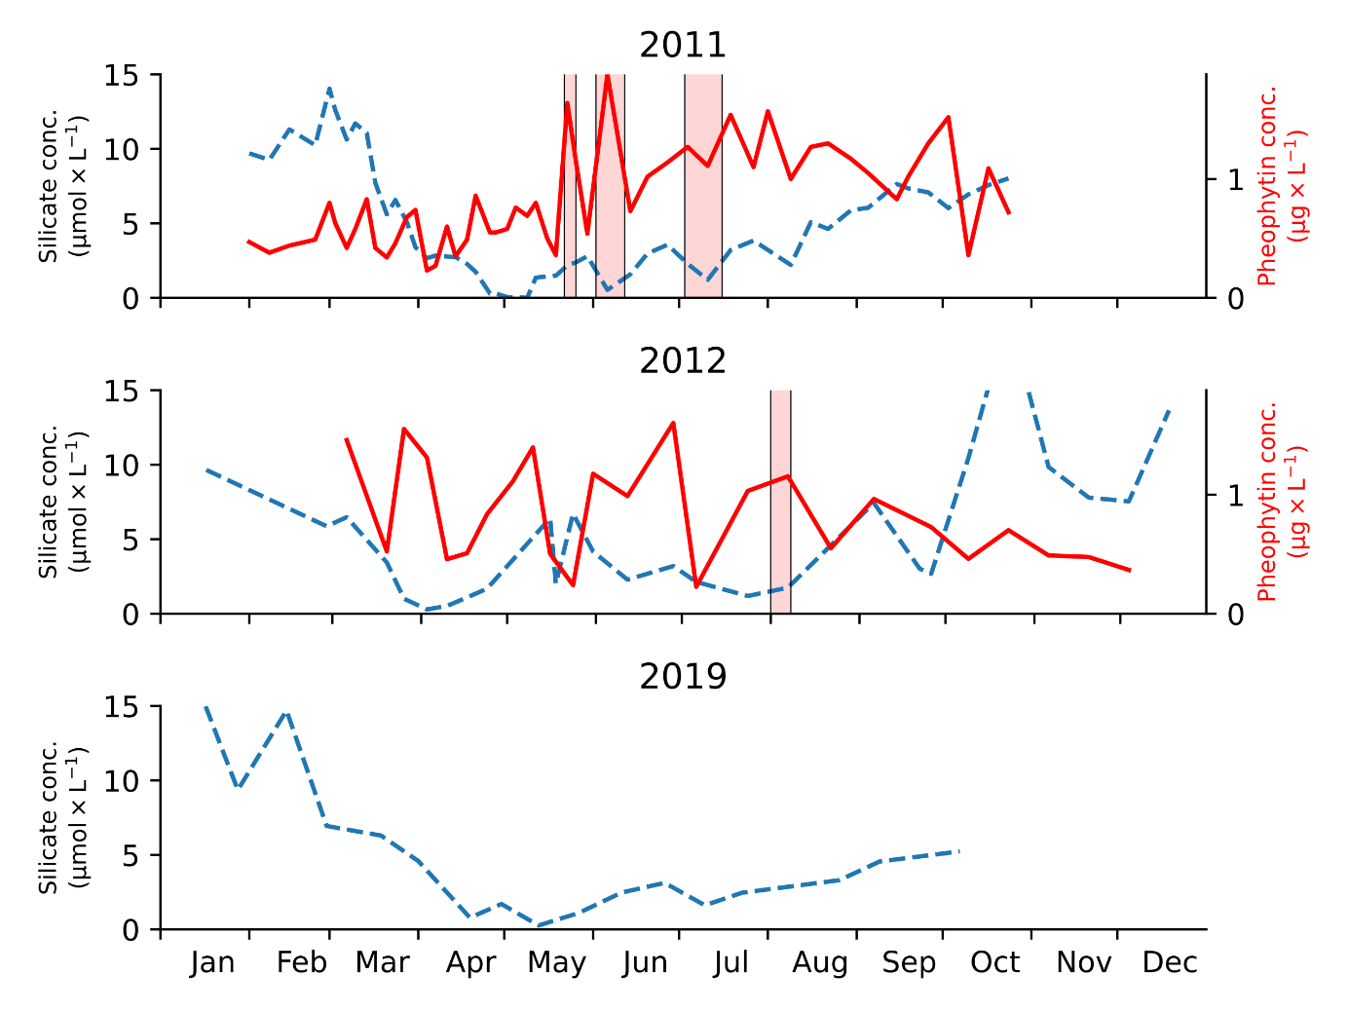
Figure S15. Silicic acid (SiOH₄) and pheophytin pigment concentrations in 2011, 2012 and 2019. No pheophytin pigments were recorded in 2019. Red vertical bars indicate periods (> 3 days) of high pheophytin levels (> 1.1 µg×L⁻¹) at contemporaneously low silicate levels (< 2.5 µmol×L⁻¹) in 2011 and 2012.

